To open the projects and setup the environment on your device please follow the steps:

1. Open the Eclipse on your device.

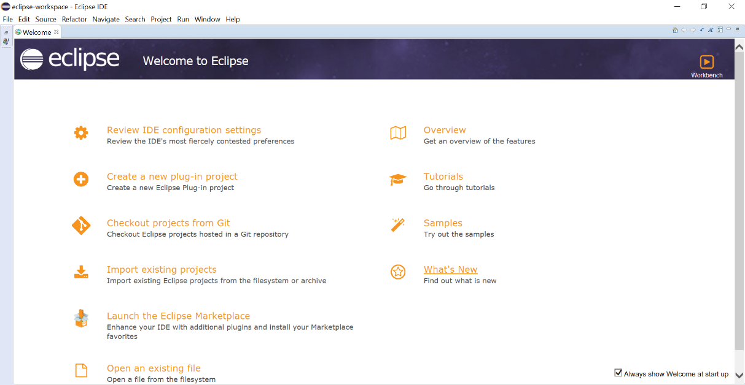

1. Select Checkout projects from Git or from tool menu File -> Import -> Git -> Projects from Git.

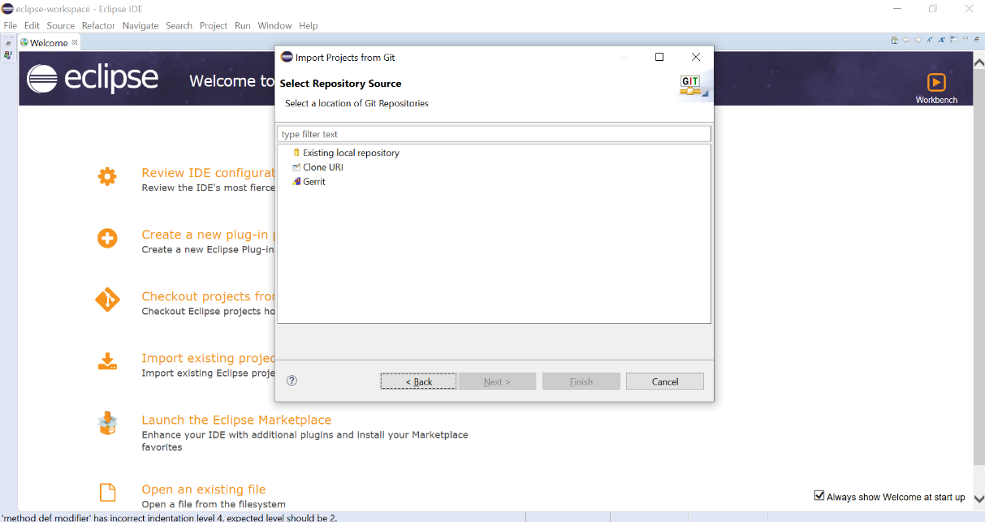

1. Select Clone URI and Next.

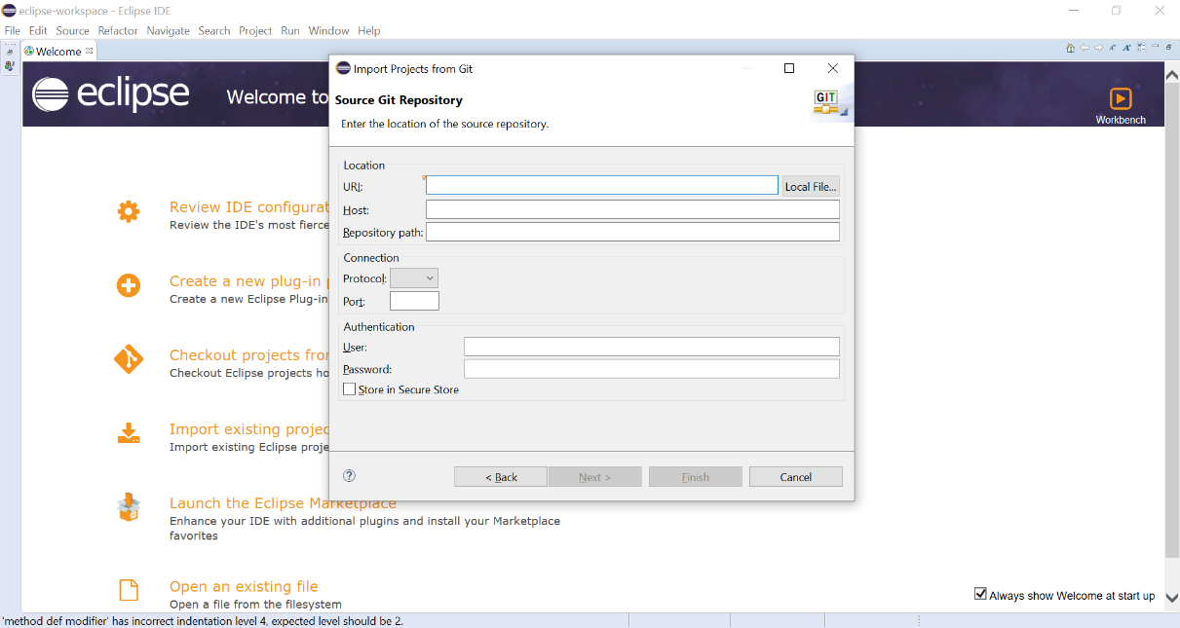

1. Insert the URI “<https://github.com/iip-ecosphere/platform.git>”. Host, Repository path, and Protocol will be fill automatically.

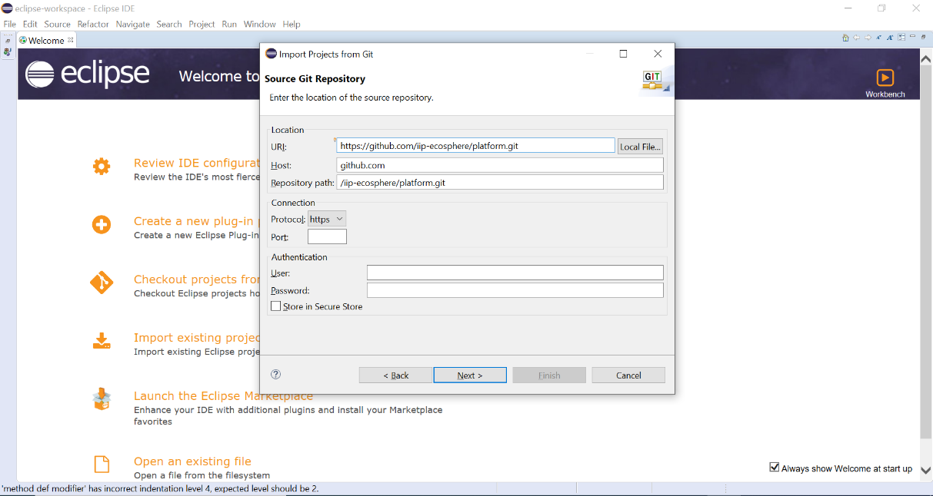

1. Next and keep main selected

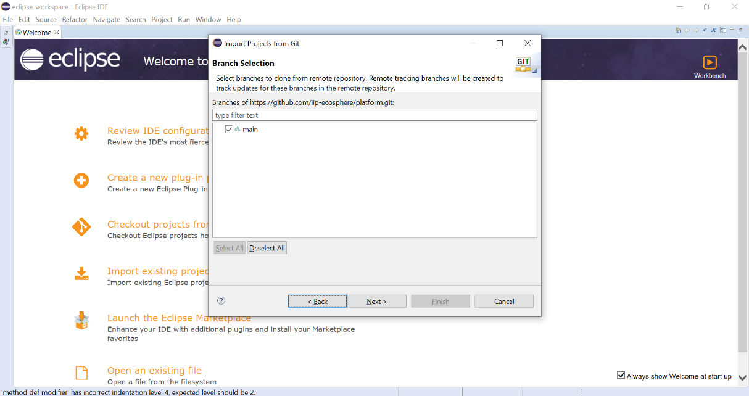

1. Next add the Directory or keep it as default.

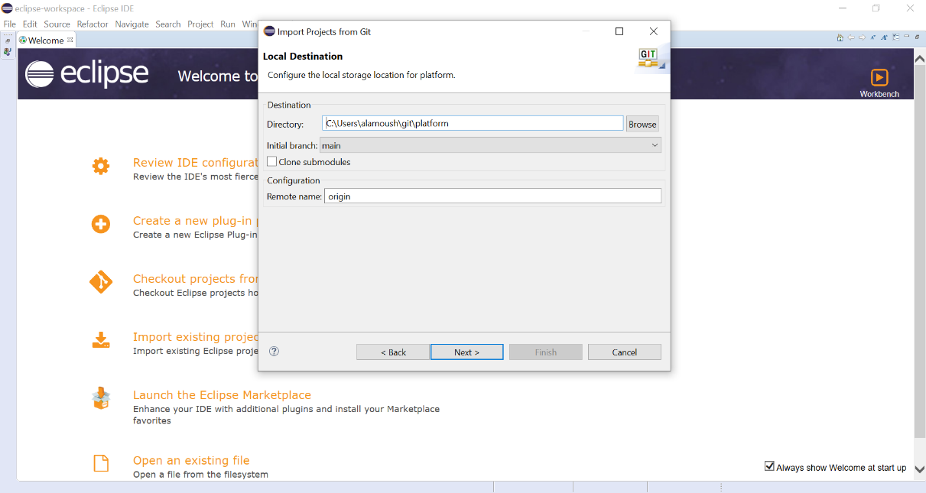

1. Select Import existing Eclipse projects and Next.

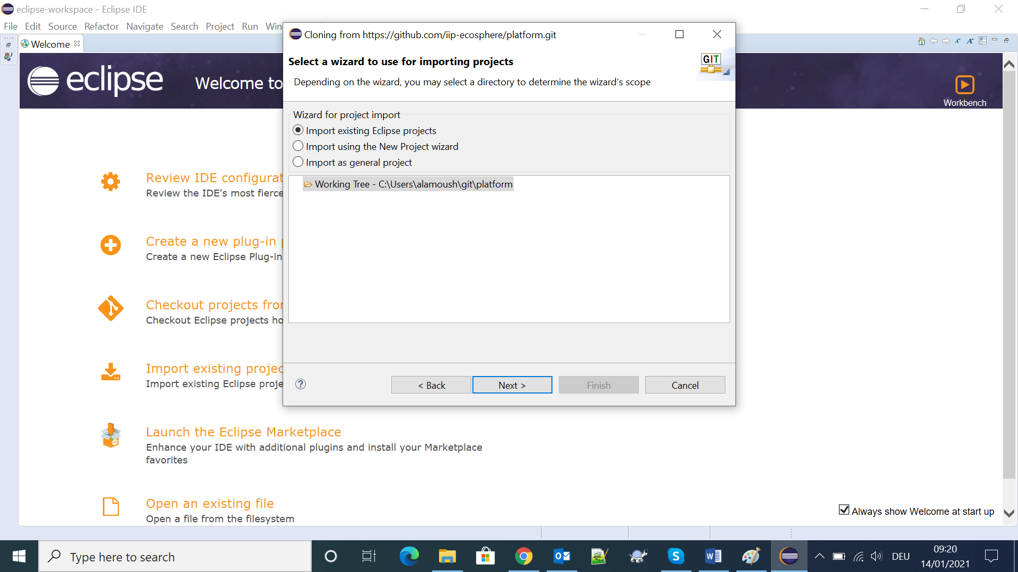

1. Deselect All and select just platformDependencies and Finish.

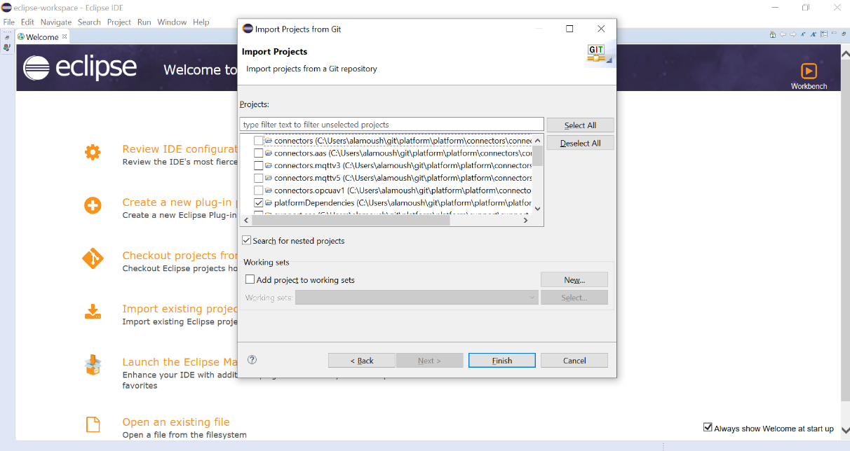

1. From the tool menu Window -> Preferences -> Checkstyle – in case you don’t have Checkstyle go to Help -> Eclipse Marketplace and install the Checkstyle Plug-in.

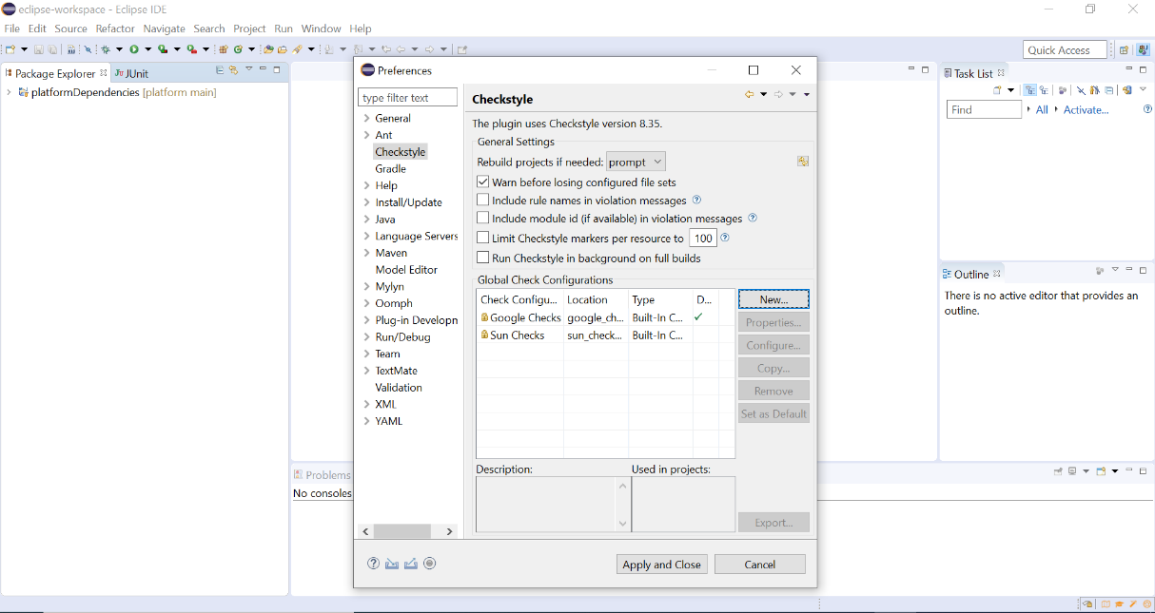

1. Select New and select External Configuration file, insert name “IIP Code Conventions”, and browse to the location of the following file in your device – same directory for the selected for Git “\platform\platform\platformDependencies\iipCodeConventions.xml” then select OK.

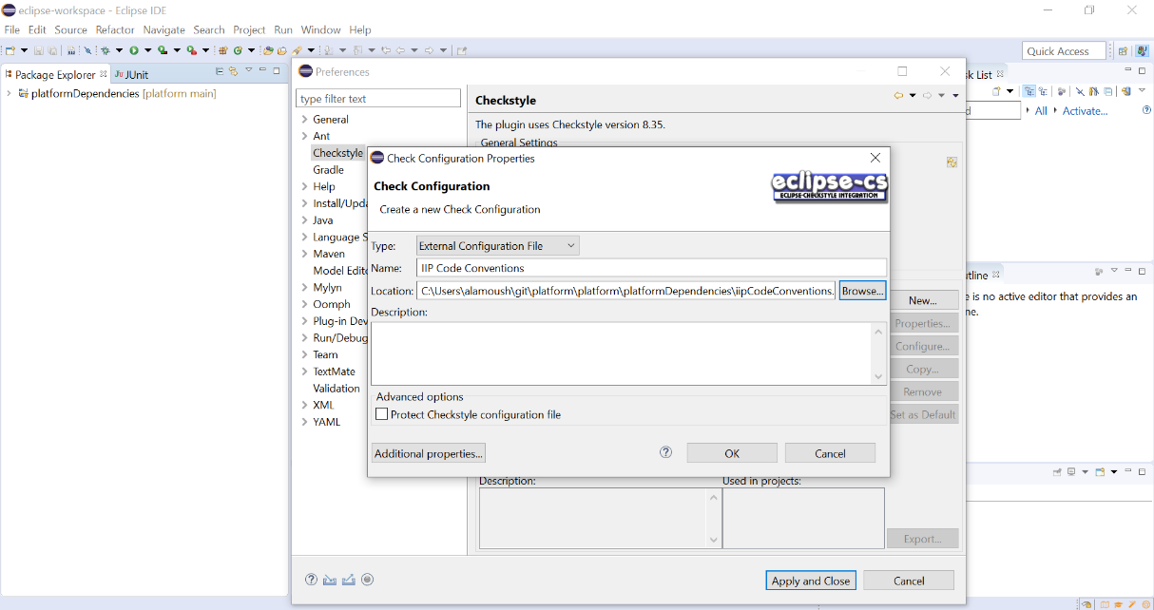

1. Select Java -> Code Style -> Formatter.

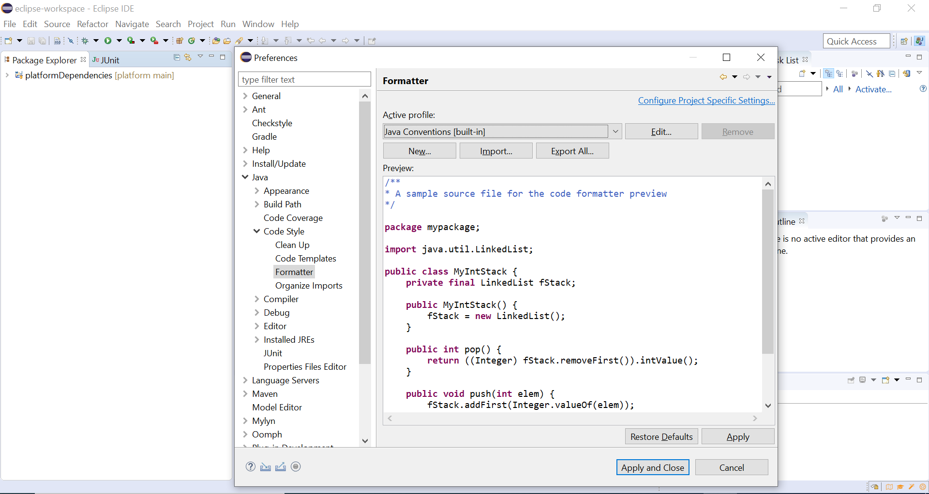

1. Select Import and browse to the location of the Git and select “\platform\platform\platformDependencies\iipCodeFormatter.xml” and click Open.

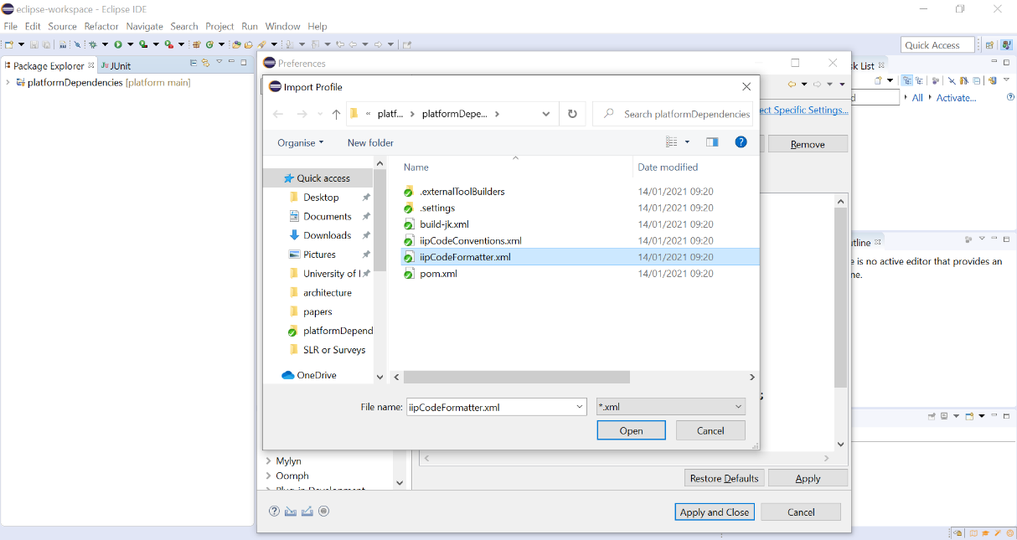

1. Click on Apply and Close.

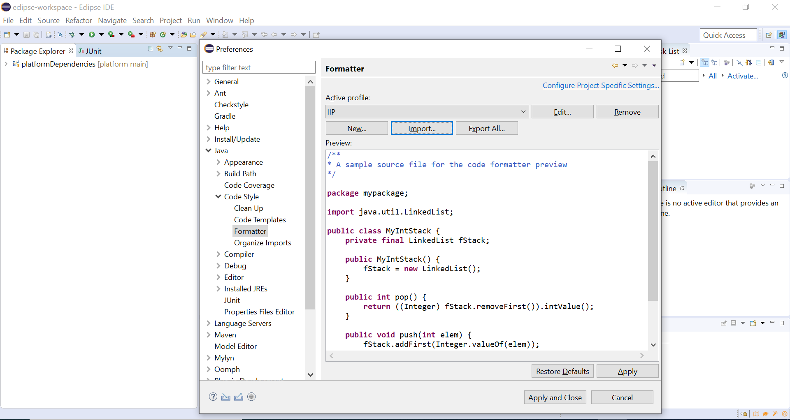

1. From tool menu File -> Import -> Git -> Projects from Git. Select Existing local repository and Next.

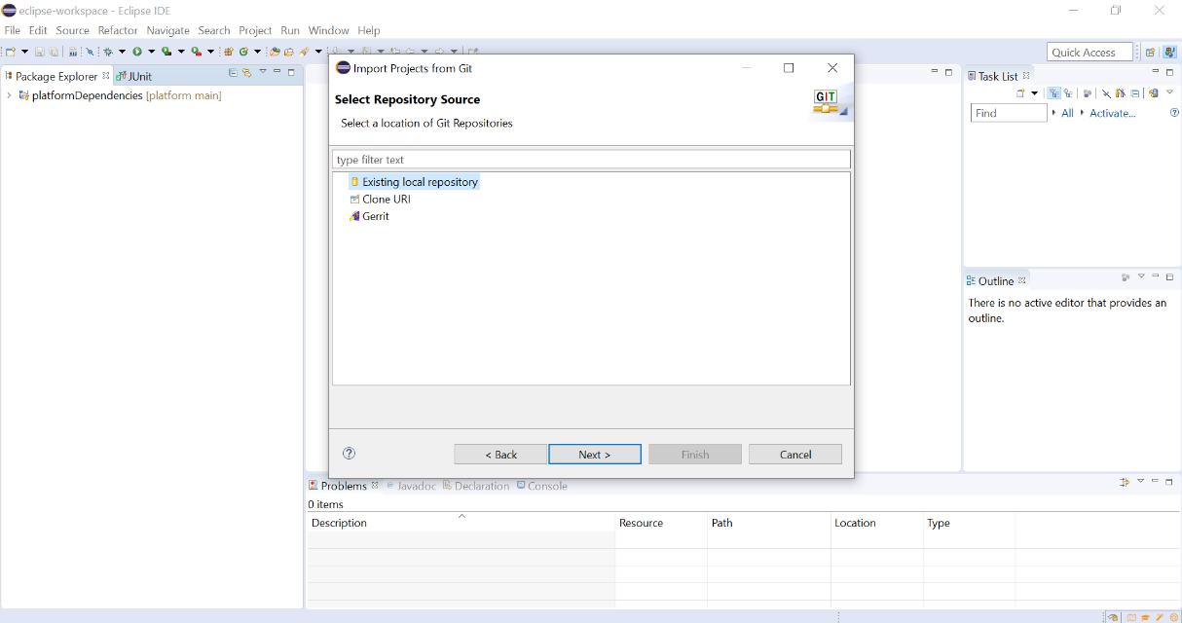

1. Select the repository that You have already cloned “in our case Platform” and Next.

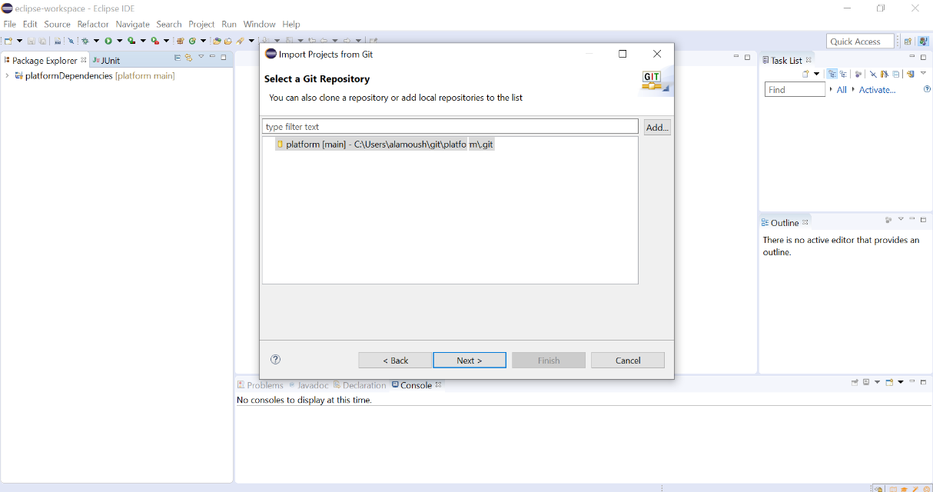

1. Select Import existing Eclipse projects and Next.

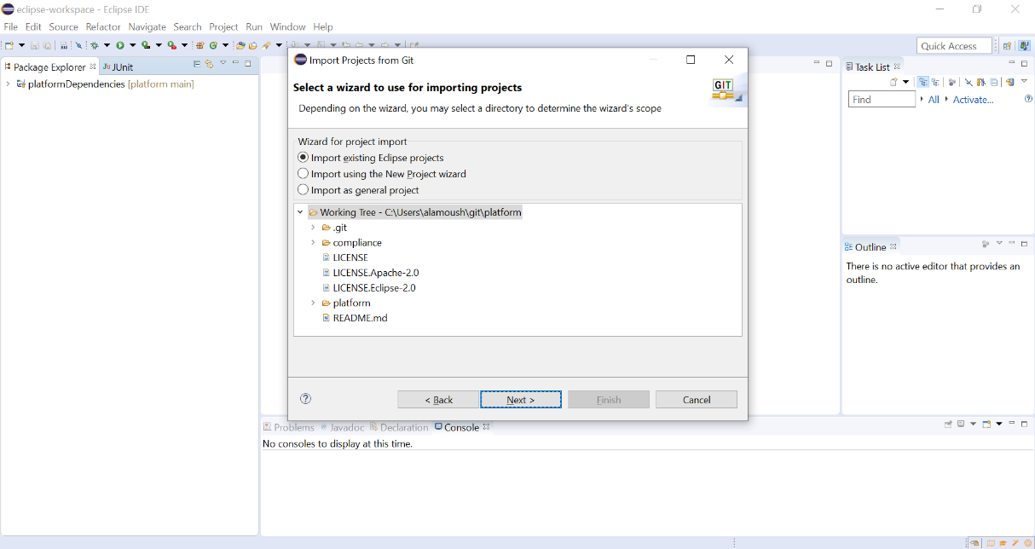

1. Selected the rest of the projects and Finish.

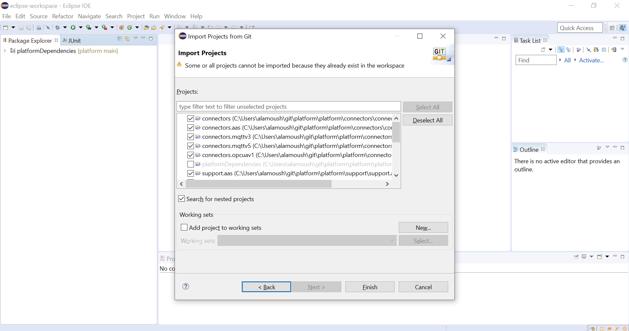

1. You should have all the projects imported without any errors or problems.

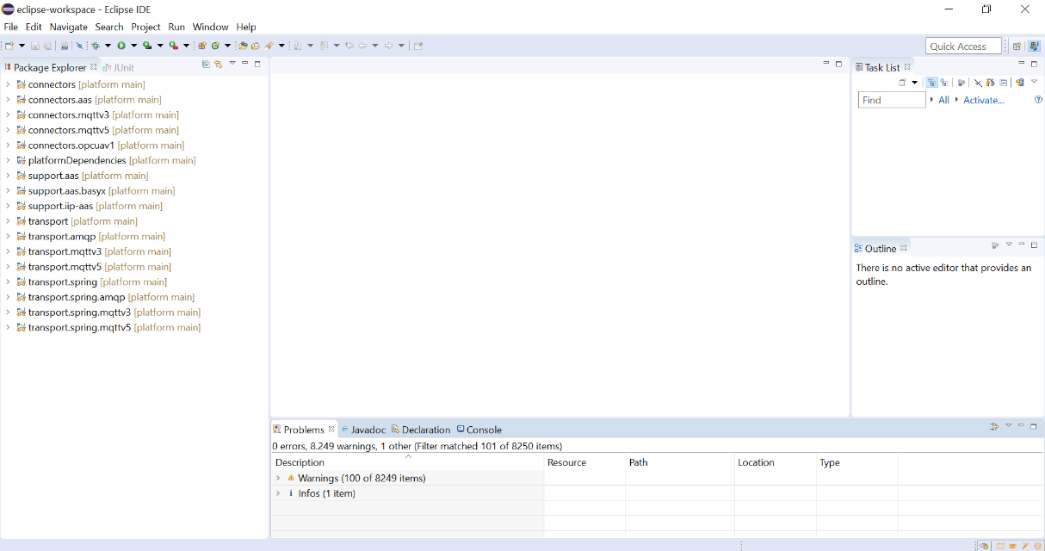

In case there are errors with some pojects try:

1. Right click on the project -> Maven -> Update Project
2. Select the project with errors.
3. Force Update of Snapshots/Releases
4. Ok.

