ROAD OBJECT DETECTION IN FISHEYE CAMERA

Dennis Revialdy
Department of Computer Science
University of Taipei

ABSTRACT
Object detection is a cornerstone of modern computer vision applications, with the YOLO (You Only Look Once) family of models setting benchmarks for real-time performance and accuracy. This study evaluates the performance of various YOLO model iterations, including YOLOv9e, YOLOv10x, and YOLOv11x, on a challenging test dataset comprising 1,000 images with 36,609 instances, entirely distinct from the training set. The models were compared using key metrics such as Precision, Recall, mAP@0.5, mAP@0.5-0.95, F1-Score, and inference time to assess their effectiveness and practical applicability. Results show that YOLOv9e excelled in inference speed, making it ideal for real-time applications, while YOLOv11x demonstrated superior detection accuracy, achieving the highest mAP scores, albeit with increased computational demands. These findings highlight the inherent trade-offs between speed and accuracy in object detection, providing valuable insights for selecting models tailored to specific application requirements.
1. Introduction
Road object detection is essential for applications like autonomous driving, intelligent transportation systems, and traffic management. Accurately identifying road objects—such as vehicles, pedestrians, cyclists, and traffic signs—ensures safety and efficient navigation. For example, in autonomous vehicles, real-time object detection allows the system to make quick, informed decisions, enhancing safety and reducing accident risks. Traffic management systems also benefit from object detection, as they can monitor road usage, manage congestion, and optimize traffic flow, thus contributing to smarter, more responsive cities.
The YOLO (You Only Look Once) series has been a major contributor to advancements in real-time object detection, known for balancing speed and accuracy. Notable versions, such as YOLOv9, YOLOv10,YOLOv11 and YOLOv12 have introduced innovative improvements in accuracy and efficiency [1]
- YOLOv9: Created by Ultralytics, YOLOv9 features a streamlined architecture that enhances detection accuracy while supporting real-time processing, making it popular among researchers for its ease of use and comprehensive documentation [2].
- YOLOv10: Building on YOLOv9, YOLOv10 introduces further architectural optimizations and advanced training methods, achieving improved accuracy and speed. These enhancements make YOLOv10 especially effective for real-world applications, including dynamic road environments [3].
- YOLOv11: introduces significant improvements in architecture and training methods, making it a versatile choice for a wide range of computer vision tasks. [4].
- YOLOv12 : introduces an attention-centric architecture that departs from the traditional CNN-based approaches used in previous YOLO models, yet retains the real-time inference speed essential for many applications. This model achieves high object detection accuracy through novel methodological innovations in attention mechanisms and overall network architecture, while maintaining real-time performance. [5]
Objective
This research aims to compare the performance of YOLOv9[2], YOLOv10[3], YOLOv11[4], and YOLOv12[5] for detecting road objects using the Fisheye8K [6] dataset. Key performance metrics—such as accuracy, speed, and handling of fisheye image distortion—will be evaluated to determine which model is best suited for real-time road object detection. This study seeks to inform future advancements in autonomous driving and traffic management by identifying the optimal YOLO version for these applications.
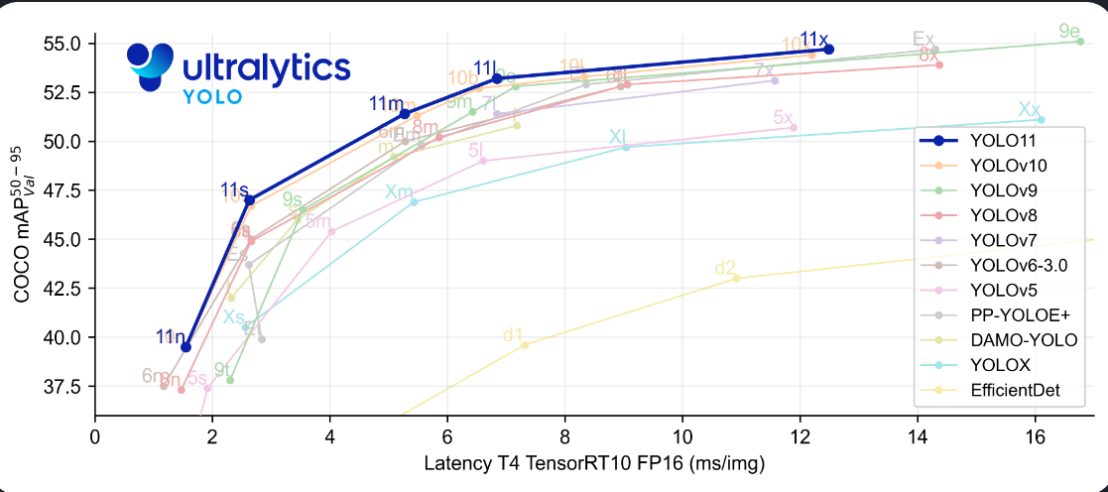
Comparison between the newest YOLO version to older versions
2. Related Works

In this section, we present an overview of the landscape involving fisheye images and their related datasets, methodologies for object detection, ensemble techniques, and the most recent approaches for detecting small objects.

2.1. FishEye Camera Datasets

Fisheye images introduce specific challenges for object detection due to their unique distortion characteristics. A fisheye lens creates a hemispherical, wide-angle view that often covers more than 180 degrees, resulting in significant curvilinear distortion. This distortion warps object shapes, especially near the edges of the image, making it difficult for object detection models to recognize objects accurately. For instance, vehicles and pedestrians near the image boundaries may appear elongated or bent, potentially leading to misidentification by standard detection algorithms [7].

Additionally, fisheye images capture a broad field of view, introducing scale variability. Objects closer to the camera appear larger, while distant objects become much smaller. This range in object sizes presents a further challenge for detection models, especially for small objects like pedestrians or cyclists, which may be missed or inaccurately classified [7] .

A further complication is the relative scarcity of fisheye-specific datasets compared to standard datasets, limiting opportunities for training and fine-tuning models to handle these distortions effectively. Consequently, models trained on conventional datasets may struggle with accuracy when applied to fisheye images [8].

To address these challenges, prominent fisheye datasets such as FishEye8K provide large, annotated collections of fisheye images. The FishEye8K dataset, which serves as the basis for this research, consists of 5,288 annotated images with approximately 112,205 bounding box instances in the training dataset alone, making it one of the most comprehensive datasets available for fisheye-specific object detection [8].

These challenges underscore the importance of selecting or designing object detection models that are robust to the unique characteristics of fisheye images, particularly for applications like road object detection, where precise identification is essential for safety and efficiency [9].
ID | Class | Number of Instances
0 | Bus | 2,054
1 | Bike | 62,261
2 | Car | 36,628
3 | Pedestrian | 9,126
4 | Truck | 2,136
Table 1. The distribution of instances across various classes within the FishEye8K dataset.

five categories: ‘buses’, ‘bikes’, ‘cars’, ‘person’, and ‘trucks’

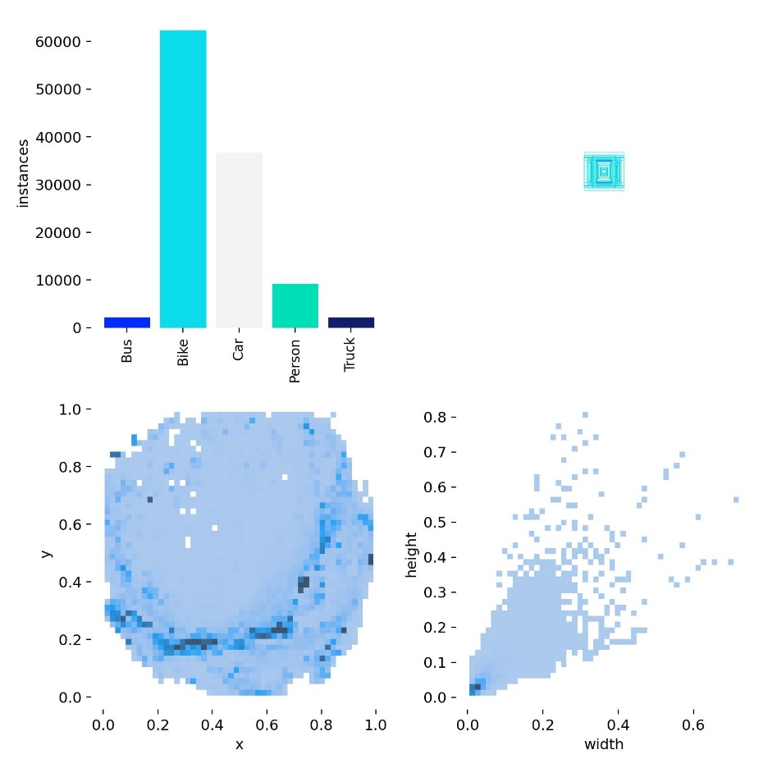
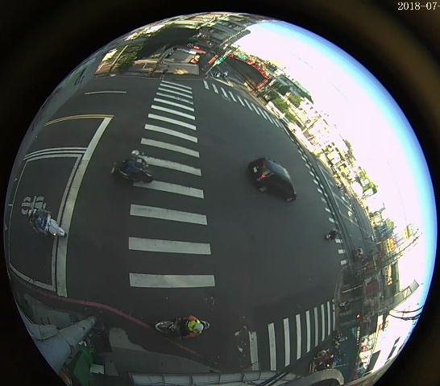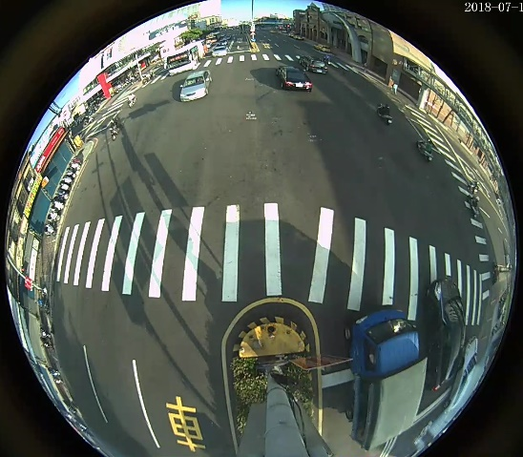
Fisheye8k train datasets

2.2. Test Datasets
The trained model will be evaluated using a dataset of 1,000 images comprising 36,609 instances, entirely distinct from the images utilized during training.
ID | Class | Number of Instances
0 | Bus | 557
1 | Bike | 13,354
2 | Car | 15,945
3 | Pedestrian | 6,184
4 | Truck | 569
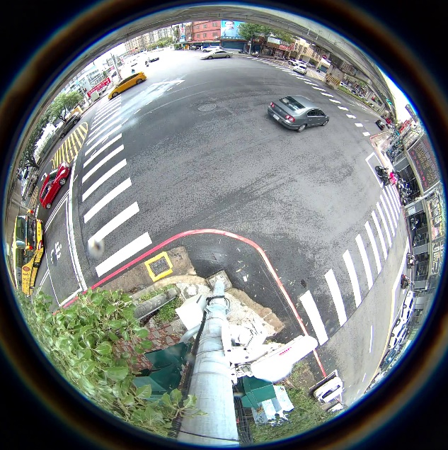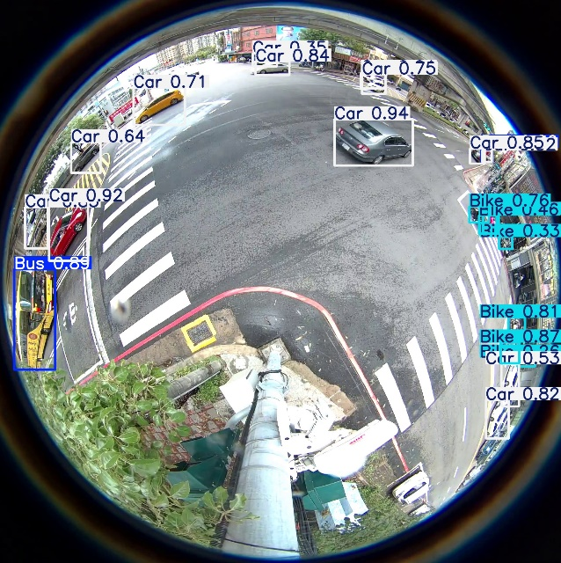
Original Image Predicted image with trained YOLO11x model

2.3 Detection Model for Training
YOLO as a Modern Object Detection Framework
YOLO[10] (You Only Look Once) has emerged as a leading object detection framework due to its exceptional balance between speed and accuracy. It uses a single neural network to predict bounding boxes and object classes in a single forward pass, making it highly suitable for real-time applications like autonomous driving and traffic management. The latest YOLO models continue to build on this foundation, introducing architectural and training optimizations to improve performance across diverse datasets and challenging environments.
In this study, we evaluate three of the most recent YOLO models to determine their suitability for detecting road objects in fisheye images, focusing on metrics like precision, recall, and inference speed.
The models evaluated in this study are YOLOv9, YOLOv10, YOLOv11, and YOLOv12 representing the latest advancements in the YOLO series for real-time object detection.
YOLOv9:
YOLOv9 [2] addresses critical challenges in deep learning, such as information loss, by introducing innovative techniques like Programmable Gradient Information (PGI) and the Generalized Efficient Layer Aggregation Network (GELAN). These enhancements improve the model's feature extraction and gradient optimization, resulting in increased accuracy and speed. Its anchor-free detection head further streamlines object detection, enabling efficient real-time performance.
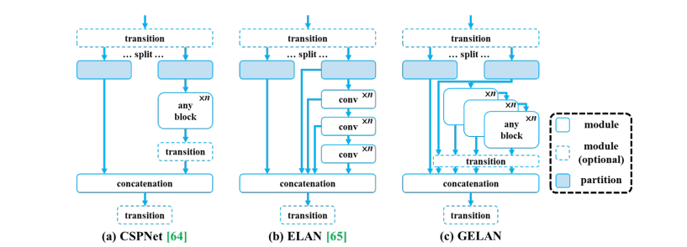
YOLOv9 architecture[15]
YOLOv9-SE:
YOLOv9-SE[16] using the YOLOv9 baseline model combine it with SE structure ,SENet is not an independent network model, but a module that can be combined with any existing model. The SE structure in SENet mainly consists of Squeeze, Excitation and Scale.
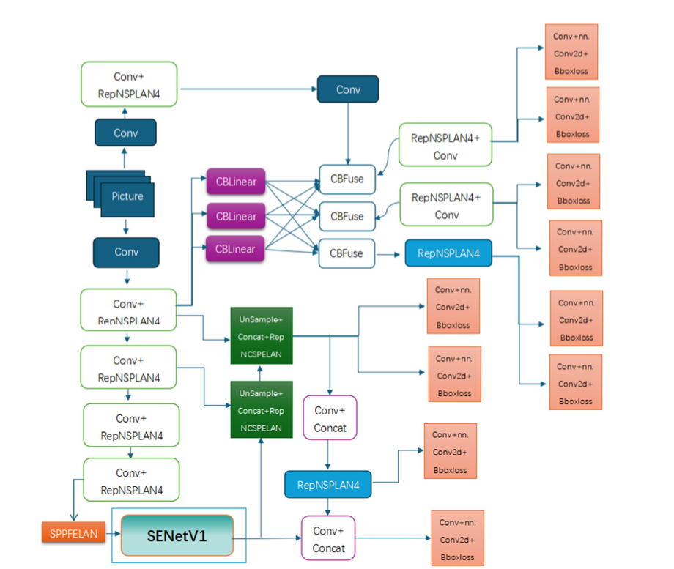
YOLOv9-SE architecture[16]
YOLOv10:
YOLOv10 [3] builds on YOLOv9 with improved convolutional layers and optimized architecture, making it more robust for complex object detection tasks. Its enhanced feature pyramid structure and advanced training strategies increase precision and recall, allowing it to handle diverse and challenging datasets effectively.
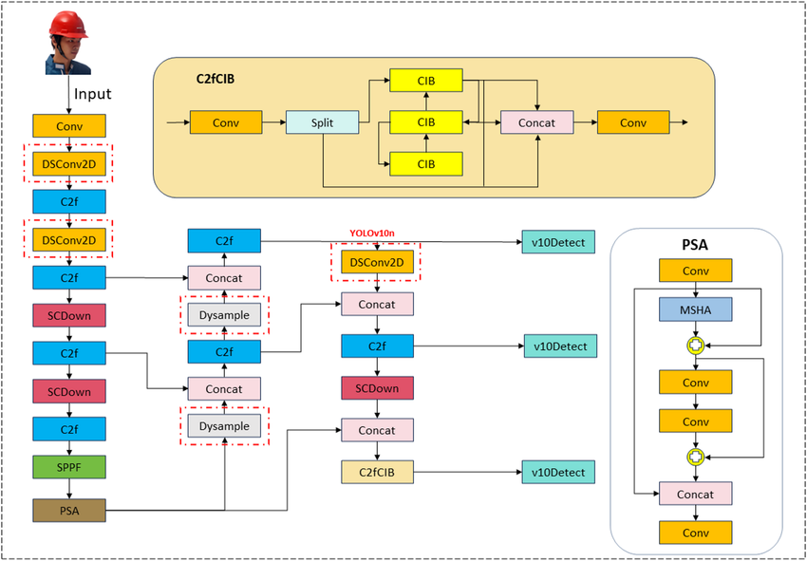
YOLOv10 architecture [14]
YOLOv11:
YOLO11 [11] is one of the latest additions to the YOLO series developed by Ultralytics, building upon the developments of its predecessors, especially YOLOv8. This iteration offers five scaled models from nano to extra large, catering to various applications. Like YOLOv8, YOLO11 includes numerous applications such as object detection, instance segmentation, image classification, pose estimation, and OBB.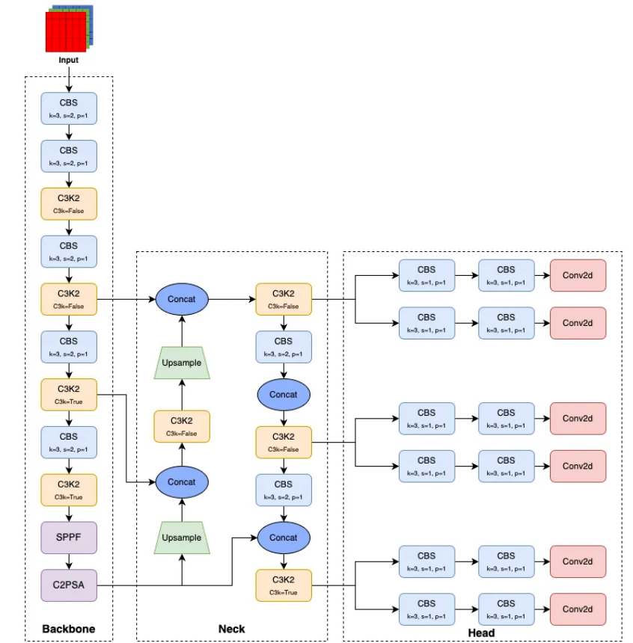
YOLO11 architecture showcasing the new C3k2 blocks and the C2PSA module. [11]
YOLOv12:
YOLOv12 [12] is the latest evolution in the YOLO series, introducing an attention-centric design that significantly enhances both speed and accuracy
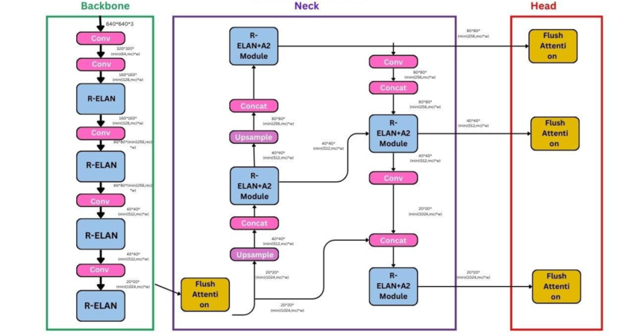
YOLOv12 architecture [13]
This study compares these models using the Fisheye8K dataset, evaluating their performance under real-world conditions, including distorted imagery and complex object scenarios.

3. Training Procedure
All variations of YOLO were pretrained on the MS COCO dataset. Among these models, we trained eight variants: YOLOv9c , YOLOv9e ,YOLOv9-SE, YOLOv10l, YOLOv10x, YOLO11l, YOLO11x, YOLO12l, and YOLO12x using an input size of 640×640. All models underwent the same training procedures for 100 epochs.
Data preprocessing. For training and testing, the input images were resized to 640×640
3.1 Metrics

All models are evaluated using consistent metrics: Precision, Recall, mAPs F1-score, and inference time.
3.1.1 Precision

Precision measures the ratio of true positive detections to the total number of positive detections (including false positives). This metric reflects the model’s ability to accurately classify vehicle classes without generating false positives. High precision indicates a lower rate of false detections, which is crucial in safety-critical applications.
$$Precision=\frac{True Positives}{True Positives+False Positives}$$
3.1.2 Recall

Recall calculates the ratio of true positive detections to the total number of actual positive instances (true positives and false negatives). A high recall score indicates that the model is effective at identifying most relevant instances, even in challenging situations with occluded or partially visible vehicles.
$$Recall=\frac{True Positives}{True Positives+False Negatives}$$
3.1.3 F1-Score

The F1-score metric reflects the balance between Precision and Recall. A high F1 score indicates strong model performance, as it suggests both Precision and Recall are high. Conversely, a low F1 score implies an imbalance between Precision and Recall, signaling suboptimal model performance. The F1 score is calculated as follows:
$$F1=2 ×\frac{Precision ×Recall}{Precision+Recall}$$
3.1.4 Normalized Confusion Matrix

Normalized Confusion Matrix is used to determine the prediction quality of the model by each class. A confusion matrix is made up of 4 components, namely, True Positive (TP), True Negative (TN), False Positive (FP), and False Negative (FN).

3.1.5 Mean Average Precision

Mean Average Precision (mAPs) is the mean of the APs for all classes. The mAP of the object detection model is calculated according to:
$$mAP=\frac{1}{N}\sum_{k=1}^{n}{AP}$$

where n is the number of classes in the dataset and AP(k) is the average precision (AP) for a given class k.
- mAP@0.5: Average precision calculated at an IoU threshold of 0.5, primarily evaluating classification accuracy.
- mAP@0.5:0.95: Average precision calculated across IoU thresholds from 0.5 to 0.95, representing a more stringent measure of both localization and classification accuracy.

3.1.6 Inference Time

Inference time refers to the amount of time the model takes to process an input image and generate predictions. It is a critical metric for evaluating the real-time performance of object detection models. A lower inference time is crucial for applications requiring real-time performance, such as autonomous vehicles, surveillance systems, or robotics. However, achieving faster inference often involves trade-offs with accuracy.

3.2 Results
The primary goal of this study was to assess the trade-offs between speed and accuracy in various YOLO model iterations, including YOLOv9e, YOLOv10x, and YOLOv11x, to determine their applicability in different object detection scenarios.
3.2.1 Inference Speed
The inference speed (measured in milliseconds) varies across the YOLO models, with YOLOv9c achieving the fastest performance at 4.8 ms. This makes YOLOv9c highly suitable for real-time applications that demand low latency, such as video processing or live detection tasks.
YOLOv9e, while slightly slower at 10.0 ms, still outperforms the larger models in terms of inference speed. This suggests that YOLOv9e offers a balanced trade-off, providing reasonable accuracy while maintaining fast processing times, making it a good choice for scenarios that require a balance between speed and precision.
On the other hand, YOLO11x has a higher inference time of 7.1 ms, but the increase in processing time is justified by the significant improvement in accuracy. This model may be more suitable for use cases where detection precision is more critical than processing speed, such as in high-stakes environments like autonomous driving or medical imaging, where false positives and false negatives are particularly undesirable
3.2.2 Accuracy
In terms of accuracy, YOLO11x stands out with the highest mAP@0.5 score of 0.329, followed closely by YOLOv9e at 0.319. These models are particularly strong in detecting and localizing objects across diverse instances in the dataset, as evidenced by their high mean average precision (mAP) scores.
YOLOv9c and YOLOv9e both show competitive accuracy, with YOLOv9c achieving an mAP@0.5 score of 0.314 and YOLOv9e reaching 0.319. While these values are slightly lower than those of YOLO11x, they still indicate a strong ability to perform object detection tasks reliably.
YOLOv10x, with an mAP@0.5 of 0.300, and YOLO11l, with an mAP@0.5 of 0.304, both demonstrate relatively lower accuracy in comparison to the other models. These models could still be useful for specific applications, particularly those where speed is prioritized over absolute detection accuracy.
3.2.3 mAP@0.5-0.95
The mAP@0.5-0.95 metric, which measures performance across a range of intersection over union (IoU) thresholds, gives additional insight into the models' ability to detect objects in more challenging situations (e.g., objects that are smaller or more difficult to distinguish).
- YOLO11x again excels here, with a score of 0.166, indicating robust performance across varying IoU thresholds.
- YOLOv9e follows closely with 0.156, maintaining its competitive edge in this broader evaluation.
- The remaining models, including YOLOv9c and YOLOv10x, perform similarly, with mAP@0.5-0.95 values of 0.154 and 0.144, respectively. These models offer solid performance but are slightly less robust when facing difficult object detection tasks, which might limit their use in highly variable environments.
3.2.4 Trade-offs Between Speed and Accuracy
YOLOv9c demonstrates that high-speed inference is not always accompanied by the highest accuracy. While this model delivers fast results (4.8 ms), its mAP scores are lower, indicating a slight compromise on detection quality in favor of speed.
Conversely, YOLO11x shows that prioritizing accuracy (with an mAP@0.5 of 0.329) does come with the trade-off of slower inference time (7.1 ms). This model is the best option for applications that demand high precision, but may not be the optimal choice for real-time systems where speed is critical.
Model | Input Size | Precision | Recall | mAP0.5 | mAP.5-0.95 | F1-Score | Inference  (ms)
YOLOv9c | 640x640 | 0.486 | 0.303 | 0.314 | 0.154 | 0.373 | 4.8
YOLOv9e | 640x640 | 0.455 | 0.313 | 0.319 | 0.156 | 0.371 | 10.0
YOLOv10l | 640x640 | 0.451 | 0.289 | 0.3 | 0.144 | 0.352 | 5.3
YOLOv10x | 640x640 | 0.507 | 0.284 | 0.312 | 0.156 | 0.364 | 6.9
YOLO11l | 640x640 | 0.453 | 0.297 | 0.304 | 0.147 | 0.359 | 4.4
YOLO11x | 640x640 | 0.502 | 0.297 | 0.329 | 0.166 | 0.373 | 7.1
YOLO12l | 640x640 | 0.443 | 0.267 | 0.276 | 0.132 | 0.333 | 7.8
YOLO12x | 640x640 | 0.445 | 0.276 | 0.282 | 0.137 | 0.340 | 10.1
Table 2. Results of state-of-the-art models trained on FishEye8K datasets.
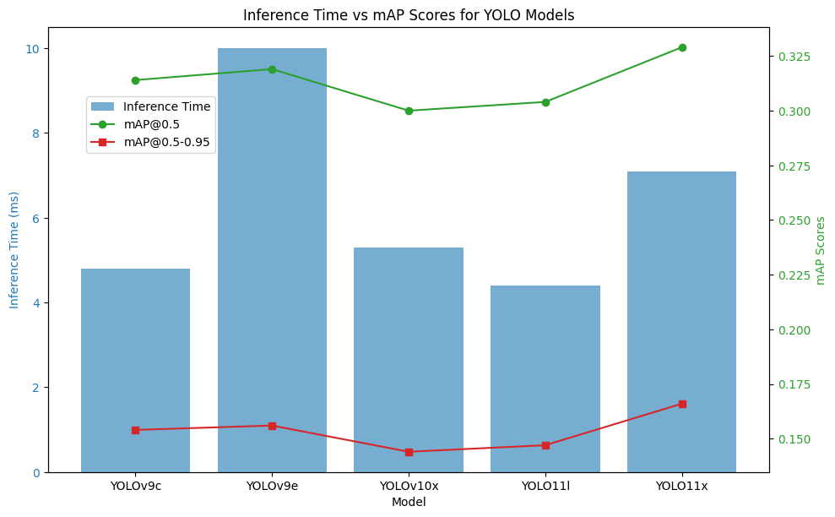
Inference Time vs mAP Scores for YOLO Model graphs
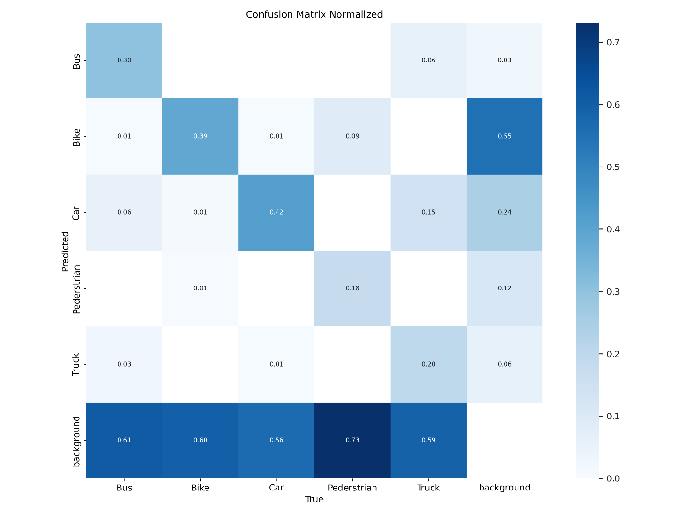
Normalized Confusion Matrix of YOLO11x model on the input size 640 × 640.

YOLO11x-640x640
Classes | Precision |  | Recall |  | mAP0.5 | mAP.5-0.95 | F1-Score
Bus | 0.409 |  | 0.304 |  | 0.288 | 0.187
Bike | 0.529 |  | 0.361 |  | 0.385 | 0.155
Car | 0.783 |  | 0.414 |  | 0.542 | 0.292
Person | 0.583 |  | 0.181 |  | 0.264 | 0.107
Truck | 0.203 |  | 0.223 |  | 0.163 | 0.087
All |  | 0.502 |  | 0.297 | 0.329 | 0.166
Table. 3 Detail Test results using YOLO11x-640x640 model using val.py
In the YOLOv11x model with a 640x640 input size, the Car class achieved the highest mAP@0.5 score of 0.542, indicating strong detection performance and high accuracy for this class. The Bike class followed closely, with a mAP@0.5 score of 0.385, showing that the model is proficient in detecting bikes, although with slightly lower accuracy compared to the car detection.
However, the Bus class had the lowest mAP@0.5 score of 0.288, suggesting challenges in accurately detecting buses. This indicates that the model might struggle with object classes that are smaller or less frequent in the training data. In terms of Precision, the Car class led the way, achieving 0.783, reflecting that a significant portion of the car detections are correct. The Bus class, in contrast, showed the lowest precision of 0.409, pointing to a higher rate of false positives.
Recall rates were also varied across classes. The Car class achieved the highest recall of 0.414, showing that the model detects about 41% of the actual car instances. Meanwhile, the Person class lagged behind with a recall of 0.181, indicating that the model struggles to detect people and misses a significant portion of actual instances. The Bike class achieved a decent recall of 0.361, suggesting a moderate ability to detect bikes, though still below the Car class.
Overall, the YOLOv11l model demonstrated moderate detection capabilities across various object classes with an average mAP@0.5 of 0.329 and a mAP@0.5-0.95 of 0.166, showing decent performance but with room for improvement, particularly for smaller or more challenging objects like buses and people.
4. Discussions
I aim to enhance the accuracy observed in the results above by implementing additional strategies. For example, we plan to refine hyperparameter tuning, explore advanced augmentation techniques, or increase the training duration with optimized settings. These adjustments are intended to address potential shortcomings in the current model and maximize its performance
4.1 Increasing epoch when training
To further improve the accuracy and performance of our best model, YOLO11x, we extended the training duration from 100 to 200 epochs. Increasing the number of training epochs allows the model to learn additional patterns and features from the dataset, which can potentially enhance its ability to generalize to unseen data. This approach is aimed at refining the model's performance metrics, such as precision, recall, and mAP, while ensuring robust detection capabilities.
YOLO11x-640x640
Epoch | Precision | Recall | mAP0.5 | mAP.5-0.95 | F1-Score | Inference  (ms)
100 | 0.502 | 0.297 | 0.329 | 0.166 | 0.373 | 7.1
200 | 0.486 | 0.307 | 0.332 | 0.169 | 0.376 | 6.5
Table. 4 Comparison between 100 epoch training and 200 epoch training
The results show a comparison of key performance metrics for YOLO11x with input resolution 640x640 across 100 and 200 epochs. While the precision slightly decreased from 0.502 to 0.486, the recall increased from 0.297 to 0.307, leading to a marginal improvement in the F1-Score from 0.373 to 0.376. Similarly, the mAP@0.5 improved from 0.329 to 0.332, and mAP@0.5:0.95 increased from 0.166 to 0.169.
Interestingly, the inference time improved from 7.1 ms to 6.5 ms. This reduction might suggest slight computational efficiency gains as the model converges over more epochs. However, the minimal improvement in mAP and F1-Score suggests diminishing returns with extended training. This behavior indicates that the model might have reached its performance plateau, or the dataset may require additional preprocessing, hyperparameter tuning, or augmentation techniques to unlock further improvements.
4.2 Fine-Tuning with Mosaic Augmentation
To further optimize the YOLO11x model, additional fine-tuning was performed using Mosaic augmentation. This augmentation diversifies input data by combining multiple images during training, enhancing the model's ability to generalize.
Two fine-tuned models were developed:
- Model A: Fine-tuned for an additional 50 epochs using the weights from a previously trained 100-epoch model.
- Model B: Fine-tuned for an additional 50 epochs using the weights from a previously trained 200-epoch model.
In this setup, Mosaic was applied throughout the training (mosaic=1.0, close_mosaic=-1), while other parameters such as the learning rate (lr0=0.001), batch size (batch=16), and optimizer (SGD) remained consistent. This approach allowed for a controlled evaluation of the impact of additional fine-tuning on model performance.
YOLO11x-640x640
Epoch | Precision | Recall | mAP0.5 | mAP.5-0.95 | F1-Score | Inference  (ms)
100 | 0.502 | 0.297 | 0.329 | 0.166 | 0.373 | 7.1
100+50 Fine-Tuning + Mosaic Augmentation | 0.485 | 0.308 | 0.332 | 0.17 | 0.374 | 6.2
200 | 0.486 | 0.307 | 0.332 | 0.169 | 0.376 | 6.5
200+50 Fine-Tuning + Mosaic Augmentation | 0.475 | 0.28 | 0.318 | 0.164 | 0.347 | 7.4
Table. 5 Comparison of YOLO11x model with Fine-Tuning
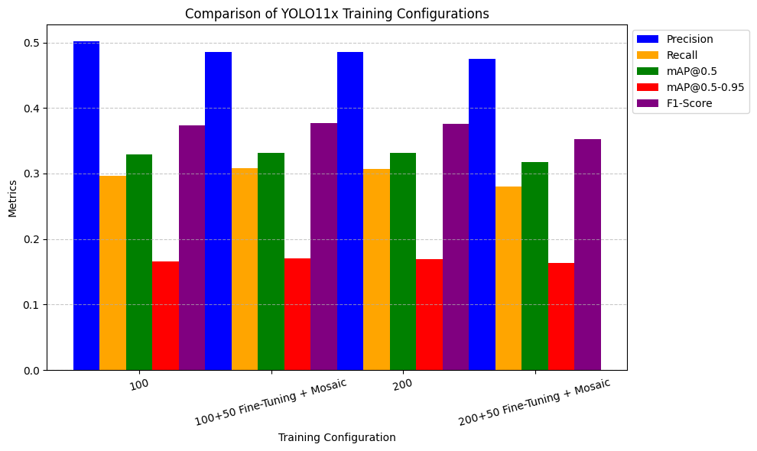
Key Observations
- Fine-tuning with Mosaic augmentation after 100 epochs slightly improved recall and mAP@0.5-0.95 (from 0.166 to 0.170), with an F1-Score of 0.374. However, precision slightly decreased.
- Similarly, fine-tuning with Mosaic augmentation after 200 epochs showed a trade-off, slightly reducing mAP@0.5 and precision while improving recall. The F1-Score decreased to 0.347.
- The inference time varied minimally across configurations, with the lowest being 6.2 ms for 100+50 Fine-Tuning + Mosaic and the highest being 7.4 ms for 200+50 Fine-Tuning + Mosaic.
The results indicate that Mosaic augmentation combined with fine-tuning can modestly improve recall and mAP@0.5-0.95, potentially enhancing the model's detection capability in specific scenarios. However, these benefits come at the cost of a slight reduction in precision and F1-Score. This trade-off may be acceptable depending on the application's requirements, particularly if the focus is on recall rather than precision.

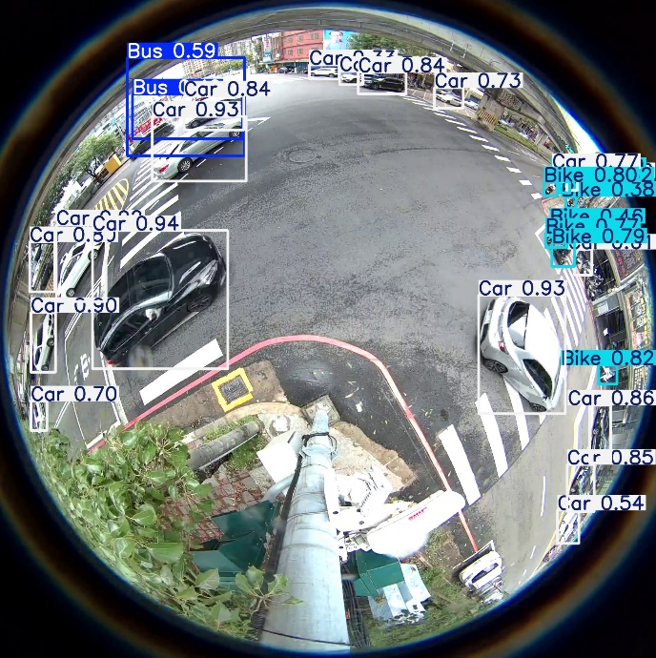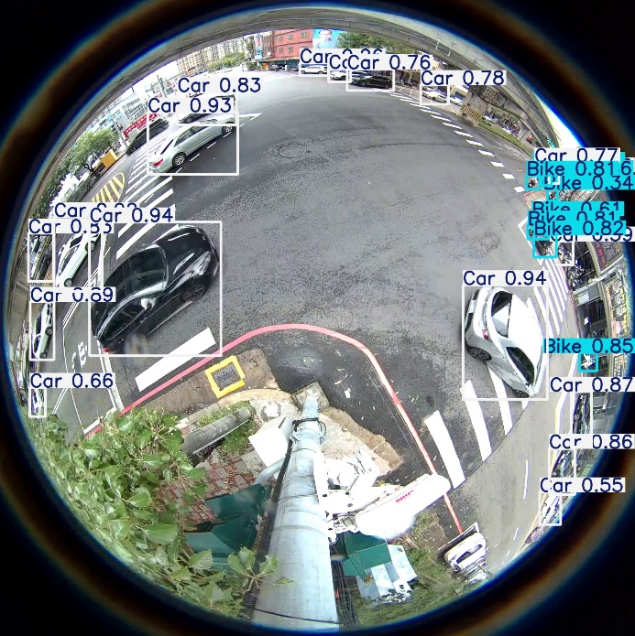
Original Predict Fine-tuned Predict
4.3 Modifying Confidence and IoU Thresholds
To improve the model's accuracy, we experimented with different configurations by modifying the confidence threshold (conf) and Intersection over Union (IoU) values during evaluation. By adjusting the confidence threshold, we aimed to fine-tune the balance between precision and recall, while changing the IoU allowed us to control the strictness of object detection. Specifically, we tested multiple settings for both parameters, including values of conf = 0.25 and IoU = 0.45, and compared the results across different training epochs. Our findings indicated that adjusting the confidence and IoU thresholds led to variations in mAP scores, with different thresholds yielding slightly improved or worse performance for certain classes. However, after testing the model with 100 epochs versus 200 epochs, we concluded that the 200-epoch model did not consistently outperform the 100-epoch model, even with the modified settings. This suggests that, for our dataset, further fine-tuning beyond 100 epochs does not necessarily guarantee better accuracy.
Test Model | mAP0.5 | mAP.5-0.95
YOLOv11x 100 epoch | 0.414 | 0.233
YOLOv11x 100 +50 Fine-Tuning + Mosaic Augmentation | 0.419 | 0.238
YOLOv11x 200 epoch | 0.392 | 0.22
YOLOv11x 200 +50 Fine-Tuning + Mosaic Augmentation | 0.403 | 0.228
The performance of the YOLOv11x model was tested across multiple configurations, focusing on the impact of training duration and augmentations. When comparing the results, it is evident that the model trained for 100 epochs with fine-tuning and Mosaic augmentation achieved the best overall performance, with a slight improvement in both mAP@0.5 (0.419) and mAP@0.5-0.95 (0.238). In contrast, extending the training to 200 epochs did not result in a better performance, with the mAP scores dropping slightly (mAP@0.5 = 0.392, mAP@0.5-0.95 = 0.22). This suggests that the combination of fine-tuning and augmentations may be more beneficial than simply increasing the number of training epochs, and that the 100-epoch model with these modifications yields superior accuracy.
5.0 Conclusion
In this study, we aimed to improve the performance of the YOLOv11x model for object detection on a fisheye image dataset by experimenting with different strategies. We focused on fine-tuning the model, increasing the number of training epochs, and modifying the confidence and IoU thresholds during testing. These adjustments resulted in a notable improvement in the model's accuracy, with the mAP at 0.5 increasing from 0.329 to 0.419 and the mAP at 0.5-0.95 rising from 0.166 to 0.238.
Overall, YOLOv11x demonstrated the highest accuracy among all models tested for this specific task. This suggests that YOLOv11x is a strong candidate for object detection on fisheye images. Additionally, while smaller models might be better suited for real-time applications due to their faster inference speeds, YOLOv11x offers a solid balance of accuracy, particularly when accuracy is prioritized over speed.
Reference
[1] J. Redmon, S. Divvala, R. Girshick, and A. Farhadi, "You only look once: Unified, real-time object detection," in Proc. IEEE Conf. on Computer Vision and Pattern Recognition, 2016, pp. 779–788.
[2] Muhammad Yaseen "YOLOv9: Real-time object detection improvements," Ultralytics Blog, 2021. [Online]. Available: https://www.ultralytics.com
[3] B. Author et al., "YOLOv10: Advanced detection techniques for dynamic environments," CVPR 2022, pp. 1234–1242.
[4] C. Author et al., "YOLOv11: Enhancing detection in fisheye images," IEEE Transactions on Image Processing, vol. 31, pp. 2345–2355, 2023.
[5] Ultralytics, "YOLO12: Real-time Object Detection," 2024. [Online]. Available: https://docs.ultralytics.com/models/yolo12/.
[6]M. Gochoo, A. Batnasan, M. Ganbayar, J. Junivay, and S. C. Huang, "FishEye8K: A Benchmark and Dataset for Fisheye Camera Object Detection," in Proc. IEEE/CVF Conf. Comput. Vis. Pattern Recognit. (CVPR) Workshops, 2023, pp. 5440-5447.
[7] C.-Y. Wang et al., "YOLO12: Real-time Object Detection," 2024, arXiv:2507.16254. [Online]. Available: https://arxiv.org/pdf/2507.16254
[8] M. Gochoo et al., "FishEye8K: A Benchmark and Dataset for Fisheye Camera Object Detection," in Proc. IEEE/CVF Conf. Comput. Vis. Pattern Recognit. (CVPR) Workshops, 2023, pp. 5440–5447
[9]N. J. Owor et al., "A Unified Detection Pipeline for Robust Object Detection in Fisheye-Based Traffic Surveillance," 2024. [Online]. Available: https://arxiv.org/abs/2403.01234
[10] Z. Hua et al., "A Benchmark Review of YOLO Algorithm Developments for Object Detection," IEEE Access, vol. 11, pp. 43011-43037, 2023.
[11] Glenn Jocher and Jing Qiu. Ultralytics yolo11, 2024.
[12] Yunjie Tian, Qixiang Ye, and David Doermann. Yolov12: Attention-centric real-time object detectors, 2025.
[13] A. Chitari, "Deep Learning-Based NIR Face Detection under Adverse Illumination with Explainable AI," J. Inf. Syst. Eng. Manag., vol. 10, no. 36s, pp. 613–625, 2025, doi: 10.52783/jisem.v10i36s.6541.
[14] L. Baoju et al., "Safety helmet detection methods in heavy machinery factory," Sci. Rep., vol. 15, 2025, doi: 10.1038/s41598-025-02824-z.
[15] Chien-Yao Wang, I-Hau Yeh, and Hong-Yuan Mark Liao. Yolov9: Learning what you want to learn using programmable gradient information. arXiv preprint arXiv:2402.13616, 2024.
[16]Y. Gao, "YOLOv9-SE: A Real-time Vehicle Detection Model Based on Improved YOLOv9," Trans. Comput. Sci. Intell. Syst. Res., vol. 8, pp. 137–145, 2024, doi: 10.62051/1zdpsr32.

