Tracking algorithm

2016/11/01 Shun-ichi Watanabe

# How to use

The src directory contains a sample code for running the main subroutine (tracking_sample.f90), the main subroutine code for the tracking (tracking_main.f90), subroutine codes used in the main subroutine, and Makefile.

When you use the tracking code, call the main subroutine as follows (in fortran):

|  |
| --- |
| call tracking_main(vor, u, v, psea,&  &proj, vert_grid,&  &nx, ny, nx1, nx2, ny1, ny2, nz, levs, nt, &  &lons, lats, lonin, latin, del_t, &  &nsmth_x, nsmth_y, r_smth, smth_type, &  &zeta_max0, zeta_min0, int_zeta_min0, gamma, &  &n_steering_x, n_steering_y, r_steering, steering_type, &  &del_lon, del_lat, del_r, track_type, &  &period_min, d_cf_min, size_synop, del_psea_min, distance_ec) |

You need 1) vorticity fields at the level where vortices are detected, 2) horizontal wind fields at the levels where steering winds are calculated, and 3) sea level pressure fields for all time steps. You also need to set parameters for the tracking as in the following list. Parameters that I am using are written in tracking_sample.f90.

# List of variables

|  |  |  |  |
| --- | --- | --- | --- |
| Variable | Type | Size | Note |
| vor | real(4) | (0:nx, 0:ny, nt) | Vorticity (s−1) at the level where vortices are detected.  Vorticity is set to −100 over the land. |
| u | real(4) | (0:nx, 0:ny, 0:nz, nt) | x-component of wind for the calculating the steering wind (m s−1) |
| v | real(4) | (0:nx, 0:ny, 0:nz, nt) | y-component of wind for the calculating the steering wind (m s−1) |
| psea | real(4) | (0:nx, 0:ny, nt) | Sea level pressure (hPa) |
| proj | integer | 1 | Horizontal grid system (1: geographical coordinate, 2: Cartesian coordinate) |
| vert_grid | integer | 1 | Vertical grid system  (1: pressure coordinate, 2: Height coordinate) |
| nx | integer | 1 | Number of x-grid of the input data |
| ny | integer | 1 | Number of y-grid of the input data |
| nx1 | integer | 1 | Index of left end of the domain for tracking |
| nx2 | integer | 1 | Index of right end of the domain for tracking |
| ny1 | integer | 1 | Index of bottom of the domain for tracking |
| ny2 | integer | 1 | Index of top of the domain for tracking |
| nz | integer | 1 | Number of z-grid of the input data |
| levs | real(4) | (1:nz) | Levels of the vertical grid. Pressure (hPa) (vert_grid=1) or height (m) (vert_grid=2) |
| nt | integer | 1 | Number of time steps of the input data |
| lons | real(4) | 1 | Longitude (degree) (proj=1) or x-coordinate (km) (proj=2) of the left end of the input data |
| lats | real(4) | 1 | Latitude (degree) (proj=1) or y-coordinate (km) (proj=2) of the bottom of the input data |
| lonin | real(4) | 1 | Interval of the longitude (degree) (proj=1) or x-coordinate (km) (proj=2) |
| latin | real(4) | 1 | Interval of the latitude (degree) (proj=1) or y-coordinate (km) (proj=2) |
| del_t | real(4) | 1 | Time interval of the input data |
| nsmth_x | integer | 1 | Number of x-grid for smoothing the vorticity (Ignored when smth_type=2) |
| nsmth_y | integer | 1 | Number of y-grid for smoothing the vorticity (Ignored when smth_type=2) |
| nsmth_r | real(4) | 1 | Radius for smoothing the vorticity (km) (Ignored when smth_type=1) |
| smth_type | integer | 1 | Type of smoothing. 1: average in a rectangular 2: average in a circle |
| zeta_max0 | real(4) | 1 | ζmax0 in Watanabe et al. (2016) (s−1). |
| zeta_min0 | real(4) | 1 | ζmin0 in Watanabe et al. (2016) (s−1). |
| int_zeta_min0 | real(4) | 1 | Interval for increasing ζmin (s−1)。 |
| gamma | real(4) | 1 | γ in Watanabe et al. (2016). |
| n_steering_x | integer | 1 | Number of x-grid for calculating a steering wind (Ignored when steering_type=2) |
| n_steering_y | integer | 1 | Number of y-grid for calculating a steering wind (Ignored when steering_type=2) |
| n_steering_r | real(4) | 1 | Radius for calculating a steering wind (km) (Ignored when steering_type=1) |
| steering_type | integer | 1 | Type of calculating a steering wind. 1: average in a rectangular 2: average in a circle |
| del_lon | real(4) | 1 | Width of the area for searching vortex at the next time step (see Fig. 5 in Watanabe et al. (2016)). Longitude (degree) (proj=1) or x-coordinate (km) (proj=2) (Ignored when steering_type=2) |
| del_lat | real(4) | 1 | Height of the area for searching vortex at the next time step. Latitude (degree) (proj=1) or y-coordinate (km) (proj=2) (Ignored when steering_type=2) |
| del_r | real(4) | 1 | Radius of the area for searching vortex at the next time step. (km) (Ignored when steering_type=1) |
| steering_type | integer | 1 | Type of the area for searching vortices at the next time step. 1: in a rectangular 2: in a circle |
| period_min | integer | 1 | Criteria for lifetime of a vortex. If the time steps during which a vortex exists is smaller than period_min, the vortex is excluded from the result. |
| d_cf_min, | real(4) | 1 | Criteria for the length of the cold front. (km). (see Fig. 7 in Watanabe et al. (2016)) |
| size_synop | real(4) | 1 | Criteria for the size of synoptic-scale low (km2). (see Fig. 6 in Watanabe et al. (2016)) |
| del_psea_min | real(4) | 1 | Criteria for detecting a SLP minimum (hPa) |
| distance_ec | real(4) | 1 | Criteria of the distance for excluding synoptic-scale low (km) (see Fig. 6 in Watanabe et al. (2016)) |

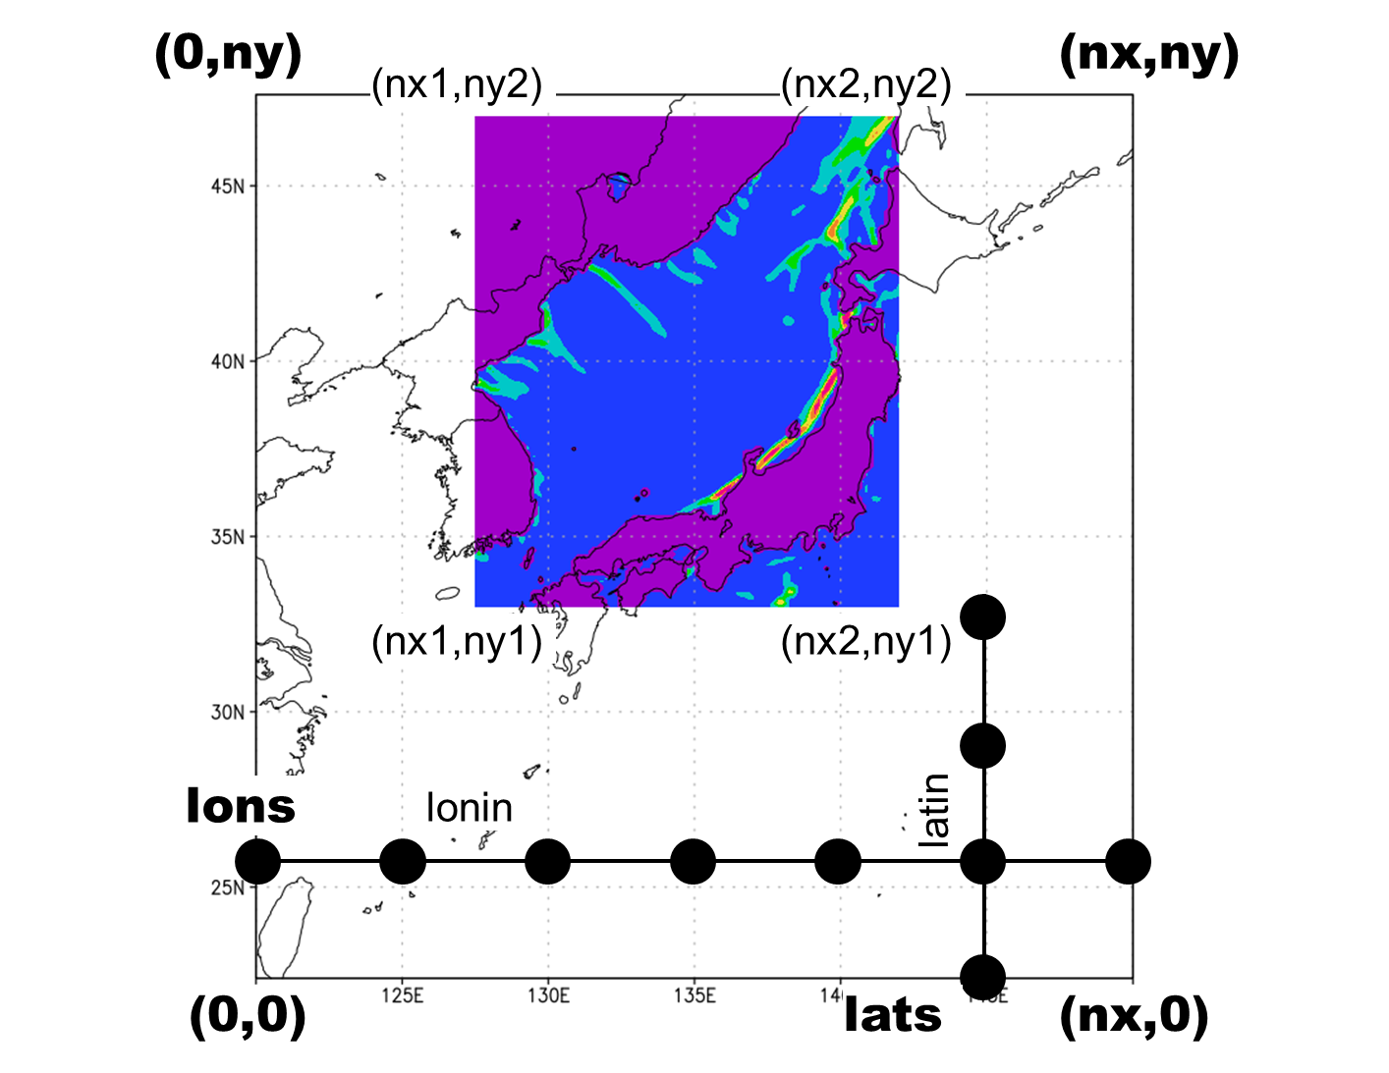

# Output

You will find the following files after run the tracking code.

vormax_loc_****.txt

vortrack_****_****.txt

vor_out_****.dat

In vormax_loc_(kt).txt, the locations of the vortices at time step = kt are written in the following format.

|  |  |  |  |  |
| --- | --- | --- | --- | --- |
| x or longitude | y or latitude | Vorticity (10-3 s-1) | Size of vortex (km2) | Type |

(Type = 0: mesocyclone, Type = 1: a part of cold front, Type = 2: synoptic-scale low, Type = 3: synoptic-scale low with cold front)

If several vortices merged into the i-th vortex, the tracks of such vortices are written in vortrack_(i)_0001.txt, vortrack_(i)_0002.txt, vortrack_(i)_0003.txt,…

The track of a vortex are written in the following format.

|  |  |  |  |  |  |
| --- | --- | --- | --- | --- | --- |
| x or longitude | y or latitude | Vorticity (10-3 s-1) | kt | Size of vortex (km2) | Type |

Vor_out_(kt).dat contains original vorticity field, smoothed vorticity field, vortex area, x and y component of steering wind, and SLP in grads format. To read this file, use read_vor_out.f90.