University of Tartu

Faculty of Mathematics and Computer Science

System Modelling

Mancala Project

User Manual

Authors: Simo Peterson

Mart Sein

Margus Sellin

Raigo Kodasmaa

Coordinator: Dmitri Danilov

Tartu, 2011

**Version Control**

|  |  |  |  |
| --- | --- | --- | --- |
| **Date** | **Changes** | **Comments** | **Author** |
| 13.11 | Using the application. | Instructions for beginner user. | Simo |

Table of Contents

Using the application 4

# Using the application

* After running the application players must first choose their player names. These can be changed later so they might be also left blank at start. The maximum allowed length of a player name is 10 characters. Choosing a longer name won’t change players name in game. Most characters are allowed to be used in a player name. Players’ names are displayed over the players’ big pits.

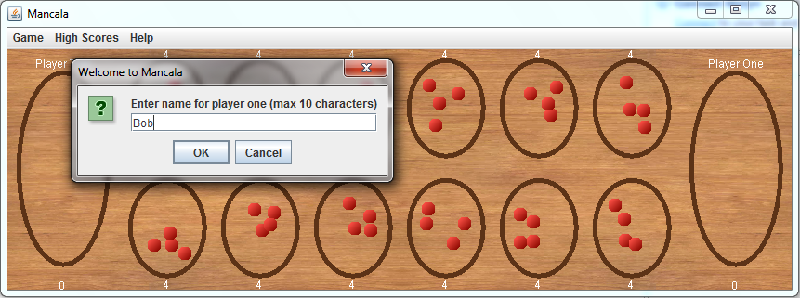

* The application has following menu structure:
  + Game
    - New game – a new game may be started at any time. There is no option to save a game so all information about previous game will be lost!
    - Change name – players can choose new player.
    - Exit – for safely closing the application.

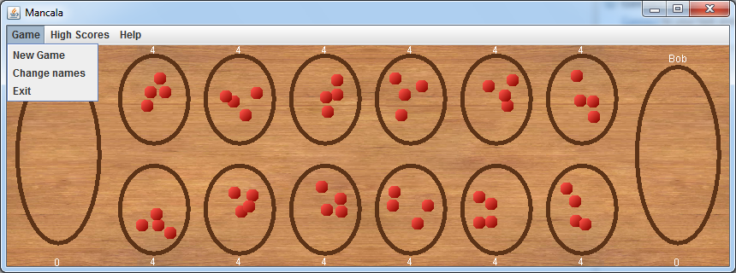

* + High Scores
    - Top 10 – best ten scores recorded since last reset.
    - Reset – empty the high scores table.

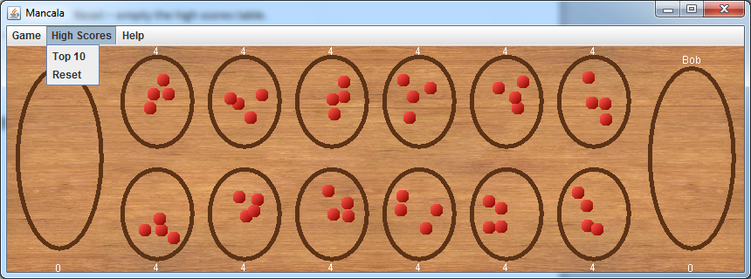

* + Help
    - Show Help – Short overview of the game rules and objectives.

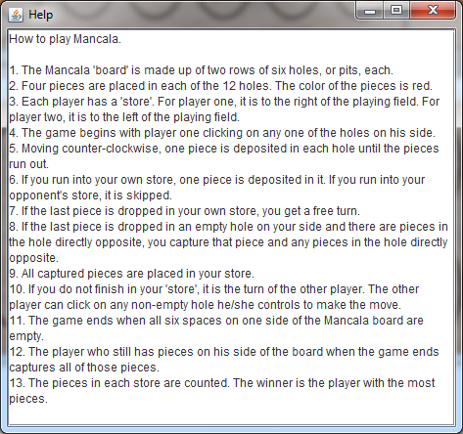

* First player has the control over bottom row 6 small pits. His big pit is on the right side and his name is displayed on his big pit. Second player has control over top row 6 small pits. His big pit is on the left side and his name is displayed on his big pit.
* The numbers under pits represent the amount of counters inside them.
* The application can be minimized, expanded and closed using the top right window options. The application window can also be stretched into any size.

