**Daniel:**

**Return to play protocol**

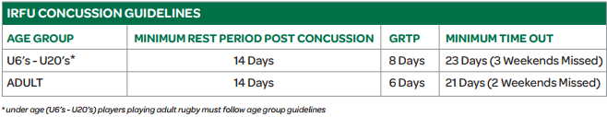

* **GRTP = graduated return to play**
* **The majority (80-90%) of concussions resolve in a short (7-10 days) period**
* **This may be longer in children and adolescents**

**GRTP**

1. **Rest 14 days**
2. **Light aerobic exercise 2**
3. **Rugby-specific exercise 2**
4. **Non contact training 2**
5. **Full contact 2**
6. **After 24hrs - return to play 23**

**Dennis:**

**Brendan:**

**Symptoms:**  
  
Balance issues  
Difficulty communicating/ slow answers  
drowsiness/Fatigue

Feeling emotionally/mentally foggy  
Headaches  
Iritiability

Memory difficulties  
Nausea  
Nervousness  
Numbness  
Sensitivity to light or noise  
Visual problems/blurry vision

**Diagnosed by:**

Focused neurological exam  
Orientation exam testing short term memory - event that caused concussion  
Orientation exam testing long term memory - names, birthday  
Assessment of athletes ability to stay attentive to complex tasks  
MRI or CT scans  
Balance assessment