The EDF scheduler is designed using the priority of tasks. In FreeRTOS, the task with the highest priority will run instead of the tasks with the lower priority. The task with the lower priority are blocked until further notice. When the tasks are created, all the priorities defaults to 3 more of the priority of the idle task. (All the priorities referred in this document are with reference to the idle task.) When the task begins to run, it saves the tick of when the task starts and calls the EDF scheduler. The EDF scheduler calculates the number of ticks till the task’s deadline by using the formula below:

$$tickTillDeadline = taskSchedules[i].started + deadlineTicks - current;$$

*deadlineTicks* is the task’s deadline in terms of ticks. *current* is the tick when this formula is calculated. The task with the lowest value will have its priority set to 2 and if any of the tasks has completed its computations, the priority is set to 3. (The computations are implemented as busy waits in the tasks.) For all other tasks, they are set to 1. If none of the tasks are selected by the EDF scheduler, all the priorities are set to 2. By setting the priority to 3, when the periodic task wakes up from *vTaskDelayUntil*, it will not get blocked by the running task.

The results of the simulation is shown below in Figure 1. The deadlines are outlined with black lines. At t=0 sec, all three of the tasks starts. Task 2 and Task 3 are blocked because their deadlines are further than Task 1. When Task 1 ends, Task 2 resumes instead of Task 3 because its deadline is closer. Then Task 3 resumes after Task 2 ends. At t=4 sec, Task 1 starts up again. Task 3 is preempted until Task 1 ends. At t=6 sec, Task 2 begins and Task 3 gets continues because its deadline is earlier. At t=7 sec, Task 2 starts.

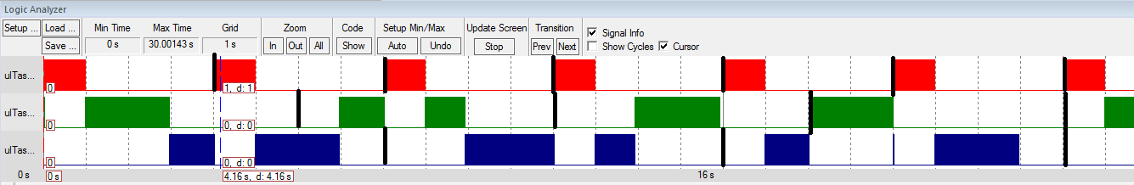

Figure : Activity Times of the Tasks with their Deadlines Highlighted

The results of the optional simulation is shown below in Figure 2.

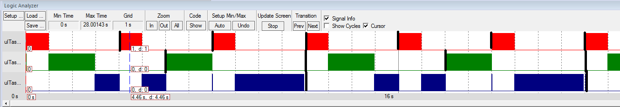

Figure 2: Activity Times of the Task with their Deadlines Highlighted [Optional]