Module 5 Critical Thinking

Dennis Weddig
Colorado State University Global
CSC450: Programming III
Dr. Jack Li
9/14/2025 11:59pm

Module 5 Critical Thinking
Repository location for Module 5 Critical Thinking assignment:
https://github.com/denniswed/csc450/tree/main/Module5/crit_think
Code:
/*
* Program: Create a C++ program that will obtain input from a user and store it
into the provided CSC450_CT5_mod5.txt.

* Your program should append it to the provided text file, without deleting the
existing data:
a. Store the provided data in the CSC450_CT5_mod5.txt file.
b. Create a reversal method that will reverse all of the characters in the CSC450_CT5_mod5.txt file and store the result in a CSC450-mod5-reverse.txt file.

* Things I added:
- File size checks to prevent excessive memory usage (FIO19-C)
- RAII principles for file handling to ensure proper resource management
- Input validation to avoid excessively long lines (STR50-CPP)
- Exception handling for robust error management (ERR50-CPP)
- Use of std::filesystem for safer file operations (C++17 feature)
- Encapsulation of functionality within a class for better organization (OOP58-CPP)
- Clear separation of concerns with helper methods for file operations
- Use of constants for file names and limits to avoid magic numbers
- copying the orginal file from backup so we start with a clean file reach run
*/

#include <algorithm>
#include <filesystem>
#include <fstream>
#include <iostream>
#include <stdexcept>
#include <string>
#include <vector>

class FileProcessor {
private:
static constexpr const char* INPUT_FILE = "CSC450_CT5_mod5.txt";
static constexpr const char* OUTPUT_FILE = "CSC450-mod5-reverse.txt";
static constexpr const char* BACKUP_FILE = "CSC450_CT5_mod5 copy.txt";
static constexpr size_t MAX_FILE_SIZE = 10'000'000; // 10MB limit

// Helper method for safe file reading (FIO51-CPP)
std::string readFileContent(const std::string& filename) const {
// Check file size first (FIO19-C)
std::error_code ec;
auto fileSize = std::filesystem::file_size(filename, ec);
if (ec || fileSize > MAX_FILE_SIZE) {
throw std::runtime_error("File too large or inaccessible: " + filename);
}

// Use RAII for file management
std::ifstream file(filename, std::ios::binary);
if (!file) {
throw std::runtime_error("Cannot open file: " + filename);
}

// Reserve space to avoid multiple allocations
std::string content;
content.reserve(static_cast<size_t>(fileSize));

// Read entire file
content.assign(std::istreambuf_iterator<char>(file), std::istreambuf_iterator<char>());

return content;
}

// Helper method for safe file writing (FIO51-CPP)
void writeFileContent(const std::string& filename, const std::string& content) const {
// Use RAII for file management
std::ofstream file(filename, std::ios::binary);
if (!file) {
throw std::runtime_error("Cannot create file: " + filename);
}

file << content;

// Explicitly check for write errors (FIO04-CPP)
if (!file.good()) {
throw std::runtime_error("Write error occurred for file: " + filename);
}
}

// Helper method for safe file appending (FIO51-CPP)
void appendToFile(const std::string& filename, const std::string& content) const {
std::ofstream file(filename, std::ios::app | std::ios::binary);
if (!file) {
throw std::runtime_error("Cannot open file for appending: " + filename);
}

file << content;

if (!file.good()) {
throw std::runtime_error("Append error occurred for file: " + filename);
}
}

public:
FileProcessor() noexcept = default;

// Non-copyable, non-movable for simplicity (OOP58-CPP)
FileProcessor(const FileProcessor&) = delete;
FileProcessor& operator=(const FileProcessor&) = delete;
FileProcessor(FileProcessor&&) = delete;
FileProcessor& operator=(FileProcessor&&) = delete;

/**
* Restores the input file from backup copy
* @return true if successful, false otherwise
*/
bool restoreFromBackup() const noexcept {
try {
std::cout << "=== Restoring Original File ===\n";

// Check if backup file exists
if (!std::filesystem::exists(BACKUP_FILE)) {
std::cerr << "Backup file not found: " << BACKUP_FILE << '\n';
return false;
}

// Read backup content
std::string backupContent = readFileContent(BACKUP_FILE);

// Delete existing input file if it exists
std::error_code ec;
if (std::filesystem::exists(INPUT_FILE)) {
std::filesystem::remove(INPUT_FILE, ec);
if (ec) {
std::cerr << "Failed to delete existing file: " << INPUT_FILE << '\n';
return false;
}
}

// Write backup content to input file
writeFileContent(INPUT_FILE, backupContent);

std::cout << "Successfully restored " << INPUT_FILE << " from " << BACKUP_FILE << '\n';
return true;

} catch (const std::exception& e) {
std::cerr << "Error restoring from backup: " << e.what() << '\n';
return false;
}
}

/**
* Safely appends user input to the specified file
* @return true if successful, false otherwise
*/
bool appendUserInput() {
try {
std::cout << "=== File Input Program ===\n"
<< "Enter text to append to " << INPUT_FILE << "\n"
<< "(Press Enter twice to finish):\n\n";

std::vector<std::string> lines;
std::string line;
bool hasContent = false;

// Collect all input first (safer approach)
while (std::getline(std::cin, line)) {
if (line.empty() && hasContent) {
break; // Stop on empty line after content
}

if (!line.empty()) {
// Input validation (STR50-CPP)
if (line.length() > 1000) { // Reasonable line length limit
std::cerr << "Warning: Line too long, truncating\n";
line.resize(1000);
}

hasContent = true;
lines.push_back(line);
std::cout << "Added: " << line << '\n';
}
}

if (!hasContent) {
std::cout << "No content entered.\n";
return false;
}

// Build content string
std::string content;
for (const auto& inputLine : lines) {
content += inputLine + '\n';
}

// Append to file using RAII
appendToFile(INPUT_FILE, content);

std::cout << "\nText successfully appended to " << INPUT_FILE << '\n';
return true;

} catch (const std::exception& e) {
std::cerr << "Error appending to file: " << e.what() << '\n';
return false;
}
}

/**
* Safely reads input file, reverses all characters, and writes to output file
* @return true if successful, false otherwise
*/
bool reverseFileContent() const noexcept {
try {
std::cout << "\n=== File Reversal Process ===\n";

// Read file content safely
std::string content = readFileContent(INPUT_FILE);

if (content.empty()) {
std::cout << "Input file is empty. Nothing to reverse.\n";
return false;
}

// Remove trailing newline for clean reversal
if (!content.empty() && content.back() == '\n') {
content.pop_back();
}

std::cout << "Original content (" << content.length() << " characters):\n"
<< "\"" << content << "\"\n\n";

// Reverse all characters (safe with std::string)
std::reverse(content.begin(), content.end());

std::cout << "Reversed content:\n"
<< "\"" << content << "\"\n\n";

// Write to output file
writeFileContent(OUTPUT_FILE, content + '\n');

std::cout << "Reversed content written to " << OUTPUT_FILE << '\n';
return true;

} catch (const std::exception& e) {
std::cerr << "Error during reversal process: " << e.what() << '\n';
return false;
}
}

/**
* Displays the contents of both files for verification
*/
void displayFileContents() const noexcept {
std::cout << "\n=== File Contents Verification ===\n";

displaySingleFile(INPUT_FILE);
displaySingleFile(OUTPUT_FILE);
}

private:
void displaySingleFile(const std::string& filename) const noexcept {
try {
std::cout << "\nContents of " << filename << ":\n" << std::string(50, '-') << '\n';

std::string content = readFileContent(filename);
std::istringstream stream(content);
std::string line;
int lineNum = 1;

while (std::getline(stream, line)) {
std::cout << lineNum++ << ": " << line << '\n';
}
} catch (const std::exception& e) {
std::cout << "Could not read file " << filename << ": " << e.what() << '\n';
}
}
};

int main() {
try {
FileProcessor processor;

// Step 1: Get user input and append to file
if (processor.appendUserInput()) {
// Step 2: Reverse the file content
if (processor.reverseFileContent()) {
// Step 3: Display results
processor.displayFileContents();

std::cout << "\n=== Program Completed Successfully ===\n"
<< "✓ User input appended to CSC450_CT5_mod5.txt\n"
<< "✓ Reversed content saved to CSC450-mod5-reverse.txt\n";
}
}

return EXIT_SUCCESS;

} catch (const std::exception& e) {
std::cerr << "Fatal error: " << e.what() << '\n';
return EXIT_FAILURE;
}
}

Screenshots of above execution (its in multiple parts):

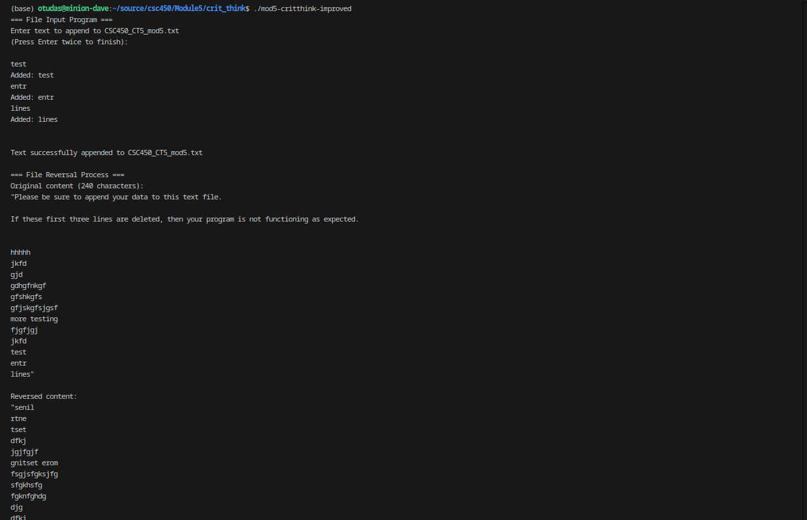

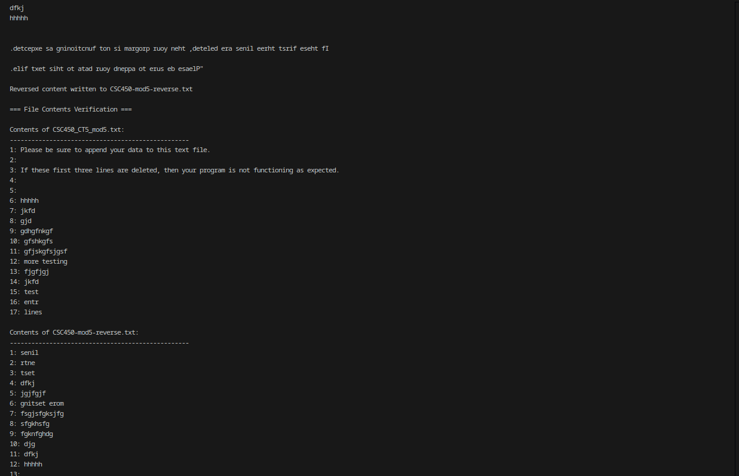
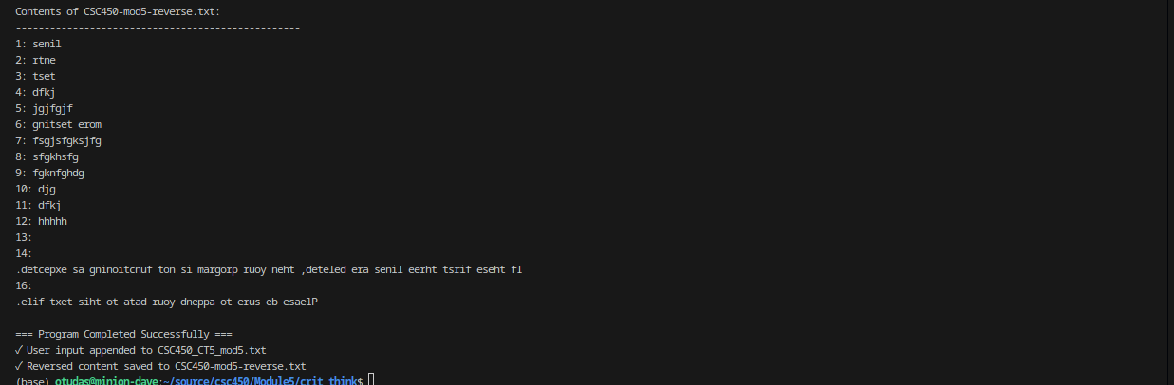
References
CPlusPlus.com. (n.d.). *Input/output with files*. CPlusPlus.com. https://cplusplus.com/doc/tutorial/files/

CPlusPlus.com. (n.d.). *<fstream>*. CPlusPlus.com. https://cplusplus.com/reference/fstream/

CPlusPlus.com. (n.d.). *std::ios_base*. CPlusPlus.com. https://cplusplus.com/reference/ios/ios_base/
Cppreference.com contributors. (n.d.). *Input/output library*. cppreference. https://en.cppreference.com/w/cpp/io

Cppreference.com contributors. (n.d.). *std::basic_fstream*. cppreference. https://en.cppreference.com/w/cpp/io/basic_fstream

Cppreference.com contributors. (n.d.). *std::filesystem*. cppreference. https://en.cppreference.com/w/cpp/filesystem

GeeksforGeeks. (n.d.). *File handling through C++ classes*. GeeksforGeeks. https://www.geeksforgeeks.org/file-handling-c-classes/

GeeksforGeeks. (n.d.). *C++ stream classes structure*. GeeksforGeeks. https://www.geeksforgeeks.org/c-stream-classes-structure/

Software Engineering Institute. (n.d.). Secure coding in C++11 and C++14. SEI Blog, Carnegie Mellon University. https://www.sei.cmu.edu/blog/secure-coding-in-c11-and-c14/

