Module 1 Critical Thinking

Dennis Weddig
Colorado State University Global
CSC450: Programming III
Dr. Jack Li
8/17/2025 11:59pm

Module 1 Critical Thinking
Repository location for Module 1 Critical Thinking assignment: https://github.com/denniswed/csc450/tree/main/Module1/crit_think
Code:
#include <iostream>
#include <string>

int main() {
// Different data types demonstration
const std::string firstname = "Sigfroid";
const std::string lastname = "Habberson";
const std::string streetaddress = "144 Dead Elm St";
const std::string city = "Springfield";
const std::string state = "IL";
const std::string zipcode = "62704";

// Display the results
std::cout << "Personal Information:" << std::endl;
std::cout << "First Name: " << firstname << std::endl;
std::cout << "Last Name: " << lastname << std::endl;
std::cout << "Street Address: " << streetaddress << std::endl;
std::cout << "City: " << city << std::endl;
std::cout << "State: " << state << std::endl;
std::cout << "Zip Code: " << zipcode << std::endl;

return 0;
}

Screenshot of above compile and execution:
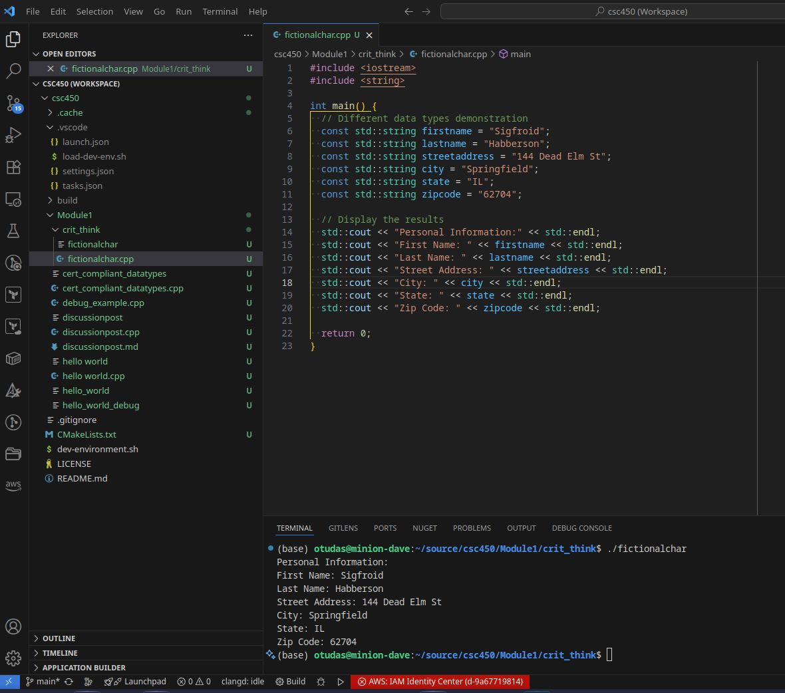

Screenshot of debug 1:
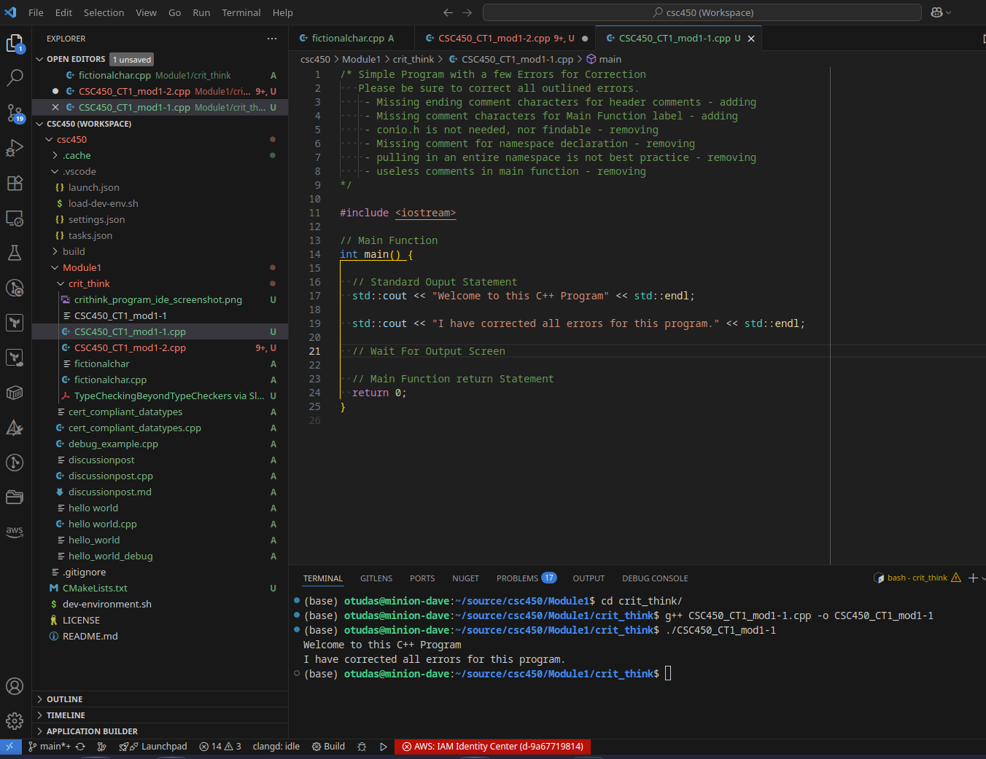

Screenshot of debug 2:
