Assignment Documentation

**ITP4506 Human Computer Interaction & GUI Programming**

|  |  |  |  |
| --- | --- | --- | --- |
| **Student ID** | **Name** | **Contribution** | **Signature** |
| 160169069 | TAM Chi Ho | 50% |  |
| 160022846 | WONG Lok Man | 50% |  |

Table of Contents

1. Introduction 3

2. User Analysis 3

1.1 User Characteristics 3

1.1.1 Primary and secondary users 3

1.1.2 Learning style 4

1.1.3 Physical Point 4

1.1.4 Cultural Point 4

1.1.5 Tool preferences 4

1.1.6 Knowledge of job 4

1.1.7 Application familiarity 4

1.2 Techniques for observing and listening to users 5

1.2.1 Think aloud: talk while doing the job 5

1.2.2 Talk right after 5

1.2.3 Role playing 5

1.2.4 Focus groups 5

1.3 Environment Analysis 5

1.4 Recruiting Users 5

1.5 Task Analysis (HTA) 5

3. Web Design Concepts 6

# Introduction

Happy Travel Ltd is a private travel agency company which provides travel and tourism related services to the customers on behalf of suppliers. The Products including airline, hotels, package tours and travel insurance.

In this project, a website will be built for Happy Travel Ltd. That is a medium-sized travel agent. The company’s target users are the tertiary student in Hong Kong. First, the user will be analyzed. Then, a tailor- made, website will be designed. While the website will be designing, the website designing will be implemented at the same time.

# User Analysis

Before the coding implementation on website, the user analysis process should be carried out. The following table is an outline of research area for listing out the user analysis.

* User Characteristics
* Techniques for observing and listening to users
* Environment Analysis
* Recruiting Users
* Task Analysis (HTA)

In this part, we will list out the research and analysis the data with more details.

## User Characteristics

In this report, we will analysis the characteristics of user from different points of view.

* Learning style
* Tool preferences
* Physical
* Cultural
* Knowledge of job
* Application familiarity
* Primary and secondary users

Later, We will analysis user of this project these different points.

### Primary and secondary users

|  |  |
| --- | --- |
| Analysis Area | Analysis result |
| Primary User | Tertiary Student interested in Travel |
| Secondary User | People with Travel Purposed |

Our User are 2 types that are primary user and secondary user. Primary user is tertiary student interested in Travel. Secondary User is People with Travel Purposed.

### Learning style

|  |  |
| --- | --- |
| Research Area | Analysis result |
| Learning style | Need common standard icons for the navigation |

We have studied our user’s habits. According our primary users are VTC student, they usually go travel in holiday. They will search their travel aspiration rapidly in different type services. Besides, they usually seek cheap price of air ticket, room and travel. Target to their habit, our website will be developed as a travel agent website.

### Physical Point

|  |  |
| --- | --- |
| Research Area | Analysis result |
| Age | 19-25 years old |
| Gender | Both |
| Growth place | Hong Kong Mostly |
| Race | Chinese Mostly |
| Physical Limitations | Vision limitations Mostly(shortsightedness) |

In order to be more user friendly, words will be larger and eye catching which related to categories, register, login. Those words are main key word, so it can easy for user to find.

### Cultural Point

|  |  |
| --- | --- |
| Research Area | Analysis result |
| Education level | tertiary students |
| Reading level | Chinese,  English (basic English) |
| Culture | Chinese Mostly |

The language of website is developed in English. Because VTC students include overseas students who don’t know Chinese very well, but reverse, local students know Chinese and English both language very well. Therefore, I decide to use international language --- English to develop the website.

### Tool preferences

|  |  |
| --- | --- |
| Research Area | Analysis result |
| Devices for Surfing | Touch screen devices (mobile phone and tablet),  Personal computer with keyboard and mouse |
| Web Browser | Chrome, Safari, Firefox, Edge, Opera |

Our website is focus on many devices for surfing such as Touch screen devices and personal computer with keyboard and mouse. And we consider user using different web browser. Therefore, we designed the web for the different type browser and different size. For example: Chrome, Safari, Firefox, edge and Opera.

### Knowledge of job

|  |  |
| --- | --- |
| Research Area | Analysis result |
| Using computer frequency | Always |
| Net Surfing | Invariably |

The user we aimed is always using computer frequency and net surfing. Therefore, they know many in using computer and net surfing. we considered that our design is used some familiar logo.

### Application familiarity

|  |  |
| --- | --- |
| Research Area | Analysis result |
| Familiarity of computer | Computer Veteran |
| Familiarity of Surfing | Computer Veteran |

Website provide search keyword function, hotel, flight and travel, filter by categories etc. Those functions can help user to find what they want rapidly.Also, website have a good design that familiarity with most of website, such as navigation bar and search function, most of website include these two components, so user do not need to spend much time to learn how to do task.

## Techniques for observing and listening to users

In this report, we will collect the opinion of user via different techniques.

* Think aloud: talk while doing the job
* Talk right after
* Role playing
* Cueing recall with videotape
* Focus groups
* Mailed/Online surveys

Later, We will analysis user of this project these different techniques.

### Think aloud: talk while doing the job

* Consult IVE student in TY about the mind of using travel agency website. By listening to their think and plan, the design of this project website can be expected.

### Talk right after

* Record the observation about the difficulties of surfing or ineffective in net surfing of ive student because of bad website design.

### Role playing

* Have a role playing with teammate

### Focus groups

* Focus the group of IVE student who is interesting in traveling and always travel

## Environment Analysis

* The speed of Internet in Hong Kong is fast. (design of website can be more animation)
* Computer running speed in Hong Kong mostly is fast. (design of website can be more animation and attractive.)
* Use different browser (Need to consider different display on different browser)
* On a combination cell phone/wireless browser, with a tiny display (Need to consider mobile phone or tablet design and the different OS)

## Recruiting Users

When the product is in use, this project will be test with project team member and invited IVE student.

## Task Analysis (HTA)

Hierarchical Task Analysis – Booking Hotel

1. Scenarios

First, user will see the homepage, there are travels, flights and hotels that show the item one by one.

New user need to scroll down the page and register. After register successful, user can log in their own account.

Then, user search product by key words and filter product by categories on the navigation bar.

To Booking Hotel with the website with Happy Travel Ltd:

1. surf to the website
2. sign up an account
   1. input personal information
3. take book to checkout counter

# Web Design Concepts

|  |  |
| --- | --- |
| Design Principles | Description |
| Mental Model |  |
| Affordance |  |
| Content Organization | Topic Types of Ambiguous schemes |
| Visual Organization | Proximity:  Alignment:  Consistency:  Contrast: |
| Navigation |  |

## Mental Model



Description: User recognize the searching bar to find out the travel, flights and hotels.

## Affordance

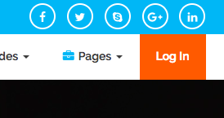

Description:

These obviously afford the website target two type of users, public user and VTC user

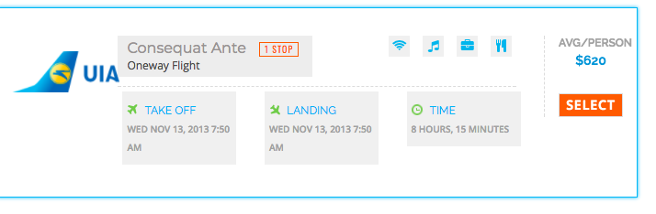

Description:

Select button affords add item

## Content Organization

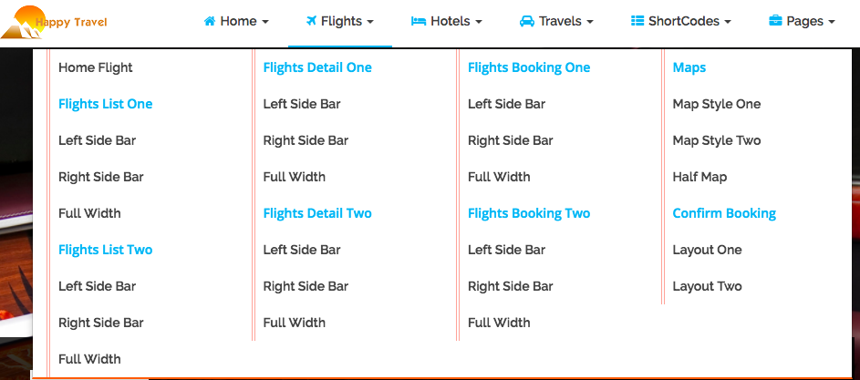

Description: Product uses Hierarchical organizational

## Visual Organization

1. Proximity: Sensible groups

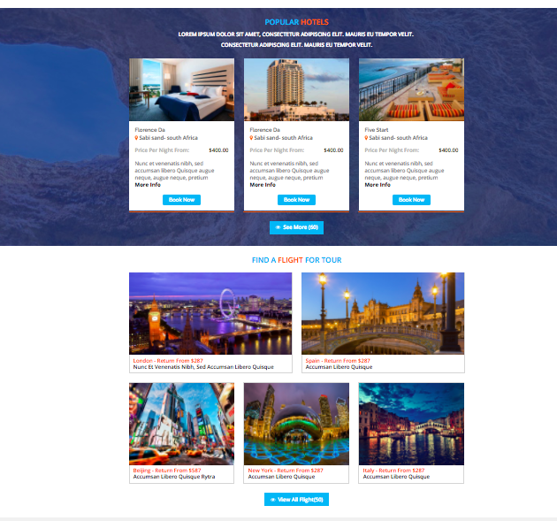

Description: Hotels and Fights item each will group together

1. Alignment: alignment



Description: Left hand side is description, right hand side is value.

1. Consistency

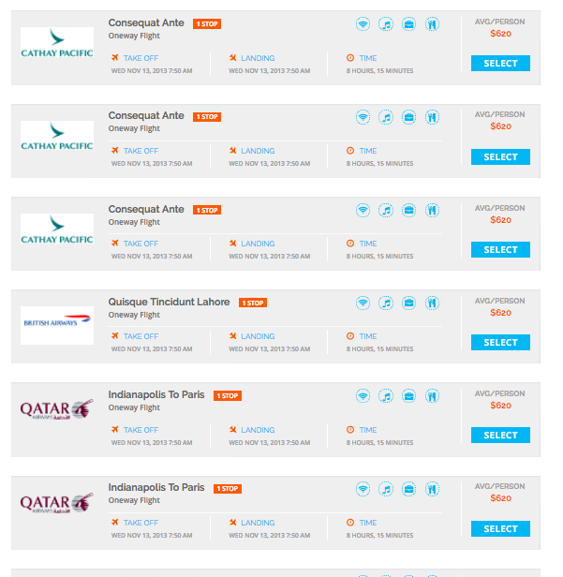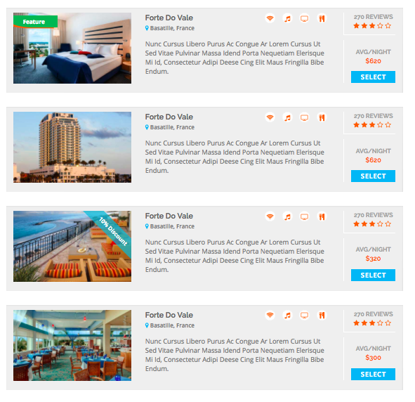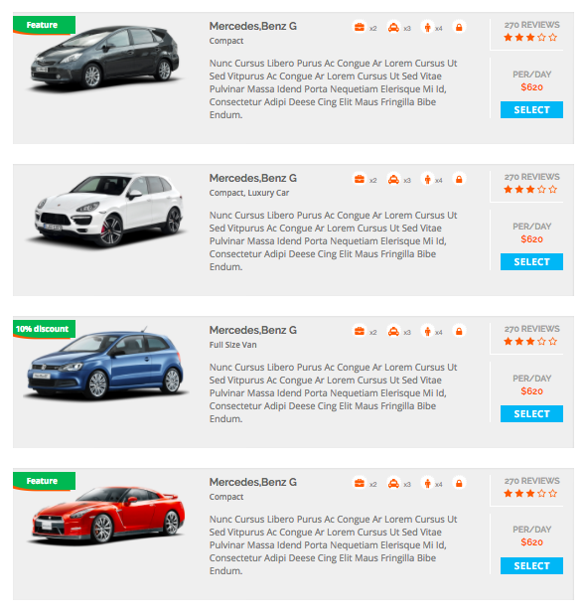

Description: Flights, Hotels and Travels have Repeat elements of the design throughout and across pages

1. Contrast

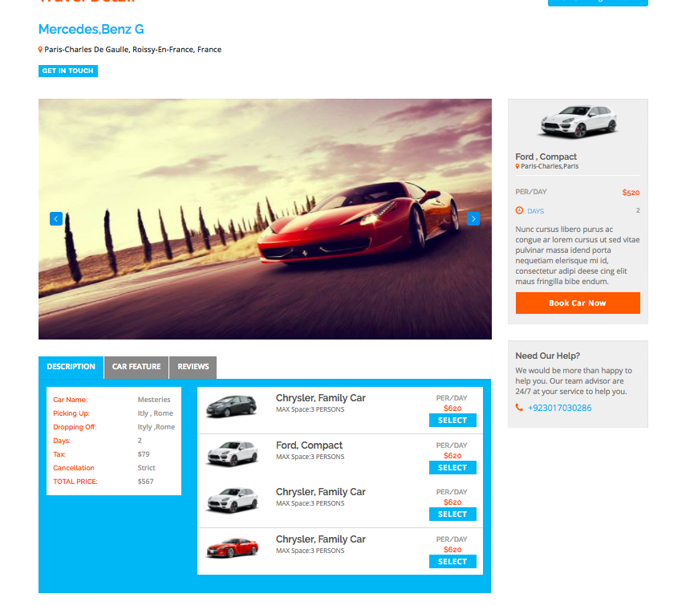

Description: Total Price larger the total details, total price change to red color because it is very important.

## Navigation



Description: Navigation bars can Drop-downs to show the next level