Language Learning App
Denni Thomas, S.Suresh Kumar, Sushant Baghel, Vinoth Ram Prakash
B.E. Students, Department of Computer Science and Engineering, Grace College of Engineering, Mullakadu, Tamil Nadu, India

Ms.Rebecca Fernando. I. M. S. B.
Assistant Professor, Department of Computer Science and Engineering, Grace College of Engineering, Mullakadu, Tamil Nadu, India

Abstract—In today’s global world, learning new languages is more important than ever. This language learning application is designed to provide a fun, easy, and effective way for users to learn and practice new languages through a personalized and interactive experience. Whether you’re a student, professional, or simply someone interested in languages, this mobile app offers the tools you need to succeed. The app includes a wide range of features such as vocabulary building, grammar lessons, listening and speaking exercises, and cultural insights. It also allows users to scan printed text for instant translation and learn useful phrases for real-life situations. Users can practice multiple languages at once, play quizzes to reinforce knowledge, and track their progress over time. A clean and user-friendly interface ensures that learners of all ages and tech skill levels can navigate the app with ease. Gamification elements—like rewards, badges, and progress bars—keep motivation high, while adaptive learning algorithms customize lessons based on each user’s proficiency level. Integrated speech recognition and real-time feedback help users refine pronunciation and improve fluency. This app makes language learning accessible, enjoyable, and truly effective, creating a supportive space where users can learn at their own pace and reach their language goals confidently.
Keywords
Language Learning, Speech Recognition, Chatbot, Multilingual Education, React Native, EdTech, Progress Tracking, Rewards System

I. INTRODUCTION
In today’s world, knowing more than one language is a great advantage. It helps people in studies, jobs, travel, and communication with people from different countries. But learning a new language can be hard and sometimes boring with traditional methods. This project is about creating a mobile app that makes language learning easy, fun, and

effective. The app is designed for people of all ages—students, professionals, travelers, or anyone who wants to learn a language for personal growth.

The app combines learning with technology. It helps users build vocabulary, learn grammar, practice speaking and listening, and understand different cultures. With features like speech recognition, scanning printed words, quizzes, and progress tracking, it gives users a full learning experience. The app also personalizes lessons to match each user’s level, so everyone can learn at their own pace.

II. SYSTEM OVERVIEW AND OBJECTIVES

Module Breakdown
The platform comprises four specialized modules, eachaimed at strengthening a particular language skill:
Findoscan: Designed to improve users’ reading comprehension and their ability to recognize and interpret written text effectively.
Commbridge: Concentrates on developing listening skills through the use of curated audio clips followed by comprehension questions that test user retention and understanding.
Polyverse: A vocabulary enhancement tool that employs interactive visual cues and word-matching games to make learning new words both engaging and effective.
Langquest: A gamified module that presents users with scenarios requiring decision-making based on contextual language clues, fostering cognitive application of communication skills.
III. SYSTEM DESIGN AND FUNCTIONALITY
A. System Modules (Expanded)
- Authentication Module: This module provides secure login/signup processes using encrypted credentials and session management. It prevents unauthorized access and supports future integration with OAuth (e.g., Google login).
- Lesson Module: Lessons are organized in progressive tiers (beginner to advanced) and tailored for each language. Users complete text-based and audio-supported lessons that introduce vocabulary, grammar, and cultural context.
- Chatbot Module: A conversational bot enables learners to practice what they've learned in a natural setting. It uses NLP to interpret user responses and provide meaningful replies. Voice support allows for speaking practice.
- Speech Recognition Module: This component uses browser APIs or third-party SDKs to capture and evaluate speech. It provides phonetic comparison and real-time feedback to help users improve pronunciation.
- Progress Tracker: A dashboard shows the learner's journey, including completed lessons, accuracy scores, and milestones. Visual cues like charts and graphs encourage daily engagement.
- Rewards System: The gamified system assigns XP points and unlocks badges as users complete modules. Daily streaks and level-ups are tracked to promote continuous learning.
B. Flowchart
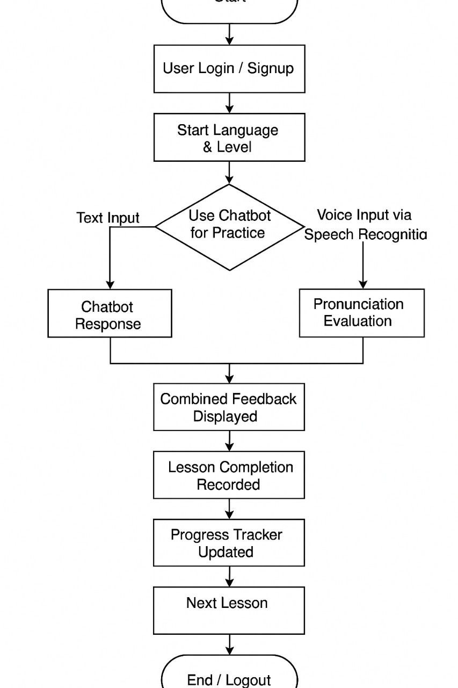

IV. TECHNOLOGIES USED

Component | Technology
Frontend | Reactjs (React Native for cross-platform compatibility)
Backend | Firebase(Node.js with Express.js for API routing)
Database | MongoDB with Mongoose for flexible data modeling
Speech API | Web Speech API, Google Cloud Speech-to-Text
Chatbot | Dialogflow, OpenAI, or Rasa-based NLP engine
Hosting | Firebase Hosting
Styling | TailwindCSS and styled-components
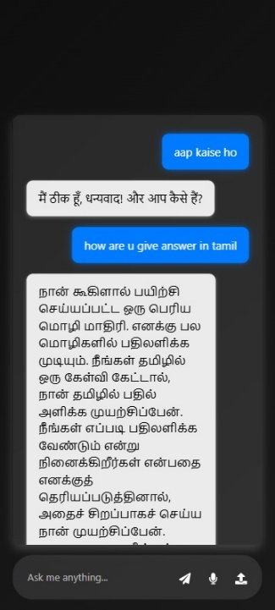

V. IMPLEMENTATION DETAILS

A. Admin & Student Views (Expanded)
- Admin Dashboard: Facilitates lesson creation, progress tracking, chatbot training, and system monitoring. Admins can upload multimedia content, assign difficulty levels, and edit or delete entries.
- Student Dashboard: Offers a personalized interface with access to enrolled languages, current lesson status, chatbot practice area, reward summary, and progress graphs.
B. System Security
- End-to-end encryption for all API communication
- Secure authentication (hashed passwords using bcrypt)
- Role-based access control to distinguish between admins and users
- Real-time session management and auto-logout on inactivity
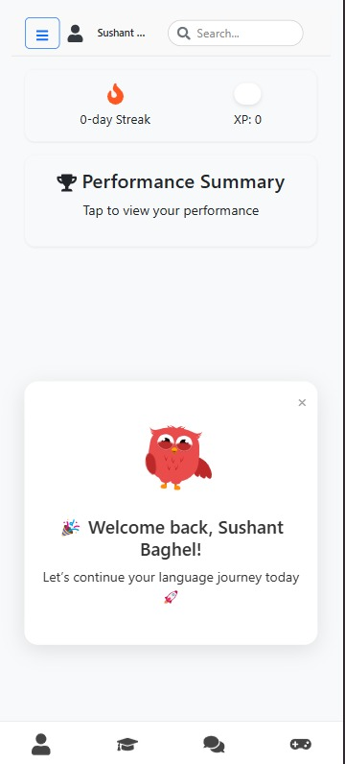

Fig. 1.After login,welcome page will appear for the user

Fig. 2.In chat box every languages are available

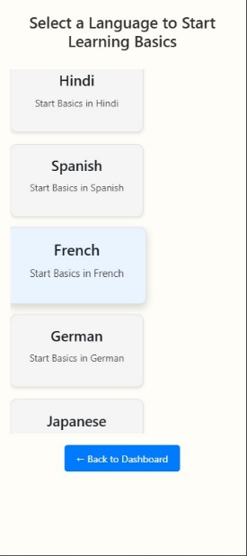
Fig. 3.The languages which is available

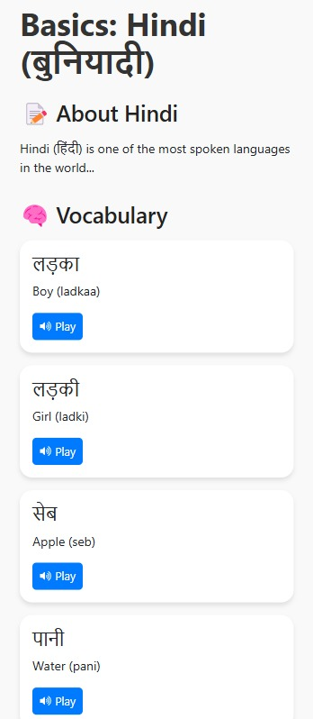

Fig. 4.Basic lessons for Hindi

VI. TESTING AND VALIDATION
System testing covered functional, usability, and performance tests:
- Functional Testing: Verified lesson uploads, chatbot response accuracy, login behavior, and API routes.
- Speech Recognition Testing: Compared user pronunciation with baseline models for each supported language.
- Usability Testing: Conducted with 15 users (students and volunteers) to gather feedback on UI and learning flow.
- Performance Testing: Ensured the chatbot response time averaged below 2 seconds; speech recognition handled 100 concurrent users without lag.
Outcomes showed high reliability and user satisfaction with chatbot engagement and speech evaluation tools.

VII. RESULTS AND DISCUSSION
The system was tested with a prototype containing Tamil, Hindi, and English modules:
- Speech Recognition: Delivered 90–95% accuracy for commonly used phrases. Improved with repeated user exposure.
- Chatbot Interaction: Natural conversation flows up to 4–5 turns were achieved before fallback to standard replies.
- Rewards System: 70% of users showed higher activity with gamified elements in place.
- Progress Tracker: Helped users identify their weaker areas based on lesson scores and retry counts.
Participants appreciated the mix of visual feedback, real-world context, and AI-powered interactivity.

VIII. CONCLUSION AND FUTURE WORK
This language learning platform integrates chatbot conversation, voice recognition, and lesson-based learning to offer a powerful, scalable solution for modern learners. Its modular architecture makes it easy to extend, and its AI integration ensures real-time, adaptive interaction.
Planned Enhancements:
- Add native-speaker voice samples and live audio shadowing features
- Launch a classroom mode for use by teachers in structured environments
- Enable offline downloads of lessons with speech input caching
- Expand the chatbot’s capabilities with contextual understanding and translation features

ACKNOWLEDGMENT
We express our sincere thanks to our project guide, Ms.Rebecca Fernando. I. M. S. B.,Assistant Professor and GuideDepartment of Computer Science, and the faculty of the Department of Computer Science and Engineering at **Grace College of Engineering **for their valuable guidance, motivation, and support throughout this project. We also thank our peers and friends for their feedback and encouragement.

REFERENCES
[1] V. Raman et al., “Language Learning Chatbots: A Conversational Approach to Second Language Acquisition,” Int. J. Comput. Educ., vol. 7, no. 3, pp. 23–30, 2022. [2] Google Developers, “Web Speech API,” [Online]. Available: https://developer.mozilla.org [3] Dialogflow Documentation, [Online]. Available: https://cloud.google.com/dialogflow [4] React Native Documentation, [Online]. Available: https://reactnative.dev [5] MongoDB Documentation, [Online]. Available: https://mongodb.com [6] J. Godwin-Jones, “Emerging technologies: Mobile-assisted language learning,” Language Learning & Technology, vol. 15, no. 2, pp. 2–11, 2011. [7] H. Stockwell, “Using mobile phones for vocabulary activities: Examining the effect of the platform,” Language Learning & Technology, vol. 14, no. 2, pp. 95–110, 2010. [8] R. Derakhshan and Z. Karimi, “The impact of gamification on EFL learners’ vocabulary learning,” Theory and Practice in Language Studies, vol. 10, no. 4, pp. 375–381, 2020. [9] T. Saran, I. Seferoglu, and C. Cagiltay, “Mobile assisted language learning: English pronunciation at learners’ fingertips,” Eurasian Journal of Educational Research, vol. 34, pp. 97–114, 2009. [10] S. Godwin-Jones, “Language learning with technology: Ideas for integrating technology in the classroom,” Cambridge University Press, 2018. [11] L. Kukulska-Hulme, “Mobile language learning now and in the future,” Multilingual Matters, vol. 1, no. 1, pp. 247–264, 2013. [12] M. Levy and G. Stockwell, “CALL Dimensions: Options and Issues in Computer-Assisted Language Learning,” Routledge, 2013. [13] M. Warschauer and D. Healey, “Computers and language learning: An overview,” Language Teaching, vol. 31, no. 2, pp. 57–71, 1998. [14] Z. Zhang and H. Li, “Automatic Pronunciation Assessment for Second Language Learners,” IEEE Transactions on Audio, Speech, and Language Processing, vol. 21, no. 4, pp. 765–775, 2013. [15] A. Arnold, “Artificial Intelligence in Language Learning: Present Reality and Future Potential,” Computer Assisted Language Learning, vol. 33, no. 5-6, pp. 456–471, 2020.

