Section I
Total Marks (75)

Part A
Total marks (15)
Attempt Questions 1-15
Allow about 30 minutes for this part

INSTRUCTIONS
Use the multiple choice answer sheet on page 5
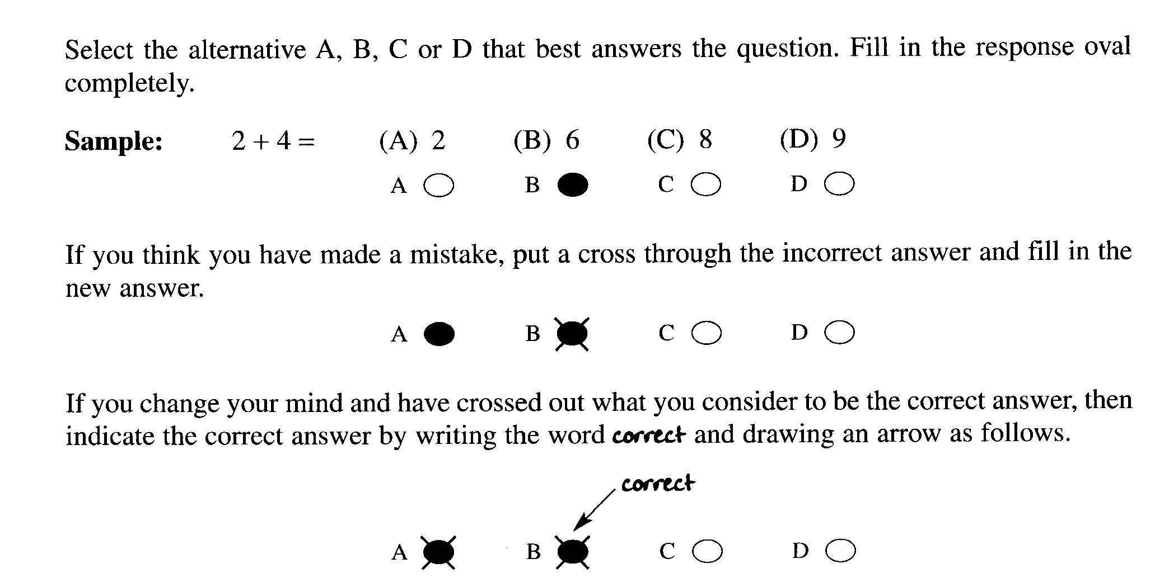

1. When equal volumes of 0.10 mol L ^{–1} HCl and NaOH are mixed in a calorimeter a temperature rise is
observed. Which equation explains the observation?

(A) H ⁺_{(aq)} + H₂O _{(l)} → H₃O ⁺_{(aq)} ∆H = – 57.9 kJ mol ^{–1}
(B) NaCl _{(aq)} → Na⁺_{(aq)} + Cl –_{(aq)} ∆H = + 57.9 kJ mol ^{–1}
(C) H ⁺_{(aq)} + OH –_{(aq)} → H₂O _{(l)} ∆H = – 57.9 kJ mol ^{–1}
(D) HCl _{(aq)} → H ⁺_{(aq)} + Cl –_{(aq)} ∆H = + 57.9 kJ mol ^{–1}

2. Which set shows the degree of ionisation of acetic, citric and hydrochloric acids?

(A) acetic < citric < hydrochloric
(B) hydrochloric > acetic > citric
(C) hydrochloric < citric < acetic
(D) citric < hydrochloric < acetic

3. An HCl solution is diluted with water increasing its volume by ten–fold.
Which change does not occur as result of this dilution?

(A) [H ⁺] decreases ten–fold.
(B) pH decreases by ten units.
(C) [OH –] increases ten–fold.
(D) pH increases by one unit.

4. The first step in the gravimetric analysis of the sulfate content of lawn fertiliser involves precipitation.
Which solution will precipitate sulfate?

(A) NaOH
(B) H₂SO₄
(C) NH₃
(D) BaCl₂

5. Which species is the conjugate acid of PO₄ ^{3–} ?

(A) H₃PO₄
(B) H₂PO₄ –
(C) HPO₄ –
(D) PO₃ ^{3–}

6. Which term describes the relationship between the compounds below?

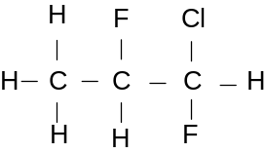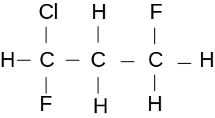

(A) Monomers
(B) Isotopes
(C) Isomers
(D) Allotropes

7. What is the purpose of adding Fe³⁺ salts in the process of water treatment?

(A) to increase tooth hardness
(B) to disinfect the water
(C) to lower the acidity of the water
(D) to coagulate fine particles to improve effective filtering

8. Which of the following methods best determines the total dissolved solids in a water sample?

(A) AAS
(B) electrical conductivity
(C) a pH meter
(D) a flame test

9. Which of the following is NOT a use for ethylene?

(A) as a monomer for the manufacture of plastics
(B) as a source of ethanoic acid
(C) as a source of ethylene glycol
(D) as a fuel in power plants

10. Why is ethylene readily transformed into many useful products?

(A) due to its high percentage carbon content
(B) due to the presence of a double bond
(C) due to its low boiling point
(D) due to its triple bond

11. Which of the following pairs of monomers are NOT likely to react by condensation polymerisation?

(A) 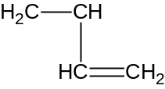 and 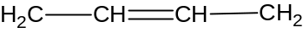

(B) and 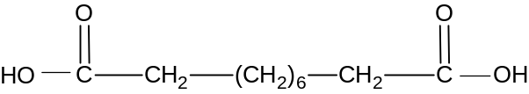

(C) and 

(D) and

12. Which catalyst is used for the production of ethanol from ethylene.?

(A) concentrated H₃PO₄
(B) dilute sulfuric acid
(C) yeast
(D) concentrated H₂SO₄

13. These results were obtained from an experiment:

Test | Metal X | Metal L | Metal Z
acid | rapid effervescence:  metal dissolves quickly | bubbles slowly form on surface; rate increases on heating | some bubbles of gas form on surface

Which of the following reactions will not occur?

(A) XCl₂(aq) + L (s) → LCl₂ (aq) + X(s)

(B) LCl₂(aq) + X (s) → XCl₂ (aq) + L(s)

(C) ZCl₂(aq) + X (s) → XCl₂ (aq) + Z(s)

(D) ZCl₂(aq) + L (s) → LCl₂ (aq) + Z(s)

14. In which of the following transformations is the underlined species undergoing reduction.?

(A) MnO₄⁻ -→ Mn²⁺
(B) Cr₂O₇²⁻ → CrO₄²⁻
(C) H₂O₂ → O₂
(D) SO₂ → SO₃

15. Which of the following transuranic syntheses can occur in a nuclear reactor?

(A) 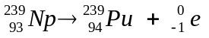

(B) 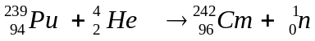

(C) 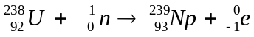

(D) 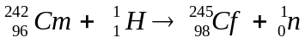

Student Number …………………………

Section I Mark -----/15
Part A

Multiple Choice Answer Sheet

1. A  B  C  D 

2. A  B  C  D 

3. A  B  C  D 

4. A  B  C  D 

5. A  B  C  D 

6. A  B  C  D 

7. A  B  C  D 

8. A  B  C  D 

9. A  B  C  D 

10. A  B  C  D 

11. A  B  C  D 

12. A  B  C  D 

13 A  B  C  D 

14. A  B  C  D 

15. A  B  C  D 

JAMES RUSE AGRICULTURAL HIGH SCHOOL
2005 CHEMISTRY TRIAL HSC EXAM Student Number …………………………

Section I (continued)

Part B - 60 marks
Attempt Questions 16 -29
Allow about 1 hour and 45 minutes for this part

Answer the questions in the spaces provided
Show all relevant working in questions involving calculations

Question 16 (3 marks) MARKS

Assess the impact of atomic absorption spectroscopy on the scientific understanding of the
effects of trace elements. 3

_________________________________________________________________________________

_________________________________________________________________________________

_________________________________________________________________________________

__________________________________________________________________________________

__________________________________________________________________________________

__________________________________________________________________________________

__________________________________________________________________________________

MARKS
Question 17 (5 marks)

Jack and his lab partner Jill are given a prac test where they must prove that a sample solution
contains ions of barium, copper and lead. The flow chart shows the test method they followed

Test Solution

Ba²⁺ Cu²⁺ Pb²⁺
Step 1
Addition of Cl –

Precipitate X
Step 2
Addition of SO₄^{2–}

Precipitate Y
Step 3
Addition of OH –

Precipitate Z

(a) Write net ionic equations showing the formation of precipitates X, Y and Z. 3

(X) ______________________________________________________________

(Y) ______________________________________________________________

(Z) ______________________________________________________________

Problem 17 continues next page…..
MARKS

(b) What problem would occur if the sequence was changed by adding SO₄^{2–} in Step 1
and Cl – in Step 2? 1

_____________________________________________________________________________

_____________________________________________________________________________

_____________________________________________________________________________

(c) Jill suggests that the test procedure could be simplified by performing flame tests on the
original test solution proving the presence of Ba²⁺ and Cu²⁺.

Comment on the validity of Jill’s suggestion 1

____________________________________________________________________________

____________________________________________________________________________

____________________________________________________________________________

_____________________________________________________________________________

Question 18 (4 marks)

Ammonium sulfate is commonly used as a lawn fertiliser.
(a) Calculate the mass percentage of sulfate in (NH₄)₂SO₄. 1

____________________________________________________________________________

____________________________________________________________________________

____________________________________________________________________________

_____________________________________________________________________________

_____________________________________________________________________________

_____________________________________________________________________________

Question 18 continues next page……
MARKS

(b) Three high schools perform a sulfate analysis of ammonium sulfate by precipitating
the sulfate followed by filtration. The schools’ results were…

School | Filtration Method | Student’s Comments | Mean Sulfate %
Avogadro H.S. | Sintered glass crucible was used. | “The filtration was very quick using a vacuum pump.”  “The filtrate was slightly cloudy”. | 63.9
Le Châtelier H.S. | 0.1% agar solution was used as a coagulating agent. Normal filter paper was used. | “The mixture filtered quickly at first, then slowed down.”  “The filtrate was clear.” | 76.3
Haber H.S. | Fine grade filter paper was used. | “The filtering took a long time.”  “The filtrate was milky.” | 58.2

Evaluate the validity of each school’s experimental results. 3

____________________________________________________________________________

____________________________________________________________________________

____________________________________________________________________________

_____________________________________________________________________________

_____________________________________________________________________________

____________________________________________________________________________

MARKS
Question 19 (5 marks)

(a) Write a balanced chemical equation showing citric acid ionising in water by donating a
proton to a water molecule. 1

_____________________________________________________________________________

(b) Write the formula of the conjugate base of citric acid. 1

_____________________________________________________________________________

(c) Citric acid and acetic acid are common food additives. Discuss their use. 2

_____________________________________________________________________________

_____________________________________________________________________________

(d) A student analyses the amount of citric acid present in orange juice by titration with
standardised NaOH. Suggest a suitable indicator for this titration 1

_________________________________________________________________________________

MARKS
Question 20 (6 marks)

(a) Identify whether sodium hydrogen carbonate is an acidic, basic or neutral salt.
Write a balanced equation to explain its acidic, basic or neutral nature in water. 2

__________________________________________________________________________

__________________________________________________________________________

(b) The hydrogen carbonate ion is amphiprotic.
Write two balanced equations showing the hydrogen carbonate ion acting as a
Brønsted–Lowry acid and as a base 2

Acting as an acid ___________________________________________________________

Acting as a base ___________________________________________________________

(c) The hydrogen carbonate ion acts as part of a buffer solution in the blood and in fresh and salt
water. Explain the effect that buffers have in these natural systems. 2

___________________________________________________________________________

___________________________________________________________________________

MARKS
Question 21 (3 marks)

A sample of acidic industrial effluent was titrated with standardised 0.100 mol L ^{– 1} NaOH.
A pH electrode connected to a data logger was used to monitor the titration.

The table and incomplete graph show the data collected, i.e. volume of NaOH added and resultant pH of titration mixture…

mL NaOH | pH | mL NaOH | pH | mL NaOH | pH
0 | 4.3 | 14 | 7.6 | 28 | 11.7
2 | 5.7 | 16 | 7.7 | 30 | 11.9
4 | 6.4 | 18 | 7.8 | 32 | 12.1
6 | 6.8 | 20 | 8.0 | 34 | 12.2
8 | 7.1 | 22 | 8.5 | 36 | 12.3
10 | 7.3 | 24 | 10.7 | 38 | 12.3
12 | 7.5 | 26 | 11.3 | 40 | 12.3

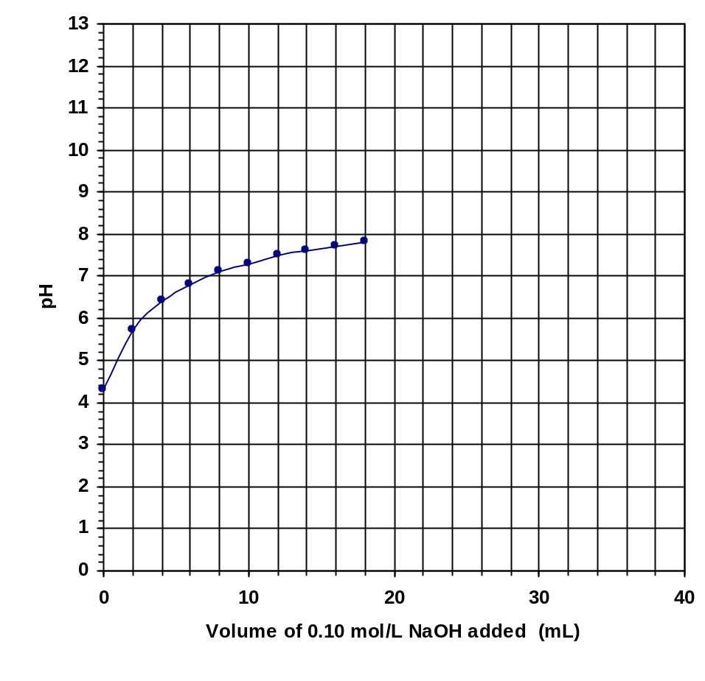

Question 21 continues next page

MARKS
(a) The first ten data points on the graph are plotted. Plot the remaining eleven data points
and complete the line of best fit. 1

(b) Use the graph to estimate the pH of the neutralisation point (equivalence point) 1

______________

(c) This titration could be performed using an indicator rather than a pH electrode.
Identify a suitable indicator. 1

________________________________________________________________________

MARKS

Question 22 (6 marks)

(a) Draw a labelled diagram of a galvanic cell consisting of a tin electrode in a solution of
tin(II)chloride and zinc electrode in a solution of zinc sulfate. . 1

(b) In the diagram;
(i) label the anode and the cathode. 1
(ii) indicate the direction of the electron flow 1

(c) Calculate the expected voltage of this cell. 1

…………………………………………………………………………………………………………

…………………………………………………………………………………………………………

….………………………………………………………………………………………………………

(d) Write the net ionic equation for the cathode reaction and the anode reaction. 1

cathode reaction:…………………………………………………………………………………………………

anode reaction: ………………………………………………………………………………………………….

(e) When this cell was constructed by a group of Year 12 students, they obtained a smaller
than expected voltage. Explain their observation. 1

…………………………………………………………………………………………………………

…………………………………………………………………………………………………………

…………………………………………………………………………………………………………

MARKS
Question 23 (7 marks)

(a) Write a balanced formula equation for the fermentation of glucose. 1

…………………………………………………………………………………………………

(b) Other than temperature, identify one condition which promotes fermentation of sugars 1

………………………………………………………………………………………………….

…………………………………………………………………………………………………..

(c ) A student is required to determine the effect of initial temperature on the rate of fermentation
of glucose using the equipment shown below.

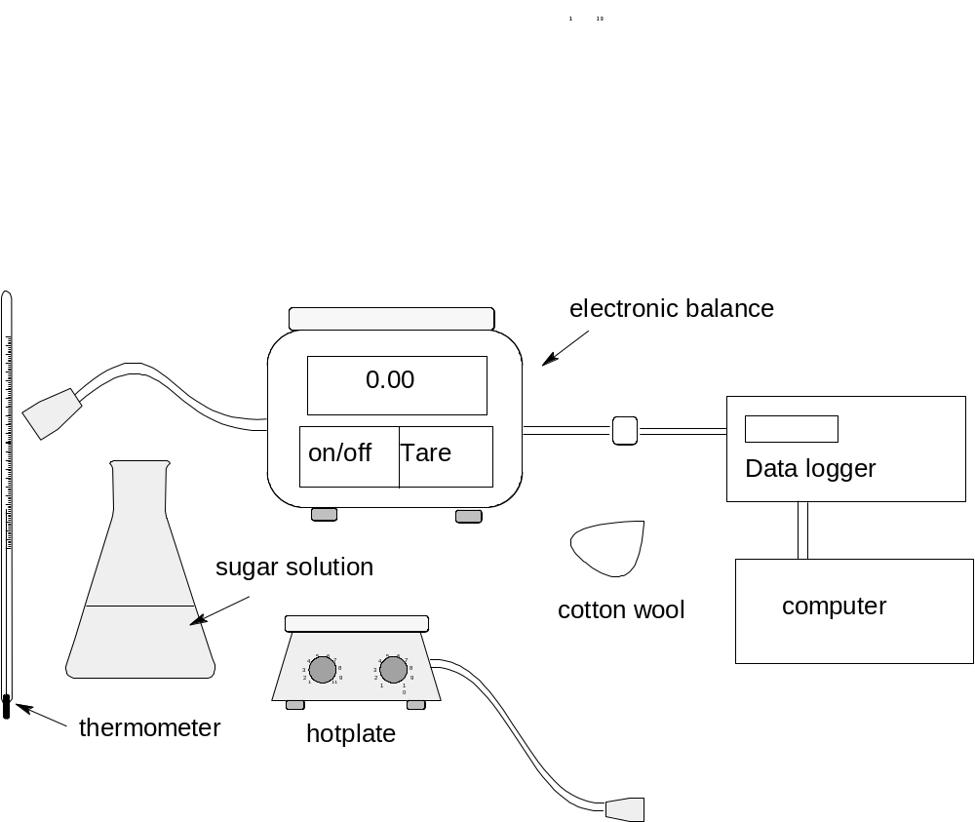

Question 23 continues next page..
MARKS

(i) Outline the steps required to accomplish the determination. .. 3

……………………………………………………………………………………………………………

…………………………………………………………………………………………………………….

…………………………………………………………………………………………………………….

…………………………………………………………………………………………………………….

…………………………………………………………………………………………………………….

…………………………………………………………………………………………………………….

……………………………………………………………………………………………………………..

……………………………………………………………………………………………………………

(ii) Sketch on the diagram below the graph(s) the student is expected to obtain. 2



MARKS
Question 24. (1 mark)

Describe one everyday use of indicators. 1

………………………………………………………………………………………………………

………………………………………………………………………………………………………

………………………………………………………………………………………………………

Question 25 (5 marks)

Assess the evidence which indicates increases in atmospheric concentration of oxides of
sulfur and nitrogen 5

…………………………………………………………………………………………………………

…………………………………………………………………………………………………………

…………………………………………………………………………………………………………

…………………………………………………………………………………………………………

…………………………………………………………………………………………………………

…………………………………………………………………………………………………………

…………………………………………………………………………………………………………

…………………………………………………………………………………………………………

…………………………………………………………………………………………………………

…………………………………………………………………………………………………………

…………………………………………………………………………………………………………

…………………………………………………………………………………………………………
MARKS

Question 26 (5 marks)

A student determined the heat of combustion of propanol using common laboratory
equipment such as an alcohol lamp, a 250-ml beaker, a tripod, a wire gauze and a
thermometer. Shown below is the student’s table of results:

 | Mass of beaker, g | Mass of alcohol lamp, g | Temperature of water, ⁰C
Initial | (empty): 35.07 | 12.98 | 15
Final | (with water) 235.1 | 11.05 | 65

(a) Calculate the heat of combustion of propanol in kJ mol⁻¹. 2

…………………………………………………………………………………………………………

…………………………………………………………………………………………………………

…………………………………………………………………………………………………………

…………………………………………………………………………………………………………

(b) The reference value (literature value) of the heat of combustion of propanol at 25⁰C is
2003 kJ mol⁻¹. Account for the great difference between the experimental
value and the reference value. 1

…………………………………………………………………………………………………………

…………………………………………………………………………………………………………

…………………………………………………………………………………………………………

(c) Describe how the student could increase the validity of this investigation. 2

…………………………………………………………………………………………………………

……………………………………………………………………………………………………….

…………………………………………………………………………………………………………

…………………………………………………………………………………………………………

…………………………………………………………………………………………………………

MARKS

Question 27 (4 marks)

Write two equations to show the reactions involving CFCs and ozone that demonstrate the removal
of ozone from the atmosphere. 4

…………………………………………………………………………………………………………

…………………………………………………………………………………………………………

Question 28 (2 marks)

Identify two possible sources of contamination of the local town water supply 2

…………………………………………………………………………………………………………

…………………………………………………………………………………………………………

…………………………………………………………………………………………………………

…………………………………………………………………………………………………………

Question 29 (4 marks)

The quality of a water sample may be determined by considering a number of factors.
Two of these factors are turbidity and hardness.
Define turbidity and hardness and give a quantitative test that could be used to measure the
levels of hardness or turbidity in a water sample. 4

…………………………………………………………………………………………………………

…………………………………………………………………………………………………………

…………………………………………………………………………………………………………

…………………………………………………………………………………………………………

…………………………………………………………………………………………………………

…………………………………………………………………………………………………………

…………………………………………………………………………………………………………

Section II Industrial Chemistry
25 marks
Attempt Question 30
Allow about 45 minutes for this section.

Answer the question in a writing booklet provided.
Show all relevant working in questions involving calculations

Question 30 Industrial Chemistry (25 marks) MARKS

(a) The flow diagram summarises the Solvay process.

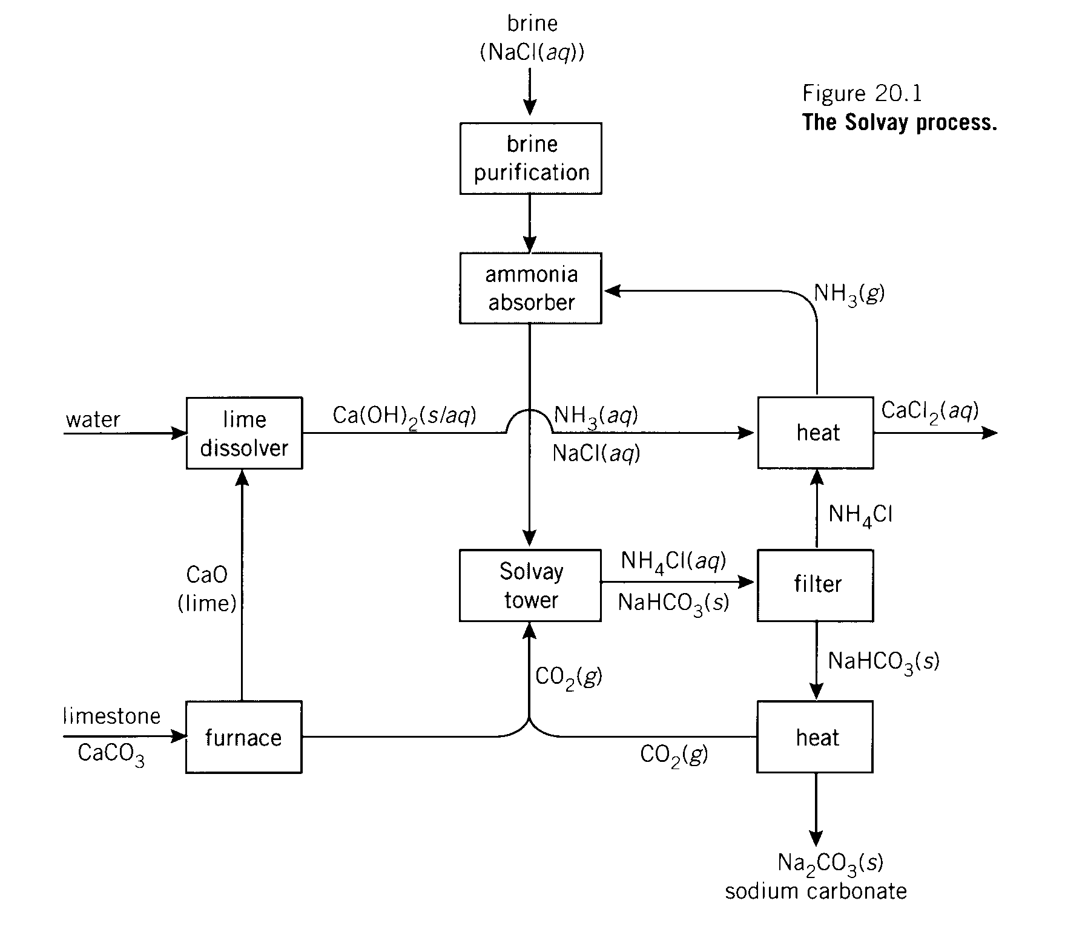


●
❍

(i) Identify the raw materials used in the Solvay process 1

(ii) Identify the number (1,2,3 or 4) on the diagram that indicates the process of ammonia
recovery and describe the chemistry involved. . 3

(iii) Discuss the environmental issues associated with the Solvay process 6
and explain how these issues are addressed.
MARKS

(b) A key reaction in the manufacture of methanol is

CO (g) + 2 H₂(g)  CH₃OH (g)

(i) This reaction is exothermic. Identify one change that could be made to increase
the yield of methanol. 1

(ii) A 1 L reaction vessel initially contained 0.35 mol CO and 0.60 mol H₂..
After equilibrium was established, there was only 0.20 mol H₂.
Calculate the equilibrium constant for the reaction. Show all relevant working. 3

(c) During your practical work you performed a first hand investigation to carry out
saponification and test the product.

(i) Define saponification. 1

(ii) Outline the procedure used in your investigation and describe the results
obtained when the product was tested. 3

(iii) Account for the cleaning action of soap by describing its structure. 4

(d) Describe one process used to extract sulfur from mineral deposits and identify one
property of sulfur which allows its extraction in this way. 3

END OF TEST

