Section I
75 marks

Part A – 15 marks
Attempt Questions 1-15
Allow about 30 minutes for this part

Use the multiple choice answer sheet on page 7

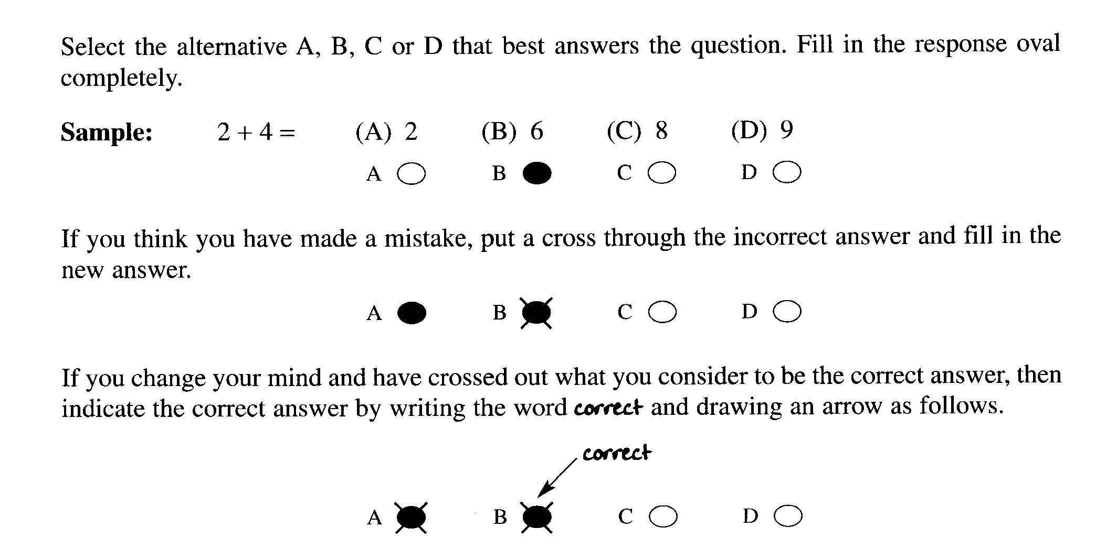

________________________________________________________________________________
1. Consider the following reactions:

(i) Ag⁺ + Cl⁻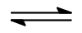 AgCl

(ii) CH₄ + O₂ → CO₂ + 2 H₂O

(iii) Mg + 2 HCl → MgCl₂ + H₂

(iv) Mg(OH)₂ + HCl → MgCl₂ + H₂O

Which of the reactions can be considered an acid-base reaction(s).

(A) (i), (ii), (iii), (iv)

(B) (i), (iii) and (iv) only

(C) (iv) only

(D) (i) only

2. Which of the following equations represent the Haber process?

(A) N + 3H → NH₃ ΔH = - 91 kJ

(B) N₂ + 3H₂ → 2NH₃ ΔH = -91 kJ

(C) N₂ + 3H₂ 2NH₃ ΔH = +91 kJ

(D) N₂ + 3H₂ 2NH₃ ΔH = -91 kJ

3. An unknown solution may contain one or more of the following ions: Mg²⁺, SO₄²⁻, CO₃²⁻, Pb²⁺, Cl⁻
The solution gave a white precipitate with Ba(NO₃)₂ but no reaction with H₂SO₄.

Which of the ions may be present ?

(A) Mg²⁺ and Cl⁻

(B) Pb²⁺ and Cl⁻

(C) Mg²⁺ and SO₄²⁻

(D) Mg²⁺ and CO₃²⁻

4. Consider the following haloalkane:

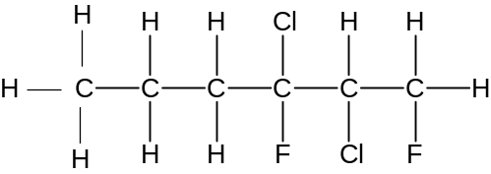

Which of the following is an isomer of the compound ?

(A) 1,1-dichloro-2-fluorohexane

(B) 1,2,5-trichloro-2-fluorohexane

(C) 1,3-dichloro-2,3-difluorohexane

(D) 2,3-dichloro-1,3-difluorohexane

5. A chemist wants to test for the presence of iron (III) ions in a water sample collected outside a
factory. Which anion could be used to test for the presence of iron (III) ions in the water?

(A) SO₄²⁻

(B) NO₃⁻

(C) OH⁻

(D) Cl⁻

6. What is the product of adding bromine water to 2-hexene?

(A) 2,3-dibromohexene

(B) 2,3-dibromohexane

(C) 1,2-dibromohexane

(D) 1,2-dibromocyclohexene

7 Where on the Periodic Table would you most likely find elements which form basic oxides?

(A) Group 1

(B) Group 6

(C) Period 2

(D) Period 3

8. Which elements on the Periodic Table have radioisotopes?

(A) Only those elements after uranium.

(B) Only the actinides.

(C) Only elements with unstable proton-neutron ratio.

(D) Only metallic elements

9. A student constructed a galvanic cell using two different metals and electrolytes of the
nitrates of the metals, under standard conditions.

Which combination of metals would give the greatest potential difference?

(A) copper and silver

(B) manganese and silver

(C) zinc and copper

(D) magnesium and zinc

10. The molar heat of combustion of propane is given in the data book as 2200 kJ mol⁻¹.
What does this mean?

(A) 1 g of propane releases 2200 kJ of heat

(B) 44 g of propane releases 2200 kJ of heat

(C) 1 g of propane absorbs 2200 kJ of heat

(D) 44 g of propane absorbs 2200 kJ of heat

11. Which of the following is a common natural source of sulfur dioxide in the atmosphere?

(A) The action of sunlight on S and O₂

(B) Smelting metal ores

(C) Soil bacteria

(D) Volcanoes

12. Which of the following may be used as a catalyst in esterification?

(A) H₂SO₄

(B) C₂H₅OH

(C) CH₃COOH

(D) H₂O

13. What is the name of the ester given below?

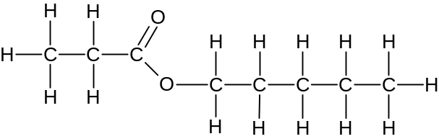

(A) butyl pentanoate

(B) pentyl butanoate

(C) propyl pentanoate

(D) pentyl propanoate

14 A soft drink may be decarbonated by heating. In observing the results, the equilibrium between
gaseous and dissolved carbon dioxide can be examined.

CO₂ (g) CO₂ (aq)

What conclusion can be drawn about this reaction?

(A) The forward reaction is exothermic.

(B) Only the reverse reaction rate is increased with heating.

(C) Heat is absorbed in the reaction shown above.

(D) Only the forward reaction rate is increases with heating.

15. Which correctly describes the relationship between an acid and its conjugate base?

(A) They are ions of opposite charge.

(B) They both contain H atom.

(C) They neutralize each other to form a salt.

(D) They have formulae that differ by a proton.

Student Number …………………………

Section I Marks-----/15
Part A

Multiple Choice Answer Sheet

1. A  B  C  D 

2. A  B  C  D 

3. A  B  C  D 

4. A  B  C  D 

5. A  B  C  D 

6. A  B  C  D 

7. A  B  C  D 

8. A  B  C  D 

9. A  B  C  D 

10. A  B  C  D 

11. A  B  C  D 

12. A  B  C  D 

13 A  B  C  D 

14. A  B  C  D 

15. A  B  C  D 

JAMES RUSE AGRICULTURAL HIGH SCHOOL
2006 CHEMISTRY TRIAL HSC EXAM Student Number …………………………

Section I (continued)

Part B - 60 marks
Attempt Questions 16 to 26.
Allow about 1 hour and 45 minutes for this part

Answer the questions in the spaces provided

Show all relevant working in questions involving calculations

Marks
Question 16 ( 5 marks)

A buffer is known to contain two of these substances:

sodium dihydrogen phosphate sodium hydrogen phosphate
ethanoic acid sodium ethanoate

(a) Define a buffer 1

……………………………………………………………………………………………..

……………………………………………………………………………………………..

……………………………………………………………………………………………..

(b) Using an equation, explain how the substances can be used as a buffer.
2
……………………………………………………………………………………………..

……………………………………………………………………………………………..

……………………………………………………………………………………………..

……………………………………………………………………………………………..

(c) Use balanced ionic equations to demonstrate how one of the above compounds can behave
as an amphiprotic substance. 2

……………………………………………………………………………………………..

……………………………………………………………………………………………..

……………………………………………………………………………………………..

Marks
Question 17 (8 marks)

Sulfate in fertilizer may be analysed gravimetrically by precipitating the sulfate with barium ion
and weighing the sulfate produced after filtering and drying. To test the technique, which is
exactly what YOU did in the lab, a group of students performed the analysis on pure ammonium
sulfate. They obtained the following results.:

Mass of sample of ammonium sulfate: 2.34 g

Mass of filter paper: 0.203 g

Mass of filter paper + ‘dried’ precipitate: 4.65 g

(a) Calculate:

(i) the theoretical percentage of sulfate in ammonium sulfate 2

……………………………………………………………………………………………..

……………………………………………………………………………………………..

……………………………………………………………………………………………..

(ii) the experimental percentage of sulfate in ammonium sulfate 3

……………………………………………………………………………………………..

……………………………………………………………………………………………..

……………………………………………………………………………………………..

……………………………………………………………………………………………..

(b) Assess the accuracy of the above determination. Identify and explain two possible sources
of error that can contribute to this particular discrepancy. 3

……………………………………………………………………………………………..

……………………………………………………………………………………………..

……………………………………………………………………………………………..

……………………………………………………………………………………………..

……………………………………………………………………………………………..
Section I – Part B (continued) Student Number ………………….

Marks
Question 18 (6 marks)

The graph shows the variation in percentage yield of the product with pressure at various
temperatures for the Haber process.

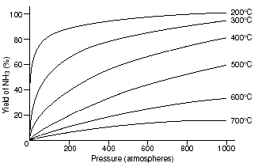

(a) Based on the graph, what conditions of temperature and pressure give the best yield for
this process? Justify your answer. 2

……………………………………………………………………………………………..

……………………………………………………………………………………………..

……………………………………………………………………………………………..

(b) In industry, the conditions usually used are 400 ºC and 500 atm pressure. Explain the
reason(s) for the use of these conditions. 2

……………………………………………………………………………………………..

……………………………………………………………………………………………..

……………………………………………………………………………………………..

……………………………………………………………………………………………..

(c) Identify the chemical composition of the catalyst used in this reaction and explain its role. 2

……………………………………………………………………………………………..

……………………………………………………………………………………………..

……………………………………………………………………………………………..
Marks
Question 19 (5 marks)

A group of students were assigned to determine the copper ion content of a certain brand
of spring water. They prepared a series of standard copper ion solutions in distilled water
and analysed the standard solutions and the undiluted spring water with the AAS
instrument. They also tested some distilled water which they used to prepare the standard
solutions. The results are given below:

Solution | Cu²⁺ion concentration (ppm) | Absorbance
Standard 1 | 1.0 | 0.0521
Standard 2 | 2.0 | 0.0634
Standard 3 | 4.0 | 0.1205
Standard 4 | 6.0 | 0.1834
Standard 5 | 8.0 | 0.2467
Spring water | unknown | 0.0412
distilled water | unknown | 0.0501

(a) Construct a well labelled calibration curve for this determination. 3


Question 19 continues on page 12
Section I – Part B (continued) Student Number ………………….
Marks

(b) Comment on the validity of the distilled water as a control. 2

…………………………………………………………………………………………….

…………………………………………………………………………………………….

Question 20 (2 marks)

Identify and describe two everyday uses of indicators. 2

...........................................................................................................................................................

...........................................................................................................................................................

...........................................................................................................................................................

...........................................................................................................................................................

Question 21 (8 marks)

Compare addition and condensation polymers using named examples of each type of polymer. 8

……………………………………………………………………………………………………….

……………………………………………………………………………………………………….

……………………………………………………………………………………………………….

……………………………………………………………………………………………………….

……………………………………………………………………………………………………….

……………………………………………………………………………………………………….

……………………………………………………………………………………………………….

……………………………………………………………………………………………………….

……………………………………………………………………………………………………….

……………………………………………………………………………………………………….

……………………………………………………………………………………………………….

……………………………………………………………………………………………………….

……………………………………………………………………………………………………….

……………………………………………………………………………………………………….

……………………………………………………………………………………………………….

……………………………………………………………………………………………………….

……………………………………………………………………………………………………….

……………………………………………………………………………………………………….

……………………………………………………………………………………………………….

……………………………………………………………………………………………………….

……………………………………………………………………………………………………….

Section I – Part B (continued) Student Number ………………….
Marks

Question 22. (6 marks)

Ethylene can be transformed into many useful substances other than plastics.

(a) Complete the table for two substances derived from ethene other than plastics 4

Name of useful substance | Use

(b) Write a balanced chemical equation to describe the formation of one of the substances
listed in (a). 2

……………………………………………………………………………………………
Marks
Question 23 (8 marks)

A student made these observations after doing the reactions:

- Metal X did not react with 1 molL⁻¹ solution containing Y²⁺ ions.

- Metal Y in a 1 molL⁻¹ solution of Z²⁺ ions formed metal Z

- Metal Z did not react with a 1 molL⁻¹ solution of X²⁺

(a) List the metals X, Y and Z in order of increasing ease of oxidation. 1

………………………………………………………………………………………………….

(b) List the ions in order of increasing ease of reduction. 1

………………………………………………………………………………………………….

(c) Draw a labelled diagram of an electrochemical cell made with two of the above metals
that would produce the greatest voltage. Indicate on your diagram which is the anode and
cathode and the direction of electron flow. 5

(d) Write a balanced net ionic equation for the chemical reaction. occurring in the
electrochemical cell 1

………………………………………………………………………………………………….
Section I – Part B (continued) Student Number ………………….
Marks

Question 24 ( 5 marks)

Consider the properties of three acids.

Acids | pH
0.1 molL⁻¹ acetic acid | 2.9
0.1 molL⁻¹ citric acid | 2.1
0.1 molL⁻¹ hydrochloric acid | 1.0

(a) Give the systematic name for citric acid 1

………………………………………………………………………………………………

(b) Explain the difference in pH between the three acid solutions. 2

………………………………………………………………………………………………

………………………………………………………………………………………………

………………………………………………………………………………………………

………………………………………………………………………………………………

(c) Calculate the pH after 100mL of 0.1 molL⁻¹ hydrochloric acid solution is diluted
by the addition of 400mL of distilled water. 2

………………………………………………………………………………………………

………………………………………………………………………………………………

………………………………………………………………………………………………

………………………………………………………………………………………………

………………………………………………………………………………………………

Marks
Question 25 (3 marks)

A source of sulfur dioxide in the atmosphere is the burning of coal in power stations.
Calculate the volume of sulfur dioxide released at 25⁰C and 100kPa when 10.0 million kg
of coal containing 0.01% sulfur, is burnt. 3

………………………………………………………………………………………………

………………………………………………………………………………………………

………………………………………………………………………………………………

………………………………………………………………………………………………

………………………………………………………………………………………………

………………………………………………………………………………………………

………………………………………………………………………………………………

Question 26 (4 marks)

An ester is prepared in the laboratory by refluxing a mixture of appropriate alkanol and
alkanoic acid using acid catalysis.

Identify two potential safety hazards and describe the experimental procedures that may be used to minimize these hazards in the preparation of the ester. 4

………………………………………………………………………………………………

……………………………………………………………………………………………….

………………………………………………………………………………………………

………………………………………………………………………………………………

………………………………………………………………………………………………

………………………………………………………………………………………………

………………………………………………………………………………………………

………………………………………………………………………………………………

2006 JAMES RUSE AGRICULTURAL HIGH SCHOOL TRIAL HSC EXAMINATION

Chemistry

Section II

25 marks

Attempt question 27
Allow about 45 minutes for this section

Answer the question in a writing booklet. Extra writing booklets are available.
Show all relevant working in questions involving calculations.

Question 27 − Industrial Chemistry

(a) Glyceryl tripalmitate is a raw material used to make soap…

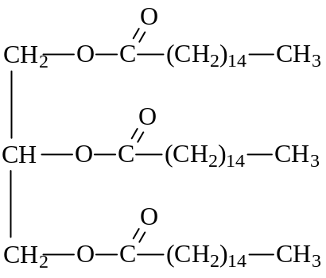

(i) Construct the structural formula of the soap formed from glyceryl tripalmitate. 1

(ii) Identify the special type of mixture which forms when the soap is shaken with
warm water and a small amount of glyceryl tripalmitate.. 1

(iii) Other than glyceryl tripalmitate identify another fat or oil which can be used
to make soap. 1

(iv) Compare the environmental impacts of the use of soaps and non–phosphate
detergents. 2

Question 27 continues next page…
Marks

(b) In his quest for the BHP Science Prize, Ken Chemiski plans to prepare sulfuric acid using
this relatively simple apparatus. Sulfur is burned in a crucible and the gas flow is forced
through the apparatus using a vacuum pump.
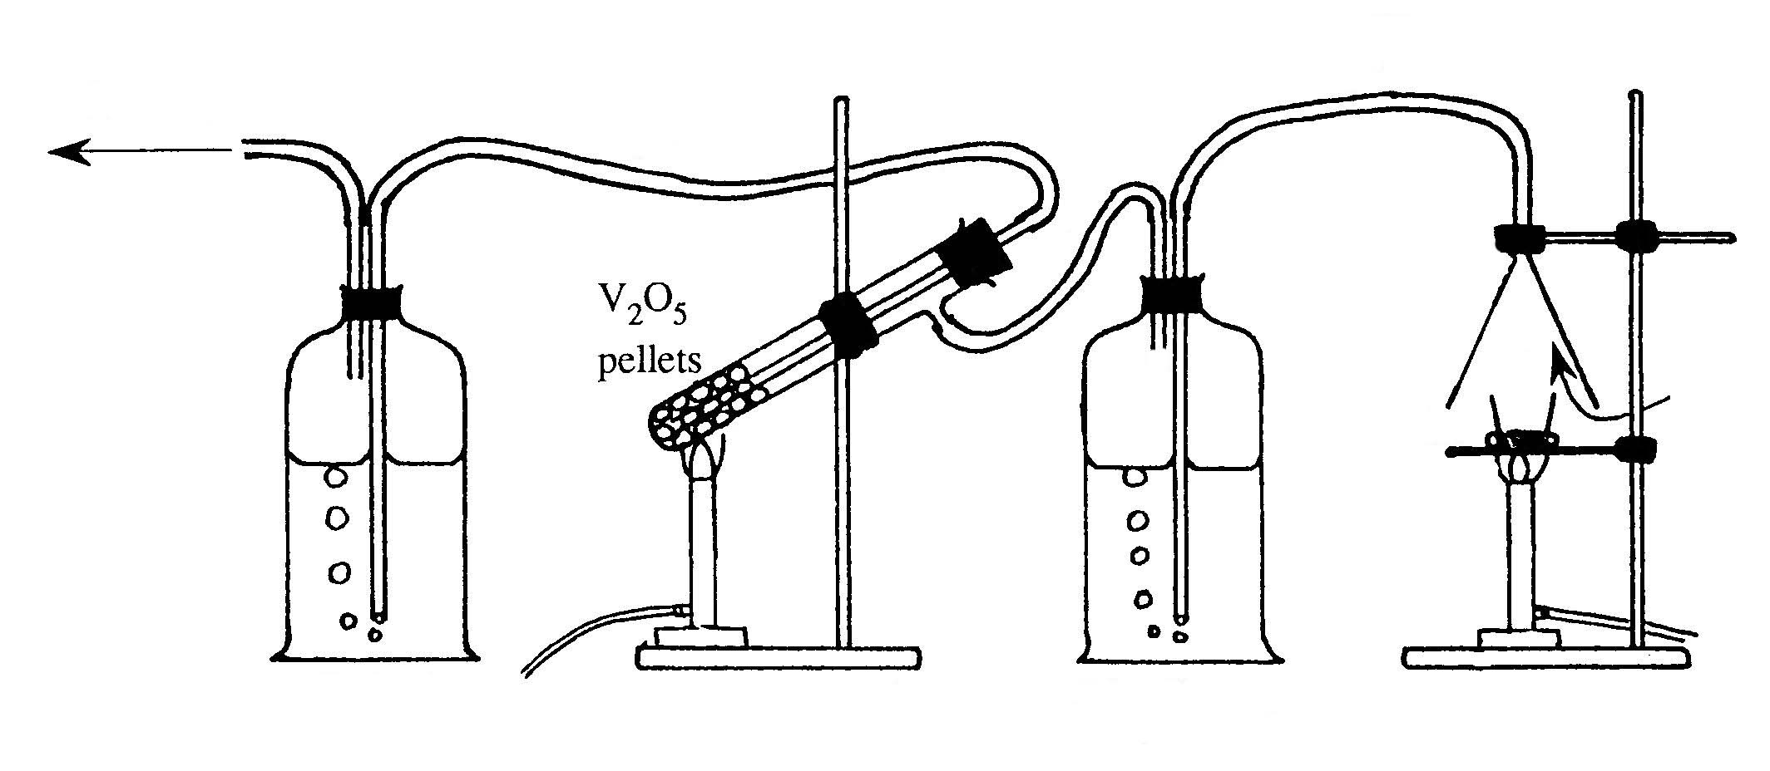
X
Z
concentrated
H₂SO₄
crucible of
burning sulfur
air
Y
to vacuum
pump
Vessels A and Z originally filled with
concentrated H₂SO₄
A
Z

(i) Evaluate the feasibility of Ken’s apparatus to produce sulfuric acid ignoring
safety issues 2

(ii) Compare the gas composition in tube X with tube Y. 2

(iii) Identify the role of the concentrated sulfuric acid in vessel A 1

(iv) Construct a chemical equation for the reaction of gas Y as it bubbles through vessel Z. 1

Question 27 continues next page…
Marks
(c) Chlorine gas can be prepared industrially by this equilibrium reaction…

4HCl _{(g)} + O₂ _{(g)} 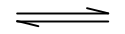 2Cl₂ _{(g)} + 2H₂O _{(g)}

An industrial chemist performs a small scale synthesis of this reaction in a two litre stainless steel
tank and records this data…

 | HCl | O₂ | Cl₂ | H₂O
Initial moles | 0.548 | 0.625 | 0 | 0
Final moles at equilibrium | 0.200 | 0.538 | 0.174 | 0.174

(i) Calculate the equilibrium constant from the data. 3

(ii) Identify how the value of the equilibrium constant could be changed. 1

(iii) Explain, using Le Châtelier’s principle, how a change in volume will affect the
equilibrium. 2

(iv) Calculate the theoretical volume of chlorine produced at 25°C and 100 kPa, if the
reaction went to completion. 2

Question 27 continues next page…
Marks
(d) Kaipara Harbour has a surrounding population of 75,000 with a mixed economy
including dairy farming, market gardens, commercial prawn trawling in the harbour and
offshore tuna fishing.. Three companies have expressed interest in building a sodium
hydroxide production facility at Pouto located in Kaipara Harbour:

HGCL Ltd. has plans for a mercury process plant;
Mem-chlor-tech is proposing a membrane process plant;
and Chlorox Industries has plans for a diaphragm process plant.

Imagine you are an Environmental Chemist for the Kaipara Regional Planning Authority.
- Write an environmental risk assessment comparing all three plant proposals and
- Make recommendations as to which proposal should be approved. 6

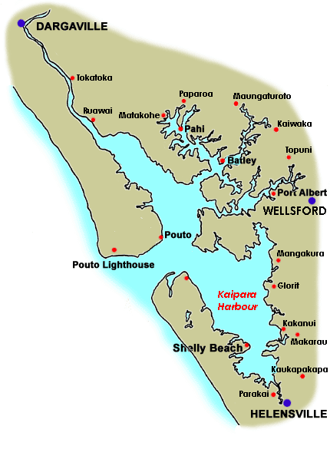
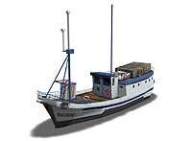
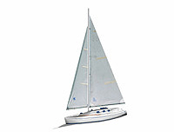

Pacific Ocean
Proposed site of NaOH factory

END of TEST

