

Sydney Girls High School
Student Number

2006

HSC TRIAL ExAMINATION

Chemistry

General Instructions
- Reading time – 5 minutes
- Working time – 3 hours
- Write using blue or black pen
- Board-approved calculators may be used
- A data sheet and Periodic Table are provided at the back of this paper.
- Draw diagrams using pencil
Total marks – 100
Section I
Pages 3–16
75 marks
This section has two parts, Part A and Part B
Part A – 15 marks
- Attempt questions 1–15
- Allow about 30 minutes for this part
Part B – 60 marks
- Attempt questions 16–26
- Allow about 1 hour and 45 minutes for this part
Section II
Page 17
25 marks
- Attempt question 27
- Allow about 45 minutes for this section

Section I
75 marks

Part A – 15 marks

Attempt questions 1 – 15

Allow about 30 minutes for this part

Use the multiple-choice answer sheet.

Select the alternative A, B, C or D that best answers the question. Fill in the response oval completely.

Sample 2 + 4 = (A) 2 (B) 6 (C) 8 (D) 9

A B C D

If you think you have made a mistake, put a cross through the incorrect answer and fill in the new answer.

A B C D

If you change your mind and have crossed out what you consider to be the correct answer, then indicate this by writing the word correct and drawing an arrow as follows:
correct

A B C D
1 Which of the following substances can be cracked as the industrial source of ethylene?

- Cellulose
- Alkanols
- Carbohydrates
- Alkanes

2 Select the correct structure of the monomer used to prepare poly(vinyl chloride).

(B)
(A)

H
C
Cl
C
Cl
H
H
C
H
C
Cl
H
Cl
C
H
C
Cl
H
H
C
H
C
Cl
Cl
(C)
(D)

3 Select the correct value for the oxidation number of sulfur in S₂O₃²⁻

- –2
- +2
- +4
- +6

4. Which of the following would be the most appropriate risk management strategy for the testing of bond saturation in hydrocarbons.

- Ensure you do not touch the equipment in the experiment.
- Pour wastes carefully down the sink so that they do not splash.
- Use chemicals in a fume cupboard if practicable.
- Heat all substances on an electric stove and not with a naked flame.

5 Select the correct alternative statement about the dry cell battery shown below.

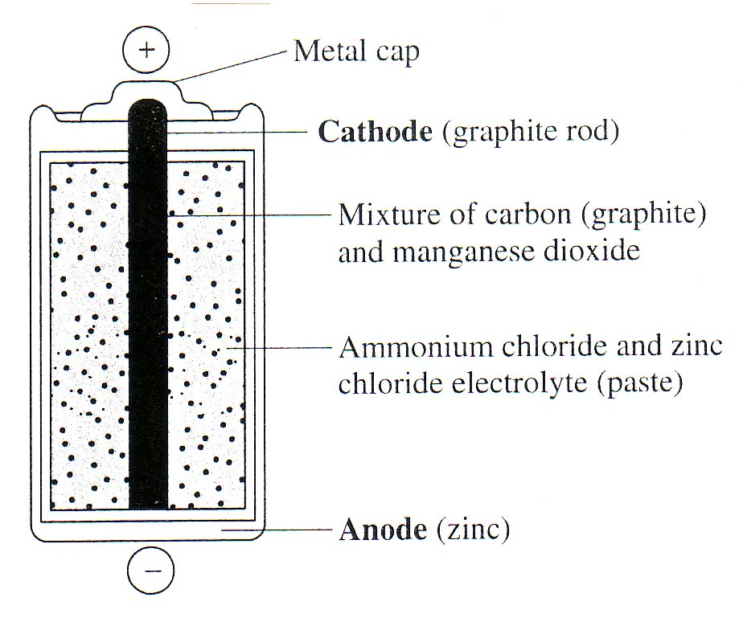

- Oxidation of Mn⁴⁺ occurs on the surface of the graphite rod.
- Graphite acts as a catalyst for the oxidation of the Mn⁴⁺.
- Oxidation of the zinc chloride occurs on the surface of the zinc anode.
- Oxidation of the zinc casing occurs at the anode.

6. Which of the following statements about the aqueous solutions of the oxides of Group 1 elements is valid?

- They are acidic.
- They are basic.
- Their pH is less than 7.
- Their pH is equal to 7.

7 A student tested household cleaning substances with litmus and recorded the following results:

Cleaning solution | Blue litmus | Red litmus
X | blue | red
Y | blue | blue
Z | red | red

Which of the solutions is most likely to contain ammonia?

- X and Y
- X and Z
- Y only
- Z only

8 Which of the following equations shows water behaving as an amphiprotic species?

- H₂O(l) + H⁺(aq) 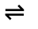 H₃O⁺(aq)
- H₂O(l) + OH⁻(aq) H₃O⁺(aq) + O²⁻(aq)
- 2H₂O(l) 2H⁺(aq) + 2OH⁻(aq)
- 2H₂O(l) H₃O⁺(aq) + OH⁻(aq)

9 Select the most accurate value for the pH of a 0.04 M solution of H₂SO₄.

- 1.1
- 1.4
- 2.5
- 3.2

10 Polluting nitrogen oxides are produced by petrol fuelled cars in the endothermic reaction

N₂(g) + O₂(g) 2NO(g)

Select, from the alternatives provided, the most effective method to minimise this pollution.

- Increase the pressure of the system.
- Decrease the pressure of the system.
- Increase the amount of available oxygen.
- Decrease the temperature of the system.

11 In a particular titration, acid is measured by the pipette and alkali by the burette. Which of the following should be used to rinse the conical flask used in this titration?

- The acid solution
- The alkali solution
- The standard solution
- Distilled water

12 Select the substance which contains a coordinate covalent bond.
N
N
C
O
O
O
H
C
N
(A)
(C)
(B)
(D)

13 The following measurements have been made at different stages in a river as it flows from the mountains, through farms, cleared land and a city, and then to the ocean.

Sample | L | M | N | O
pH | 6.5 | 6.6 | 9.2 | 7.6
DO (ppm) | 5.7 | 8.7 | 6.0 | 2.2
TDS (ppm) | 400 | 50 | 200 | 250
Turbidity (NTU) | 90 | 4 | 30 | 65

Which of the measurements is most likely to be the clean mountain stream?

- L
- M
- N
- O

14 Which of the following procedures would be most useful to identify some unknown anions in a sample of water?

- Flame tests
- AAS
- IR spectroscopy
- Precipitation reactions

15 A simple way of detecting ozone in polluted air is to bubble the air through potassium iodide solution.

O₃(g) + 2H⁺(aq) + 2I⁻(aq) → I₂(aq) + H₂O(l) + O₂(g)

What mass of iodine (in g) would be produced from 0.02g of ozone?

- 0.79
- 1.06
- 1.59
- 3.17

2006 HIGHER SCHOOL CERTIFICATE TRIAL EXAMINATION

Chemistry
Student Number

Section I (continued)

Part B – 60 marks

Attempt Questions 16 – 26
Allow about 1 hour and 45 minutes for this part.
Answer the questions in the spaces provided.
Show all relevant working in questions involving calculations.

Marks

Question 16 (4 marks)

Explain why the chemical properties of alkanes and alkenes are very different. Outline an experiment you performed to demonstrate this difference.
4

…………………………………………………………………………………………

…………………………………………………………………………………………

…………………………………………………………………………………………

…………………………………………………………………………………………

…………………………………………………………………………………………

…………………………………………………………………………………………

…………………………………………………………………………………………

…………………………………………………………………………………………

Question 17 (3 marks)

Using specific examples, compare addition and condensation polymerisation reactions.
3

…………………………………………………………………………………………

…………………………………………………………………………………………

…………………………………………………………………………………………

…………………………………………………………………………………………

…………………………………………………………………………………………

…………………………………………………………………………………………

5
Question 18 (5 marks)

Discuss one recent development in polymer science that alleviates the uncertainty about future sources of raw materials for current polymers.
Refer to one specific polymer and include details of how it can be made.

…………………………………………………………………………………………

…………………………………………………………………………………………

…………………………………………………………………………………………

…………………………………………………………………………………………

…………………………………………………………………………………………

…………………………………………………………………………………………

…………………………………………………………………………………………

…………………………………………………………………………………………

…………………………………………………………………………………………

…………………………………………………………………………………………

…………………………………………………………………………………………

…………………………………………………………………………………………

Question 19 (8 marks)
A galvanic cell operating under standard conditions and using nickel as the cathode, produced an emf of 1.44 volts.
2
  - Identify the element reacting as the anode and justify your choice.

…………………………………………………………………………………………

…………………………………………………………………………………………

…………………………………………………………………………………………

…………………………………………………………………………………………

  - Draw a labelled diagram of this galvanic cell.
3

2
  - Explain what is meant by standard conditions.

…………………………………………………………………………………………

…………………………………………………………………………………………

…………………………………………………………………………………………

…………………………………………………………………………………………

1
  - Identify the oxidising agent in this cell.

…………………………………………………………………………………………

…………………………………………………………………………………………
Question 20 (7 marks)

An environmental officer measured the pH of a lake near a zinc mine and smelter. The zinc sulfide mined was roasted in air to produce crude zinc. The pH of the lake was 5.5.
1
- Write an equation for the release of sulfur dioxide into the environment.

………………………………………………………………………………………………

- What volume of gas (at SLC) would be released per tonne (1000kg) of zinc sulfide refined?
2

………………………………………………………………………………………………

………………………………………………………………………………………………

………………………………………………………………………………………………

………………………………………………………………………………………………
4
- Evaluate reasons for concern about the release of this gas into the environment.

………………………………………………………………………………………………

………………………………………………………………………………………………

………………………………………………………………………………………………

………………………………………………………………………………………………

………………………………………………………………………………………………

………………………………………………………………………………………………

………………………………………………………………………………………………

………………………………………………………………………………………………

Question 21 (8 marks)

A data logger with a pH probe attached was used in the titration of 30mL of dilute propanoic acid with 0.010 mol L⁻¹ sodium hydroxide to determine its concentration.
The following results were obtained.

Volume of NaOH added (mL) | pH | Volume of NaOH added (mL) | pH
0 | 5.0 | 14 | 7.7
2 | 5.5 | 15 | 9.0
4 | 5.9 | 16 | 10.3
6 | 6.1 | 18 | 10.6
8 | 6.3 | 20 | 10.9
10 | 6.4 | 22 | 11.0
12 | 6.7 | 24 | 11.1
13 | 7.0 | 26 | 11.2
.
(a) Draw a graph of pH versus volume of NaOH added on the grid supplied.
3

.

(b) Use the graph to determine the volume of NaOH used to reach the equivalence point
1

…………………………………………………………………………………………
(c) Propanoic acid is monoprotic. Determine the concentration of the acid from the titration results.
2

…………………………………………………………………………………………

…………………………………………………………………………………………

…………………………………………………………………………………………

…………………………………………………………………………………………
2
(d) Is propanoic acid a strong or weak acid? Justify your response using two different pieces of evidence from the data and responses above.

…………………………………………………………………………………………

…………………………………………………………………………………………

…………………………………………………………………………………………

…………………………………………………………………………………………

Question 22 (5 marks)
2
(a) Write an equation for the esterification reaction used to prepare propyl butanoate.

………………………………………………………………………………………………

………………………………………………………………………………………………
2

(b) Describe the effect of using concentrated sulfuric acid on the yield and rate in this process.

………………………………………………………………………………………………

………………………………………………………………………………………………

………………………………………………………………………………………………

………………………………………………………………………………………………
1
(c) Identify one use of esters in processed food.

………………………………………………………………………………………………

………………………………………………………………………………………………

Question 23 (5 marks)

Explain why monitoring of the reaction vessel used in the Haber process is crucial, and describe the monitoring required.

…………………………………………………………………………………………

…………………………………………………………………………………………

…………………………………………………………………………………………

…………………………………………………………………………………………

…………………………………………………………………………………………

…………………………………………………………………………………………

…………………………………………………………………………………………

…………………………………………………………………………………………

…………………………………………………………………………………………

…………………………………………………………………………………………

…………………………………………………………………………………………

Question 24 (4 marks)

Some students measured the sulfate content of lawn fertiliser. The value they obtained was
68.4 % and the value quoted on the packet was 72.7 %.
Explain the chemistry involved in this analysis and one possible cause for the inaccurate result.

…………………………………………………………………………………………

…………………………………………………………………………………………

…………………………………………………………………………………………

…………………………………………………………………………………………

…………………………………………………………………………………………

…………………………………………………………………………………………

…………………………………………………………………………………………

…………………………………………………………………………………………

Question 25 (6 marks)

As the demand for drinking water increases, it has become necessary to monitor levels of contaminants and to develop new technologies for treating impure water sources.

- To measure the concentration of chloride ions in a sample of water, 20.0 mL of this water was titrated with 0.0050 mol L⁻¹ silver nitrate using a suitable indicator such as potassium chromate. The volume of the titre was 8.0 mL.

- Write an ionic equation for the precipitation reaction.
1

……………………………………………………………………………………………...
2
(ii) Calculate the concentration of the chloride ions in ppm (mg L⁻¹).

…………………………………………………………………………………………..….

…………………………………………………………………………………………..….

………………………………………………………………………………………….….

………………………………………………………………………………………….….

3
- Describe the design and composition of microscopic membrane filters and explain how they purify contaminated water.

……………………………………………………………………………………………

……………………………………………………………………………………………

……………………………………………………………………………………………

………………………………………………………………………………………...…

……………………………………………………………………………………………

……………………………………………………………………………………………

Question 26 (5 marks)

(a) Describe, using equations, how the compound 1,1-dichloro-1,1-difluoro methane contributes to ozone depletion.
3

…………………………………………………………………………………………

…………………………………………………………………………………………

…………………………………………………………………………………………

…………………………………………………………………………………………

…………………………………………………………………………………………

…………………………………………………………………………………………
2
(b) During your study of ozone depletion you gathered secondary information to evaluate the effectiveness of alternative chemicals to replace CFC’s.
Describe how you processed and analysed the gathered information.
State how you assessed the reliability of the data obtained.

…………………………………………………………………………………………

…………………………………………………………………………………………

…………………………………………………………………………………………

…………………………………………………………………………………………

…………………………………………………………………………………………

…………………………………………………………………………………………

2006 HIGHER SCHOOL CERTIFICATE TRIAL EXAMINATION

Chemistry

Section II
25 marks

Attempt Question 27
Allow about 45 minutes for this part.
Answer the question in a writing booklet. Extra writing booklets are available.
Show all relevant working in questions involving calculations.

Marks

(a) To predict the extent of corrosion in wrecks, you performed first hand investigations on the effect of temperature and oxygen concentration on the rate of corrosion.
3
- Describe the use of controls in your experiment and outline the results you obtained.
- Evaluate the use of these results in predicting the amount of corrosion occurring on the Titanic.
4

(b)
Brass wire anode
Brass spoon (cathode)
Molten KOH
Voltaic Pile
Early battery
Davy was the first scientist to electrolyse molten potassium hydroxide.
1
- Write the half reaction that occurs at the cathode.
1
- What is the minimum voltage that must be supplied by the Voltaic Pile for this electrolysis to occur.
2
- Analyse the contribution made by Davy to understanding of electron transfer reactions.

(c) Corrosion of iron in a marine environment is a huge problem for many ships.
3
(i) Explain, using appropriate equations, the process of rusting in a marine environment.

(ii) Compare two different types of cathodic protection, used in the marine environment, in terms of the oxidation/reduction chemistry involved.
4

(d) Discuss conservation and restoration of marine artefacts and compare the techniques applied to two Australian maritime archaeological projects.
7

BLANK PAGE

