AN END-TO-END DATA SCIENCE PIPELINE
FOR NSEI VOLATILITY FORECASTING
Ensemble Modeling, Explainable AI, and Interactive Visualization

DATA SCIENCE AND VISUALIZATION

Submitted by
DENNIS ABRAHAM R
Roll No.: 2026165001
National Stock Exchange of India (NSEI)

Abstract
This project presents an end-to-end data science workflow for forecasting the five-day forward volatility of the National Stock Exchange of India (NSEI). Daily historical market data are processed through a leakage-aware time-series pipeline that includes data validation, exploratory analysis and financial feature engineering. The engineered inputs include lagged returns, rolling statistics and technical indicators such as the Relative Strength Index (RSI) and Moving Average Convergence Divergence (MACD).
Three gradient-boosting models—XGBoost, LightGBM and CatBoost—are trained and compared with linear-regression and persistence baselines. Hyperparameters are optimized using Optuna with chronological time-series validation and a five-day gap. SHAP is then applied to examine both global feature importance and individual predictions. Among the evaluated models, CatBoost records the strongest overall results, with an RMSE of 0.002992, an R² of 0.4233 and directional accuracy of 65.6%. The final workflow is presented through an interactive Streamlit dashboard supported by Plotly visualizations, allowing users to explore market patterns, forecasts, model comparisons and SHAP explanations.
The project demonstrates how a carefully structured forecasting pipeline can combine predictive modeling, interpretability and interactive visualization to support the analysis of market volatility. Its results should be understood as decision-support information rather than a guarantee of future market movements.
Keywords: NSEI; stock market volatility; five-day forward forecasting; ensemble learning; XGBoost; LightGBM; CatBoost; feature engineering; time-series validation; SHAP; explainable AI; Streamlit; interactive visualization.

1. Introduction

1.1 General Introduction
Financial markets are dynamic systems in which prices respond to economic developments, market expectations, investor behaviour and unexpected events. These influences can cause volatility to vary substantially over time. Understanding and anticipating changes in volatility is important for risk assessment, portfolio management and the evaluation of financial strategies.
Conventional econometric approaches provide useful tools for modeling financial time series, but their assumptions may limit their ability to represent complex nonlinear relationships. Machine-learning methods, particularly gradient-boosting algorithms, offer an alternative by learning interactions among engineered features. However, predictive performance alone is not sufficient: a useful forecasting system should also employ a valid time-series evaluation procedure and provide interpretable explanations.
This project therefore combines financial data preparation, feature engineering, ensemble learning, explainable AI and interactive visualization in a single workflow. The system focuses on five-day forward volatility in the NSEI and presents the results through a dashboard intended to make the analysis accessible.

1.2 Problem Statement
Forecasting forward volatility is challenging because financial observations are time-dependent, market behaviour can change abruptly, and the relationship between current indicators and future volatility is not necessarily linear. A model may appear highly accurate if information from the prediction period inadvertently enters the training features or validation process. Such leakage can produce performance estimates that do not reflect genuine out-of-sample forecasting ability.
The referenced XGBoost study reports an R² value of 0.98. The available project material does not establish whether that result is caused by target leakage; nevertheless, the unusually high value motivates careful attention to chronological splitting and separation between the feature window and the forward-looking target. The project addresses this methodological concern by developing a leakage-aware pipeline, comparing multiple boosting algorithms with baseline models, and explaining model behaviour using SHAP. The resulting analysis is also made accessible through an interactive dashboard.

1.3 Scope of Study
The study is limited to daily historical OHLCV data for the NSEI covering the period from 2020 to 2026, as specified in the project dataset description. The prediction target is five-day forward volatility, defined using the rolling standard deviation of log returns over the next five trading observations. The work includes data cleaning, exploratory data analysis, feature engineering, chronological model evaluation, hyperparameter tuning, model comparison, SHAP-based interpretation and dashboard development.
The modeling comparison includes XGBoost, LightGBM and CatBoost, together with linear-regression and persistence baselines. The dashboard uses Streamlit and Plotly to present selected data visualizations, forecasts, performance measures and explainability outputs. Intraday trading, high-frequency forecasting, automated trade execution and macroeconomic forecasting are outside the scope of this study.

2. Literature Survey
The following studies were reviewed to understand existing approaches to stock-market and volatility forecasting. Each entry presents the paper title, authors, publication venue and year, followed by a concise explanation of its approach and relevance to the present project.
TITLE: Forecasting Stock Market Volatility Using XGBoost: A Time Series Analysis
AUTHOR: Tripti Sharma, Indu Verma, Sanjeev Kumar Prasad, Anupama Sharma, and Shreeya Prasad
PUBLISHER: 2024 International Conference on Communication, Control, and Intelligent Systems (CCIS), IEEE YEAR: 2024.
CONTENT: The study applies XGBoost to NSEI/Nifty 50 time-series data using lagged returns and rolling statistical features to forecast stock-market volatility. It provides a single-model reference for the present project. The current work extends this direction by comparing XGBoost with LightGBM and CatBoost, incorporating additional technical indicators such as RSI and MACD, applying SHAP for model interpretation, and presenting the results through a Streamlit dashboard.
TITLE: Forecasting Method of Stock Market Volatility in Time Series Data Based on Mixed Model of ARIMA and XGBoost
AUTHOR: Wang Y. and Guo Y.
PUBLISHER: China Communications, Volume 17, Issue 3, pages 205–221 YEAR: 2020.
CONTENT: This paper combines ARIMA and XGBoost to model linear temporal structure and nonlinear patterns within financial time-series data. The hybrid approach demonstrates the potential of combining econometric and machine-learning methods, although it introduces multiple modeling components. The present project instead evaluates standalone gradient-boosting models within a common feature-engineering and time-series validation workflow, and adds SHAP-based explanations.
TITLE: Enhancing Stock Market Prediction with LSTM: A Review of Recent Developments and Comparative Analysis
AUTHOR: Melika Shafiei Hafshejani and Najme Mansouri
PUBLISHER: Archives of Computational Methods in Engineering, Volume 33, pages 6177–6274 YEAR: 2026.
CONTENT: This review discusses LSTM-based methods for stock-market prediction and their ability to represent temporal dependencies in sequential financial data. The present project follows a different modeling route by using tree-based gradient-boosting algorithms with lagged and rolling financial features. SHAP is included to provide global and local explanations of the model's predictions.
TITLE: Advances in Forecasting Realized Volatility: A Review of Machine Learning and Econometric Models
AUTHOR: Radmir Mishelevich Leushuis and Nicolai Petkov
PUBLISHER: Financial Innovation, Volume 12, Article 14 YEAR: 2026.
CONTENT: This review surveys machine-learning and econometric approaches to realized-volatility forecasting. It provides a broader context for comparing predictive methods in financial applications. The present project narrows the application to the NSEI and implements an end-to-end workflow connecting data preparation, model evaluation, explainability and dashboard-based visualization.
TITLE: Examining Challenges in Implied Volatility Forecasting: A Machine Learning Perspective
AUTHOR: Argimiro Arratia, Mahmoud El Daou, Jan Kagerhuber, and Yulia Smolyarova
PUBLISHER: Computational Economics, Volume 68, pages 3323–3345 YEAR: 2026.
CONTENT: The paper examines machine-learning methods for implied-volatility forecasting and discusses methodological challenges including data leakage and overfitting. These concerns are important in time-series prediction, where inappropriate data splitting can allow future information to influence model development. The present project uses chronological partitioning and a five-day gap for the forward-looking target, together with time-series validation during hyperparameter tuning.
TITLE: Machine-Learning Stock Market Volatility: Predictability, Drivers, and Economic Value
AUTHOR: Juan Díaz, Erwin Hansen, and Gabriel Cabrera
PUBLISHER: International Review of Financial Analysis, Volume 94, Article 103286 YEAR: 2024.
CONTENT: This study examines the predictability of stock-market volatility using several machine-learning approaches and considers the role of forecasting horizon. Its focus on predictive drivers and economic value is relevant to the design of financial forecasting systems. The present project focuses on a five-day forward-volatility target for the NSEI and complements model comparison with SHAP explanations and an interactive dashboard.
TITLE: An Interpretable Machine Learning Framework for Predicting Next Day Firm Level Market Stress in the Dhaka Stock Exchange
AUTHOR: Md Sadman Haque, Mohammad Sameer Ahmed, Md Tasfikur Rahman, Robiul Awoul Robin, Zannatul Zahan Meem, and Jannatun Noor
PUBLISHER: Discover Artificial Intelligence, Volume 6, Article 1066 YEAR: 2026.
CONTENT: This study evaluates statistical and machine-learning methods using expanding-window walk-forward validation with embargo periods. Its emphasis on temporal validation and interpretable modeling is relevant to the present work. The current project adopts a focused chronological workflow, compares three gradient-boosting models, and integrates the selected model with a Streamlit dashboard so that forecasts and explanations can be explored interactively.

3. Objectives
- To derive informative financial features, including lagged returns, rolling volatility statistics, RSI and MACD, from raw OHLCV observations.
- To construct a chronological training and testing procedure for the forward-looking target, incorporating a five-day separation gap to reduce the risk of temporal leakage.
- To train, tune and compare XGBoost, LightGBM and CatBoost against linear-regression and persistence baselines.
- To apply SHAP values to examine global feature importance and the contribution of input features to individual predictions.
- To develop an interactive Streamlit dashboard using Plotly for data exploration, forecast inspection, model comparison and explainability.

4. Methodology
The methodology follows a sequential data-science workflow. Daily market observations are ingested and validated, transformed into model-ready features, divided chronologically, used to train and evaluate candidate models, and finally presented through visual analytics and an interactive dashboard.

4.1 Block Diagram
The block diagram summarizes the main stages of the project, from data acquisition and preprocessing through exploratory analysis, feature engineering, model training, prediction, evaluation, visualization, dashboard interaction and interpretation.
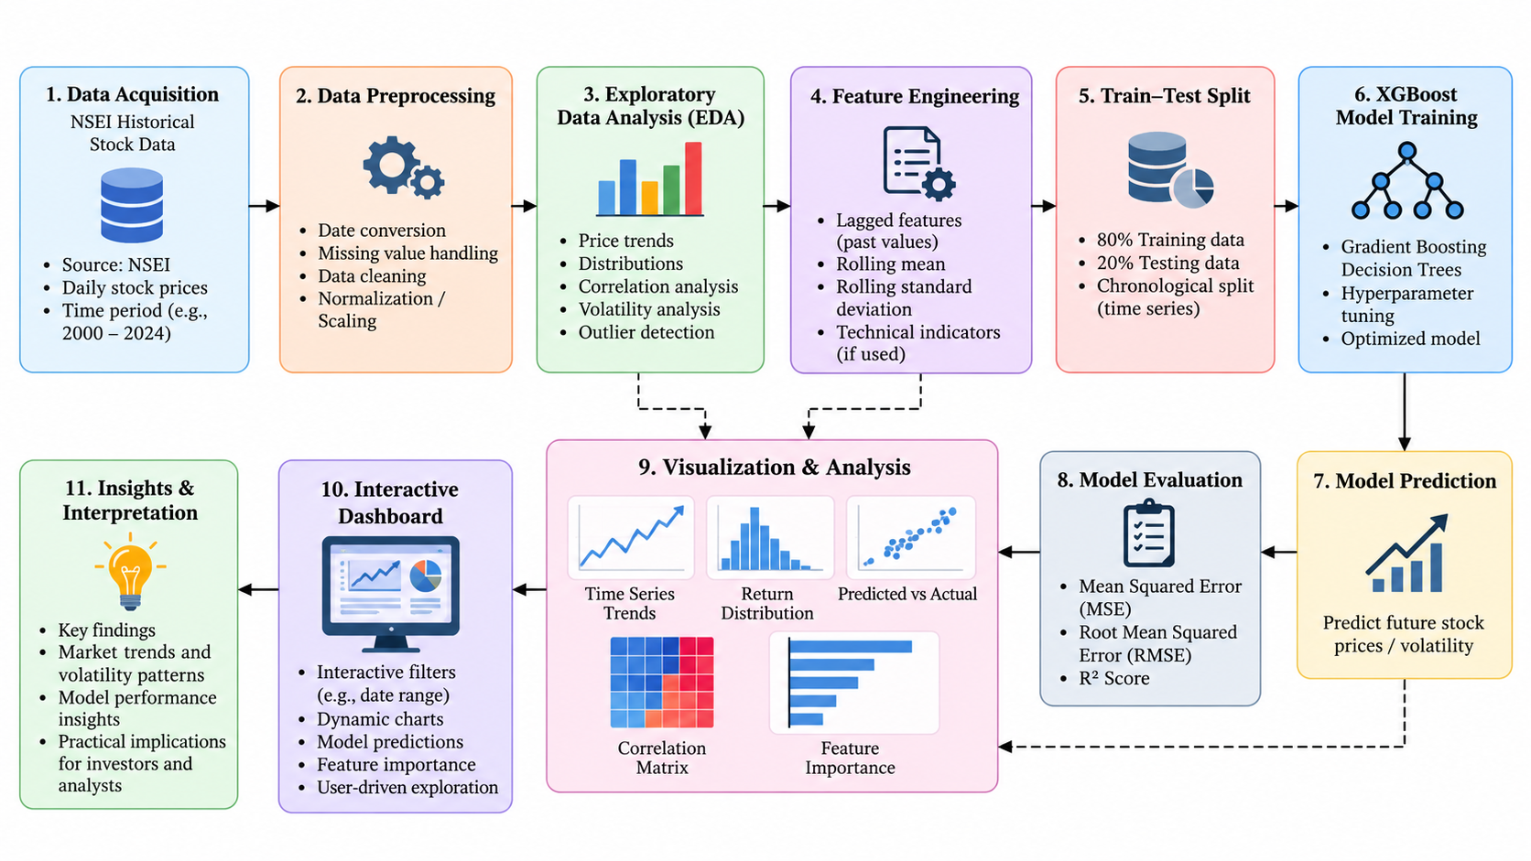
Figure 1. Block diagram of the proposed NSEI volatility forecasting workflow.

4.2 System Architecture
The system architecture describes the implementation layers and the flow of information between them. The data layer reads the NSEI CSV file into a Pandas DataFrame. The processing layer performs cleaning, feature engineering and chronological splitting. The modeling layer uses Optuna to tune XGBoost, LightGBM and CatBoost. The evaluation layer calculates performance metrics and generates SHAP explanations. The presentation layer combines processed data, predictions, metrics and explanation outputs in a Streamlit dashboard.
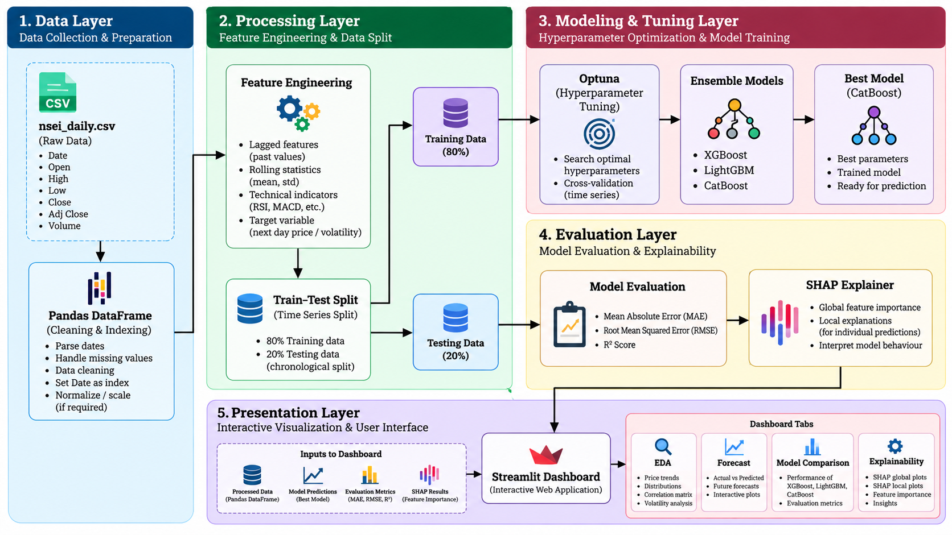
Figure 2. Layered system architecture showing data, processing, modeling, evaluation and presentation components.

4.3 System Requirements
Category | Requirement
Hardware | Standard personal computer; the draft specifies a minimum of 8 GB RAM.
Programming environment | Python 3.12.
Data handling and analysis | Pandas, NumPy and scikit-learn.
Machine learning and optimization | XGBoost, LightGBM, CatBoost and Optuna.
Explainability | SHAP.
Visualization and deployment | Streamlit and Plotly.
Input data | Daily NSEI OHLCV dataset covering 2020–2026, as described in the draft.

4.4 Module Description

4.4.1 Data Pipeline Module
Files: src/data_cleaning.py and src/feature_engineering.py.
The data pipeline prepares the raw daily market observations for analysis and model development. It ingests the CSV file, converts and validates date fields, checks the consistency of OHLC values, handles missing observations and removes duplicate records. The date column is used to establish the time index.
- Data validation: checks logical relationships among Open, High, Low and Close values, including the requirement that the daily high should not be below the daily low.
- Missing-data handling: uses forward filling where appropriate to maintain continuity in the daily series.
- Feature construction: derives log returns, lagged returns, rolling means and standard deviations, and technical indicators including RSI, MACD and ATR.
- Target generation: constructs the five-day forward volatility target from the standard deviation of subsequent log returns.
The use of lagged and rolling features allows the models to use information available up to the forecast origin. Care is required to ensure that future observations used to calculate the target do not enter the predictors.

4.4.2 Exploratory Data Analysis Module
File: 02_eda.ipynb.
The exploratory data analysis module examines the statistical and visual characteristics of the NSEI series before model fitting. It is used to identify trends, unusual observations, distributional properties and evidence of volatility clustering.
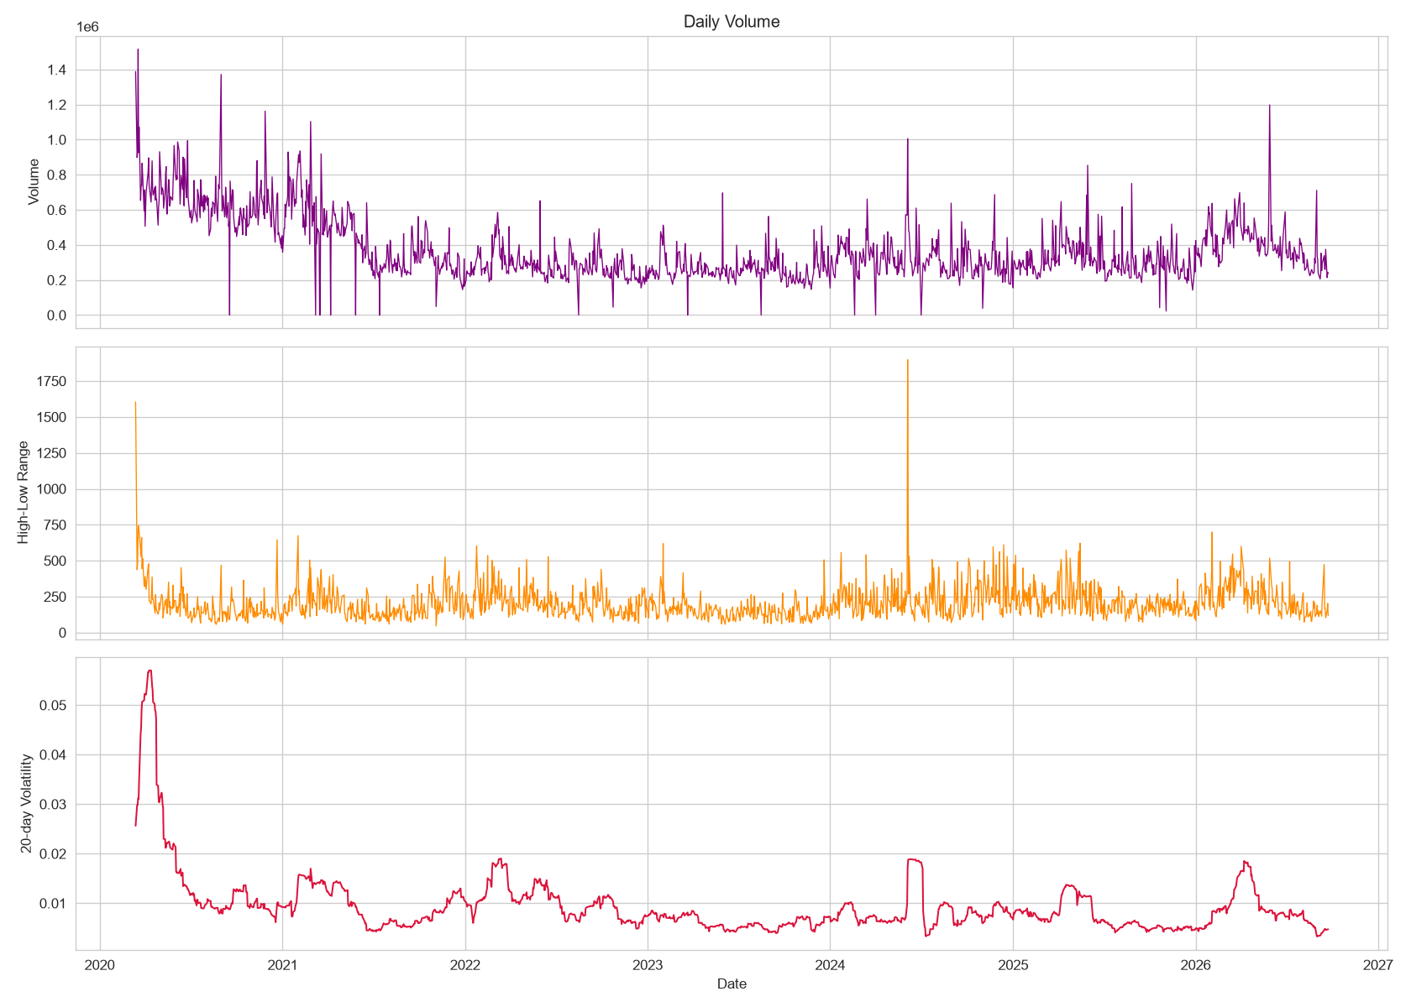
Figure 3. Time-series and distributional visualizations used during exploratory data analysis.
- Time-series plots: examine closing-price behaviour and moving-average trends over the observation period.
- Histograms and boxplots: inspect the distribution of daily log returns and identify heavy tails and outliers.
- Autocorrelation analysis: compare the autocorrelation of raw returns with that of squared returns to investigate volatility clustering.
- Correlation heatmaps: examine relationships among engineered features and the forward-volatility target.

4.4.3 Modeling and Evaluation Module
Files: src/models.py and src/evaluation.py.
This module defines the candidate models, performs hyperparameter optimization and evaluates the resulting forecasts. XGBoost, LightGBM and CatBoost are trained as gradient-boosting candidates. Linear regression and persistence are included as reference baselines.
- Hyperparameter optimization: Optuna searches candidate parameter configurations using five-fold TimeSeriesSplit validation with a five-day gap.
- Chronological evaluation: the dataset is divided into an 80% training segment and a 20% testing segment without shuffling.
- Model assessment: MAE, RMSE, R² and directional accuracy are calculated on the held-out test period.

4.4.4 Explainability Module
File: src/explainability.py.
The explainability module uses SHAP TreeExplainer to interpret the predictions of the selected tree-based model. Global explanations summarize the contribution patterns of features across observations, while local explanations show how individual feature values contribute to a particular prediction.
- Global explanation: a SHAP Beeswarm plot ranks features and displays the direction and distribution of their contributions.
- Local explanation: a SHAP Waterfall plot decomposes an individual prediction into feature-level contributions relative to the model's expected output.

4.4.5 Interactive Dashboard Module
File: app/dashboard.py.
The dashboard is implemented with Streamlit and Plotly. It provides a user-facing interface for exploring the dataset and inspecting model outputs without requiring users to interact directly with the training code.
- EDA Highlights: presents selected market trends, distributions and exploratory visualizations.
- Forecast Viewer: displays actual and predicted volatility over a selected date range.
- Model Comparison: presents evaluation metrics for the candidate models and baselines.
- SHAP Explainability: provides global feature-importance views and local explanations for selected dates.

5. Performance Metrics
The models are evaluated using complementary metrics so that forecast error, explained variation and the ability to identify the direction of volatility changes can be considered together.
Metric | Meaning and interpretation
Mean Absolute Error (MAE) | The average absolute difference between predicted and observed volatility. It is expressed in the same units as the target and is straightforward to interpret.
Root Mean Squared Error (RMSE) | The square root of the average squared prediction error. Squaring gives larger errors greater influence, making RMSE more sensitive to substantial misses.
Coefficient of Determination (R²) | Measures the proportion of variation in the target explained by the model relative to a mean-prediction reference. Its interpretation depends on the test data and evaluation design.
Directional Accuracy | Measures the proportion of evaluated observations for which the model correctly identifies whether predicted volatility rises or falls relative to the current trailing-volatility reference.

6. Results and Discussion

6.1 Model Comparison
The candidate models were evaluated on a held-out chronological test segment. The comparison below reproduces the numerical results supplied in the project draft.
Model | MAE | RMSE | R² | Directional Accuracy
CatBoost | 0.002334 | 0.002992 | 0.4233 | 65.6%
XGBoost | 0.002358 | 0.002993 | 0.4230 | 64.7%
LightGBM | 0.002443 | 0.003042 | 0.4038 | 64.7%
Linear Regression | 0.002326 | 0.003058 | 0.3975 | 65.3%
Persistence | 0.002592 | 0.003537 | 0.1940 | 0.0%

CatBoost produced the highest R² and the lowest RMSE among the evaluated models, with XGBoost performing very closely. Linear regression recorded the lowest MAE, indicating a slightly smaller average absolute error, but its RMSE and R² were weaker than CatBoost's. This distinction shows why model selection should not rely on a single metric. The persistence baseline recorded the weakest overall results in this comparison.

6.2 Comparison with the Base Paper
The referenced base paper reports an R² value of 0.98 for its XGBoost model, whereas the present project obtains an out-of-sample R² of 0.4233 for CatBoost and 0.4230 for XGBoost. These values should not be compared as if they were produced under identical datasets, targets, splits and evaluation procedures. The difference highlights the importance of examining the experimental design behind a reported score.
The project uses chronological separation and a five-day gap because the target is forward-looking. These safeguards are intended to reduce the possibility that information from the target period influences model fitting or validation. The available material does not independently prove that the base paper's higher score resulted from leakage; therefore, target leakage is treated here as a possible methodological concern rather than an established explanation.

6.3 SHAP Explainability: Global Insights
The global SHAP Beeswarm plot ranks the engineered features by their contribution to the CatBoost model's predictions. The plot in the supplied draft places rolling-volatility measures, including Vol_rolling_20 and Vol_rolling_10, among the most influential features. It also shows contributions from ATR, returns, Vol_rolling_5 and other technical and lagged variables.
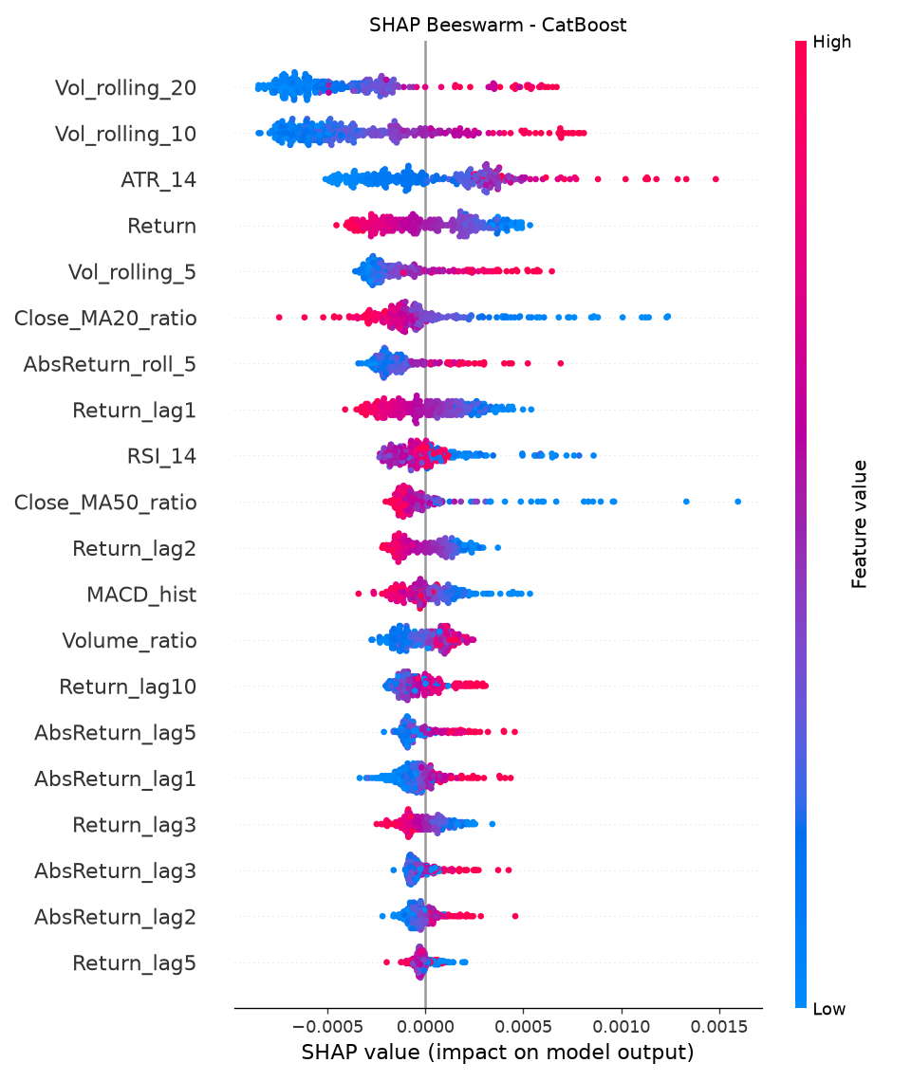
Figure 5. Global SHAP Beeswarm plot for the CatBoost model.
The distribution of SHAP values indicates that feature values can push predictions in either direction. In particular, higher values of selected rolling-volatility features are associated with positive contributions for a portion of observations. This pattern is consistent with the idea of volatility clustering, in which periods of elevated market variability tend to be followed by further elevated variability. SHAP indicates how the fitted model uses these features; it does not by itself establish a causal relationship.

6.4 SHAP Explainability: Local Insights
The local SHAP Waterfall plot explains an individual prediction by showing how feature contributions move the model output away from its expected value. The draft describes a high-volatility example in which recent return shocks and rolling-volatility measures contribute to the forecast. The plot should be interpreted for the specific date and prediction shown, rather than generalized to every market-stress observation.
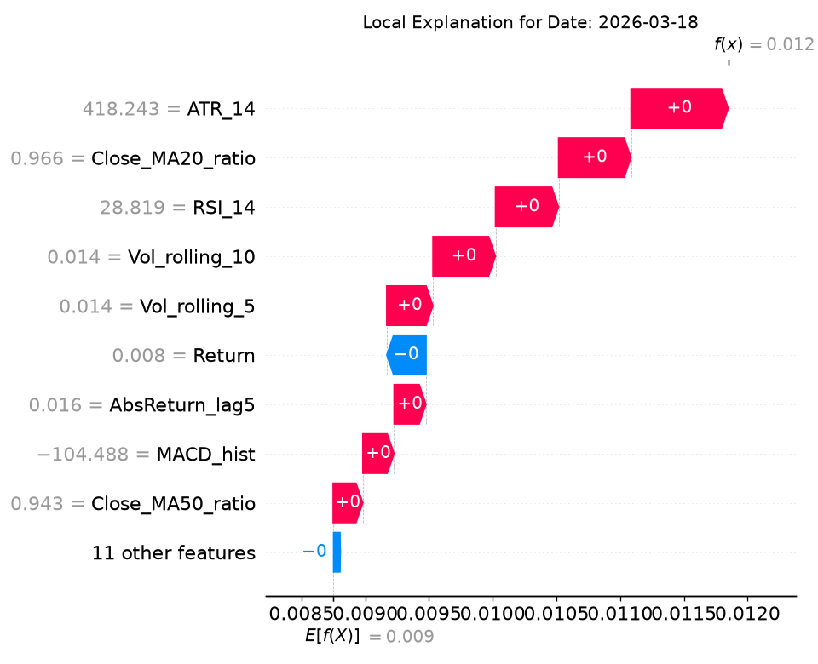
Figure 6. Local SHAP Waterfall explanation for the selected observation.

6.5 EDA and Data Visualization Highlights
The exploratory plots show that volatility varies over time rather than remaining constant. The squared-return autocorrelation plot displays positive autocorrelation across several lags, supporting the presence of volatility clustering in the sample. The distributional plots and time-series views provide context for the feature-engineering choices and for the use of rolling volatility measures in the forecasting pipeline.
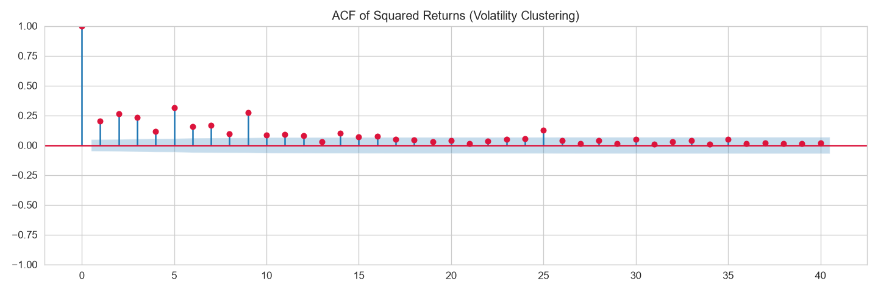
Figure 7. Autocorrelation of squared returns, used to examine volatility clustering.

6.6 Interactive Dashboard Deployment
The project findings are presented through a Streamlit dashboard built with Plotly. The forecast interface allows users to inspect actual and predicted volatility over a selected date range. The explainability interface presents global feature importance and local SHAP explanations. The dashboard also includes views for EDA highlights and model comparison, converting static analysis outputs into an interactive application.
The supplied draft indicates that users can select date ranges, inspect chart values through hover interactions and examine local explanations for selected observations. The dashboard therefore serves as the presentation layer for the data pipeline, model outputs and interpretability results.
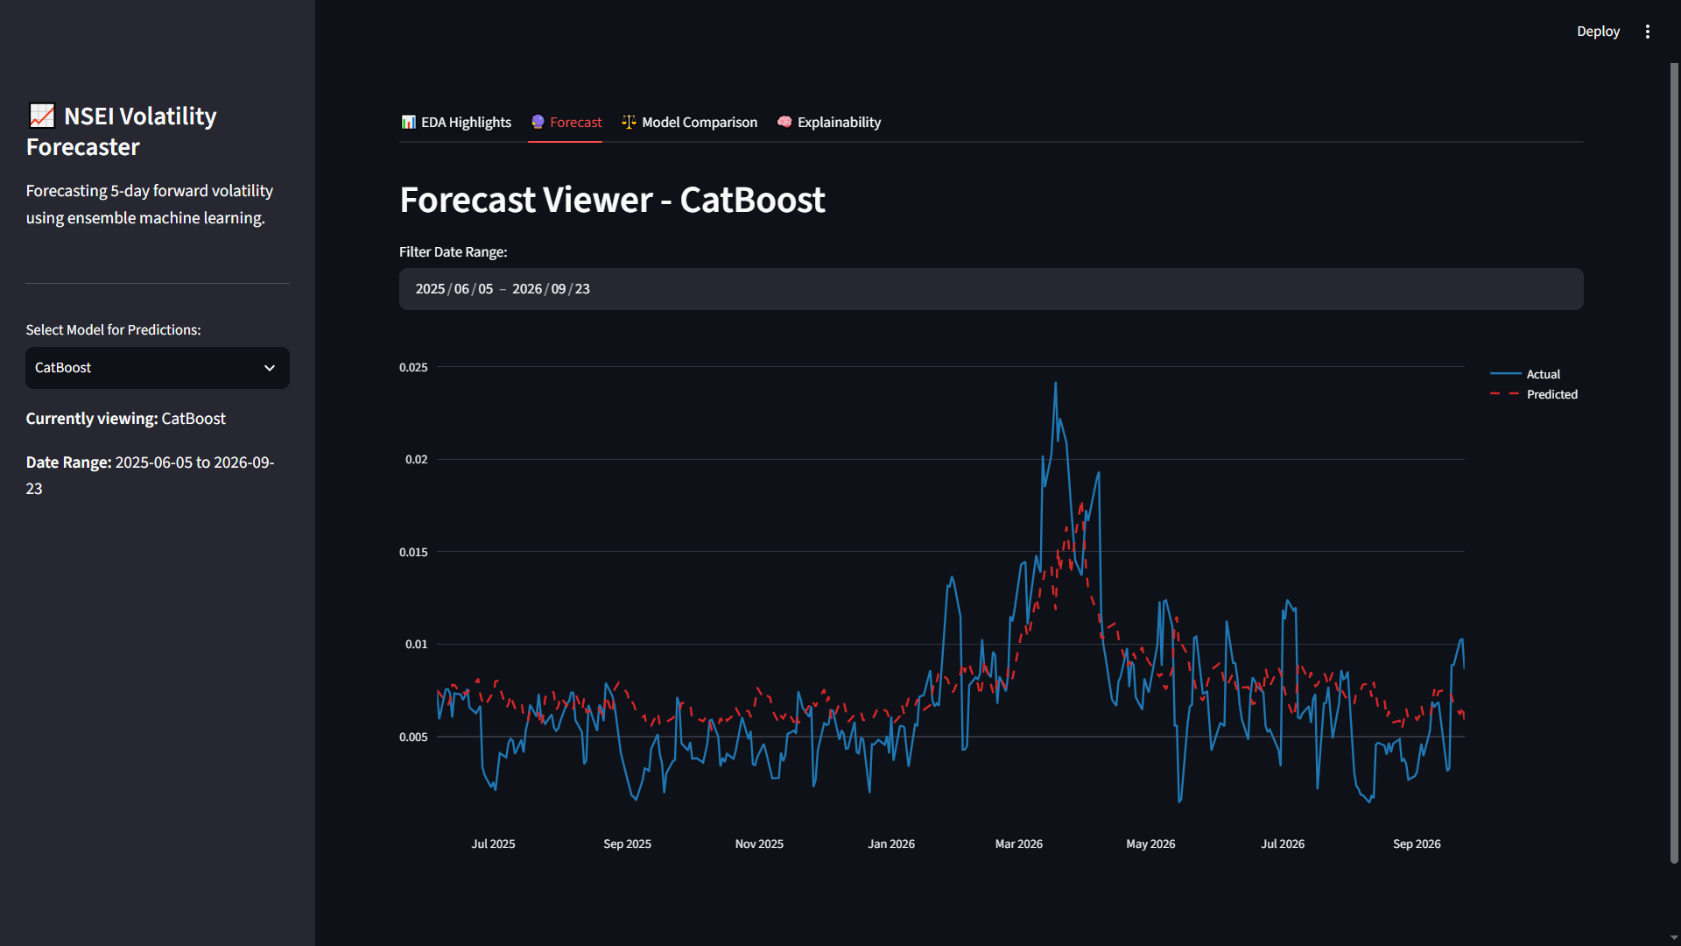
Figure 8. Streamlit forecast viewer showing actual and predicted volatility.
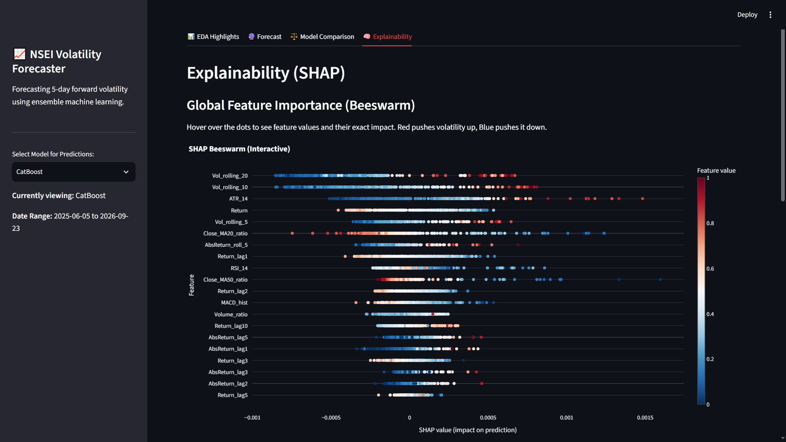
Figure 9. Dashboard view of global SHAP feature importance.
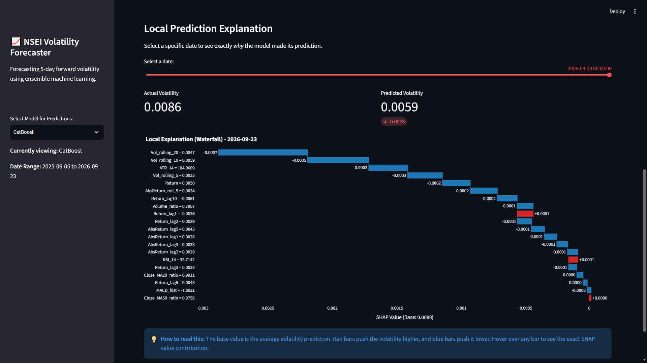
Figure 10. Dashboard view of a local SHAP prediction explanation.

7. Conclusion
This project developed an end-to-end data science workflow for forecasting five-day forward volatility in the NSEI. The workflow combines daily market-data preparation, exploratory analysis, financial feature engineering, chronological model evaluation, ensemble learning, SHAP explainability and interactive visualization. XGBoost, LightGBM and CatBoost were compared with linear-regression and persistence baselines under a time-series evaluation design.
CatBoost achieved the strongest overall result in the reported comparison, with an RMSE of 0.002992, an R² of 0.4233 and directional accuracy of 65.6%. Linear regression recorded a marginally lower MAE, demonstrating that model performance depends on the metric considered. The SHAP analysis provided global and local views of the model's use of rolling-volatility, return and technical-indicator features. The Streamlit dashboard brought these outputs together in an interactive interface.
Financial volatility remains difficult to forecast, particularly during abrupt market changes and rare events. The results should therefore be treated as analytical support rather than certainty about future market behaviour. Within this limitation, the project demonstrates the value of combining leakage-aware time-series modeling with explainability and visualization in a practical forecasting workflow.

8. References
- T. Sharma, I. Verma, S. K. Prasad, A. Sharma, and S. Prasad, “Forecasting Stock Market Volatility Using XGBoost: A Time Series Analysis,” in 2024 International Conference on Communication, Control, and Intelligent Systems (CCIS), IEEE, 2024. doi: 10.1109/CCIS63231.2024.10932089.
- Y. Wang and Y. Guo, “Forecasting Method of Stock Market Volatility in Time Series Data Based on Mixed Model of ARIMA and XGBoost,” China Communications, vol. 17, no. 3, pp. 205–221, 2020. doi: 10.23919/JCC.2020.03.017.
- M. S. Hafshejani and N. Mansouri, “Enhancing Stock Market Prediction with LSTM: A Review of Recent Developments and Comparative Analysis,” Archives of Computational Methods in Engineering, vol. 33, pp. 6177–6274, 2026. doi: 10.1007/s11831-025-10370-0.
- R. M. Leushuis and N. Petkov, “Advances in Forecasting Realized Volatility: A Review of Methodologies,” Financial Innovation, vol. 12, article 14, 2026. doi: 10.1186/s40854-025-00809-5.
- A. Arratia, M. El Daou, J. Kagerhuber, and Y. Smolyarova, “Examining Challenges in Implied Volatility Forecasting: A Critical Review of Data Leakage and Feature Engineering Combined with High-Complexity Models,” Computational Economics, vol. 68, pp. 3323–3345, 2026. doi: 10.1007/s10614-025-11172-z.
- J. D. Díaz, E. Hansen, and G. Cabrera, “Machine-Learning Stock Market Volatility: Predictability, Drivers, and Economic Value,” International Review of Financial Analysis, vol. 94, article 103286, 2024. doi: 10.1016/j.irfa.2024.103286.
- M. S. Haque, M. S. Ahmed, M. T. Rahman, R. A. Robin, Z. Z. Meem, and J. Noor, “An Interpretable Machine Learning Framework for Predicting Next Day Firm Level Market Stress in the Dhaka Stock Exchange,” Discover Artificial Intelligence, vol. 6, article 1066, 2026. doi: 10.1007/s44163-026-02065-7.
- M. Nguyen, M. H. Nguyen, H. H. Nguyen, V. D. Do, and H. Le, “Volatility-Clustering Adaptation for Financial Time Series,” arXiv preprint arXiv:2609.37715, 2026.
- Y. C. Tjen and H. F. Zuhri, “Impact of Volatility and Feature Engineering on the Forecasting Performance of LSTM and XGBoost Models: Evidence from Indonesian Banking Stocks,” Ingénierie des Systèmes d’Information, vol. 31, no. 5, pp. 1389–1402, 2026. doi: 10.18280/isi.310502.
- R. Sabharwal, S. J. Miah, S. F. Wamba, and P. Cook, “Extending Application of Explainable Artificial Intelligence for Managers in Financial Organizations,” Annals of Operations Research, published online, 2024. doi: 10.1007/s10479-024-05825-9.
- S. Kumar, M. Vishal, and V. Ravi, “Explainable Reinforcement Learning on Financial Stock Trading Using SHAP,” arXiv preprint arXiv:2208.08790, 2022.
- L. Dowson, X. Song, and X. Li, “Explainable AI for Stock Price Prediction: A Comparative Study of Deep Learning and Feature Attribution Methods,” in Proceedings of the 2025 11th International Conference on Communication and Information Processing (ICCIP ’25), ACM, pp. 488–494, 2026. doi: 10.1145/3784833.3784870.

