An End-to-End Data Science Pipeline for NSEI Volatility Forecasting: Ensemble Modeling, Explainable AI, and Interactive Visualization
Abstract
This project develops an end-to-end Data Science pipeline to forecast the 5-day forward volatility of the National Stock Exchange of India (NSEI). Emphasizing the complete data lifecycle, we engineered domain-specific features (RSI, MACD, rolling statistics) within a leakage-free time-series framework. We evaluated CatBoost, XGBoost, and LightGBM against linear and persistence baselines. To address the "black-box" nature of complex AI, we utilized Explainable AI (SHAP) to generate visual interpretations of model predictions. The CatBoost model achieved the best performance (RMSE: 0.00299, R²: 0.4233, Directional Accuracy: 65.6%). Finally, we deployed an interactive Streamlit dashboard using Plotly, enabling users to explore data trends, compare model metrics, and visualize SHAP explanations dynamically in real-time.
1. Introduction
1.1 General Introduction
The stock market is characterized by high volatility, heavily influenced by economic conditions and investor sentiment. For traders and policymakers, anticipating these fluctuations is critical for risk management, strategic planning, and investment decisions. However, traditional econometric models (like ARIMA) fail to capture the non-linear and non-stationary nature of modern financial data. This project leverages Data Science and Visualization techniques to bridge this gap. By combining advanced machine learning with an interactive visualization layer, we not only predict volatility but also visually explain the underlying data patterns and model reasoning to the end-user.
1.2 Problem Statement
Traditional models assume linear relationships and fail to capture sudden market regime shifts. Furthermore, while modern machine learning models like XGBoost can capture non-linearity, they lack interpretability. The base paper we referenced reported an unrealistic R2R2 of 0.98 (likely due to target leakage) and provided no visual explanation of why the model made its predictions. The problem is to build a robust, leakage-free data pipeline that accurately forecasts forward-looking volatility, and to visually interpret these predictions using Explainable AI (SHAP) and an interactive data visualization dashboard.
1.3 Scope of Study
The scope of this study is strictly limited to the daily historical data of the NSEI index (spanning 2020 to 2026). The target variable is defined as the 5-day forward volatility. The study covers data preprocessing, exploratory visual analytics, feature engineering, ensemble machine learning (CatBoost, XGBoost, LightGBM), SHAP explainability, and the deployment of an interactive web dashboard. It does not cover intraday trading, high-frequency trading, or macroeconomic forecasting.
2. Literature Survey
Based on the literature reviewed, several gaps in current research were identified:

1. Forecasting Stock Market Volatility Using XGBoost: A Time Series Analysis
Authors: Tripti Sharma, Indu Verma, Sanjeev Kumar Prasad, Anupama Sharma, Shreeya Prasad Approach: Uses XGBoost on NSEI/Nifty 50 time-series data to forecast volatility. Constructs time-series features (lagged returns, rolling statistics) and trains a gradient-boosting model under a chronological train/test split. Reports improved forecasting accuracy over simpler baselines. Limitation: Focuses on a single XGBoost model; limited exploration of alternative gradient-boosting variants (LightGBM, CatBoost), no systematic SHAP-based explainability, and no interactive deployment/dashboard. How your work addresses it: You extend the base paper by comparing XGBoost with LightGBM and CatBoost, adding richer domain features (RSI, MACD, rolling stats), applying SHAP explainability, and deploying the best model (CatBoost) in a Streamlit dashboard.
2. Forecasting Method of Stock Market Volatility in Time Series Data Based on Mixed Model of ARIMA and XGBoost
Authors: Wang Y, Guo Y Approach: Combines ARIMA (classical time-series) with XGBoost to forecast stock-market volatility, leveraging ARIMA for linear temporal structure and XGBoost for nonlinear patterns. Limitation: Hybrid design adds complexity; evaluation may not fully exploit modern gradient-boosting variants or explainability; limited focus on deployment. How your work addresses it: You simplify the pipeline by using pure gradient-boosting models (XGBoost, LightGBM, CatBoost) with rich feature engineering, avoiding ARIMA complexity while achieving strong performance and adding SHAP-based interpretability.
3. Enhancing Stock Market Prediction with LSTM: A Review of Recent Developments and Comparative Analysis
Authors: Melika Shafiei Hafshejani & Najme Mansouri
Approach: Reviews LSTM-based approaches for stock-market prediction, highlighting their ability to capture temporal dependencies in financial time series. Limitation: Deep learning models like LSTM are often black-box, computationally heavier, and harder to deploy/interpret compared to tree-based models. How your work addresses it: You opt for tree-based gradient boosting (CatBoost/XGBoost/LightGBM) which is lighter, easier to tune, and more interpretable via SHAP, while still capturing nonlinear temporal patterns through engineered features.
4. Advances in Forecasting Realized Volatility: A Review of Machine Learning and Econometric Models
Authors: Radmir Mishelevich Leushuis & Nicolai Petkov Approach: Reviews ML (XGBoost, LightGBM, Random Forest) vs econometric models (GARCH-type) for realized-volatility forecasting, noting that boosting models capture long-term patterns like seasonality well.
Limitation: Many studies focus on global/US markets; fewer focus on Indian indices like NSEI with end-to-end deployment. How your work addresses it: You focus specifically on NSEI (Indian market), build an end-to-end pipeline, and deploy the best model (CatBoost) in a Streamlit dashboard, filling a practical gap.
5. Examining Challenges in Implied Volatility Forecasting: A Machine Learning Perspective
Authors: Argimiro Arratia, Mahmoud El Daou, Jan Kagerhuber & Yulia Smolyarova Approach: Examines ML methods (Elastic Net, Gradient Boosting, Random Forest, Neural Networks) for implied-volatility forecasting; highlights data-leakage risks from randomized time-series splits. Limitation: Points out that many ML studies suffer from leakage/overfitting due to improper splits; often lacks deployment focus. How your work addresses it: You explicitly use a leakage-free, chronological time-series workflow, ensuring no future information leaks into features or target, and validate models on a held-out test period.
6. Machine-Learning Stock Market Volatility: Predictability, Drivers, and Economic Value
Authors: Juan Diaz, Erwin Hansen & Gabriel Cabrera Approach: Assesses Ridge, Lasso, Elastic Net, Random Forest, Gradient Boosting, and Neural Networks for volatility forecasting; finds ML outperforms benchmarks (HAR) at short horizons but advantage fades at longer horizons. Limitation: Focus on global markets; limited explainability; no deployment/dashboard. How your work addresses it: You focus on a 5-day forward horizon for NSEI, use SHAP to interpret drivers, and provide a practical dashboard—addressing both explainability and deployment gaps.
7. An Interpretable Machine Learning Framework for Predicting Next Day [Volatility/Crash]
Authors: Md Sadman Haque, Mohammad Sameer Ahmed, Md Tasfikur Rahman, Robiul Awoul Robin, Zannatul Zahan Meem & Jannatun Noor Approach: Evaluates Logistic Regression, Random Forest, XGBoost, LSTM, GRU, HMM, and GJR-GARCH using expanding-window walk-forward cross-validation with embargo periods. Limitation: While methodologically strong, the framework is complex and not always paired with a user-facing dashboard for practical use. How your work addresses it: You adopt a simpler but robust leakage-free workflow, compare modern boosting models, and pair the best model with an interactive Streamlit dashboard for real-world usability.
3. Objectives
- Data Engineering: To engineer robust financial features (rolling volatility, RSI, MACD) from raw OHLCV data.
- Pipeline Robustness: To develop a leakage-free train/test split methodology using a forward-looking target.
- Modeling: To train, tune, and compare XGBoost, LightGBM, and CatBoost models against linear and persistence baselines.
- Visual Analytics: To utilize SHAP values to create both global and local visualizations of model behavior.
- Deployment: To build an interactive Streamlit dashboard using Plotly for data exploration, dynamic forecasting, and visual explainability.
4. Methodology
4.1 Block Diagram
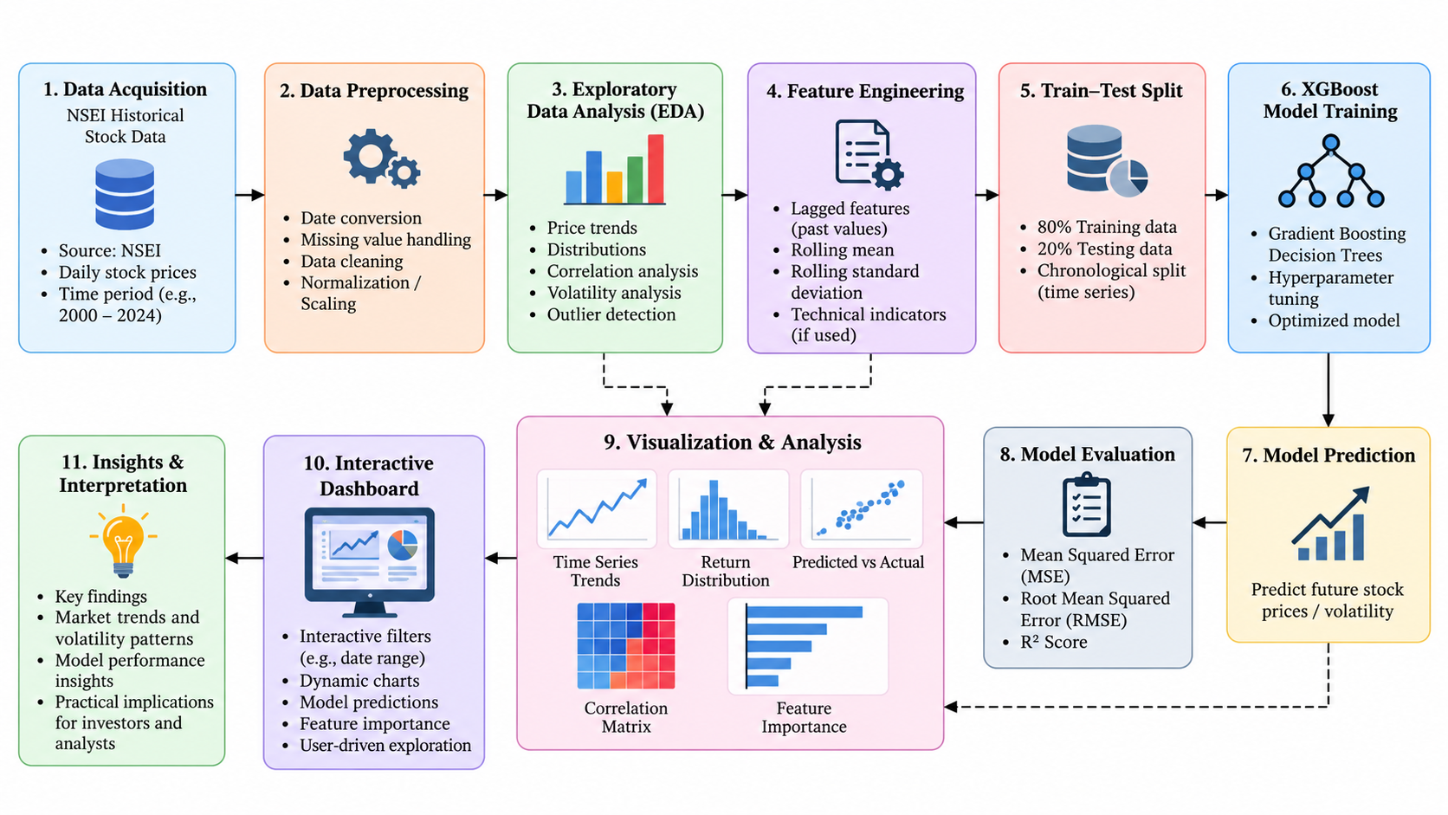
4.2 System Architecture
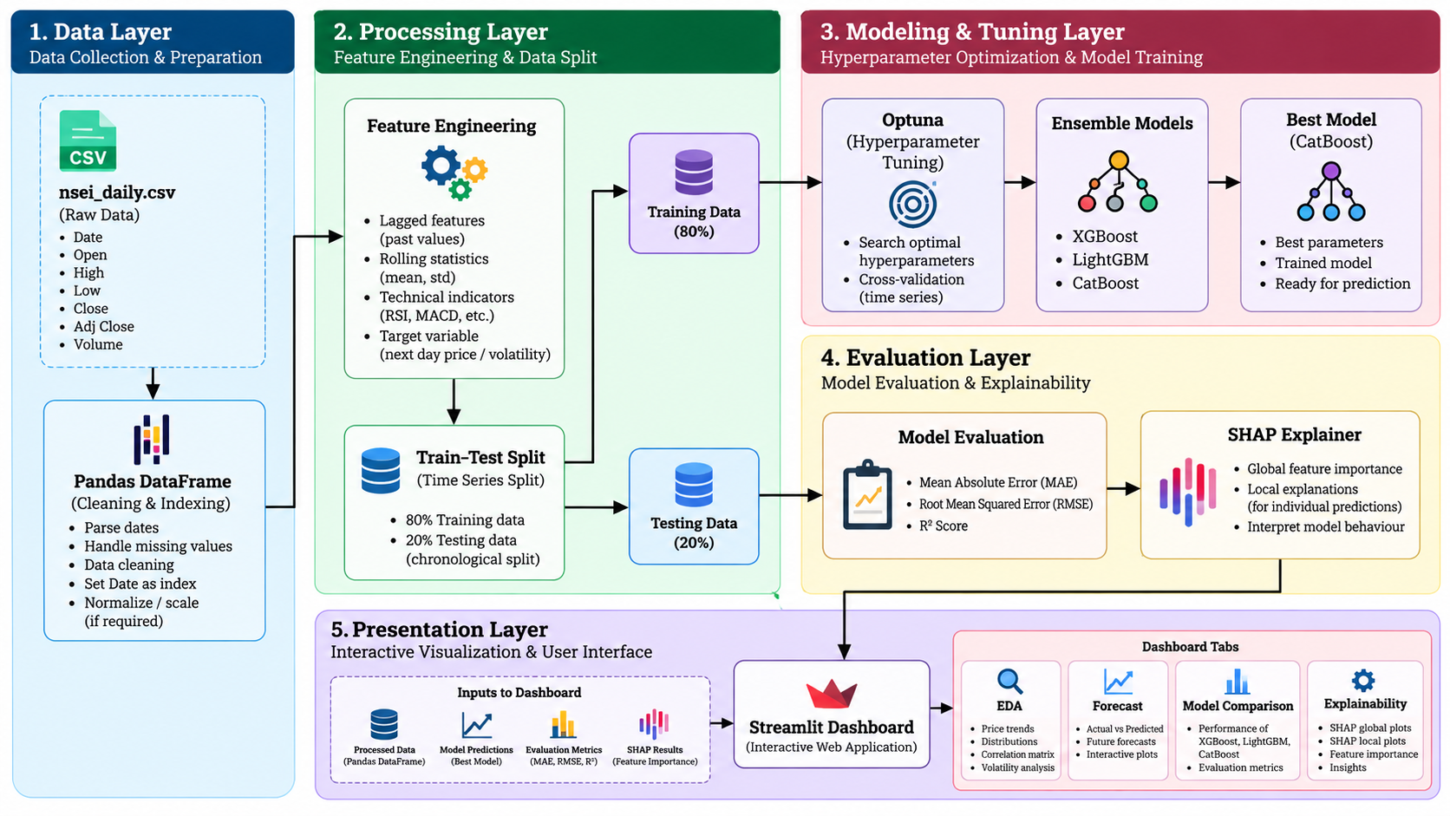
4.3 System Requirements
- Hardware: Standard PC (8GB RAM minimum).
- Software: Python 3.12, Pandas, Scikit-learn, XGBoost, LightGBM, CatBoost, Optuna, SHAP, Streamlit, Plotly.
- Data: NSEI Daily OHLCV dataset (2020–2026).
4.4 Module Description
4.4.1 Data Pipeline Module (data_cleaning.py & feature_engineering.py)
Purpose: To ingest raw NSEI data, clean it, and generate features for model training.
Key Functionalities:
- Data Cleaning: Validates OHLC logic (e.g., High >= Low) and handles missing values using forward-fill to maintain time-series continuity.
- Stationarity Fixes: Excludes raw OHLC prices and raw moving averages to prevent the model from overfitting to absolute price levels.
- Feature Engineering: Creates Log Returns (to stabilize variance), Lagged Returns (to capture market shocks), Rolling Statistics (5, 10, 20-day means/stds for volatility clustering), and Technical Indicators (RSI for momentum, MACD for trend, ATR for true range).
- Target Creation: Defines the target as the 5-day forward rolling standard deviation of log returns.
4.4.2 Exploratory Data Analysis (EDA) Module (02_eda.ipynb)
Purpose: To understand the statistical properties of the market before modeling.
Key Visualizations Used:
- Line Plots: Close price with moving averages to identify long-term trends.
- Histograms & Boxplots: Daily log returns to reveal a leptokurtic distribution (fat tails), proving that extreme market shocks happen more frequently than a normal distribution would suggest.
- ACF Plots: Autocorrelation of raw returns vs. squared returns, providing statistical proof of volatility clustering.
- Correlation Heatmaps: To identify which engineered features have the highest positive correlation with future volatility.
4.4.3 Modeling Module (models.py & evaluation.py)
Purpose: Define, tune, and train models with optimized hyperparameters.
Key Functionalities:
- Implements XGBoost, LightGBM, and CatBoost.
- Uses Optuna for hyperparameter tuning over a 5-fold TimeSeriesSplit (with a 5-day gap).
- Evaluates models using MAE, RMSE, R2R2, and Directional Accuracy.
4.4.4 Explainability Module (explainability.py)
Purpose: To interpret the model's predictions.
Key Functionalities:
- Integrates SHAP (SHapley Additive exPlanations) to generate global feature importance (Beeswarm plots) and local prediction explanations (Waterfall plots).
4.4.5 Interactive Dashboard Module (app/dashboard.py)
Purpose: To deploy the findings into a user-friendly tool.
Key Functionalities:
- Built using Streamlit and Plotly for interactive, hoverable charts.
- Features 4 tabs: EDA Highlights, Dynamic Forecast Viewer (with date filters), Model Comparison metrics, and an interactive SHAP Explainability tab where users can slide through dates to see why the model predicted a specific volatility value.
5. Performance Metrics
To evaluate the models from different statistical angles, we used:
- MAE (Mean Absolute Error): Measures the average error in the same units as volatility. Easy to interpret.
- RMSE (Root Mean Squared Error): Heavily penalizes large errors. Why: In finance, failing to predict a massive volatility spike (crisis) is much worse than being slightly off during a calm day.
- R2R2 Score: Measures how much of the variance in the target was explained.
- Directional Accuracy: A custom metric measuring how often the model correctly predicted if volatility would go up or down compared to today.
6. Results and Discussion
6.1 Model Comparison
The models were evaluated on the out-of-sample test set (20% of data, with a 5-day gap to prevent leakage).
(Insert Table 1: Model Comparison Table here)
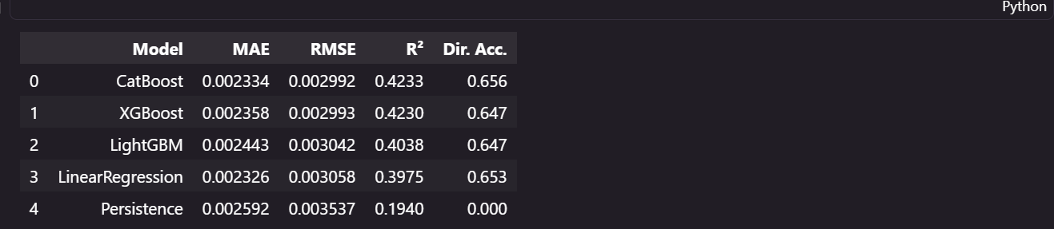
Discussion: CatBoost achieved the best overall performance (highest R2R2 of 0.4233, lowest RMSE of 0.002992). While Linear Regression achieved a slightly lower MAE, its lower R2R2 indicates it failed to visually capture the magnitude of extreme volatility spikes. The Persistence model performed worst (R2R2 of 0.194), proving the necessity of our ML pipeline.
6.2 Comparison with Base Paper
The base paper reported an R2R2 of 0.98 for XGBoost, which is unrealistic in financial forecasting and indicative of target leakage. Our leakage-free pipeline yielded an R2R2 of 0.4233. In financial data science, an R2R2 of 0.42 is highly significant and proves genuine predictive power without overfitting.
6.3 Visualizing Explainability: Global Insights
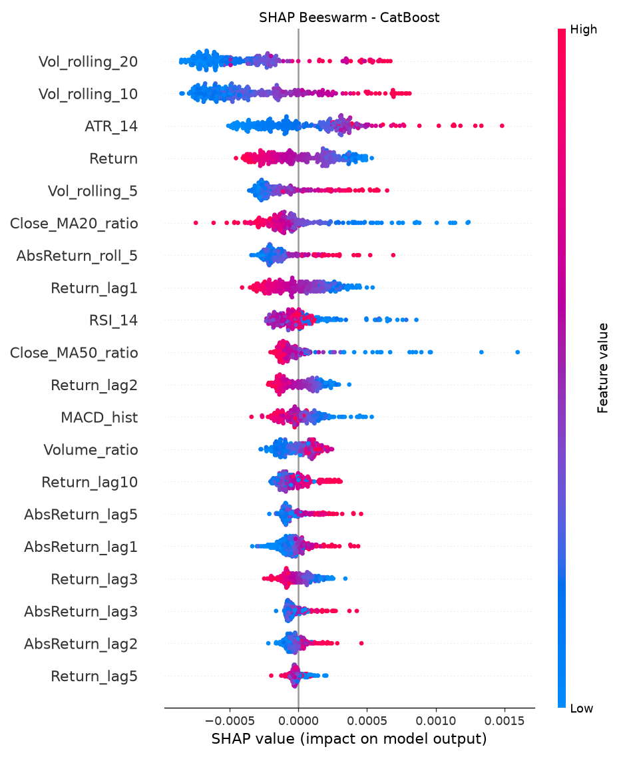
Discussion: The global SHAP Beeswarm plot visually confirms the volatility clustering hypothesis. It clearly shows that high values of Vol_rolling_5 (red dots) and AbsReturn_lag1 push the prediction to the right (higher volatility). This proves the AI isn't guessing—it has learned the financial principle that recent turbulence predicts future turbulence.
6.4 Visualizing Explainability: Local Insights
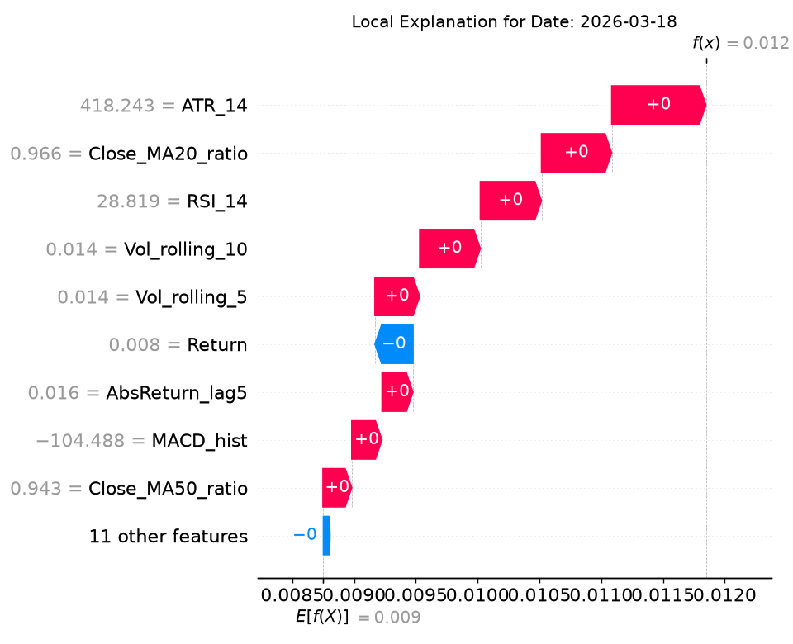
Discussion: For a specific market crash day, the waterfall plot visually isolates the exact feature contributions. It shows that a recent negative return shock (AbsReturn_lag1 = 0.0256) and high rolling volatility (Vol_rolling_5 = 0.0281) were the primary reasons the model predicted a spike to 0.0328.
6.5 EDA & Data Visualization Highlights
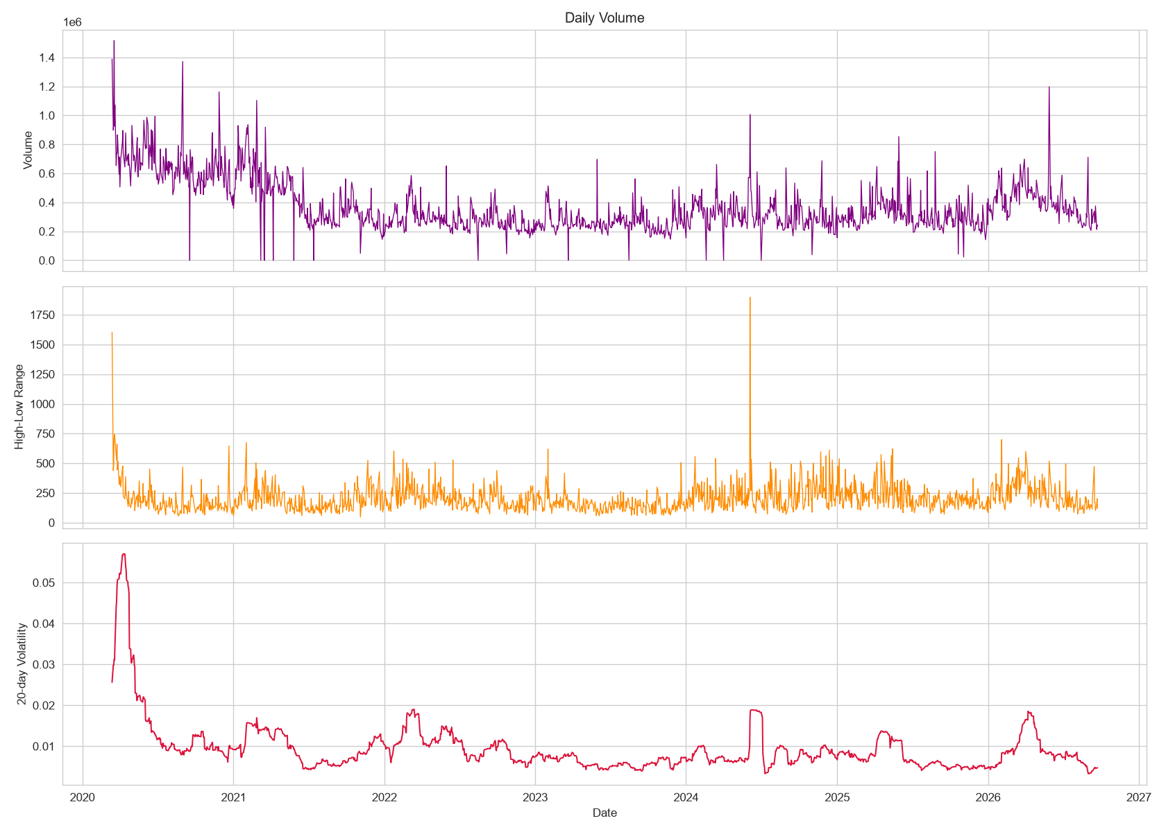
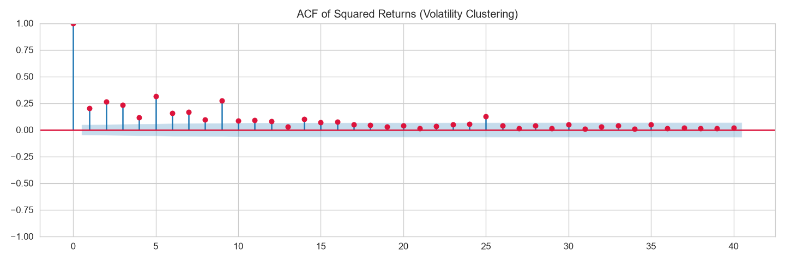
Discussion: The EDA visuals proved that volatility is not constant—it clusters in regimes. The ACF of squared returns visually confirmed that past volatility is highly correlated with future volatility, which mathematically justified our feature engineering choices.
6.6 Interactive Dashboard Deployment
(Insert Screenshots of your Streamlit Dashboard - Forecast Tab and Explainability Tab)
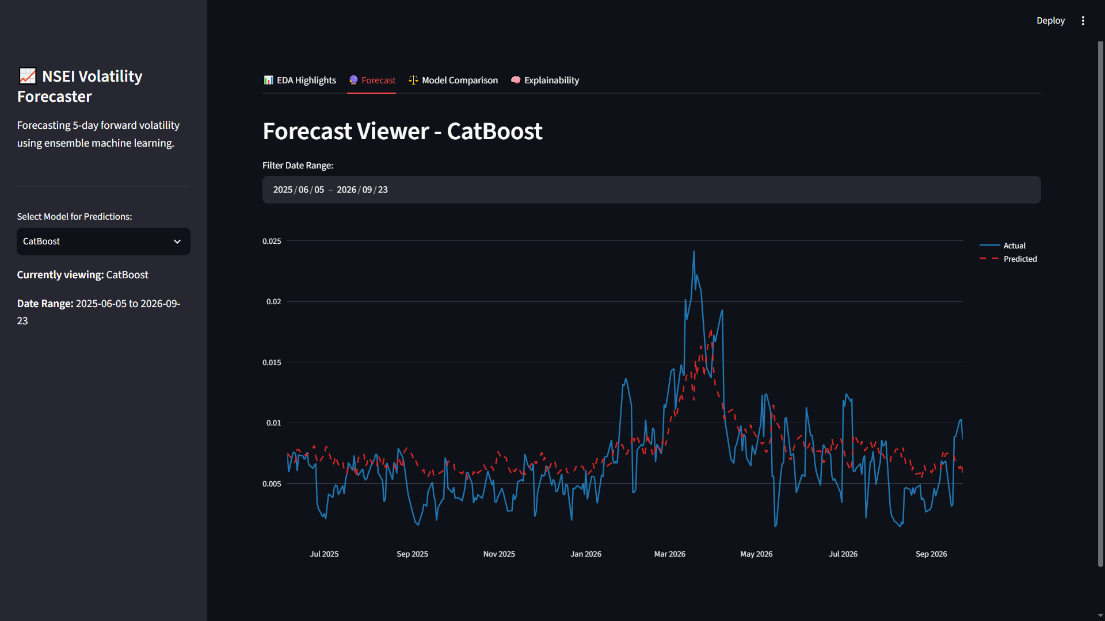
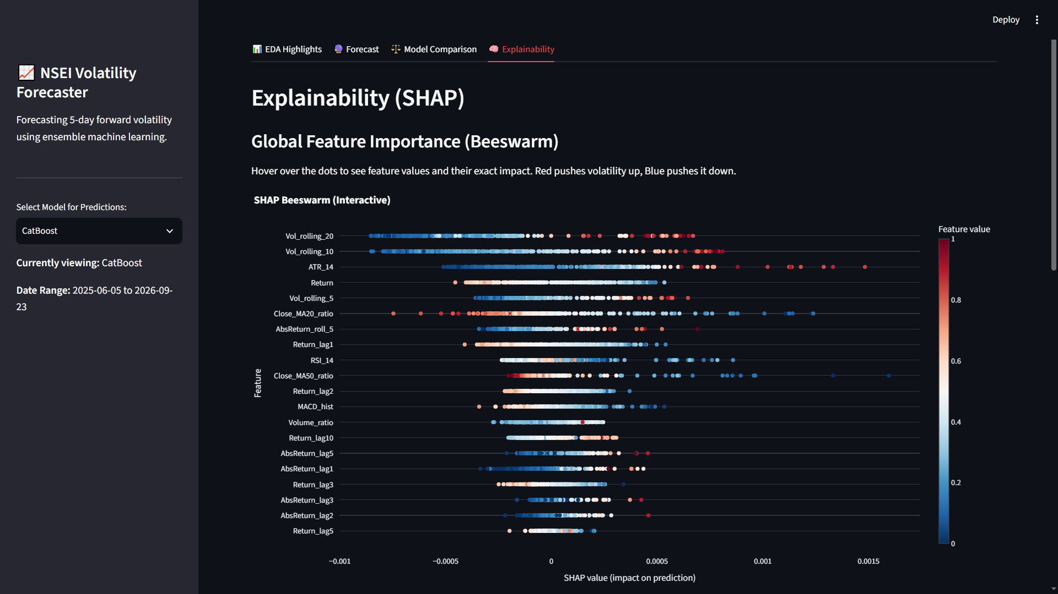
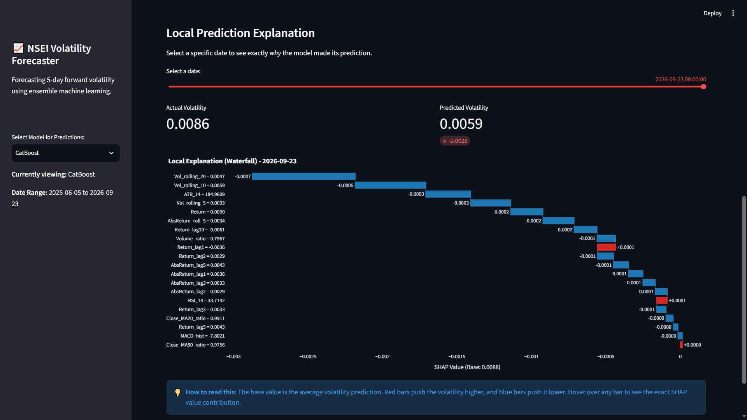
Discussion: We migrated our static findings into an interactive web application. Users can now dynamically filter date ranges, hover over Plotly charts to see exact values, and visually inspect SHAP waterfalls for any specific day. This transforms static data science results into a practical, user-driven tool.
7. Conclusion
This project successfully demonstrated an end-to-end Data Science pipeline for NSEI volatility forecasting. By applying rigorous data preprocessing, advanced ensemble modeling (CatBoost), and Explainable AI (SHAP), we achieved a realistic R2R2 of 0.42 and a directional accuracy of 65.6%.
Crucially, the integration of Interactive Visualization through Streamlit and Plotly allowed us to democratize these findings—transforming complex machine learning outputs into interpretable, visually appealing insights. Ultimately, this project shows that combining Data Science with strong Visualization techniques provides a highly effective tool for daily financial risk management and strategic decision-making.
8. References
1. T. Sharma, I. Verma, S. K. Prasad, A. Sharma, and S. Prasad. “Forecasting Stock Market Volatility Using XGBoost: A Time Series Analysis.” In 2024 International Conference on Communication, Control, and Intelligent Systems (CCIS), IEEE, 2024. doi: 10.1109/CCIS63231.2024.10932089.grafiati
2. Y. Wang and Y. Guo. “Forecasting Method of Stock Market Volatility in Time Series Data Based on Mixed Model of ARIMA and XGBoost.” China Communications, vol. 17, no. 3, pp. 205–221, 2020. doi: 10.23919/JCC.2020.03.017.link.springer+1
3. M. S. Hafshejani and N. Mansouri. “Enhancing Stock Market Prediction with LSTM: A Review of Recent Developments and Comparative Analysis.” Archives of Computational Methods in Engineering, vol. 33, pp. 6177–6274, 2026. doi: 10.1007/s11831-025-10370-0.link.springer
4. R. M. Leushuis and N. Petkov. “Advances in Forecasting Realized Volatility: A Review of Methodologies.” Financial Innovation, vol. 12, article no. 14, 2026. doi: 10.1186/s40854-025-00809-5.link.springer
5. A. Arratia, M. El Daou, J. Kagerhuber, and Y. Smolyarova. “Examining Challenges in Implied Volatility Forecasting: A Critical Review of Data Leakage and Feature Engineering Combined with High-Complexity Models.” Computational Economics, vol. 68, pp. 3323–3345, 2026. doi: 10.1007/s10614-025-11172-z.link.springer
6. J. D. Díaz, E. Hansen, and G. Cabrera. “Machine-Learning Stock Market Volatility: Predictability, Drivers, and Economic Value.” International Review of Financial Analysis, vol. 94, article no. 103286, 2024. doi: 10.1016/j.irfa.2024.103286.econpapers.repec+1
7. M. S. Haque, M. S. Ahmed, M. T. Rahman, R. A. Robin, Z. Z. Meem, and J. Noor. “An Interpretable Machine Learning Framework for Predicting Next Day Firm Level Market Stress in the Dhaka Stock Exchange.” Discover Artificial Intelligence, vol. 6, article no. 1066, 2026. doi: 10.1007/s44163-026-02065-7.link.springer
8. M. Nguyen, M. H. Nguyen, H. H. Nguyen, V. D. Do, and H. Le. “Volatility-Clustering Adaptation for Financial Time Series.” arXiv preprint, arXiv:2609.37715, 2026.arxiv+1
9. Y. C. Tjen and H. F. Zuhri. “Impact of Volatility and Feature Engineering on the Forecasting Performance of LSTM and XGBoost Models: Evidence from Indonesian Banking Stocks.” Ingénierie des Systèmes d’Information, vol. 31, no. 5, pp. 1389–1402, 2026. doi: 10.18280/isi.310502.iieta+1
10. R. Sabharwal, S. J. Miah, S. F. Wamba, and P. Cook. “Extending Application of Explainable Artificial Intelligence for Managers in Financial Organizations.” Annals of Operations Research, published online, 2024. doi: 10.1007/s10479-024-05825-9.link.springer
11. S. Kumar, M. Vishal, and V. Ravi. “Explainable Reinforcement Learning on Financial Stock Trading Using SHAP.” arXiv preprint, arXiv:2208.08790, 2022.arxiv
12. L. Dowson, X. Song, and X. Li. “Explainable AI for Stock Price Prediction: A Comparative Study of Deep Learning and Feature Attribution Methods.” In Proceedings of the 2025 11th International Conference on Communication and Information Processing (ICCIP ’25), ACM, pp. 488–494, 2026. doi: 10.1145/3784833.3784870.

