

Precision Considerations for Analysis Services Users
SQL Server Best Practices Article

Writers: Denny Lee, Eric Jacobsen
Contributors: Matt Burr, Chris Clayton
Technical Reviewer: Stuart Ozer

Published: September 2007
Updated: January 2008
Applies To: SQL Server 2005

Summary: This white paper covers accuracy and precision considerations in SQL Server 2005 Analysis Services. Although it is not explicitly covered in this paper the same issues can be seen in all of the versions of SQL Server Analysis Services that are in support at the time of writing. For example, it is possible to query Analysis Services with similar queries and obtain two different answers. While this appears to be a bug, it actually is due to the fact that Analysis Services caches query results and the imprecision that is associated with approximate data types. This white paper discusses how these issues manifest themselves, why they occur, and best practices to minimize their effect.

Copyright

The information contained in this document represents the current view of Microsoft Corporation on the issues discussed as of the date of publication. Because Microsoft must respond to changing market conditions, it should not be interpreted to be a commitment on the part of Microsoft, and Microsoft cannot guarantee the accuracy of any information presented after the date of publication.

This White Paper is for informational purposes only. MICROSOFT MAKES NO WARRANTIES, EXPRESS, IMPLIED OR STATUTORY, AS TO THE INFORMATION IN THIS DOCUMENT.

Complying with all applicable copyright laws is the responsibility of the user. Without limiting the rights under copyright, no part of this document may be reproduced, stored in or introduced into a retrieval system, or transmitted in any form or by any means (electronic, mechanical, photocopying, recording, or otherwise), or for any purpose, without the express written permission of Microsoft Corporation.

Microsoft may have patents, patent applications, trademarks, copyrights, or other intellectual property rights covering subject matter in this document. Except as expressly provided in any written license agreement from Microsoft, the furnishing of this document does not give you any license to these patents, trademarks, copyrights, or other intellectual property.

© 2007 Microsoft Corporation. All rights reserved.

Microsoft, Visual C#, and Windows are either registered trademarks or trademarks of Microsoft Corporation in the United States and/or other countries.

The names of actual companies and products mentioned herein may be the trademarks of their respective owners.

Table of Contents
Introduction 1
Scenario 1
Scenario Preparation 1
Test Scenario 3
Scenario Results 4
Inconsistency 4
Inaccuracy 4
Imprecision 5
Recreating the Test Scenario in SQL 5
Illustrating the Problem 10
Discussion 10
Potential Solutions 10
Solving the Problem at the Data Source 10
Solving the Problem with MDX 11
Conclusion 11
Appendix A 12
Conversion of a Number 12
Conversion in SQL Server 13
Number Comparison Sample Code 15
Appendix B 17

Introduction
When working with any reporting system, one concern is the degree of accuracy and precision of the values provided. The accuracy of a value can be described as how close the value provided is to the “true” value. The consistency of a value can be described as how consistently reproducible the value is. Being precise does not necessarily mean that one is accurate, nor does accuracy mean precision. For example, if you have a true population mean of µ = 225:
- An accurate system would have a sample means of {m₁ = 220, m₂ = 228, m₃ = 224, … } where the value is quite close to the true population mean of µ = 225.
- A consistent system would have a sample means of {m₁ = 180, m₂ = 181, m₃ = 180, … } where the values are consistently reproducible but not necessarily accurate.
Usually, you want values that are both accurate and consistent; but this is not always possible.
The scenario in this paper is an example of inaccuracy and inconsistency that can be seen by querying an Analysis Services database. Please note that this is not caused by SQL Server™ 2005 Analysis Services (SSAS), but it is easy to present and manifest these problems by using Analysis Services due to its fast, ad hoc querying. The overall effect is that querying the same data set at different levels of the hierarchy may result in different answers. To show how this occurs, we set up a scenario against the [Adventure Works] OLAP database. You can recreate this scenario by following along with an installed version of the SQL Server 2005 Samples and Sample Databases (February 2007).

Scenario
To create a reproducible, inaccurate, and inconsistent scenario in Analysis Services, we provide two queries to run. The first MDX statement queries the [Adventure Works] cube and provides the x measure broken out by geography and filtered for fiscal year 2004. The x measure is actually the [Discount Amount] value multiplied by the [Average Rate]. We did this because the [Discount Amount] measure is created by [Measures].[Discount Amount]/[Measures].[Average Rate]. Therefore, [Measures].[X] is equivalent to the original [Measures].[Discount Amount]. This is important because we want to compare the values generated by this measure with the [Discount Amount] column from the original SQL relational data source.

Scenario Preparation
Following are the queries that are used in the scenario.

MDX Query 1

// Query 1: Query for product category “bikes” for ALL geographics
with
member [Measures].[X] as '([Measures].[Discount Amount]*[Measures].[Average Rate])'
select {
Crossjoin(
{[Geography].[Geography].[All Geographies], [Geography].[Geography].[All Geographies].children},
{[Measures].[x]}
)
} on columns, {
[Product].[Category].&[1]
} on rows
from [Adventure Works]
where ([Date].[Fiscal Year].[Fiscal Year].[FY 2004])

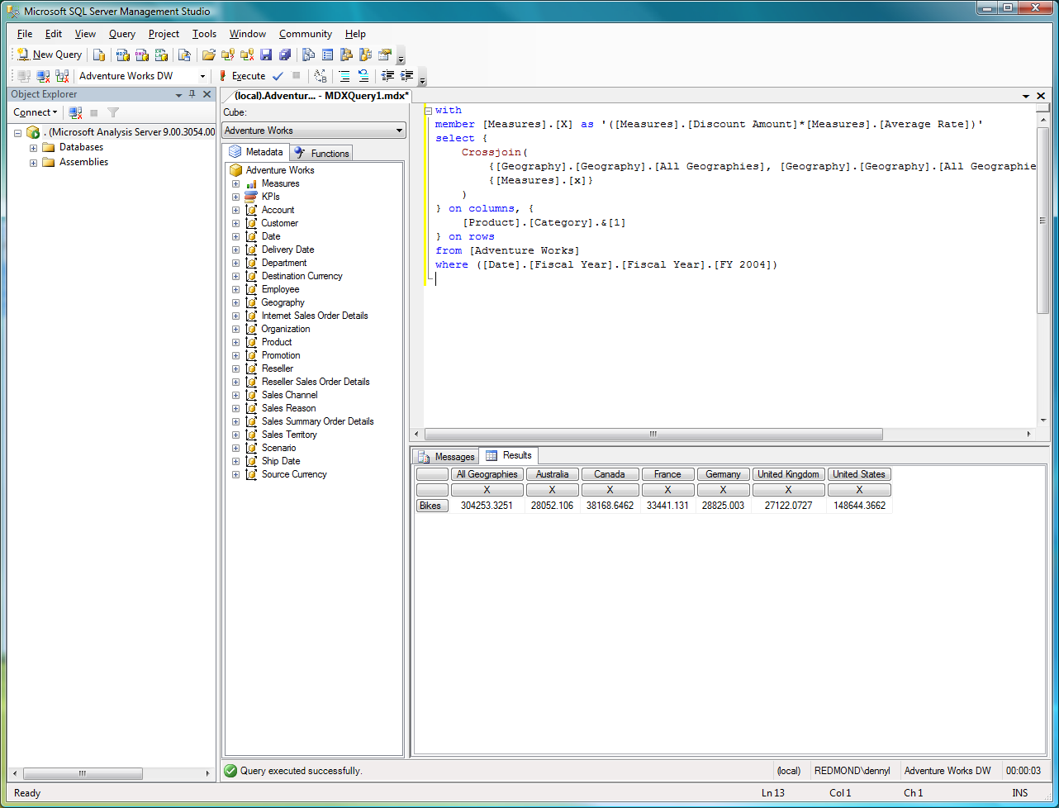
Figure 1: Query output from MDX Query 1
The second MDX query, in the following code, is similar to the first except that all of the geographics are rolled up into “all geographics” (that is, into one value).

MDX Query 2

// Query 2: Query for product category “bikes” for "all geographies"
with
member [Measures].[X] as '([Measures].[Discount Amount]*[Measures].[Average Rate])'
select {
Crossjoin(
[Geography].[Geography].[All Geographies],
{[Measures].[x]}
)
} on columns, {
[Product].[Category].&[1]
} on rows
from [Adventure Works]
where ([Date].[Fiscal Year].[Fiscal Year].[FY 2004])

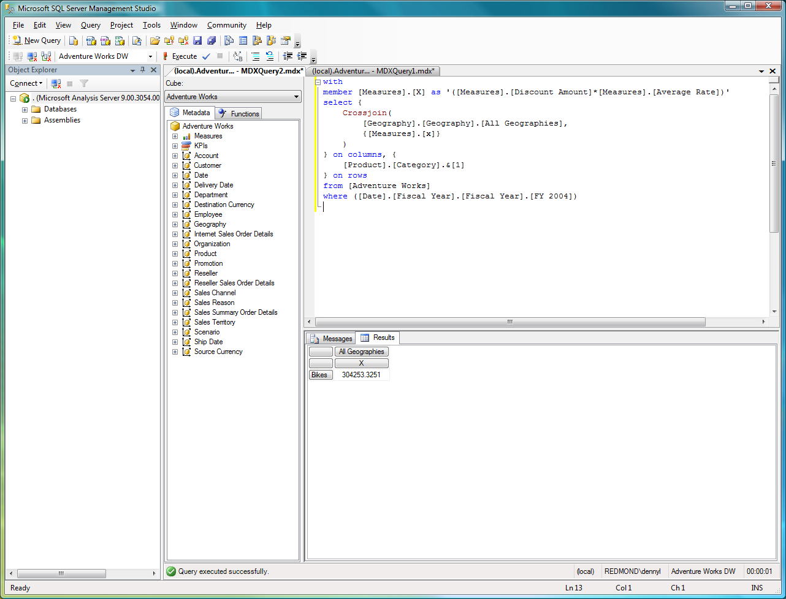
Figure 2: Query output from MDX Query 2

Also important for this particular scenario is to remove any cached aggregations from memory when querying the [Adventure Works] OLAP database. Following is an XML for Analysis (XMLA) script that performs this task.

ClearCache XMLA statement

<ClearCache xmlns="http://schemas.microsoft.com/analysisservices/2003/engine">
<Object>
<DatabaseID>Adventure Works DW</DatabaseID>
</Object>
</ClearCache>

Test Scenario
The only difference between the two queries is that the first query (MDX Query 1) summates and lists the geographies while the second query (MDX Query 2) only summates them together. To run the scenario and produce inconsistent results, use SQL Server Management Studio to connect to the [Adventure Works] OLAP database and do the following:
- Clear the cache by using the ClearCache XMLA statement.
- Execute MDX Query 1 – note that the result for [All Geographies, X] is 304253.3251
- Execute MDX Query 2 – note that the result for [All Geographies, X] is 304253.3251
- Clear the cache by using the ClearCache XMLA statement.
- Execute MDX Query 2 – note that the result for [All Geographies, X] is 304253.325100001
- Execute MDX Query 1 – note that the result for [All Geographies, X] is 304253.325100001
As you can see from this relatively simple test scenario, querying one way returns one set of answers (x = 304253.3251) and querying another way returns another set of answers (x = 304253.325100001).

Scenario Results
As you can see from the results of the test scenario, issues of inaccuracy and inconsistency are evident. The results are inconsistent because you can different results depending on how you query the system. The results are inaccurate because you can get incorrect results.

Inconsistency
The reason for the inconsistency in this environment has to do with the caching mechanism that Analysis Services provides in concert with floating point representation. If it detects a query in which the subcube (in the test scenario, [All Geographies, X]) is already placed into its cache, Analysis Services obtains this result from the cache instead of querying its storage engine to obtain the results. This caching behavior allows the Analysis Services storage engine to execute queries more efficiently by reducing the amount of work it is required to perform. As a result of this caching, the order and composition of the preceding queries may cause you to receive different results.
A way to avoid this imprecision is to set Analysis Services to not use its caching so that it always goes to the storage engine for all queries. Turning off caching is not an optimal choice since the purpose of the caching is to improve query performance. In this particular scenario, the imprecision is due to the inaccuracy of the results as well. The fact that it is possible to get a different answer from the same query, depending on how you query (the inaccuracy) is the root of the inconsistency. If we can find a way to remove the inaccuracy, in this particular case we can also remove the inconsistency.

Inaccuracy
The real issue in this scenario is the fact that the query results are different when you use different methods to run the same query. Recall that one test case returned an answer of 304253.3251 and in the other test case returned an answer of 304253.325100001. This occurs because the underlying data types that were queried are float and real. The float and real data types are ANSI SQL approximate data types. For more information on the behavior of these data types, see the IEEE 754 specification. We often find cases of inaccuracy that are due to numbers that cannot be represented exactly by the floating point data types.

Imprecision
Precision is defined as the quantity of digits in a number within the context of working with regular data types such as decimal and numeric, and approximate data types such as real and float.
What is significant about precision in the case of approximate data types is that instead of storing the exact value of a number as with regular data types, they may store an extremely close approximation of it. This means that it is possible for precision loss to occur if the number of floating point digits cannot be reliably quantified in the floating-point value. As a general rule, it is better to store the original data by using the money, numeric, or decimal SQL data types. If an approximate data type must be used, these precision issues can result in inaccuracy and inconsistency as shown in the next section.

Recreating the Test Scenario in SQL
To illustrate the precision issue described in the previous section, we recreate the test scenario in SQL. To execute these queries, connect to the [Adventure Works DW] SQL database by using SQL Server Management Studio. The [Adventure Works DW] SQL database is the source for the [Adventure Works] OLAP database. We first create a [FactSalesSummary] view; the source for the [Sales Summary] measure group is the SQL statement that is used to create this view.

/* Create the FactSalesSummary view */
-- This is the view used by the Adventure Works DW OLAP database
-- and required for the SQL statements below.
CREATE VIEW FactSalesSummary
AS
SELECT ProductKey, OrderDateKey, DueDateKey, ShipDateKey, ResellerKey, NULL AS CustomerKey, EmployeeKey, PromotionKey, CurrencyKey, SalesTerritoryKey, SalesOrderNumber, SalesOrderLineNumber, RevisionNumber, OrderQuantity, UnitPrice, ExtendedAmount, UnitPriceDiscountPct, DiscountAmount, ProductStandardCost, TotalProductCost, SalesAmount, TaxAmt, Freight, CarrierTrackingNumber, CustomerPONumber, 'Reseller' AS SalesChannel, CONVERT(CHAR(10), SalesOrderNumber) + 'Line ' + CONVERT(CHAR(4), SalesOrderLineNumber) AS SalesOrderDesc
FROM FactResellerSales
UNION
SELECT ProductKey, OrderDateKey, DueDateKey, ShipDateKey, NULL AS ResellerKey, CustomerKey, NULL AS EmployeeKey, PromotionKey, CurrencyKey, SalesTerritoryKey, SalesOrderNumber, SalesOrderLineNumber, RevisionNumber, OrderQuantity, UnitPrice, ExtendedAmount, UnitPriceDiscountPct, DiscountAmount, ProductStandardCost, TotalProductCost, SalesAmount, TaxAmt, Freight, CarrierTrackingNumber, CustomerPONumber, 'Internet' AS SalesChannel, CONVERT(CHAR(10), SalesOrderNumber) + 'Line ' + CONVERT(CHAR(4), SalesOrderLineNumber) AS SalesOrderDesc
FROM FactInternetSales

After you create the [FactSalesSummary] view, execute the following two SQL statements. The first SQL query is equivalent to MDX Query 1, where the aggregations are broken up and totaled by geography.

SQL Query 1

/* By Country */
DECLARE @ByGeo table (
EnglishProductCategoryName varchar(256),
SalesTerritoryCountry varchar(256),
Cnt int,
DiscountAmount numeric(20,4)
)

INSERT INTO @ByGeo
SELECT c.EnglishProductCategoryName,
st.SalesTerritoryCountry,
count(*) AS Cnt,
sum(f.DiscountAmount) AS DiscountAmount
FROM FactSalesSummary f
INNER JOIN DimTime t
ON t.TimeKey = f.OrderDateKey
INNER JOIN DimProduct p
ON p.ProductKey = f.ProductKey
INNER JOIN DimProductSubcategory s
ON s.ProductSubCategoryKey = p.ProductSubcategoryKey
INNER JOIN DimProductCategory c
ON c.ProductCategoryKey = s.ProductCategoryKey
LEFT OUTER JOIN FactCurrencyRate cr
ON cr.TimeKey = f.OrderDateKey
AND cr.CurrencyKey = f.CurrencyKey
LEFT OUTER JOIN DimSalesTerritory st
ON st.SalesTerritoryKey = f.SalesTerritoryKey
WHERE t.FiscalYear = '2004'
AND c.ProductCategoryKey = 1
GROUP BY
c.EnglishProductCategoryName, st.SalesTerritoryCountry

SELECT * FROM @ByGeo
UNION ALL
SELECT 'Bikes', 'All Geo', sum(Cnt), sum(DiscountAmount) FROM @ByGeo

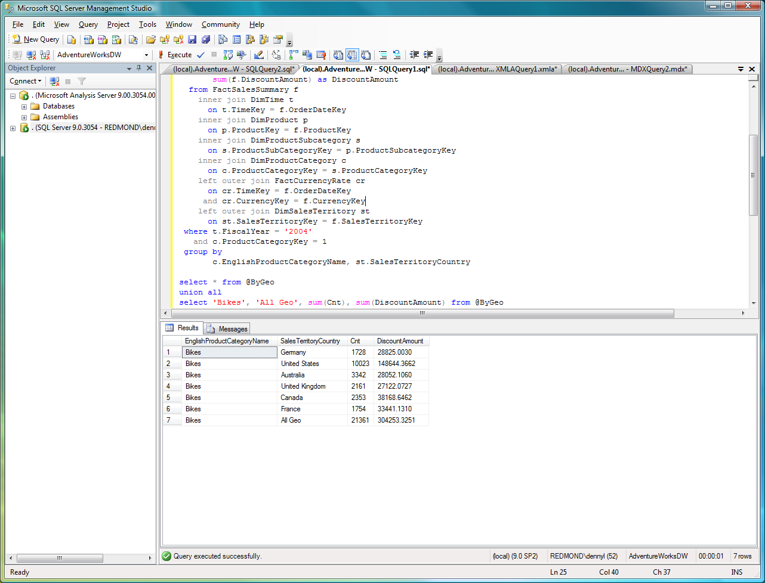
Figure 3: Query output from SQL Query 1

The second SQL statement is equivalent to MDX Query 2 where the results are rolled up to “All Geographies.”

SQL Query 2

/* All Geographies */
-- Provides total output
SELECT c.EnglishProductCategoryName,
count(*) AS Cnt,
sum(f.DiscountAmount) AS DiscountAmount,
sum(cast(f.DiscountAmount AS numeric(20,10))) as DiscountAmount2,
sum(cast(f.DiscountAmount AS numeric(20,4))) as DiscountAmount3,
sum(cast(f.DiscountAmount AS money)) as DiscountAmount4
FROM FactSalesSummary f
INNER JOIN DimTime t
ON t.TimeKey = f.OrderDateKey
INNER JOIN DimProduct p
ON p.ProductKey = f.ProductKey
INNER JOIN DimProductSubcategory s
ON s.ProductSubCategoryKey = p.ProductSubcategoryKey
INNER JOIN DimProductCategory c
ON c.ProductCategoryKey = s.ProductCategoryKey
LEFT OUTER JOIN FactCurrencyRate cr
ON cr.TimeKey = f.OrderDateKey
AND cr.CurrencyKey = f.CurrencyKey
WHERE t.FiscalYear = '2004'
AND c.ProductCategoryKey = 1
GROUP BY
c.EnglishProductCategoryName

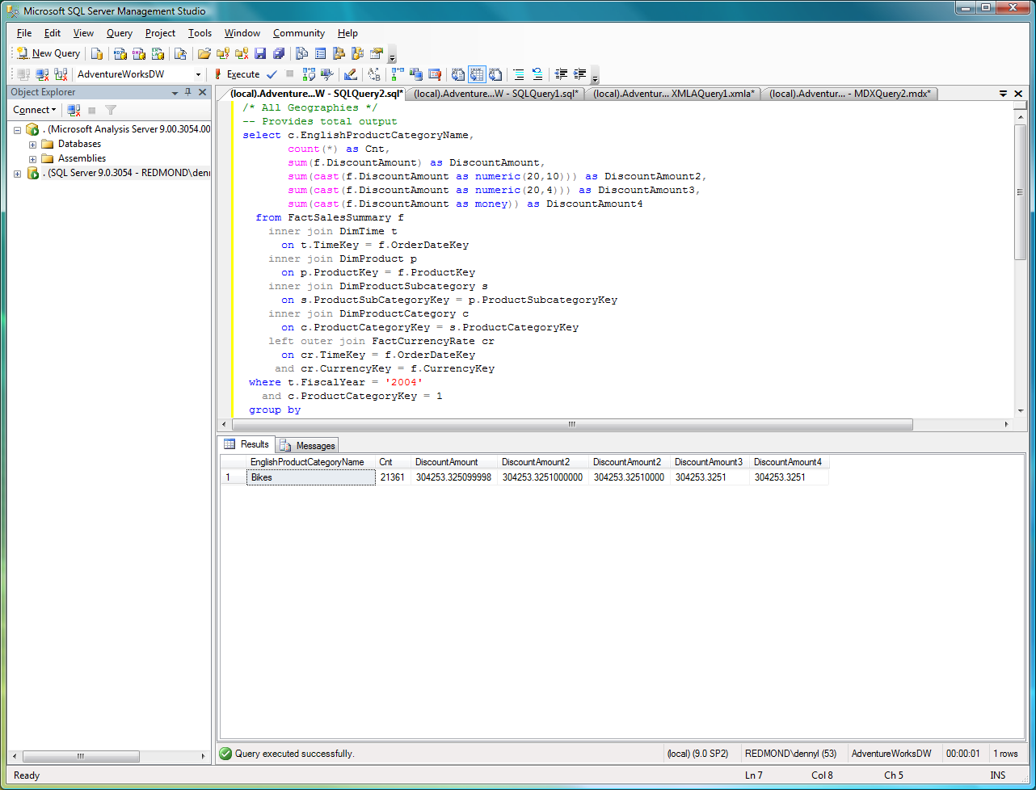
Figure 4: Query output from SQL Query 2

SQL Query 2 returns the following results:
Query 1.DiscountAmount: 304253.3251
Query 2.DiscountAmount: 304253.325099998

In SQL, because there are corner case issues with summating the data and implicitly converting the float data type, the second query has nine nonzero decimal digits, while the first query only has four post-decimal digits. Note that there is nothing special about how SQL Server does the summation to cause this; it occurs because of the nature of the specific numbers and the use of floating point data types.
You may have also noticed that the MDX query result is 304253.325100001 while the SQL statement result is 304253.325099998. When rounded to four digits of precision, both the MDX and SQL queries return the same answer (304253.3251) but at nine digits of precision, they return different answers. Recall that the [AdventureWorksDW] SQL database and the [Adventure Works DW] OLAP database have different data types for the [Discount Amount] column (SQL) and measure (OLAP).

Column/Measure | SQL | Analysis Services
Discount Amount | Float (double)* | Currency
Average Rate | Float (double)* | Double
* SQL Server float is equivalent to double; an 8-byte floating point value consistent with IEEE 754.
Because of the different data types, the resulting conversion yields the different results.

Illustrating the Problem
To help illustrate this issue, following is the binary representation of the mantissa bits of the value of 304253.3251. To generate these examples yourself, see IEEE-754 Floating Point Conversion from Floating-Point to Hexadecimal.
1 .0010100100011111010101001100111001110000001110110000
Note that ln(10^10)/ln(2) = 33, so we might expect that 33 bits of mantissa are necessary, but the binary representation of this value cannot be represented exactly.
However when the value is represented as an integer, 3042533251, the mantissa bits are:
1 .0110101010110010101111110000011000000000000000000000
where only 32 bits in the mantissa are needed and the value can be represented exactly.
This occurs because there are certain base-10 numbers that cannot be represented exactly in IEEE-754 format. Within the [Adventure Works DW] SQL database, there are a number of float values such as 85.5344, 93.3103, 325.4342, and 363.5264 where approximate data types cannot represent the value exactly.
For an extended look at the precision values associated with the value 304253.3251, see the Appendix.

Discussion
Because the above conversion problem happens within the relational SQL data, it translates across to the OLAP database as well (even when specifying currency or double data types). This is why this occurs in the MDX output queries as well.
Data type conversion may also be a factor. For example, in SQL Server 2000 Analysis Services, calculations involving the currency (VT_CY) data type retain the currency data type. But in SQL Server 2005 Analysis Services, the Windows® OLEAUT variant functions are used for basic math functions, so data type conversions are slightly different between these major product versions. In this case, a currency type divided by an integer is not currency (as in SQL Server 2000 Analysis Services)—it is R8 (double-precision floating point). As data type conversions are a factor in precision, it is important to note the MDX functions where any conversion occurs. For the full list of functions, see Description of variant data types that are returned for calculated members in SQL Server 2005 Analysis Services (KB Article 927166).

Potential Solutions
There are two approaches to solving the problem—you can either solve it at the data source itself (that is, in SQL) or solve it in the MDX query.

Solving the Problem at the Data Source
If you decide to solve the problem by using SQL, note the DiscountAmount2 and DiscountAmount3 columns in SQL Query 1:

sum(cast(f.DiscountAmount as numeric(20,10))) as DiscountAmount2,
sum(cast(f.DiscountAmount as numeric(20,4))) as DiscountAmount3,
sum(cast(f.DiscountAmount as money)) as DiscountAmount4

The results are:
Query 1.DiscountAmount2: 304253.3251000000
Query1.DiscountAmount3: 304253.3251
Query1.DiscountAmount4: 304253.3251

As you can see, by casting the relational data source from the float data type to the numeric or money data types, you can reduce precision loss.

Solving the Problem with MDX
In MDX, alter the MDX queries so that [Measures].[X] is:

member [Measures].[X] as '([Measures].[Discount Amount]*[Measures].[Average Rate])', FORMAT_STRING="#.####"

By using FORMAT_STRING, you can force the SSAS query engine to display only four digits to the right of the decimal so that your answers are consistent. Because the data might still be affected by the rounding effects even after this display change, it is best to change the original source data (that is, instead of using real or float, use money, which is fundamentally an integer data type). In some instances FORMAT_STRING may not be propagated through nested functions. This behavior is by design for performance reasons and means that testing is required to ensure that the desired behavior is exhibited in each scenario.
Casting the data as close to the original source as possible improves consistency throughout queries and reports. Casting the float data type to numeric or money in SQL Server (or other OLTP) is best. If it cannot be cast in SQL Server (or other OLTP), the next best place is in the SSAS cube. If you must keep these data types, use the MDX FORMAT_STRING property to help alleviate the problem.

Conclusion
When aggregating a floating point number, there is no guarantee that the results will be consistent; there may be a loss of precision. The reason for this loss of precision is based on the principles of floating-point math and the fact that Analysis Services is a multithreaded architecture, and may re-use intermediate and/or cached results (aggregations) as appropriate. Following are some approaches that may help mitigate the impact of this:
- Format the result values to a lower precision or scale.
- Use SQL exact numeric data types such as Analysis Services currency and SQL Server money as appropriate, including source relational data types, SSAS data types, and/or intermediate calculations.
- Comparisons can be made by using a dead band type algorithm, making equality have a maximum tolerance (ex. +- .0000001). Sample code for performing number comparisons in Visual C#® is included in the Appendix.
These are not the only mitigations available but are some of the more common ones. As with any mitigation, they do not eliminate the precision loss from occurring; they only reduce the chance of it occurring.

Appendix A
This appendix has additional queries in SQL and in C# that show how the conversion of an approximate data type can result in different answers depending on the precision level you specify.

Conversion of a Number
Consider the conversion issues associated with the value 304253.3251 that is input within the following simple C# program. Because the number is part of the code, conversion from C# code to a double-precision value is done at compile time by the compiler.

using System;
using System.Text;

namespace NumberConversion
{
class Program
{
static void Main(string[] args)
{
Double d = 304253.3251;
String s = Convert.ToString(d);
Double d2 = Convert.ToDouble(s);
Decimal d3 = Convert.ToDecimal(d);

// String Value
Console.WriteLine("Input Value: {0:e18}", s);

// Original Value (4 places)
Console.WriteLine("Original Value (4): {0:e10}", d);

// Convert back to double (4 places)
Console.WriteLine("Convert back to Double (4): {0:e10}", d2);

// Original Value (12 places)
Console.WriteLine("Original Value (12): {0:e18}", d);

// Convert back to double (12 places)
Console.WriteLine("Convert back to Double (12): {0:e18}", d2);

// Convert to decimal (4 places)
Console.WriteLine("Convert to Decimal (4): {0:e10}", d3);

// Convert to decimal (12 places)
Console.WriteLine("Convert to Decimal (12): {0:e18}", d3);

}
}
}

The output of this program is:

Conversion | Value
Input value | 304253.3251
Original double value  exponential format to four places | 3.0425332510e+005
Convert double to string and back to double  exponential format to four places | 3.0425332510e+005
Original double value  exponential format to twelve places | 3.042533251000000200e+005
Convert double to string and back to double  exponential format to twelve places | 3.042533251000000200e+005
Convert double to decimal  exponential format to four places | 3.0425332510e+005
Convert double to decimal  exponential format to twelve places | 3.042533251000000000e+005

As you can see from these results, the conversions performed in C# result in similar precision differentiations when storing the approximate value. To resolve this issue, store the value in a decimal format.

Conversion in SQL Server
The following code is an extension of SQL Query 2. This code shows the different precision values based on the conversion of the approximate data type of float.

SELECT c.EnglishProductCategoryName,
count(*) as Cnt,
sum(f.DiscountAmount) as DiscountAmount,
sum(cast(f.DiscountAmount as numeric(20,10))) as DiscountAmount2,
sum(cast(f.DiscountAmount as numeric(20,4))) as DiscountAmount3,
sum(cast(f.DiscountAmount as money)) as DiscountAmount4,
sum(cast(f.DiscountAmount as numeric(38,32))) as DiscountAmount5a,
sum(cast(f.DiscountAmount as numeric(38,12))) as DiscountAmount5b,
sum(cast(cast(cast(f.DiscountAmount as money) as float) as numeric(38,32))) as DiscountAmount99
FROM FactSalesSummary f
INNER JOIN DimTime t
ON t.TimeKey = f.OrderDateKey
INNER JOIN DimProduct p
ON p.ProductKey = f.ProductKey
INNER JOIN DimProductSubcategory s
ON s.ProductSubCategoryKey = p.ProductSubcategoryKey
INNER JOIN DimProductCategory c
ON c.ProductCategoryKey = s.ProductCategoryKey
LEFT OUTER JOIN FactCurrencyRate cr
ON cr.TimeKey = f.OrderDateKey
AND cr.CurrencyKey = f.CurrencyKey
WHERE t.FiscalYear = '2004'
AND c.ProductCategoryKey = 1
GROUP BY
c.EnglishProductCategoryName

The output is:

sum(f.DiscountAmount) as DiscountAmount,
304253.325099998

sum(cast(f.DiscountAmount as numeric(20,10))) as DiscountAmount2,
304253.3251000000

sum(cast(f.DiscountAmount as numeric(20,4))) as DiscountAmount3,
304253.3251

sum(cast(f.DiscountAmount as money)) as DiscountAmount4,
304253.3251

sum(cast(f.DiscountAmount as numeric(38,32))) as DiscountAmount5a,
304253.32509999999291100000000000000000

sum(cast(f.DiscountAmount as numeric(38,12))) as DiscountAmount5b,
304253.325100000000

sum(cast(cast(cast(f.DiscountAmount as money) as float) as numeric(38,32))) as DiscountAmount99
304253.32509999999291100000000000000000

Notice that the different conversions result in different levels of precision of the expected value of 304253.3251. This is an aggregation of many values stored internally in the float data type, and in some cases the intended four-decimal digit numbers cannot be represented exactly.

Number Comparison Sample Code
The following sample code compares two different numbers at a level of precision of 1 x 10¹². You can use this sample to develop your own number comparison functions.

using System;
using System.Text;

namespace NumberComparison
{
class Program
{
static void Main(string[] args)
{
double dVal1;
double dVal2;

//Set values
dVal1 = 0.0;

// No Difference
//dVal2 = 0.000;

// Difference very small: -2.220446049250313E-16
//dVal2 = -0.00000000000000022204460492503131;

// Difference small, but noticable:
dVal2 = 0.0000000001;

double dRatio;
if (Math.Abs(dVal1) < 1.0 || Math.Abs(dVal2) < 1.0)
dRatio = Math.Abs(dVal1 - dVal2);
else
dRatio = Math.Abs((dVal1 - dVal2) / ((dVal1 + dVal2) / 2.0));

if (dRatio > 1.0e-12) {
Console.WriteLine("Error: Small values have big difference, dRatio={2}: \n {0}\n {1}", dVal1, dVal2, dRatio);
} else {
Console.WriteLine("No differences\n");
}
}
}
}

Appendix B
Throughout this paper we have outlined various methods and techniques that may be used to help mitigate the chances of the precision loss from occurring. To help illustrate this you can modify the Adventure Works sample as follows:

- Change the SQL Server columns of the underlying data source from float to money
- Change the cube data types from float to currency
- Remove any calculated measures that utilize division
- Remove the measured calculations and perform the calculations in the underlying SQL Server stored procedures
- Remove the measure which uses AverageOfChildren

