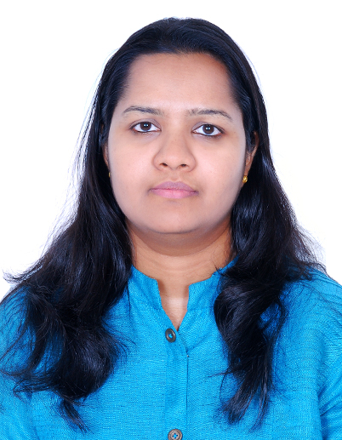

Tess Abraham (M.Tech_Structural Engineering)

Civil Structural Engineer (G+4 Dubai Municipality qualified)

+971 56 269 9782│ tesskvg@gmail.com

|  |
| --- |
| **Profile Summary** |

|  |
| --- |
| * Civil Structural Engineer with over 12 years of engineering experience specifically related to Cement and Mineral Plants, Oil & Gas, Residential & Commercial buildings. * Led successfully medium Scale Projects (approx. 250 million $) as Lead Engineer overseeing a team of 10 persons with high degree of focus on co-ordination of Engineering, Procurement and Site activities. * Accomplished cost optimization in overall Civil/Structural Material Cost for the projects executed by lean design principles and with excellent Client management skills * Proficient with International Codes and standards i.e. BS, IS and AISC Standards and able to use of software's i.e. STAAD PRO, AUTO CAD, LIMCON, HILTI and TEKLA. |
| **Professional Experience** |
| * **Senior Structural Engineer for German Steel Contracting LLC, Ajman, U.A.E Since August 2018.**  1. Analysis & Design of steel structures for Commercial, industrial and Residential high-rise buildings in UAE 2. Preparation of Design document for Municipality approval 3. Perform Seismic Analysis for the buildings 4. Estimation of structural and miscellaneous steel based on the Architectural drawings 5. Coordination of structural steel with Architectural and MEP drawings  * **Senior Lead Engineer for FLSMIDTH Pvt Ltd, Chennai, India from Oct 2014 till Dec 2017**.  1. Analysis & Design of various structures in Cement Plants including Preheater buildings, Cement mill feed Building, Palletizer sheds, Sub stations, Conveyors and Transfer Towers including Foundations 2. Analysis and Design of Static and Dynamic Equipment Foundations 3. Preparation of Budget B.O.Q, Procurement B.O.Q and As Engineered B.O.Q. 4. Responsible to closely coordinate with other disciplines for obtaining correct information in timely manner for scheduling structural deliverables without compromising on quality and optimized budget. 5. Meticulous planning on change control mechanism on structural deliverables resulted through various changes like Mechanical DCN, Vendor data to have minimum effect on fabrication and erection. 6. Implementing QA procedures in the team to meet quality objectives of the company which is customer satisfaction as goal. 7. Coordination with the clients to interpret their needs & requirements and representing them in the field. 8. Control project plan by reviewing design, specifications, plan and schedule changes and recommending corrective actions. 9. Provide engineering support during construction and assist in inspection, commissioning, snagging, and startup.  * **Structural Engineer for Vector Shades Engineering Services, Cochin, India from Jul 2012 till Aug 2014**  1. Analysis and design of various steel and PEB structures serving commercial purpose. 2. Analysis and design of institutional buildings like schools and university. 3. Preparation of Standardized Connection Design drawings (Moment, Shear & Bracing connections) & detailed report using self-developed Spread sheets.  * **Project Engineer for Pan gulf technologies Pvt Ltd, Mumbai, India from Jan 2011 till May 2012**  1. Preparation of Technical Document Register, identify requirements and scope of work, reviewing specifications, Plot plans, General Arrangement drawings, and other relevant documents 2. Analysis and Design of steel Pipe rack Structures and technological buildings including Connections 3. Quantity estimation based on bid document.  * **Design Engineer for Aar Bee Structures Pvt Ltd, Bangalore, India from Aug 2006 till Oct 2010.**  1. Preparation and Checking of Tekla Models for Various Steel Buildings including Power Plants and Commercial Structures. 2. Preparation & Checking of fabrication drawings & Erection drawings and ensure delivery at proper schedule with thorough checking of weld & member designation. 3. Preparation of RFI & Design documentation. 4. Preparation of preliminary material take-off, Bill of Material, Bolt list  |  | | --- | | **Key Skills** |  * Preparation of Project reports and Project Specifications * Preparation of design document for the statutory approval * Preparation of Man Hour Estimate and Project Schedule * Preparation and Verification of Bill of Quantities covering grading & levelling, excavation, trenches, embedded items, grouting, concrete, road works and fencing, steel, and fireproofing * Familiarity with design in all commonly used building materials. * Analysis and Design of Structural Steel buildings, technological structures, pipe racks etc. including Connection Design * Analysis and Design of RCC Structures including Foundations * Analysis and Design of Static/Dynamic Equipment Foundations * Review and Checking of Vendor Drawings and Design Documents * Coordination with Clients, Fabricators, EPC Contractors and Manufacturers   Able to move projects from Concept through detailed design, and final handover |
| **Notable Projects Undertaken** |
| * UC HOTEL 4-STAR Double Tree by Hilton Sharjah   + Design Standard – AISC * Downtown views Canopy, EMAAR Properties, Dubai   + Design Standard – AISC * Mobility Signature Pavilion Amphitheatre, Expo Dubai * Design Standard – AISC * Gulf Nations Construction Material Company Cements, Kuwait   + Design Standard - British Standard   + Steel Tonnage – 5000 Tons   + RCC – 20,000 M3 * Oman Cements, Oman   + Design Standard - British Standard   + Steel Tonnage – 4000 Tons   + RCC – 45,000 M3 * Cielo Azul Cementos, Uruguay   + Design Standard - British Standard   + Steel Tonnage – 8000 Tons   + RCC – 30,000 M3 * Riddhi Siddhi Cements, Nepal   + Design Standard - Indian Standard   + Steel Tonnage – 12000 Tons   + RCC – 50,000 M3 * UltraTech Cements, Alwarpur, India   + Design Standard - Indian Standard   + Steel Tonnage – 4000 Tons   + RCC – 25,000 M3 * Tampa University Residence Building, Tampa – USA   + Design Standard - AISC   + Steel Tonnage – 300 Tons * Paradip Refinery _IOCL, India   + Design Standard - Indian Standard   + Steel Tonnage – 200 Tons   + RCC – 5,00 M3 |
| **Educational Qualifications and Certifications** |
| * M. Tech – Structural Engineering from SRM University, Chennai, India * B. Tech - Civil Engineering from Government Rajiv Gandhi Institute of Technology, Kerala, India |