After School and Summer Programs Help Students Learn:

Empathy Teamwork Conflict Resolution
Manners Leadership Self Confidence

Patience Communication Physical Fitness
Diversity Sportsmanship Problem Solving
Creativity Responsibility Self Control

Which of these will they need in the Workplace?
….in the Community?
….in their Families?
….in their Schools?
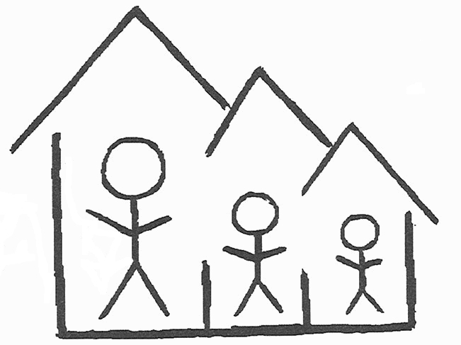

BELIEVE IN BALTIMORE

BELIEVE IN ME

Fitness Fun & Games

