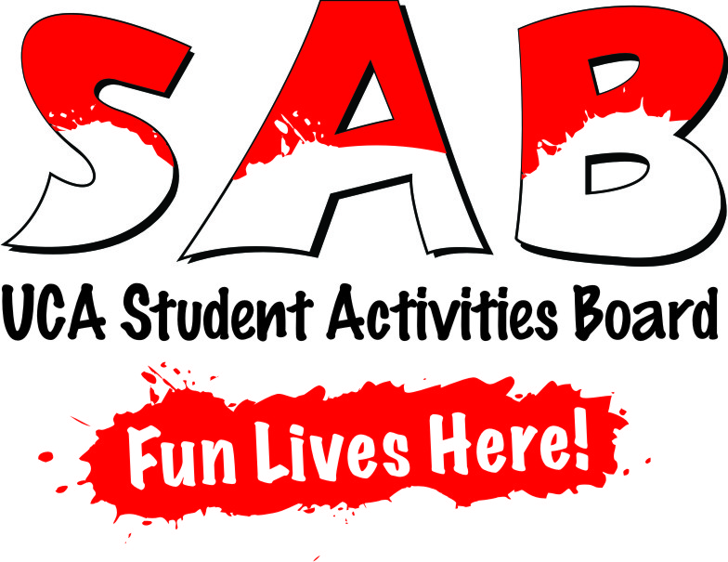

After you turn in the attached application we will assign you to a team. You will be under one of the Executive Board Members, and they will use your e-mail to contact you throughout the year about upcoming events and also to let you know WHERE to go and WHEN to be there. Your chairperson is your lifeline!

Although you will be a part of a team, we are all one collective SAB, and we expect everyone to participate in every different type of SAB event.

SAB Committees

Film-We bring entertainment to the students of UCA through popular NEW movies that have not made it to DVD/Blu-Ray/VHS/Laserdisc/iTunes/ Netflix. We always have lots of free pizza, popcorn, and soda at our “Sunday Night at the Movies” series. And did we mention…DoOr PrIzEs????!!!

Pop-Culture- Examples of the events that Pop-Culture have brought in the past include: Holocaust Survivor, Nesse Godin; Chuck D; and Malcolm Jamal Warner. SAB has also hosted the Discovery Channel’s “Extreme Storm Chaser”, Reed Timmer; Charlie Todd, the founder of “Improv Everywhere”; and David Coleman, the famous “Dating Doctor,” who was the inspiration for The blockbuster movie, “Hitch.”

Novelty- This area of SAB focuses on wild rides and the unusual. Motion Simulators, Rock Walls, Spray Paint Artists, Laser Tag and Caricatures are a few events sponsored by this committee. In the spring, we have a huge Spring Fling Carnival that is always something to look forward to!

Comedy- SAB brings many hilarious, popular comedians throughout the year. We always plan one huge comedy event as well. Past acts include Dave Chappelle, Jimmy Fallon, Demetri Martin, and Daniel Tosh!

Music- We bring a handful of smaller and local musicians throughout the year and also put on a huge Spring show. Some of the big artists in the past include Gavin DeGraw, David Cook, Dierks Bentley, Jimmy Eat World, and Train.
Student Activities Board Application
(Please print)

Name________________________ Hometown_____________________
Classification__________________ Major________________________
E-mail_______________________ Phone Number__________________
Shirt Size: S M L XL 2XL
Live in a Residence Hall? Which One? ____________________________
In what ways could you make a significant contribution to SAB?
______________________________________________________________________________________________________________________________________________________________________________________________________________________________________________________________________________________________________________________

List your top 3 favorite musicians/bands, films, and comedians of ALL TIME!!

Musicians Films Comedians
__________________ __________________ __________________
__________________ __________________ __________________
__________________ __________________ __________________

What is one fun show or activity you would want to see at UCA (sky is the limit)?
________________________________________________________________________________________________________________________________________________________________________________________________________________________________________________________

List some activities you are involved in at UCA or were involved in during High School:
________________________________________________________________________________________________________________________________________________________________________________________________________________________________________________________

Do you have any friends that are involved or are planning to be involved in SAB? If so, list them:
________________________________________________________________________________________________________________________________________________________________________________________________________________________________________________________

*Please turn in the application to the SAB office (Student Center 207) or to Kendra’s Office (Student Center 206).

**Your assigned Executive Board Member will call you once we have reviewed your application!!

