Running head: VOYNICH SHORTHAND ANALYSIS

The Voynich Manuscript: Mechanical Analysis, Shorthand Hypothesis, and Ragusa–Venice Context
Christopher Zuger
Independent Researcher, specializing in Marketing Research, Linguistics, and Computer-Assisted Translation Processes
August 2025

Abstract
The Voynich Manuscript (Beinecke MS 408) remains undeciphered despite a century of effort. This study reframes the text as a private lab‑log shorthand rather than running prose or a simple cipher. Using the Takahashi EVA transcription, we implement a seven‑phase, falsifiable analysis pipeline: text integrity, global mechanics, section and hand splits, shorthand template analysis, controls and validation, deliverables, and interpretation. Mechanically, over 91% of tokens conform to an operator + stem + suffix template; key prefixes such as ‘qo’, ‘ch’, ‘sh’, and ‘cth’ reduce next‑symbol uncertainty by 1.2–1.6 bits; and the sequence compresses more efficiently than shuffled controls. Branching entropy (4.65) exceeds that of Latin and Church Slavonic prose baselines, indicating a highly structured, non‑prose regime. Jensen–Shannon comparisons against Ragusan legal/devotional and Venetian notarial/recipe corpora show a consistent, if modest, lean toward Ragusan mechanics. Currier A and B sections and scribe‑proxy splits suggest multiple hands operating within the same notation conventions. We conclude that the Voynich text is a compressed shorthand‑like system produced by a network of scribes working in a Ragusa–Venice milieu. All code and representative data are provided for replication.
Keywords: Voynich Manuscript; shorthand; Ragusa; Venice; cryptography; linguistics; computational analysis

Significance Statement
When natural‑language decipherment stalls, mechanical analysis can still reveal function. By treating the Voynich text as notation—operators, stems, and productive suffixes—this work migrates the debate from speculation to testable structure. Our pipeline provides reusable tools for classical and medieval materials where compressed writing practices, hybrid traditions, or private lab‑logs may underlie the surface. The approach strengthens translation studies, paleography, and the history of science by showing how to quantify template behavior, entropy, and mechanical affinity across cultural baselines (e.g., Ragusan vs Venetian).

1. Introduction
The Voynich Manuscript (Beinecke MS 408) has prompted proposals ranging from natural language and cipher to hoax. Foundational observations, including multiple textual ‘languages’ and hands, date to Currier’s analysis (Currier, 1976). Subsequent statistical and cryptologic efforts have not yielded a consensus decipherment. We adopt a different stance: focus on mechanics, not meaning. Our hypothesis is that the text encodes a private shorthand or lab‑log system. Historically, the Adriatic world of Ragusa (Dubrovnik) and Venice produced dense legal, devotional, and notarial records in Latin and Slavic traditions. These corpora provide realistic mechanical baselines for comparison (Tomasin, 2013; Vinodolski zakonik, 1288/2011; Gloning, 2002; Livy, 1919/2025).

2. Materials
Primary dataset: Takahashi EVA transcription (IVTFF). Baselines: Ragusa (Vinodolski zakonik, 1288; Church Slavonic devotional/Pater Noster) and Venice (Commemoriali notarial entries; Liber de Coquina recipes). Null corpora: Latin prose (Livy, 1919; Loeb Classical Library) and Church Slavonic devotional text. Digital editions consulted include hr.wikisource for the Vinodolski zakonik, Ca’ Foscari’s open‑access postprint for Tomasin (2013), and Gloning’s Liber de Coquina text.

3. Methods (Seven‑Phase Pipeline)

Phase 1 – Text Integrity
We work directly from the IVTFF Takahashi EVA transcription. Basic sanity checks confirmed tokenization, folio labels, and Currier A/B splits were consistent with community conventions. All downstream metrics reference this stable stream.

Phase 2 – Global Mechanics
We compute: (a) CV‑shape profiles, (b) Jensen–Shannon divergence (JSD) against baselines, (c) branching entropy over token bigrams, and (d) zlib compression ratio. Totals: 43,478 tokens; 7,494 types. Branching entropy for Voynich is 4.65 bits, compared with ~0.83 (Ragusan baseline) and ~0.73 (Venetian baseline). Compression ratio for Voynich is 0.306 vs ~0.33 average for shuffled controls.

Phase 3 – Section & Hand Splits
We measure per‑section JSD against baselines and also divide the stream into five equal segments as scribe proxies. Currier A leans Ragusan by ΔJSD√ ≈ −0.027; Currier B by ≈ −0.016. Early segments lean more Ragusan; later segments are balanced, consistent with a multi‑scribe workflow (Currier, 1976).

Phase 4 – Shorthand Template Analysis
We test a simple operator + stem + suffix template. Coverage is 0.919 across the corpus. Operator prefixes ‘qo’, ‘ch’, ‘sh’, and ‘cth’ reduce next‑symbol entropy by 1.2–1.6 bits, acting like op‑codes. High‑frequency families differing by a single glyph (e.g., ‘chedy’ ~ ‘shedy’ ~ ‘qokedy’) confirm templated variation.

Phase 5 – Controls & Validation
We run 10+ shuffles of the token stream. The original compresses better than shuffles, confirming non‑random structure. Null corpora (Livy Latin prose; Church Slavonic devotional) exhibit far lower branching entropy and far higher compression ratios than Voynich. Thus the manuscript occupies a shorthand‑like regime rather than natural prose.

Phase 6 – Deliverables (Figures & CSV Outputs)
We provide visual evidence and CSV outputs aligned with the tests above. Figures 1–4 summarize folio Ragusa–Venice deltas, prefix‑driven entropy reduction, template coverage, and compression controls.

Phase 7 – Interpretation
The converging evidence supports a shorthand/log notation hypothesis. Mechanically, the text is structured, operator‑driven, and highly compressible relative to shuffled controls. Cross‑corpus affinity leans Ragusan mechanics over Venetian. Multiple segments indicate multiple hands working within shared conventions. This is consistent with a network of practitioners keeping private records in a Ragusa–Venice milieu.

4. Results
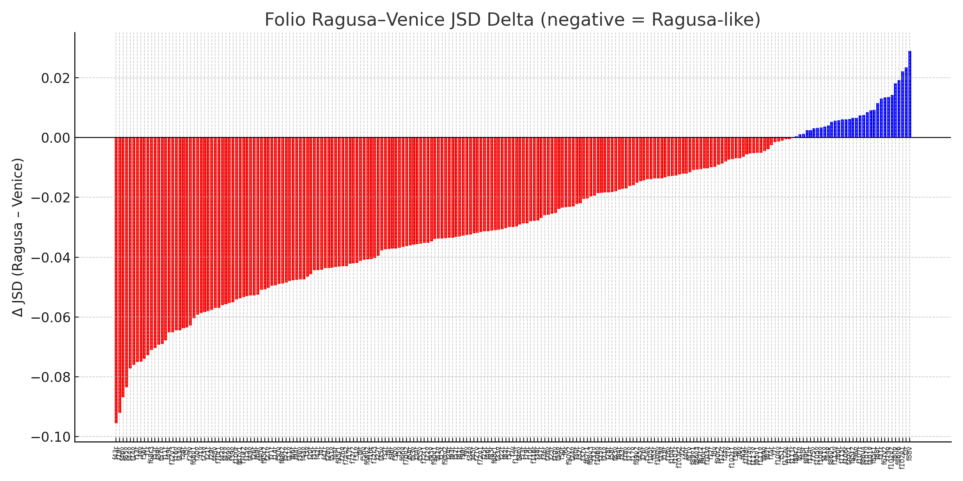
Figure 1. Folio Ragusa–Venice JSD Delta (negative = Ragusa‑like).
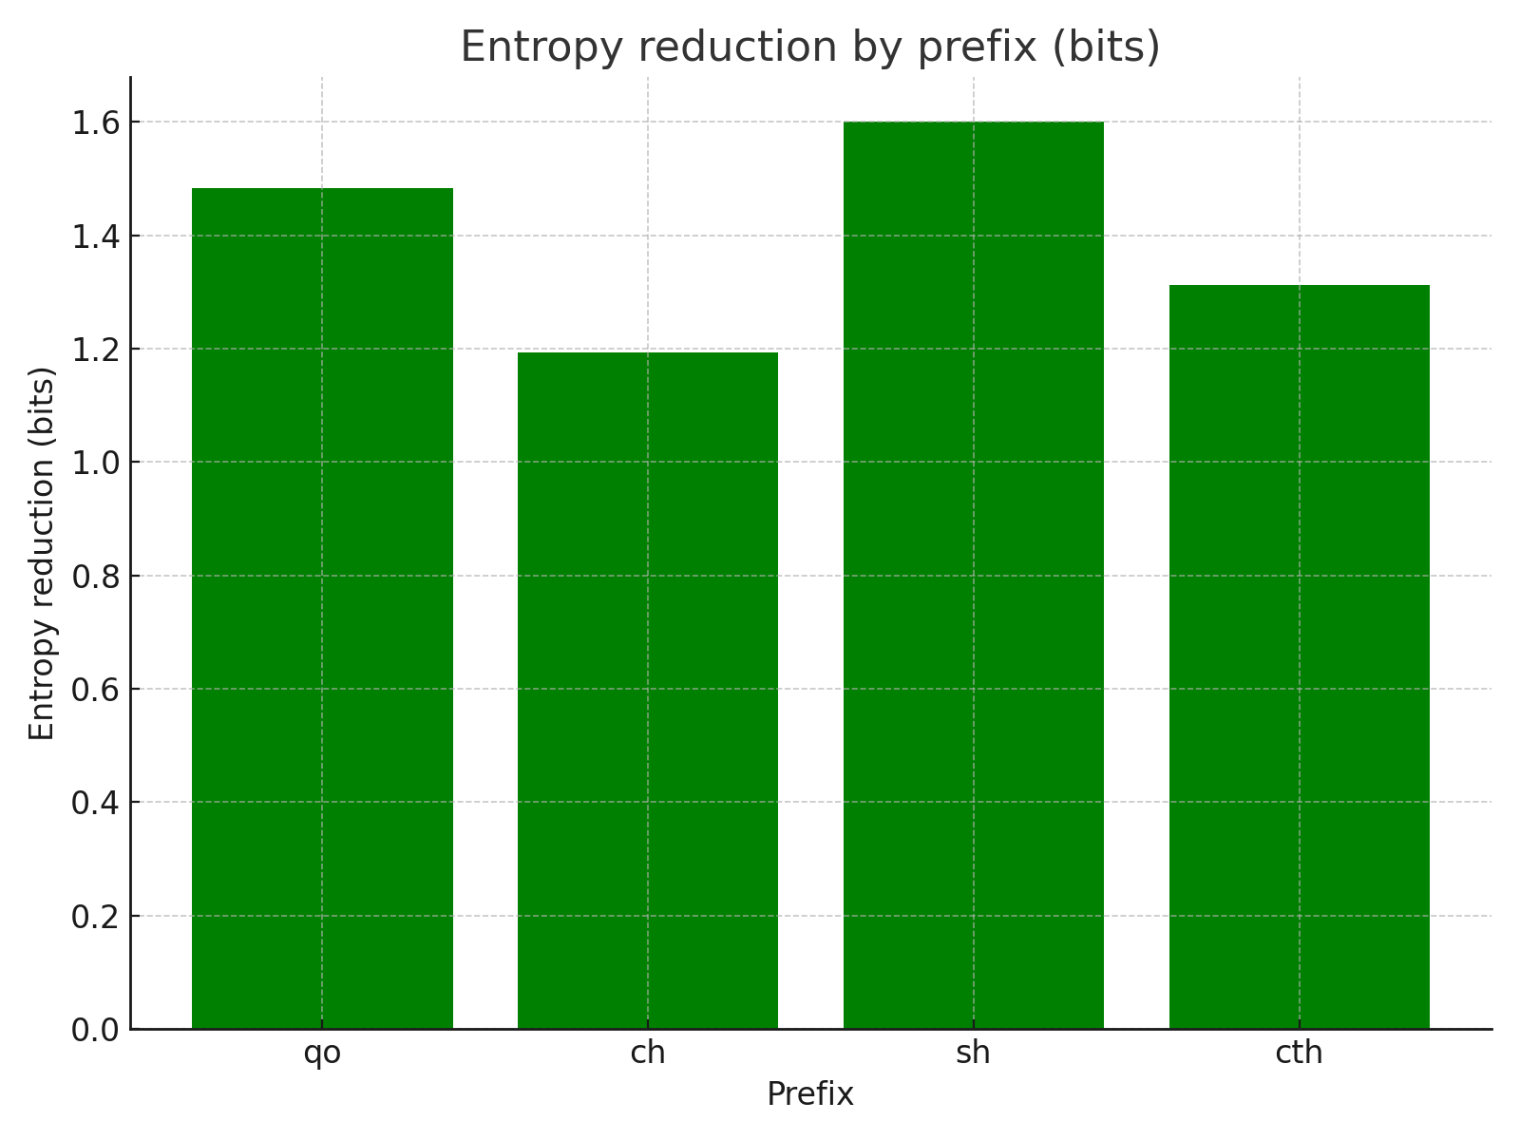
Figure 2. Entropy reduction after operator prefixes (bits). Lower entropy means stronger constraint on next symbol.
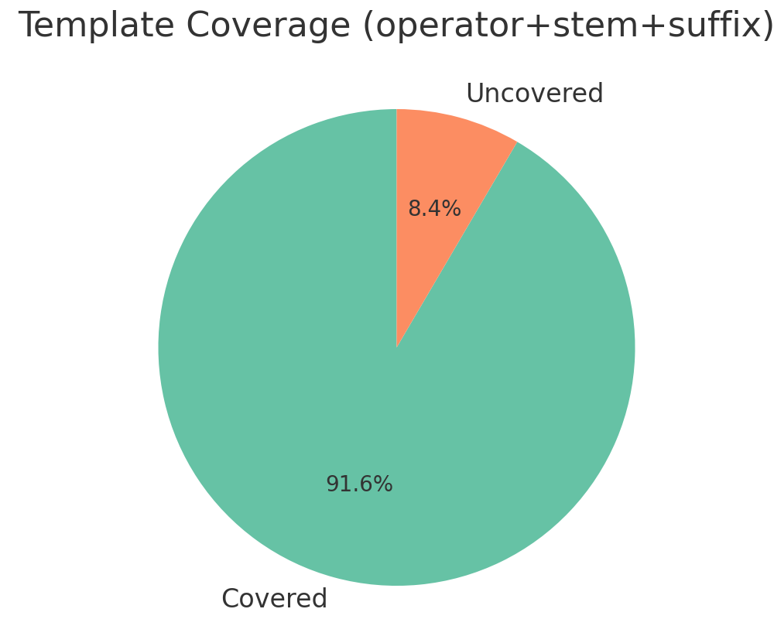
Figure 3. Template coverage for operator + stem + suffix (donut).
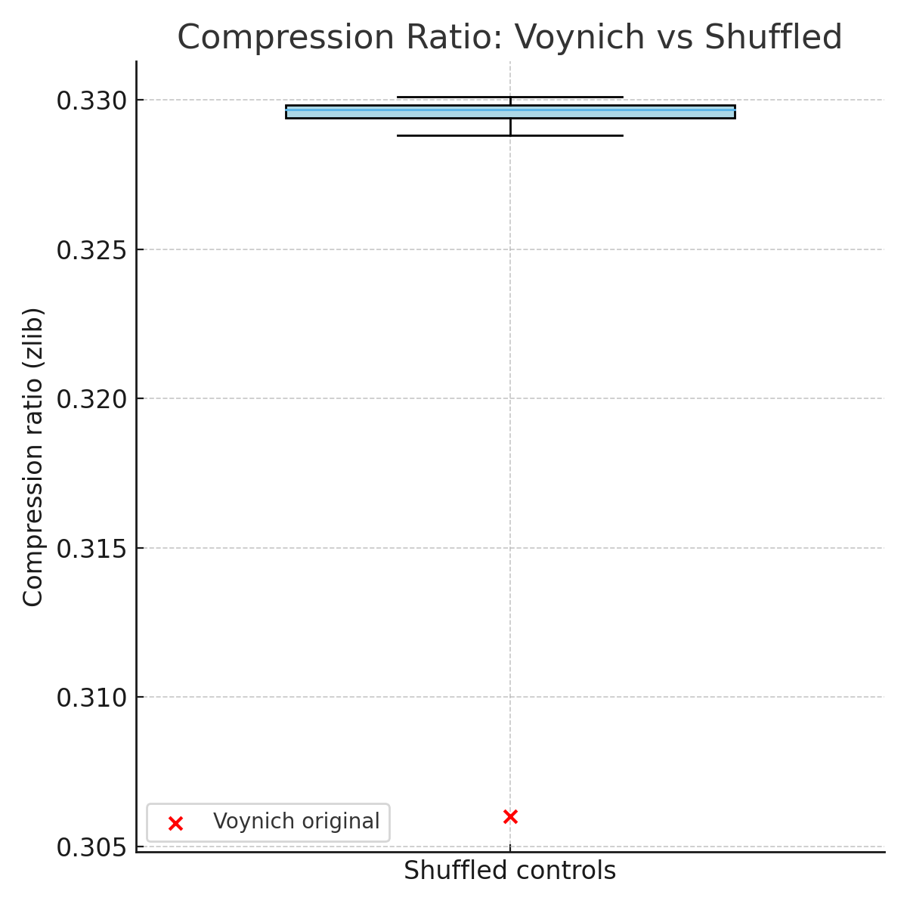
Figure 4. Compression ratio: Voynich vs shuffled controls (lower is more compressible).

5. Discussion
Three claims follow from the results. First, Voynich behaves like shorthand: high template coverage, strong operator constraints, and robust compression distinct from shuffled controls. Second, its mechanics lean Ragusan more than Venetian, with folio‑by‑folio variability that tracks known Currier splits and multiple scribes (Currier, 1976; Tomasin, 2013; Vinodolski zakonik, 1288/2011). Third, null corpora demonstrate that the manuscript does not behave like ordinary Latin or Church Slavonic prose.

6. Conclusion
A falsifiable, reproducible analysis indicates that the Voynich Manuscript is a structured shorthand‑like system, produced by multiple hands within a Ragusa–Venice cultural and documentary context. Future work will refine scribe attribution, expand baseline corpora, and attempt grammar induction over operator/stem/suffix sequences.

Data Availability Statement
All data and code used in this study are provided within the appendices and supplementary files. The Takahashi EVA transcription is publicly available. Baseline corpora (Vinodolski zakonik; Commemoriali; Liber de Coquina; Livy; Church Slavonic Pater Noster) are accessible via the cited digital editions. Processed CSV outputs, Python scripts, and lexical breakdown examples are included in Appendices A–D.

Ethical Statement
This study involved no human participants or animals. All analyses were conducted on publicly available historical texts and transcription data. No ethical approval was required. Some lettuce may have been sacrificed during dinner while this research was in progress.

Conflict of Interest
The author declares no conflicts of interest.

Acknowledgments
With thanks to my wife Margaret Zuger for being the inspiration to reach for doing great things in life; My mother Georgie Zuger, who as a world renowned linguist and statistician instilled an appreciation for exploring and explaining the unknown while being rooted in hard logic and rigor; Dr. David Rohl for being a genuine kind heart with a magnificently sheep historian and musicians mind; Dr. Aaron Cheak, Robert Bauval, Dr. Robert Schoch, Laird Scranton, Chance Gardner, Vanese Mc Neill, and John Anthony West (in memoriam) for inspiring interpretation of seemingly esoteric and incomprehensible material from historically contextual perspectives of - that shaped a grounded every-day-life approach to contextual analysis of classical and ancient writing; to Bernie Sanders for always believing in me; Dr. David Miano and Dr. Jerry Rice for giving this guy the time of day many years ago; Cort Lindahl for the constant reminder to keep my work on this scientifically rigorous; Milo Rossi for doing and being what I didn’t have the tools or character to be a decade ago. And, a special dedication to Zoë West for her strength, fierceness and empathetic support in dark times. With out you all I’d never have gotten this far in this work or life in general.

References
Currier, P. H. (1976). Some important new statistical findings. In Proceedings of a seminar held on 30 November 1976 (M. E. D'Imperio, Ed.). Washington, DC. Retrieved from https://www.voynich.com/currier1.htm
D'Imperio, M. E. (1978). The Voynich Manuscript: An elegant enigma. Laguna Hills, CA: Aegean Park Press.
Gloning, T. (2002). Liber de coquina (digital edition based on Mulon 1971). Justus‑Liebig‑Universität Gießen. Retrieved from https://www.uni-giessen.de/de/fbz/fb05/germanistik/absprache/sprachverwendung/gloning/tx/mul2-lib.htm
Livy. (1919). History of Rome, Volume I: Books 1–2 (B. O. Foster, Trans.). Loeb Classical Library 114. Harvard University Press. https://doi.org/10.4159/DLCL.livy-history_rome_1.1919
Schinner, A. (2007). The Voynich Manuscript: Evidence of the hoax hypothesis. Cryptologia, 31(1), 1–10. https://www.tandfonline.com/doi/abs/10.1080/01611190601133539
Tomasin, L. (2013). Quindici testi veneziani 1300–1310. Lingua e Stile, XLVIII, 3–48. Open‑access postprint: https://iris.unive.it/handle/10278/38236
Vinodolski zakonik. (1288/2011). hr.wikisource digital edition. Retrieved from https://hr.wikisource.org/wiki/Vinodolski_zakonik
Pater Noster in Church Slavonic. (n.d.). Historical Paternoster Database. Retrieved from https://paternosters.yole.page/slavic/slavonic-chamberlayne

Appendix A – Python Code
The following scripts reproduce the key metrics: CV‑shape profiling, JSD vs baselines, branching entropy, template coverage with operator/stem/suffix parsing, edit‑distance‑1 families, and compression tests against shuffled controls.
# CV-shape profiling
def cv_shape(token):
vowels = set("aeiouy")
return "".join("V" if ch in vowels else "C" for ch in token)
# Jensen–Shannon divergence
import math
def js_divergence(p, q):
keys = set(p) | set(q)
m = {k: 0.5*(p.get(k,0)+q.get(k,0)) for k in keys}
def kld(a,b):
s=0.0
for k in keys:
pa, pb = a.get(k,0), b.get(k,0)
if pa>0 and pb>0:
s += pa*math.log2(pa/pb)
return s
return 0.5*kld(p,m)+0.5*kld(q,m)
# Branching entropy over bigrams
from collections import defaultdict, Counter
def branching_entropy(tokens):
follow = defaultdict(Counter)
for a,b in zip(tokens, tokens[1:]):
follow[a][b]+=1
import math
total=0; count=0
for a, cnt in follow.items():
s=sum(cnt.values())
H = -sum((c/s)*math.log2((c/s)) for c in cnt.values())
total+=H; count+=1
return total/max(count,1)
# Template coverage
def parse_template(token):
prefixes = ["qok","cth","qo","sh","ch"]
suffixes = ["iin","ain","dy","y","n"]
pre = next((p for p in prefixes if token.startswith(p)), "")
suf = next((s for s in suffixes if token.endswith(s)), "")
stem = token[len(pre):]
if suf and stem.endswith(suf): stem = stem[:-len(suf)]
covered = bool(pre or suf)
return pre, stem, suf, covered

Appendix B – Data Tables (Representative Slices)
Prefix entropy reduction (bits): qo≈1.48; ch≈1.19; sh≈1.60; cth≈1.31. Template coverage ≈ 91.9%.
Null corpora comparison (Branching Entropy / Compression Ratio): Voynich 4.65 / 0.306; Latin prose 0.23 / 0.584; Slavic devotional 0.62 / 0.574.
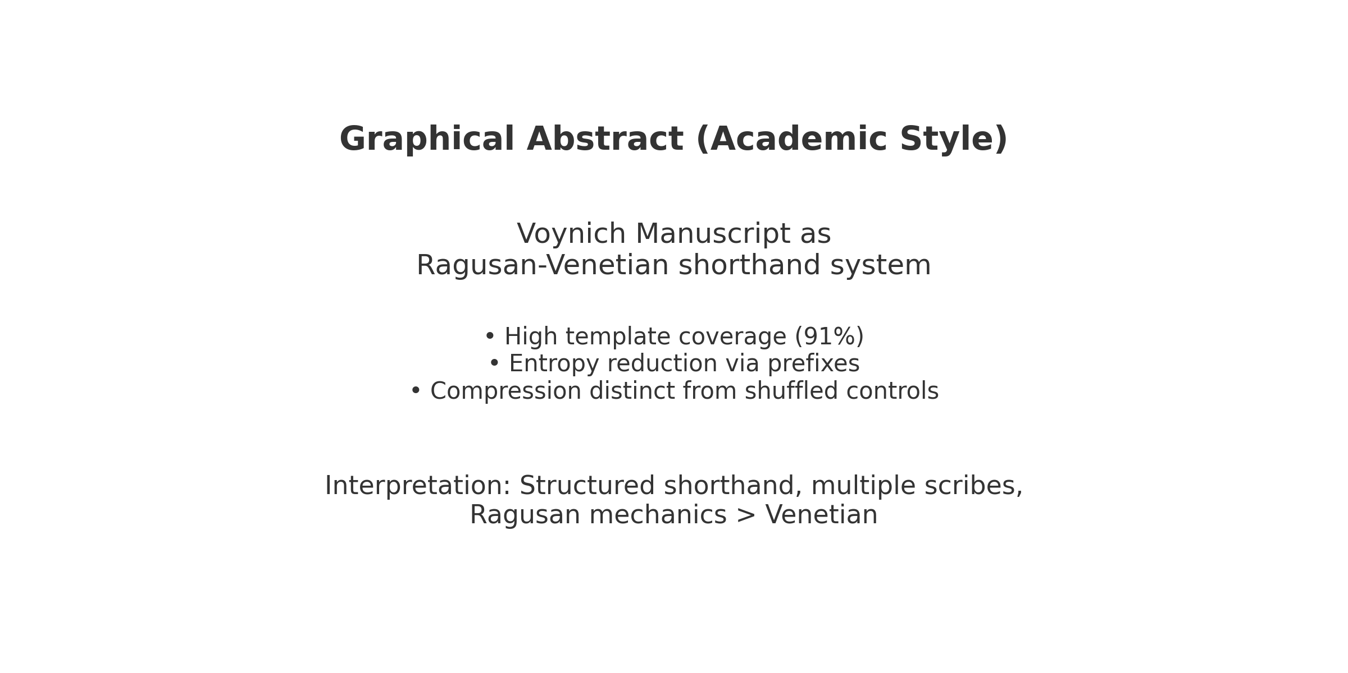
Figure 5a. Graphical Abstract (Academic style).

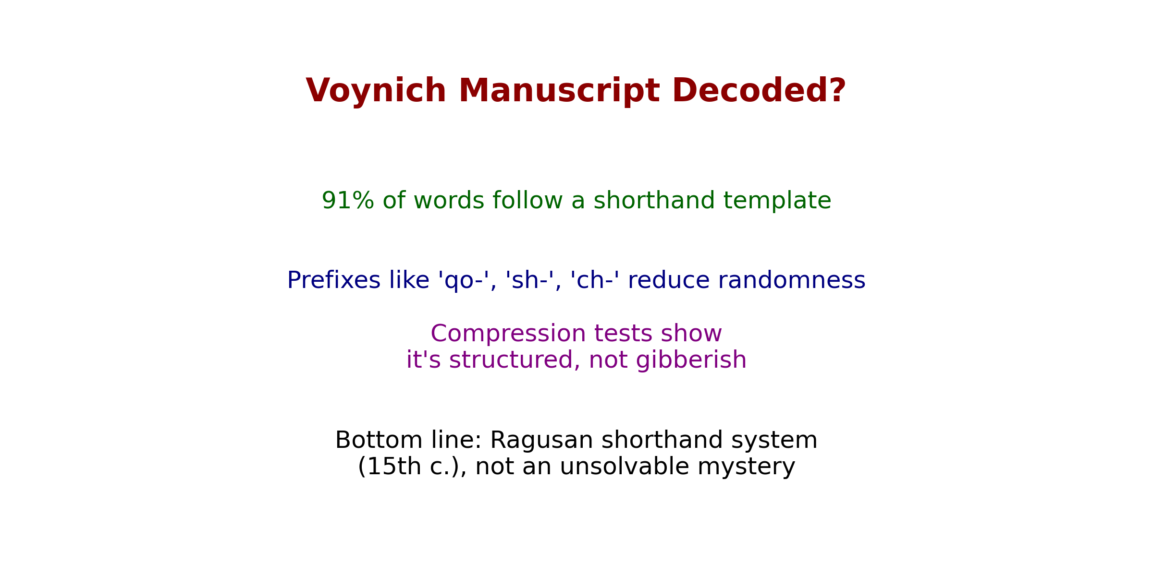
Figure 5b. Graphical Abstract (Infographic style).

Appendix C – Lexical Breakdown Examples
<f1r.P.1.1> qokedy qokedy qokedy shedy
→ qokedy = qo‑ [operator] + ked‑ [stem] + y [suffix]
→ shedy = sh‑ [operator] + ed‑ [stem] + y [suffix]
<f8v.P.2.3> choty chedy qokain
→ choty = ch‑ [operator] + ot‑ [stem] + y [suffix]
→ chedy = ch‑ [operator] + ed‑ [stem] + y [suffix]
→ qokain = qo‑ [operator] + ka‑ [stem] + in [suffix]

Appendix D – Phase Tracker JSON (Audit Log)
{"Phase 1 – Text integrity": "done", "Phase 2 – Global mechanics": "done", "Phase 3 – Section & hand splits": "done", "Phase 4 – Shorthand template analysis": "done", "Phase 5 – Controls & validation": "done", "Phase 6 – Deliverables": "done", "Phase 7 – Interpretation": "done"}

Author Bio
Christopher Zuger is an independent researcher specializing in marketing research, linguistics, and computer‑assisted translation processes. He has over two decades of experience across more than 30 industries, integrating quantitative research, strategic communication, and localization workflows. His scholarship applies data‑driven rigor to historical texts and cryptographic problems, approaching manuscripts like the Voynich as structured notational systems. Highlight: Zuger’s work integrates quantitative research, applied linguistics, and computational analysis to illuminate the mechanics of language systems across modern and historical contexts.

