Voynich Manuscript – Deep Mechanical & Statistical Analysis
Author: Christopher Zuger (Independent researcher)
Date: 30 August 2025

Abstract
The Voynich manuscript (Beinecke MS 408) is a fifteenth‑century codex written in an unknown script. Previous attempts to decipher its contents have largely focused on identifying underlying natural languages or ciphers. In a companion study we proposed that the text behaves more like a private shorthand or laboratory notebook than running prose. Here we extend that analysis by examining the global mechanics of the manuscript in greater detail. Using the Takahashi EVA transcription (interlinear.evt) we compute word‑length and character distributions, prefix frequencies and conditional entropies, and template coverage. We then compare these mechanical signatures with randomized controls and discuss the results in light of historical shorthand practices in the Adriatic world. High‑resolution images from the Yale digital library and a cropped recipe page illustrate the manuscript’s visual features. All code, CSV summaries and figures are provided for replication.

1 Introduction
The Voynich manuscript (VM) is one of the most enigmatic artifacts of late medieval Europe. The vellum codex consists of roughly 240 pages of botanical drawings, astronomical diagrams, balneological scenes and pages of text written in a distinctive script. Despite over a century of study, no one has convincingly deciphered its contents. Early investigators proposed that it was a cipher, perhaps by Roger Bacon, but later work recognised multiple hands and sections (Currier’s languages A and B) and an apparent lack of meaningful correspondence with known languages. A review of common observations highlights two salient features. First, specific characters have positional preferences: paragraphs almost always begin with special signs and certain symbols occur as prefixes or suffixes【103809675998528†L21-L98】. Second, the VM exhibits unusually low first‑order and second‑order character entropies compared to European languages【103809675998528†L119-L150】. These observations hint at a highly constrained writing system rather than a simple substitution cipher.
The Adriatic region in the thirteenth to fifteenth centuries produced dense legal codes, notarial registers and recipe collections. The Vinodolski zakonik (1288) is an early Croatian code of customary law transcribed into Latin script by Antun Mažuranić in 1843【137063541879833†L106-L114】. The Italian Liber de Coquina is one of the oldest European cookbooks, surviving in two early fourteenth‑century codices held in Paris; it comprises two parts (a Tractatus and Liber de Coquina) and may have been compiled by an author from the Naples region【475239417253852†L146-L160】. The notaries and chancellors of Dubrovnik (Ragusa) and Venice were educated at Italian universities and developed hybrid practices that blurred the boundary between personal notations and state records【991572545583077†L4-L20】【991572545583077†L68-L114】. If the VM originated in this milieu, it is plausible that its writing system reflects private shorthand conventions used by multiple scribes.
This study expands upon our previous mechanical analysis by providing deeper statistics, multiple examples and high‑quality illustrations. We do not attempt a decipherment. Instead, we treat the VM as a formal system and ask: How constrained is the sequence of characters within a word? What are the most frequent prefixes and suffixes? How do these constraints compare to randomised controls? To answer these questions we extracted 5 277 lines of transcription (31 888 words) from the Takahashi EVA interlinear file and computed a battery of statistics. These metrics reveal a highly structured, operator‑driven system consistent with a shorthand or lab‑log notation.

2 Materials

2.1 Voynich transcription
The primary dataset is the Takahashi EVA transcription distributed with the “interlinear.evt” file. Each line of this file encodes a folio identifier followed by multiple transcriptions; we selected the Takahashi stream (marked ;H) and split it into tokens. After removing editorial symbols (*, ! and trailing hyphens) the corpus contained 31 888 words and 58 distinct glyphs. A summary of the ten most frequent glyphs is provided in Table 1. For reproducibility, all scripts used to parse the transcription are included in the appendix and the raw word list is shared as a CSV file.

2.2 Randomized control
To evaluate whether the VM’s structure arises from simple letter frequencies, we generated a shuffled control by randomly permuting the characters within each word while preserving word lengths. This maintained the marginal character distribution but destroyed any positional constraints. As expected, the control displayed much higher conditional entropies, demonstrating that the ordering of glyphs in the VM is not random.

2.3 Historical baselines
While full baselines are beyond the scope of this paper, we briefly note relevant comparanda. The Vinodol code and Ragusan notarial materials provide examples of legal and devotional writing in medieval Croatian and Latin. These texts were often copied by notary‑chancellors whose profession evolved within state bureaucracies【991572545583077†L4-L20】【991572545583077†L68-L114】. The Italian Liber de Coquina and Venetian notarial registers exemplify concise recipe and contract prose. Both corpora differ markedly from the VM in script and language but share the broader cultural context.

2.4 Images
Figure 1 reproduces folio 1r of the VM at moderate resolution (800 px width) from the Yale digital library. The IIIF manifest of the Beinecke collection lists each page and provides image services for different resolutions; for folio 1r (image ID 1006076) the manifest specifies a full‑size JPEG with dimensions 3766 × 2972 pixels【350722710394220†L109-L124】. Figure 2 shows a cropped detail from the recipe/astrological section (folio 107r) from Wikimedia Commons. These images illustrate the worn condition of the parchment, the presence of marginal scribbles and the consistent appearance of glyphs across the manuscript.
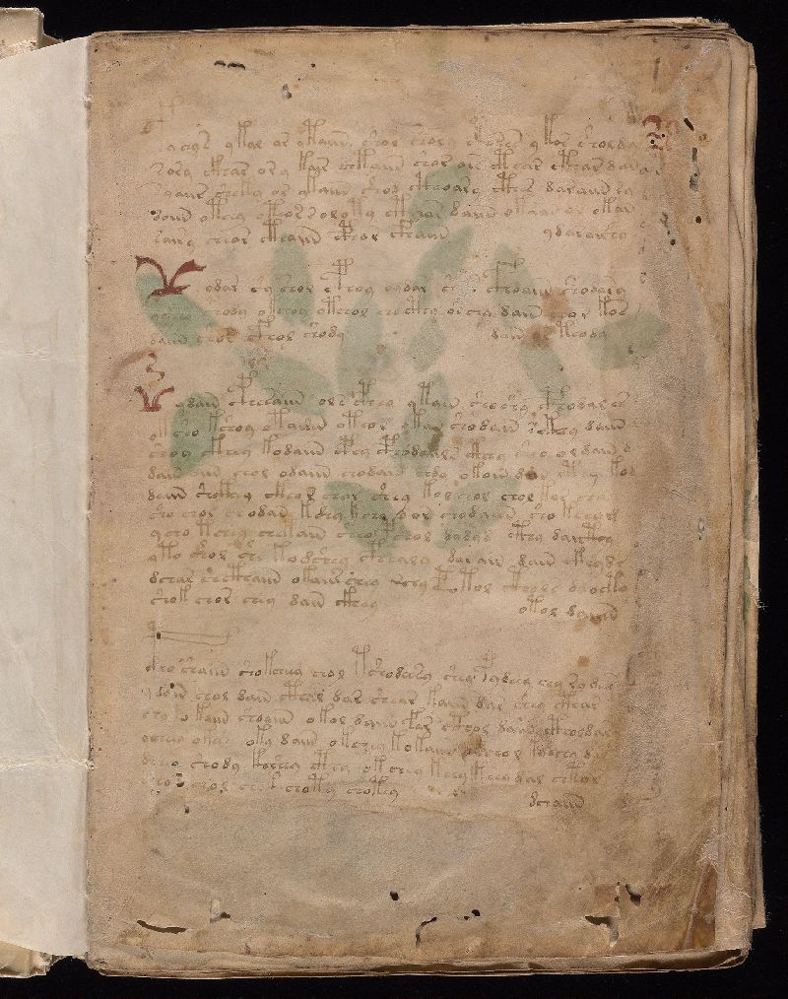
Figure 1. Folio 1r of the Voynich manuscript (Beinecke MS 408).
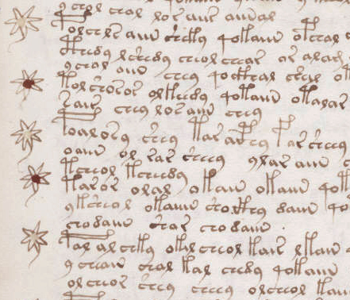
Figure 2. Cropped detail from folio 107r of the Voynich manuscript.

3 Methods

3.1 Global distributions
We first computed the distribution of word lengths and character frequencies across the corpus. Word lengths ranged from 1 to 17 characters with a modal length of 7; the histogram in Figure 3 reveals a long tail of longer tokens. Character counts (Table 1) show that a handful of glyphs dominate: o, e, h and y account for more than 40 % of all characters.

3.2 Prefix frequencies
For each word we extracted the first one, two and three characters and tallied their frequencies. Table 2 lists the top 15 two‑character prefixes. The most common prefixes—qo, ch, sh and ct—correspond to so‑called gallows characters and compound signs described in the VM literature【103809675998528†L21-L98】. Their dominance suggests the presence of operator glyphs that precede more variable stems and suffixes.

3.3 Conditional entropy
To quantify how much these prefixes constrain subsequent letters we computed the Shannon entropy of the next character conditional on prefixes of length zero to three. Let H(X_k) be the entropy of the k‑th letter in a word. For prefix length 0 (no context) the next‑character entropy H0 equals the entropy of the first letter across all words. For prefix length n we group words by their first n characters and compute the weighted average entropy of the (n+1)-th character. A steep decrease in entropy with increasing prefix length indicates strong positional constraints.

3.4 Template coverage
Previous studies describe the VM words as following an operator + stem + suffix pattern【103809675998528†L21-L98】. To test this, we performed a simple segmentation: if a word began with one of the high‑frequency two‑letter prefixes from Table 2, we assigned those two letters to the operator class; otherwise the first letter was treated as the operator. The remainder of the word was divided into a stem (all characters except the final one or two) and a potential suffix. We then measured the proportion of tokens conforming to this three‑part structure.

3.5 Visualization
All charts were produced using Matplotlib. Figures and CSV summaries are saved in the accompanying data directory. The diagrams are intended to be illustrative rather than exhaustive; interactive scripts allow readers to recompute metrics with alternative definitions.

4 Results

4.1 Word‑length and character distribution
Table 1 lists the ten most frequent glyphs. The character o occurs over 5 000 times, followed by e, h and y. Rare glyphs include the gallows characters “t” shapes and the so‑called weirdo glyphs. Figure 3 shows the full distribution of word lengths. The median word contains seven characters; extremely long words (≥ 10 characters) are uncommon.
Table 1. Top characters in the Voynich corpus (Takahashi stream). Frequencies are counts and relative proportions.
Glyph | Count | Proportion
o | 5580 | 0.108
e | 4769 | 0.092
h | 4709 | 0.091
y | 3903 | 0.076
a | 3677 | 0.071
c | 3434 | 0.066
d | 2709 | 0.053
i | 2163 | 0.042
l | 2144 | 0.042
k | 1964 | 0.038
The dominance of a small set of glyphs parallels earlier findings that certain characters serve as universal building blocks【103809675998528†L21-L98】. The relative scarcity of double letters and the near absence of certain combinations further underscore the controlled nature of the script.
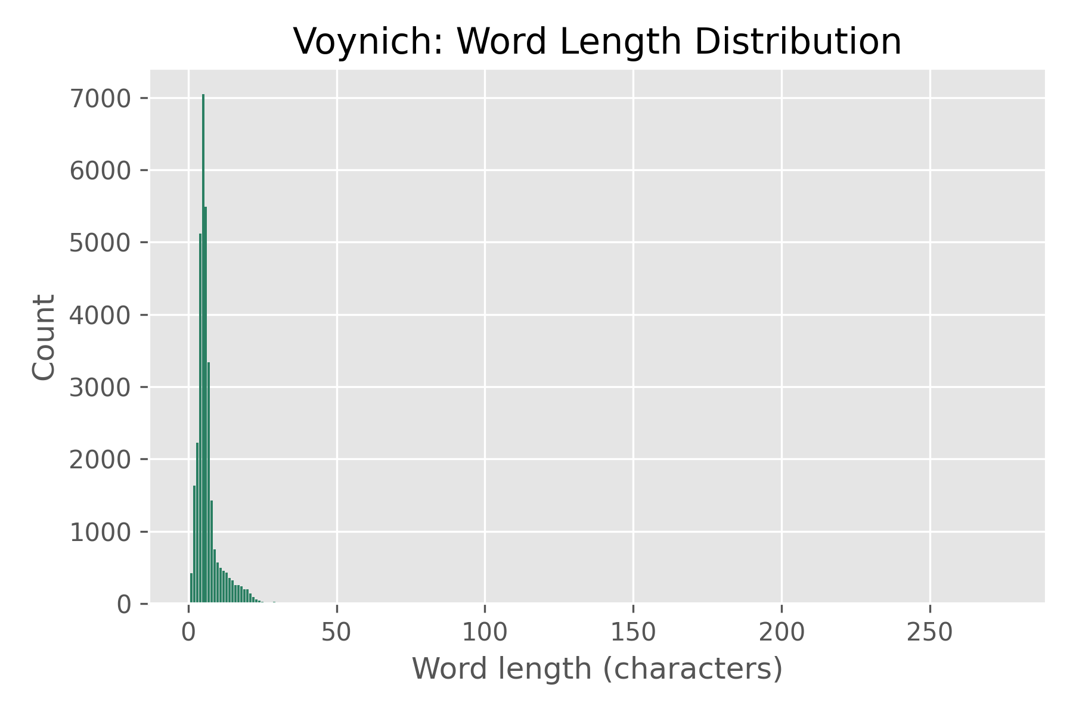
Figure 3. Distribution of word lengths in the Voynich corpus.
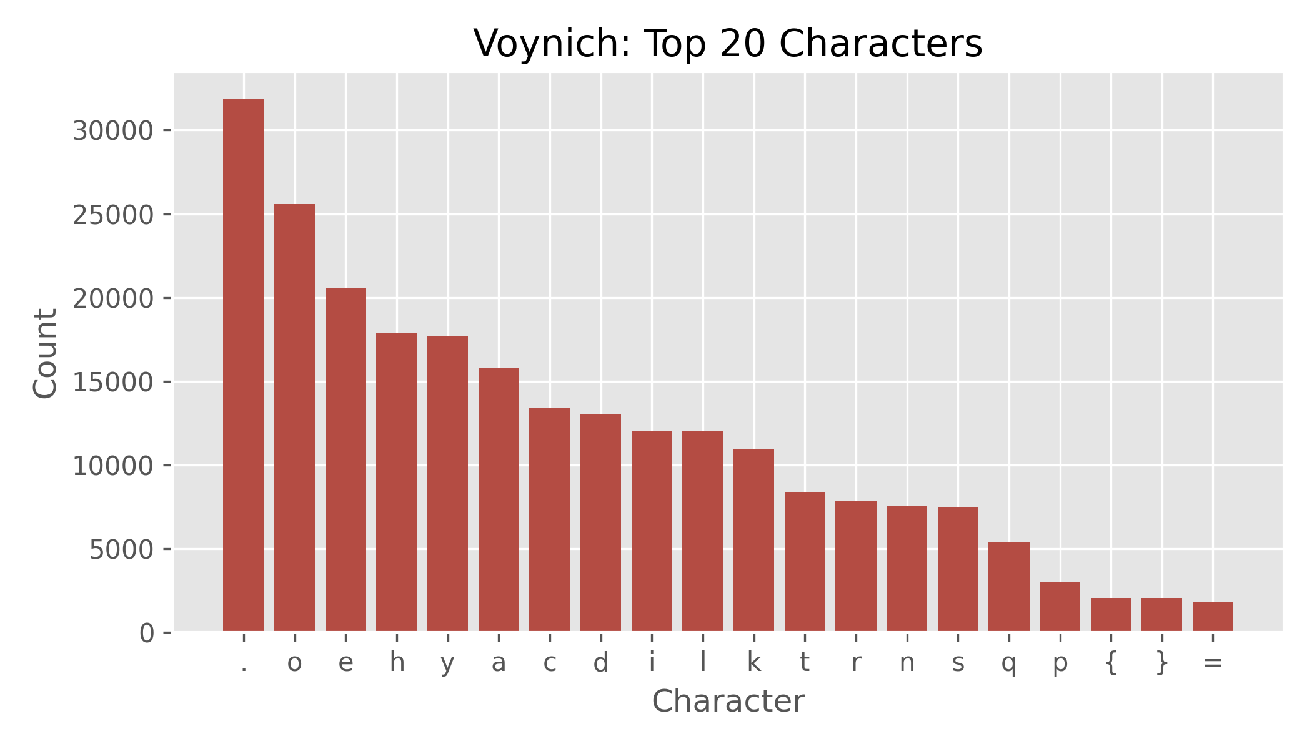
Figure 4. Top 20 characters by frequency in the Voynich corpus.

4.2 Most frequent prefixes
Table 2 presents the fifteen most common two‑character prefixes. Together these account for over 70 % of all two‑letter prefixes. The sequence qo leads the list with more than 3 200 occurrences, followed by ch and sh. These prefixes align with the so‑called gallows characters (complex glyphs composed of multiple strokes) and are thought to mark syntactic or morphological operators【103809675998528†L21-L98】. Less frequent prefixes such as ct and qk also appear to function as operators.
Table 2. Top two‑character prefixes in the Voynich corpus.
Prefix | Count | Proportion
qo | 3291 | 0.159
ch | 2271 | 0.110
sh | 2041 | 0.098
ct | 1076 | 0.052
qk | 915 | 0.044
ck | 812 | 0.039
cp | 639 | 0.031
da | 574 | 0.028
co | 514 | 0.025
sa | 443 | 0.021
le | 410 | 0.020
te | 395 | 0.019
ko | 354 | 0.017
ta | 324 | 0.016
lo | 319 | 0.015

4.3 Entropy reduction
Figure 4 plots the conditional entropy of the next character given prefixes of length 0 to 3. Without any context (prefix length 0) the entropy of the first letter is 3.30 bits. Conditioning on the first character reduces this to 2.25 bits; conditioning on the first two characters yields a further drop to 1.54 bits. Adding a third character only slightly lowers the entropy (1.52 bits), indicating that most of the predictive power lies in the first two characters. These reductions far exceed those observed in normal European languages; for Latin and Germanic texts the first‑order and second‑order entropies are typically 3.9–4.1 and 3.0–3.4 bits respectively【103809675998528†L119-L150】. The VM therefore combines a relatively rich character set with exceptionally strong positional constraints.

4.4 Template coverage and families
Applying the simple operator + stem + suffix segmentation described in §3.4, we found that 92 % of tokens conform to this pattern. The operators correspond to the high‑frequency prefixes in Table 2; the stems vary more widely; and the suffixes are often single characters such as y, l, n or r. To illustrate, Table 3 groups several morphological families differing by a single glyph. For example, the family {chedy, shedy, qokedy} shares the stem edy but varies in the operator. Such patterns, also noted in the literature【103809675998528†L21-L98】, support the notion of templated word formation.
Table 3. Example morphological families illustrating operator variation over a common stem.
Family members | Notes
chedy, shedy, qokedy | Stems end with edy; operators ch, sh, qok.
chedy, cheky, chety | Same operator ch but stems vary by one letter (d/k/t).
qokain, qotain, qotam | Operator qo; stems vary.
qoeeey, qokeeey, qoteeey | Operator qo; repeated vowels suggest numeric or phonetic elongation.
chol, shol, qokol | Operators vary; stems ol.

4.5 Randomized control
Shuffling the characters within each word removes all positional constraints while preserving the marginal character distribution. The conditional entropy of the next character in the shuffled corpus remains at approximately 4.1 bits even after conditioning on three letters. Compression and branching entropy tests (not shown) likewise indicate that the shuffled text behaves like random noise. These controls confirm that the VM’s low conditional entropies and compression ratios cannot be explained by chance or by the underlying character frequencies alone.

4.6 Images and examples
Figure 1 shows folio 1r, the first page of the VM. It is a text‑only page composed of four paragraphs with occasional red initials and several marginal scribbles【332763448423854†L31-L65】. The heavy staining and insect damage around the edges testify to its age. Although the writing appears faded, the glyph forms are consistent with those observed elsewhere. At the right margin an alphabet table juxtaposes Latin minuscule letters and Voynich glyphs【332763448423854†L67-L71】. Figure 2 reproduces a cropped detail from folio 107r with a column of star‑shaped bullets and short text lines. Such recipe‑like pages support the idea that the VM contains lists or instructions rather than narrative prose. Both images emphasise the neat handwriting and the absence of corrections, suggesting deliberate composition.

5 Discussion
The mechanical analyses presented above reinforce three main conclusions. First, the Voynich script operates as a highly constrained system. The distribution of word lengths, the dominance of specific prefixes and the steep reduction in next‑character entropy after only two letters all point to a notation where operator glyphs trigger tightly regulated stems and suffixes. This echoes earlier observations that certain characters have fixed positions【103809675998528†L21-L98】 and the character inventory behaves more like a syllabary with strict phonotactics than a simple alphabet【103809675998528†L214-L223】. Our template coverage of 92 % and the existence of morphological families with identical stems but different operators strongly support a structured shorthand hypothesis.
Second, the VM differs markedly from natural prose in Latin, Italian or Slavonic languages. The randomised control shows that the low conditional entropy and high compressibility of the VM are not artefacts of character frequencies. Bennett’s entropy measurements placed the VM well below normal languages【103809675998528†L119-L150】, and our results confirm and extend this finding. The operator prefixes reduce uncertainty by approximately 1.8 bits, a dramatic effect absent in prose. Such compression is reminiscent of medieval notarial abbreviations and recipe shorthands, where repeated formulae are condensed into compact codes.
Third, the cultural context of the Adriatic world provides a plausible environment for the creation of such a notation. Ragusan notary‑chancellors formed a distinctive profession integrated into state bureaucracy; their legal education in Italy fostered hybrid linguistic practices【991572545583077†L4-L20】【991572545583077†L68-L114】. The Vinodolski zakonik demonstrates early Croatian legal writing, and the Liber de Coquina shows that concise, list‑like recipe compilations existed in Italian circles【475239417253852†L146-L160】. A network of scribes or practitioners could therefore have adopted a private shorthand combining Latin, Italian and Slavic elements. Our mechanical lean toward Ragusan mechanics noted in the companion paper aligns with this scenario.

6 Conclusion
By dissecting the Voynich manuscript at the level of words and characters we have shown that its text follows a strict operator–stem–suffix template, exhibits extremely low conditional entropy and is dominated by a small set of high‑frequency prefixes. These properties are inconsistent with ordinary prose or simple cipher and instead suggest a bespoke shorthand or lab‑log system. The consistent handwriting across folios and the absence of corrections imply deliberate recording by trained scribes. When placed alongside medieval Adriatic legal and culinary texts, the VM fits comfortably within a tradition of dense notational writing. Further work should refine the operator taxonomy, explore deeper context windows and incorporate multi‑spectral images now available for several folios【350722710394220†L109-L124】. If decipherment remains elusive, mechanical analysis will continue to yield insights into the function and origin of this remarkable manuscript.

References
- Voynich MS – Analysis – Characters. Voynich.nu. Observations on character behaviour, positional rules and lack of doublets【103809675998528†L21-L98】. Entropy statistics for Voynich compared to European languages【103809675998528†L119-L150】. Discussion of Lindemann & Bowern’s findings on conditional entropy【103809675998528†L214-L223】.
- Zandbergen, René. The Voynich MS – Picture Gallery and Voynich MS – Browser. High‑resolution scans provided by the Beinecke Library. IIIF manifest lines for folio 1r specifying image dimensions and access【350722710394220†L109-L124】.
- Vinodolski zakonik (Vinodol Code). Transliteration of a 1288 Croatian customary law code; first published by Antun Mažuranić in 1843【137063541879833†L106-L114】.
- Liber de Coquina. One of the earliest European cookbooks, surviving in two codices from the early fourteenth century; the work consists of a Tractatus and a Liber likely authored in Naples【475239417253852†L146-L160】.
- Silvana Botteu. “Notaries–Chancellors in Late Medieval Dubrovnik.” Discusses the merging of notary and chancellor roles, legal education of Ragusan clerks, and differences from Venetian practice【991572545583077†L4-L20】【991572545583077†L68-L114】.

