**Recording Mouse x,y positions**

Here we provide short scripts to record Mouse x,y cursor positions in three different stimulus presentation packages.

*PsyScopeX*

Platform: Mac OSX

Available: from: http://psy.ck.sissa.it/

Free

PsyScopeX provides a user-friendly GUI to produce stimulus presentations for experimental psychology. Events are added to a timeline and are populated using tables and lists. To enable recording mouse position, simply make the adjustments below to an event that begins when you wish to begin recording.

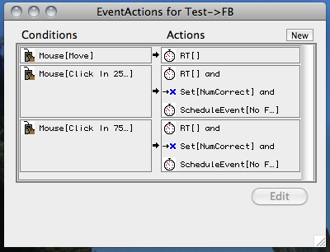

In the script, the action above adds this EventAction to the PsyScopeX script file

Conditions[ Mouse[ Move ] ] => Actions[ RT[ Instances: 1000]

*E-Prime*

Platform: Windows

Available from: http://www.pstnet.com/

Costs $995

E-Prime also provides a user-friendly GUI for experiment generation. Underneath this GUI, E-Prime runs a type of Basic. In E-prime or VB-6, the Mouse.GetCursorPos command can be used to query the current cursor position.

For example:

Mouse.GetCursorPos hold.x, hold.y

In E-Prime, you will need to create an InLine object to run the Mouse.GetCursorPos code and to turn it on and off when you need to do so. PST provide and example called TrackMouseCoordinates at:

http://support.pstnet.com/support/samples.asp?Mode=View&SampleID=55

*Psychophysics toolbox for Matlab*

Platform: All

Available from: http://psychtoolbox.org/HomePage

Costs Free, but requires matlab