**Molecular Marker Research for Conservation Genomics: Assessing the Genetic Diversity of Acacia Tree Species in Kenya.**

Mwangi Denis Muiruri¹, <https://orcid.org/0009-0007-9052-1254> , [mwangidmuiruri@yahoo.com](mailto:mwangidmuiruri@yahoo.com),

Martin Ngunjiri Kanyeki¹, <https://orcid.org/0009-0004-6362-8943>,  [martinkanyeki@gmail.com](mailto:martinkanyeki@gmail.com)

Chepngetich Mercy¹, <https://orcid.org/0000-0002-4772-9486> ,  [chepngetichmercy88@gmail.com](mailto:chepngetichmercy88@gmail.com)

SEQART AFRICA, Nairobi, Kenya¹

Corresponding Author Email: [mwangidmuiruri@yahoo.com](mailto:mwangidmuiruri@yahoo.com)

# **Received (Date) 0000 | Revised 0000 | Accepted 0000 | Available Online 0000**

**Citation: ------------- (2025). Assessment Of the Genetic Diversity of The Acacia Tree Species in Kenya Using Molecular Markers for Conservation Genomics.**

***Journal of Plant Biota*. V00i00.00-00. DOI:**

# **ABSTRACT**

Acacia trees are vital to Kenyan ecosystems, contributing to soil enrichment, biodiversity, and wildlife support. They belong to the Fabaceae family and include species like Acacia nilotica and Acacia xanthophloea, which are essential for agroecosystem restoration, land reclamation, and local livelihoods in arid areas. These trees offer resources such as fodder, medicinal products, timber, and honey, with some species also showing potential for new uses, like vegetable tannin from Acacia xanthophloea bark. Recent research using advanced DArTseq technology aims to explore the genetic diversity and population structure of Acacia trees in Kenya, providing crucial data for conservation and sustainable management.

Four populations containing seven samples of the ancient Acacia tree were used to investigate genetic diversity through DArTSeq technology. The samples were collected from different locations and DNA was extracted, libraries generated, and sequenced under the Illumina Hiseq 2500 system. The data was then filtered for SilicoDArT and SNP marker calling and generation.

The genetic diversity among Acacia samples was low, indicating minimal environmental and human impact on the species. Older tree samples from Kitui and Naivasha exhibited slight differences in unique alleles, contributing to variance within populations. The study revealed that while the DArT platform effectively genotyped indigenous Acacia species, the genetic diversity was low, suggesting potential vulnerability to environmental and genetic challenges. Despite this, high polymorphisms and moderate genetic differentiation indicate that Acacia species have not been significantly impacted by human activities, highlighting their potential for future research and conservation efforts.

*Keywords: Acacia trees, DArTseq, SNP markers, DNA extraction, Genetic diversity, Conservation, Population structure, Sequencing, bioinformatics, dartR*

# **Abbreviations**

AMOVA - Analysis of Molecular Variance

ASAL - arid and semi-arid lands

DArT - Diversity Arrays Technology

DArTseq - Diversity Array Technology Sequence

DNA - Deoxyribonucleic acid

GBS - Genotyping by Synthesis

HWE - Hardy-Weinburg Equilibrium

MAF - Minor Allele Frequency

PCR - Polymerase chain reaction

PCA - Principal Component analysis

PIC - Polymorphism Information Content

SNP - Single Nucleotide Polymorphism

# **INTRODUCTION**

## **1.1 Background Information**

Acacia trees are prominent components of ecosystems in Kenya, playing crucial roles in soil enrichment, biodiversity maintenance, and supporting numerous wildlife species. The acacia classification is of the kingdom: Plantae, order: Fabales, family: Fabaceae, genus: Vachellia, and species: V. *nilotica*. The Fabaceae or Leguminosae family includes plants like Peas, beans, or legumes family, is the third largest Angiosperm (flowering plants) family with over 700 genera and about 20,000 species.

This tall tree reaches a height of up to 30 meters and is characterized by its smooth, yellow/green photosynthetic bark. The small bipinnate leaves feature paired straight stipules that are white and spinescent. The numerous bisexual flowers form round yellow spikes, each exhibiting regularity. The flowers contain exserted stamens and pistils with a superior ovary and extending style. The fruit is a non-sickle-shaped, flattish pod, tardily dehiscent, measuring up to 13cm in length. The tree has a dense spherical crown, with stems and branchlets often dark to black in color, fissured bark, and a greyish-pinkish slash that releases reddish low-quality gum. Young trees display thin, straight, light-gray spines in axillary pairs, typically ranging from 3 to 12 pairs long and 5 to 7.5 cm in length. Mature trees, on the other hand, usually lack thorns. The bipinnate leaves have 3-6 pairs of pinnulae and 10-30 pairs of leaflets, each leaflet measuring 4-5 mm long and exhibiting +/- tomentose characteristics. The rachis bears a gland at the bottom of the last pair of pinnulae. The flowers are arranged in globulous heads, 1.2-1.5 cm in diameter, of a bright golden-yellow color, either axillary or whorly on peduncles 2-3 cm long located at the end of the branches. The pods are grey, thick, softly tomentose, straight or slightly curved, measuring 5 to 15 cm long on a pedicel, and 0.5 to 1.2 cm wide[1].

In Kenya, the most dominant species are the *Acacia Senegal, Acacia xanthophloea, Acacia nilotica,* and the *Acacia brevispica*. The arid and semi-arid land (ASALs) of Africa is mostly degraded due to human interference, and climate change. They barely receive adequate rainfall annually (less than 400mm). Hence the Acacia tree species has been detrimental in ensuring both agroecosystem restoration, land reclamation through nitrogen fixation, and providing local communities with survival income[2].

Acacia trees play a vital role as a valuable natural resource for rural communities inhabiting arid regions worldwide. These trees serve multiple purposes, including providing livestock fodder, medicinal resources, timber, poles, charcoal, and fuel wood. Acacia pollination is by insects, and they later develop fruits after 4 to 6 months. Additionally, Acacia plants contribute to sustaining various life forms while offering pollen and nectar for honey production. In the Arid and Semi-arid Lands of Kenya, specific Acacia species serve as crucial livelihood sources. In Kitui County, Kenya, efforts have been made to explore wild silk production, but the primary significance of Acacia woodlands lies in the generation of high-quality honey. The honey, renowned for its exceptional quality, experiences strong demand both locally and nationally, making honey production a significant source of livelihood for the communities in the area. [3]. *Acacia xanthophloea* bark tannin could be a potential new source of vegetable tannin agents [4].

In India, there are more than 1500 medicinal plants and half of these are being effectively used in curing different diseases. And the leaves of the *Acacia nilotica* have been tested to have high levels of total phenolic content, higher antioxidant activity, and higher protein content, compared to the pods and bark. Hence A. *nilotica* is being used in the control and cure of diabetismelitus as it contains anti-diabetic properties[5].

Understanding the genetic diversity and population structure of Acacia trees is essential for effective conservation and sustainable management. According to [2], few studies have been done on the genetic diversity of the acacia trees of Kenya. One study of *A. Senegal* using random amplified polymorphic DNA (RAPD) and inter-specific simple sequence repeat (ISSR), resulted in a moderate level of diversity (H = 0.283)of the tree species.

## **1.2 Justification of the study**

Understanding the genetic diversity within *A. xanthophloea* populations are crucial for conservation efforts, particularly in the face of habitat loss and fragmentation. The use of new genetic technologies has still been rarely used for conservation efforts[6] Investigating the potential impacts of climate change on *A. xanthophloea* populations is essential for developing effective conservation and management strategies.DArTseq uses genotyping-by-sequencing (GBS) technology to sequence and generate data from novel non-referenced genomes. This then generates single-nucleotide polymorphisms (SNP) and DArTseq markers called silicoDArTs. This technology has proved to be robust, and of high quality in genomics studies across various species and applications [7].

## **1.3 Research Objectives**

The objective of this research is to; (1) assess the genetic diversity of Acacia trees in Kenya using DArTseq technology; (2) identify the population structure and relatedness of Acacia tree species across different regions in Kenya, and (3) provide valuable data for the formulation of effective conservation strategies and further research for Acacia trees in the region. And lastly, (4) generating the first Acacia genome assembly using open-source tools.

# **2. LITERATURE REVIEW**

* 1. **Acacia xanthophloea Classification and Morphology**

Historically placed within the large and diverse genus *Acacia, A*. *xanthophloea* has been subject to taxonomic revisions. Recent phylogenetic studies, based on both morphological and molecular data, have led to the reclassification of many Acacia species, including *A.xanthophloea*, into the genus Vachellia[8]. This reclassification reflects a more accurate understanding of evolutionary relationships within the family Mimosaceae (now Fabaceae, subfamily Mimosoideae). While the name *Vachellia xanthophloea* is now accepted scientifically, the older name *Acacia xanthophloea* is still frequently encountered in older literature and some local contexts.

*Acacia xanthophloea's* most striking feature is the smooth, yellowish-green to greenish-white bark, which peels in papery flakes, giving the tree a distinctive mottled appearance. This bark coloration is due to the presence of chlorophyll in the outer layers, enabling some degree of photosynthesis. Its smooth texture and tendency to peel are adaptations to the hot, dry environments it inhabits[1].

The leaves are bipinnately compound, meaning they are divided into numerous small leaflets arranged along a central axis. This leaf structure is common in many arid and semi-arid adapted species, minimizing water loss while maximizing photosynthetic surface area. The leaflets are typically small and numerous, further reducing transpiration. *A. xanthophloea* possesses stipular spines, which are modified structures arising from the base of the leaves. These spines are usually paired and can be quite large and conspicuous, serving as a defense mechanism against herbivores. The size and shape of the spines can vary somewhat between individual trees. The flowers are small, globose, and arranged in dense, spherical heads. They are typically bright yellow or cream-colored, producing copious amounts of pollen. This flower structure is characteristic of many Mimosoideae species and facilitates pollination by insects. The fruits are pods, which are initially green and later turn brown as they mature. They are typically dehiscent, meaning they split open to release the seeds. The pods are relatively thin and flat, and their dispersal is often aided by wind or animals.

* 1. **Ecological Significance**

*Acacia xanthophloea* plays a crucial role in the ecosystems it inhabits. It is a common component of woodlands and savannas in Kenya, often found along river courses and in areas with relatively high-water tables. The trees provide shade and shelter for various animals, and the flowers are an important source of nectar for pollinators. The leaves and pods are browsed by herbivores, including both wild animals and livestock[2].

# **3. MATERIALS AND METHODS**

## **3.1 Plant Material:**

A total of 7 Acacia tree leaf samples were randomly collected from different ecological zones across Kenya, ensuring representation from distinct habitats. Their geographical position coordinates were recorded. The low number is due to the wild and unchartered nature of some of these tree locations including wildlife game reserves. To ensure the collection of ancient samples, the trees had to have a DBH (diameter at breast height) greater than 90 cm.

**Table 1: Origin, collection sites, and geographical coordinates of Acacia samples from Kenya used in this study**

|  |  |  |  |  |
| --- | --- | --- | --- | --- |
| Sample | Sample type | County | Area Name | Co-ordinates |
| SBK1 | Leaf | Kitui | Kitui | -1.379637, 37.987279 |
| SBK2 | Leaf | Taita taveta | Tsavo | -2.800206, 38.262899 |
| SBK3 | Leaf | Nakuru | Kaptembwa | -0.295316, 36.019097 |
| SAK1 | Leaf | Nakuru | Naivasha | -0.709782, 36.446686 |
| SAK2 | Bark | Machakos | Tala | -1.272193, 37.329637 |
| SAK3 | Bark | Kiambu | Juja | -1.135752, 37.020516 |
| SAK4 | Bark | Kajiado | Ongata Rongai | -1.384197, 36.775701 |

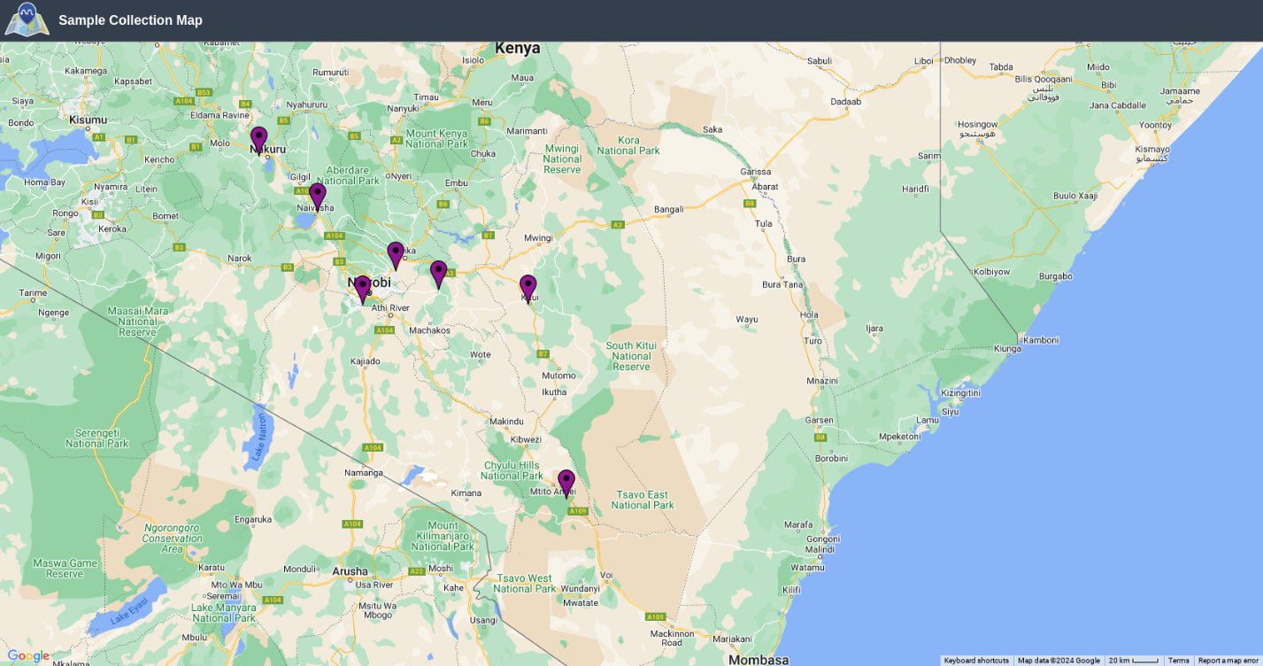

**Figure 1: The geographical map of Acacia sample collection locations in Kenya used in this study**

## **3.2 DNA Extraction:**

High-quality genomic DNA was extracted from the leaves of each collected sample using the NucleoMag 96 Plant genomic DNA extraction kit (Macherey–Nagel, Du¨ren, Germany), following the manufacturer’s instructions. The quantification of the extracted DNA was then checked manually using 0.7% agarose.

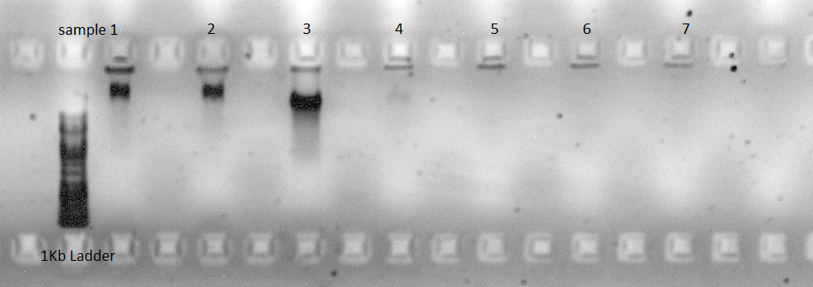

**Figure 2:DNA Quality Check showing bands on 0.7% Agarose Gel for the 7 Acacia samples**

**Table 2: DNA quality and purity measurements were recorded using a DeNovix spectrophotometer.**

|  |  |  |  |  |
| --- | --- | --- | --- | --- |
| Sample name | Sample type | Concentration (ng/ul) | 260/280 | 260/230 |
| SBK1 | Leaf | 9.760 | 1.79 | 1.08 |
| SBK2 | Leaf | 202.150 | 1.58 | 0.56 |
| SBK3 | Leaf | 42.529 | 1.17 | 0.87 |
| SAK1 | Leaf | 31.660 | 1.59 | 0.50 |
| SAK2 | Bark | 28.149 | 1.114 | 0.24 |
| SAK3 | Bark | 3.894 | 1.37 | 0.42 |
| SAK4 | Bark | 7.532 | 1.38 | 0.36 |

## **3.3 Library Preparation and Sequencing**

The genomic DNA samples underwent DArTseq library preparation, which is a genome representation method that targets specific genomic regions, mostly exons due to methylation sensitivity. This technology allows for the simultaneous screening of thousands of loci, providing extensive coverage of the genome.2ul of DNA, in full replication was digested using a combination of the rare cutting endonuclease enzyme PstI (5`-CTGCA|G-3`) in combination with the frequently cutting restriction enzyme MseI (5`-T|TAA-3`). The resulting digested DNA fragments were ligated to other pieces of fragments like the barcoded adaptors (4-9 bp) and sequencing adapter overhangs. The new fragments were then amplified in a Polymerase Chain Reaction (PCR) machine using optimized settings for 35 cycles. The PCR products were then checked for quality and correct fragment size by running them in a 1.2% agarose gel.

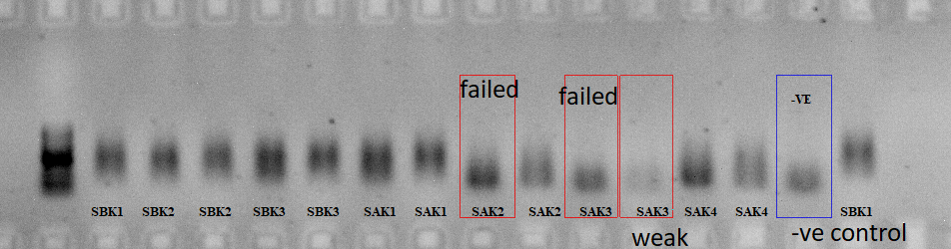

**Figure 3: Acacia library quality control check in agarose showing failed sample SAK3**

SampleSAK3, failed the quality check, due to poor DNA concentration and purity as shown in the quality scores highlighted above.

The samples that passed the quality check were then pooled together, purified, and loaded onto the cBot (Illumina, Inc., San Diego, CA, USA) for cluster generation via bridge amplification on a single read flowcell. The sequencing was then carried out on an Illumina HiSeq2500. Allele calling was done using the proprietary analytical pipeline called DArTsoft14, developed by DArT Pty Ltd, Canberra, Australia. SNP and DArT markers are then generated where DArTseq markers scored a ‘0’, ‘1’, ‘and ‘- ‘, representing presence, absence, and no-zero count. The SNP markers were scored as ‘1’ for the SNP allele homozygote, ‘0’ for reference allele homozygote, and ‘2’ for heterozygote presence[9]. Automatic marker quality and filtering were done after sequencing using the proprietary software DArTsoft v14 using parameters like reproducibility, call rate, and polymorphic information content (PIC)[10]

## **3.4 Genetic Diversity and Population**

Genetic diversity and population structure were calculated from the 6 samples using both DArTseq and SNP data. Using the new version of dartR for conservation genetic data analysis and visualization. Diversity indices such as inbreeding coefficient, total gene diversity, and heterozygosity, observed heterozygosity (Ho), expected heterozygosity (He), and allelic richness (Ar) were determined. Using the SNP and DArTSeq, a neighbor-joining tree was built. The hierarchical structure analysis was supported by the use of hierarchical analysis of molecular variance (AMOVA), principal components analysis (PCA), and a pairwise genetic distance matrix of the accessions. Estimating the pairwise fixation index (Fst) allowed for the analysis of genetic divergence between the Acacia populations[11].

# **4. RESULTS**:

## **4.1 DArTseq and SNP Detection**

After sequencing was done in the HiSeq2500, a total of 49,678 SNP markers were generated. A final selection of 31,823 markers were selected with over 94% reproducibility, and above 50% call rate. DArTseq markers were reduced to 188,499 from a total of more than 500,000 markers. The file was too large to work with due to many low call rate markers below 70%. The average call rate was observed at 99% while reproducibility for the markers was observed at 95%. This was all done automatically from the proprietary DArTSoft14 algorithm program after sequencing was complete.

The summary of polymorphism information content (PIC) for SNP markers was between 0.5 and 0.14 with an average of 0.42. For the DArTseq markers, the PIC ranged from 0.5 to 0.27, with an average PIC of 0.30.

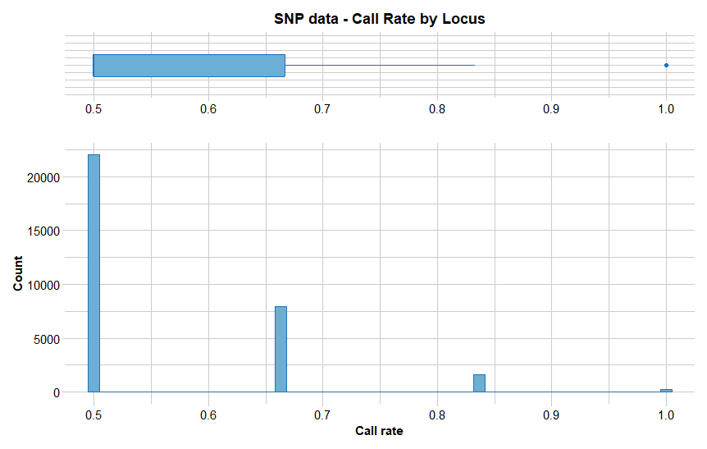

**Figure 4. Call rate of the 31,823 markers, with most showing to be around 50%.**

From figure 4 above, the 31,823 markers had to be filtered with a call rate above 80% to remove junk data. We then remained with 1,816 SNP markers. Further filtering with read depth resulted in a total of 1,448 markers between a low and high threshold of 0 and 90 respectively.

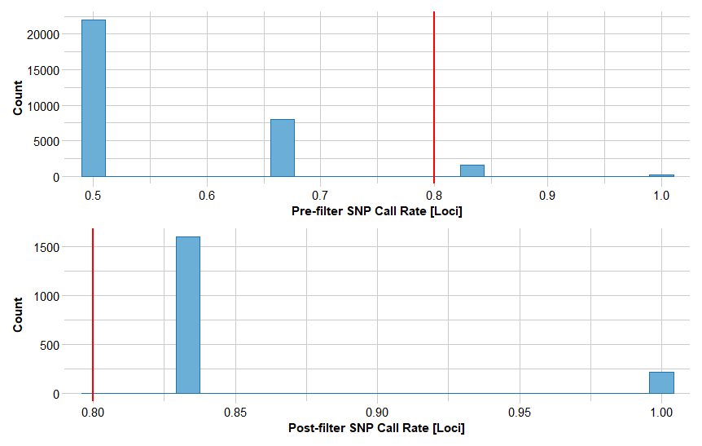

**Figure 5. Observed Call rate of SNP markers after dartR filtering at 80% threshold.**

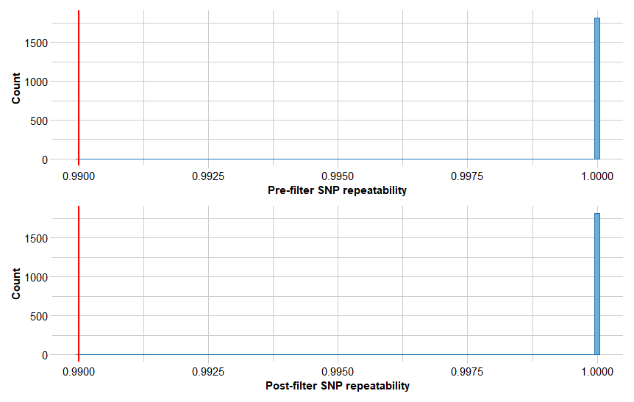

**Figure 6. Observed Reproducibility of SNP data. All above 94%.**

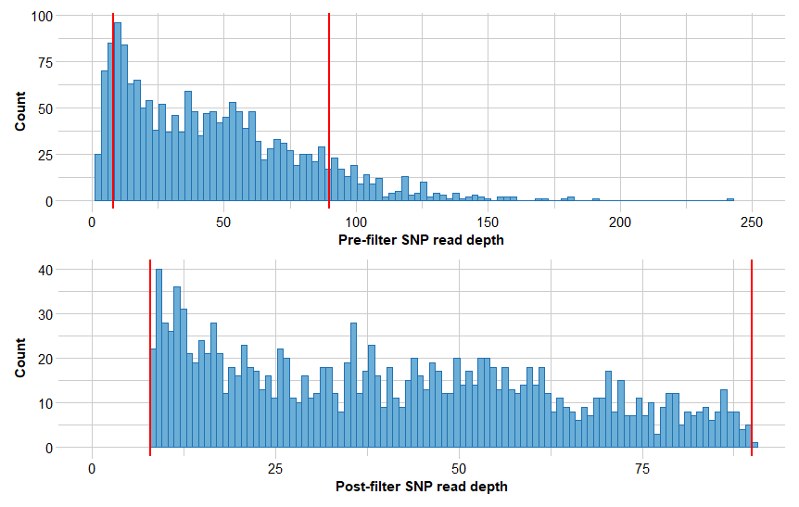

**Figure 7. Observed SNP Read Depth filtering.**

## **4.2 Genetic Diversity**

The expected heterozygosity (He) for SNP markers in the population ranged from 0.0029 to 0.068. The mean observed heterozygosity (Ho) and the He, was in synchronization with the high PIC values described above (0.39 to 0.45).

**Table 3. SNP observed and expected heterozygosity based on population**

|  |  |  |  |
| --- | --- | --- | --- |
| pop | Ho | He | Fis |
| kitui | 0.005848 | 0.002924 | 0 |
| naivasha | 0.011558 | 0.034802 | 0.809228 |
| rongai | 0.00443 | 0.002215 | 0 |
| tsavo | 0.009414 | 0.068719 | 0.921739 |

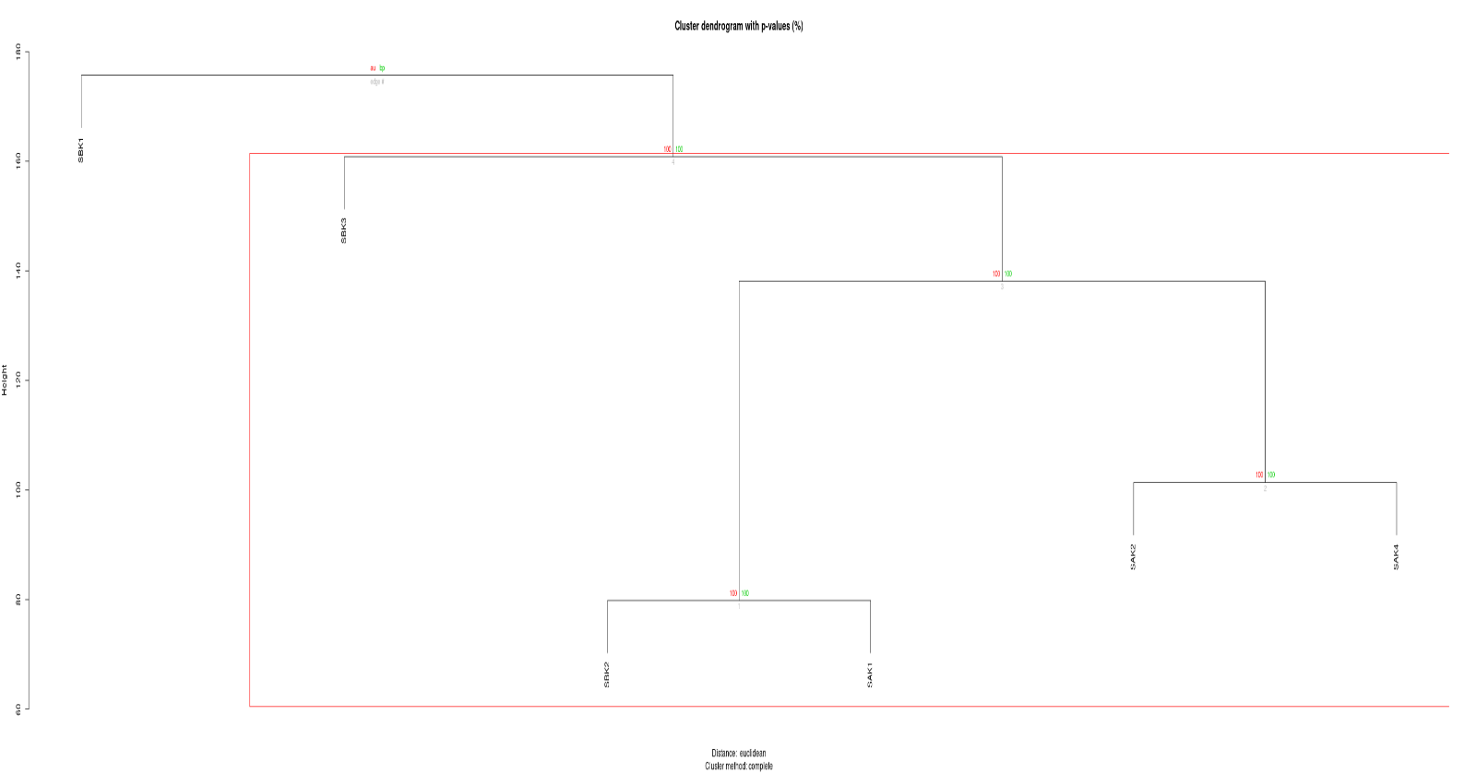

**Figure 8. Hierarchical clustering dendrogram with bootstrap P-values Acacia SNP data**

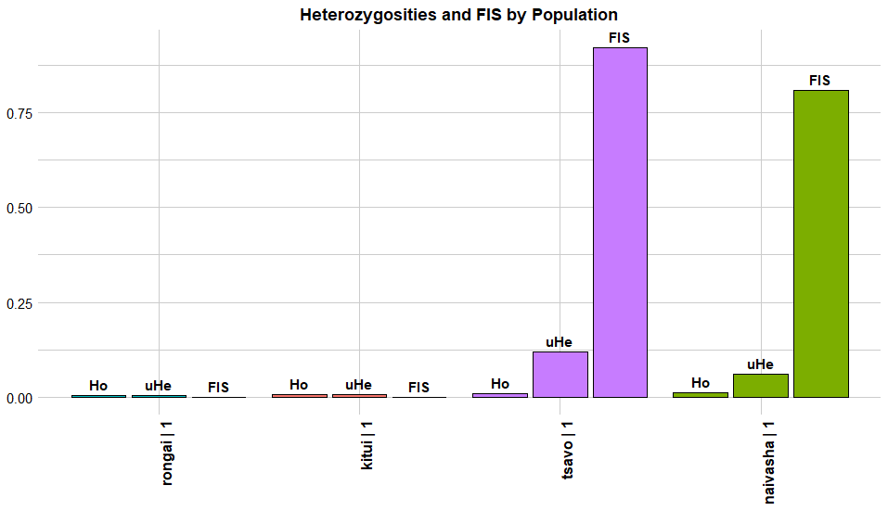

**Figure 9. SNP observed heterozygosity per population**

## **4.3 Population Structure Analysis**

Similarities in the genetic makeup among the Acacia samples were assessed using the SNP markers exposing 5 clusters. This is strictly supported by the delta-k plot. A neighbor-joining tree was developed showing similar clustering between the SNP and SilicoDArT data. The phylogenetic tree grouped the populations into three groups, with two internal nodes (Figure 12). The locus minor allele frequency (MAF) for the SNP data set scores between 0.08 and 0.5, with a mean of 0.3. Allelic richness (q =0) of the acacia samples was calculated, including Shannon information (q = 1), and heterozygosity (q = 2). Population Structure analysis using the STRUCTURE software, revealed 3 variated group structures within SNP marker data as shown below.

The genetic diversity of individual samples was backed up by principal coordinate analysis (PCA) despite the individuals per population being too few, with the minimum required being ten individuals per population. These showed a substantial variance in the diversity gap between the various populations based on combined SNP and SilicoDArT data.

**Table 4. Basic SNP statistics for Acacia samples based on SNP data**

|  |  |  |  |  |  |
| --- | --- | --- | --- | --- | --- |
| **Ho** | **Hs** | **Fis** | **Ht** | **Dst** | **Fast** |
| 0.008 | 0.5631 | 0.9858 | 0.5459 | -0.0173 | -0.0316 |

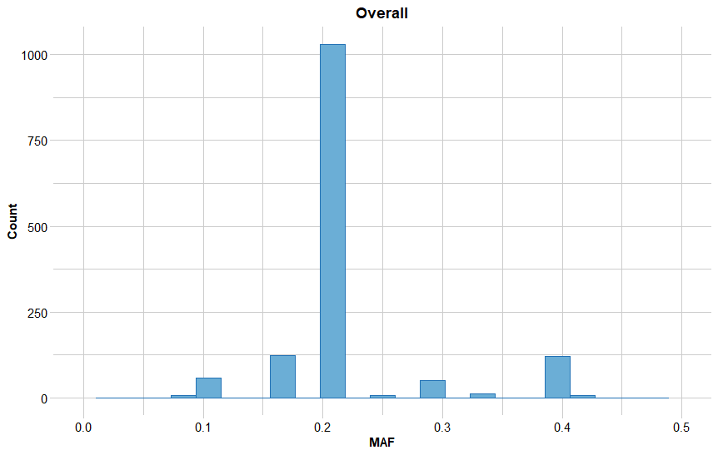

**Figure 10. The mean minor allele frequency (MAF) for all SNP loci**

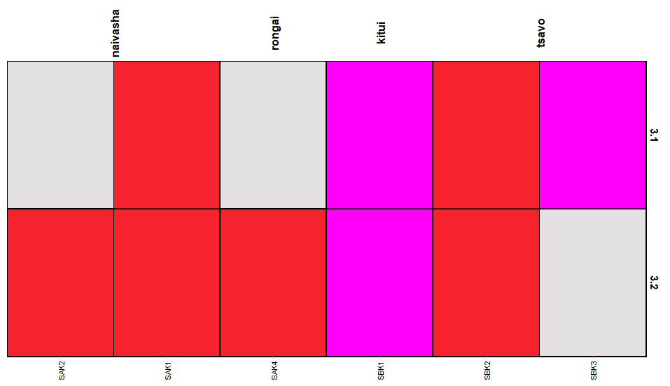

**Figure 11. SNP population structure heat map**

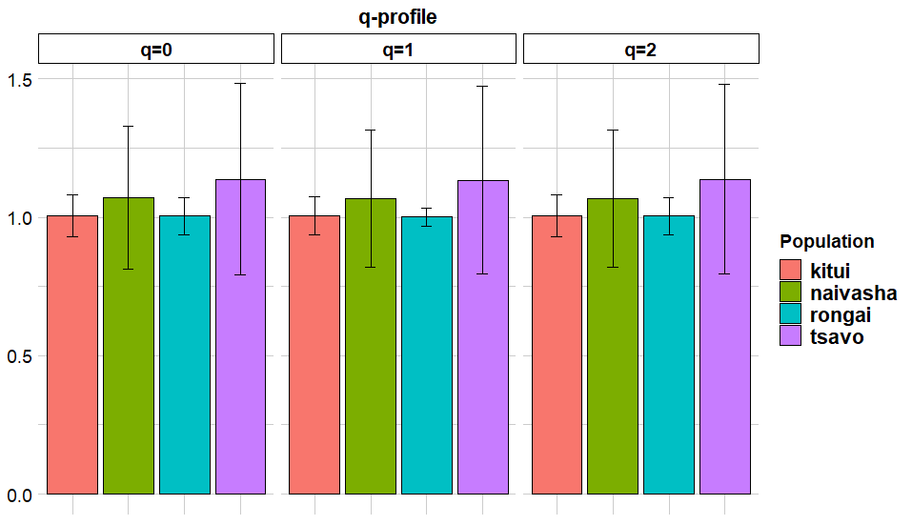

**Figure 12. SNP population diversity summary.**

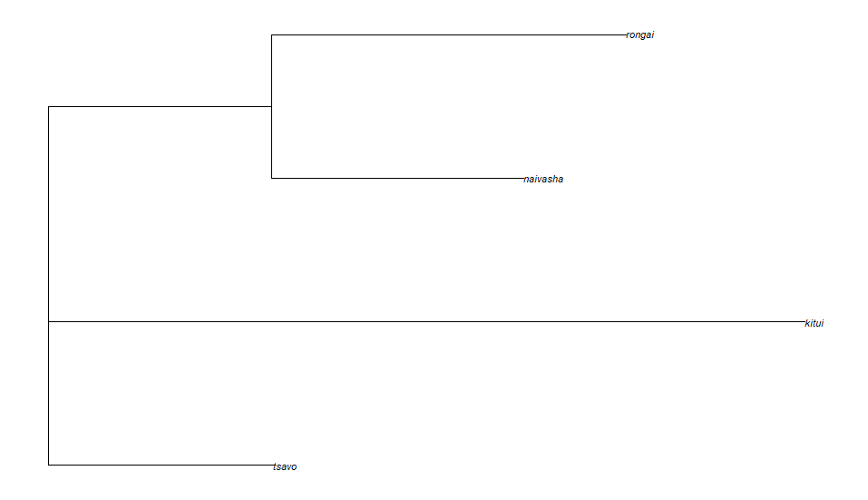

**Figure 13. A SNP neighbour joining tree of the Acacia population**

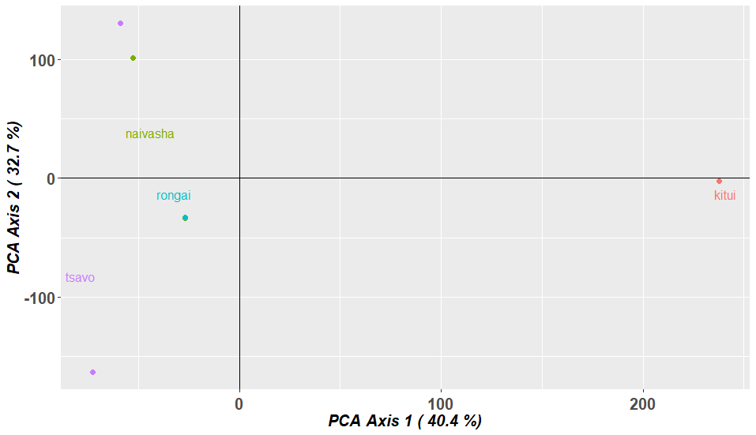

**Figure 14. PCA plot to infer group structure of Acacia based on SNP marker data.**

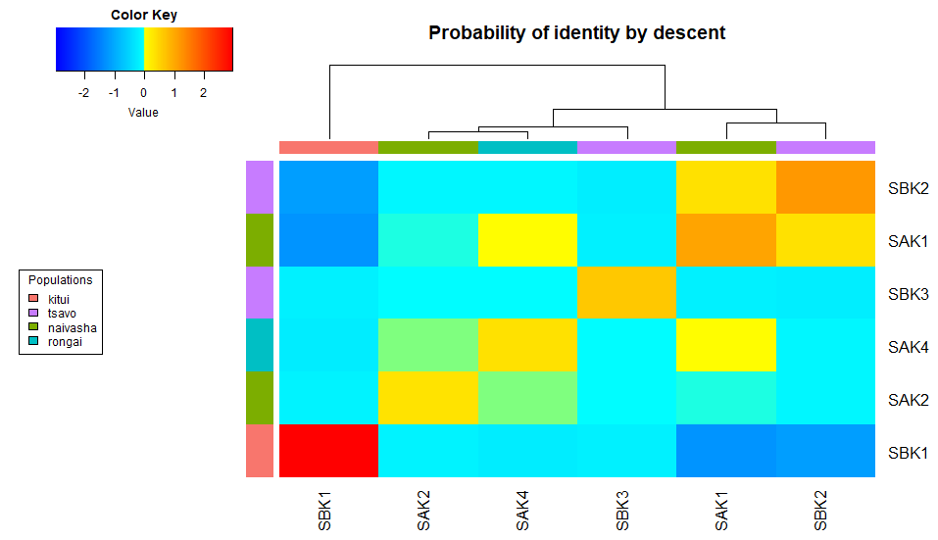

**Figure 15. Acacia SNP sample identity by descent matrix**

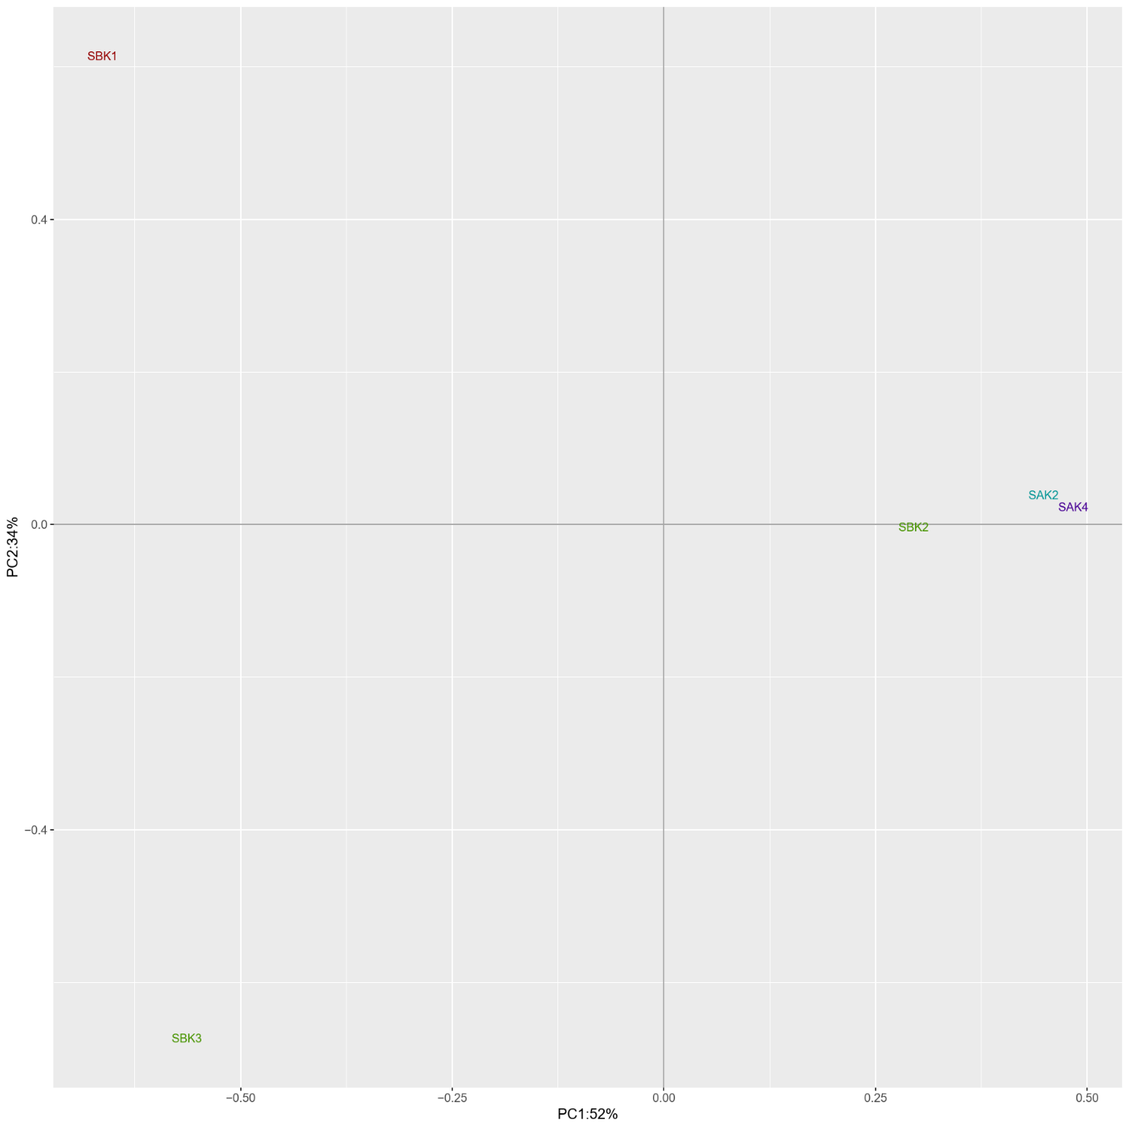

**Figure 16. PCA analysis based on samples.**

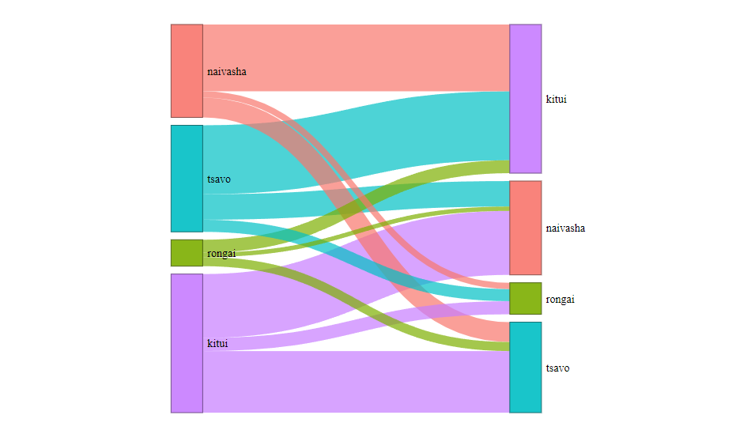

**Figure 17. Mean SNP absolute allele frequency differences (AFD) between pairs of populations.**

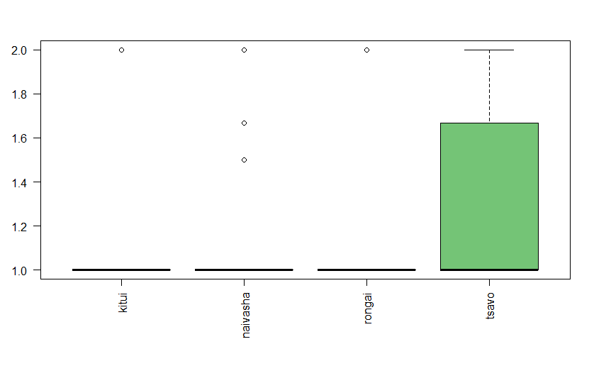

**Figure 18. Allelic richness of SNP data based on population.**

## **4.4 Sequence Similarity**

The 31,823 SNP markers generated were exposed to a nucleotide blast search. The results were further filtered based on E-value (equal to 999), and Chromosome Position (equal to 0). This left a total of 1,896 SNP markers. All blast hits had an E-value greater than 1.24E-26. The SNP markers matched various species such as *Acacia mellifera, Acacia mangium, Dichrostachys cinerea, Lupinus angustifolius, Lophophytum mirabile, Bretschneidera sinensis, Parapiptadenia rigida, Arachis duranensis, Acacia koa, and Anadenanthera colubrina.*

After E-value marker filtration, 3320 SilicoDArTs were selected for nucleotide blast, the markers were matching with*Acacia harpophylla, Acacia argyrophylla, Acacia mangium, Arachis duranensis, Dichrostachys cinerea, Millettia pinnata, Parkia javanica, Piptadenia communis, Pararchidendronpruinosum, Bupleurum falcatum,*and*Lophophytum mirabile.*

The blast results from the SNP and SilicoDArT markers showed similar species similarities which mostly consist of shrubs, trees, and herb species.

# **5. DISCUSSION**

Indigenous tree species like the Acacia, have been in existence for thousands of years and it is important to understand their genetic structure and genetic components for conservational purposes. Their potential for pharmaceutical use needs to be understood even from a genetic perspective. Affordable sequencing of the Acacia tree samples using DArTSeq technology provided major insights into the genetic diversity of the tree species across the country of Kenya. Both silicoDArT and SNP markers showed high reproducibility (above 95%) on technical replicates, and a high call rate for marker scoring therefore indicating their efficiency and reliability.

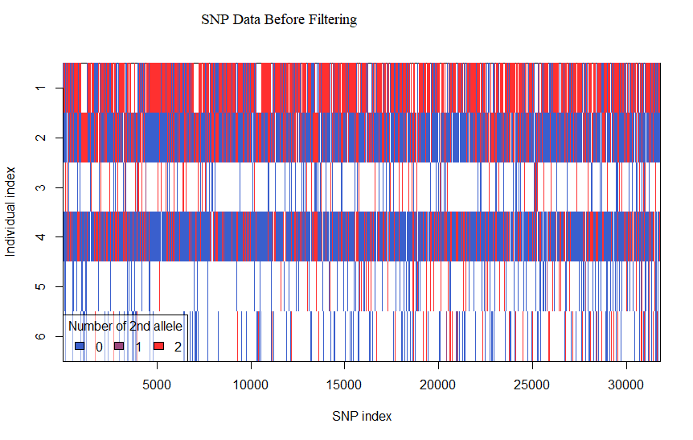

**Figure 19. A general overview of the SNP data distribution between the individuals, showing adequate gaps of missing data before quality filtering.**

Selected SNP data for diversity and population analysis initially showed some data gaps that would eventually affect the overall results. After quality filtering, the data seemed complete and more intact for data analysis as seen in figure 20 below.

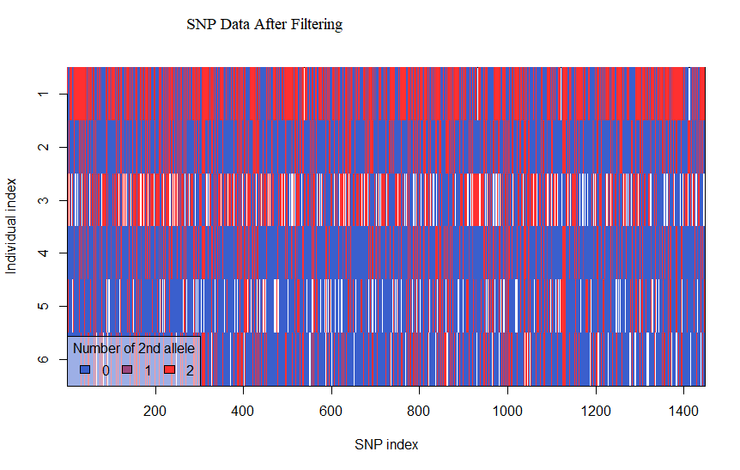

**Figure 20. SNP data visualization after quality filtering.**

Genetic diversity measured using the proportion of polymorphism in the sequence data shows the low genetic variance between the different Acacia samples. This also indicated low effects on the tree species from environmental and human factors. The observed (Ho) versus the expected heterozygosity (He) also showed little difference that was almost negligible (0.001). The SNP data averaged a PIC of 0.42, while silicoDArTwas 0.30. This is high PIC translating to high genetic diversity within the populations due to high heterozygosity.

Older tree samples like the SBK1 from Kitui county and the SAK1 from Naivasha showed a small amount of significant difference in unique alleles as shown in PCA onFigure15.Both populations have the highest amount of unique SNP markers hence contributing to their variance. This is also supported by the minor allele frequency of 0.31 as seen in Figure 9.

The observed genetic diversity (Hs) and the observed inbreeding coefficient (Fis), in Table 4, were calculated from the SNP markers. The average Fis being 0.98 means individuals in the populations are more alike to 98% similarity. The observed genetic diversity was also high at 0.561, showing less impact of human and ecological factors on the gene pool dilution of the species.

From the population structure analysis with the STRUCTURE software, we saw the populations being divided into three groups at K set to 5. This was supported by the population PCA analysis (Figure 14), and the neighbor-joining tree (Figure 13). The MAF was calculated as 0.33 for the SNP data, indicating significantly high heterozygosity due to the limited proliferation of seeds of Acacia tree species, as seed dispersal is via animals, especially migrating livestock and wild animals. The seed is also very hard-coated, so dormancy is hard to break. Especially for the wild tree species according to [12].

Genetic diversity (Dst) and genetic differentiation (Fst) were extremely low from the SNP data. AMOVA analysis also showed 1.4% significance for both silicoDArTs and SNP markers. The consistency of results generated by this analysis for both marker types was calculated using the Mantel test in dartR, which gave a significant score of 0.68. Hence 68% significance showed good consistency between the two data types.

The blast search showed both data sets had close matches with similar tree species of Acacia, especially *Acacia mangium*, and *Acacia koa.* This shows the potential of mapping this new data to some native Kenyan species and developing a Kenyan genetic map. This also shows significant pharmaceutical prospecting opportunities based on known traditional methods and new genetic gains.

# **6. CONCLUSION**

Understanding the genetic diversity of indigenous Acacia species is crucial for revealing their relationships with other plants and their genetic and phytochemical potentials. The DArT platform has proven effective in genotyping Acacia species affordably, using silicoDArTs and SNP markers which demonstrated high call rates and reproducibility. Results indicated low genetic diversity in Acacia, potentially affecting its ability to recover from environmental and genetic challenges.

Genetic diversity was assessed through polymorphic loci and heterozygosity measures, with PIC values ranging from 0.39 to 0.45, indicating high polymorphisms. The analysis showed that Acacia has not been significantly impacted by human activities, and the findings suggest that the species has moderate genetic differentiation and high diversity, with potential implications for future research and conservation.

# **REFERENCES**

1. David Becking: The Trees of Southern Africa, https://treesa.org/vachellia-xanthophloea/?unapproved=77441&moderation-hash=df1f45fc547293d1bc8e6f2586442c10#comment-77441

2. Omondi, S., Kireger, E., Dangasuk, O., Chikamai, B., Odee, D., Cavers, S., Khasa, D.: Genetic Diversity and Population Structure of Acacia senegal (L) Willd. in Kenya. Trop Plant Biol. 3, 59–70 (2010). https://doi.org/10.1007/s12042-009-9037-2

3. Warui, M., Gikungu, M., Bosselmann, A., Hansted, L.: Pollination of Acacia woodlands and honey production by honey bees in Kitui, Kenya. 6, 40–50 (2018)

4. Cheloti, M., Fedha, P., Kiprop, A., Onyuka, A., Asava, A., Mutuku, M., Induli, M., Kundu, B., Masenge, E.: Evaluation of Mechanical Properties of Goat Leather Tanned using Acacia xanthophloea. Textile & Leather Review. 6, 333–342 (2023). https://doi.org/10.31881/TLR.2023.053

5. Sadalage, N., Baidya, M.M., Kondrapu, P., Ghiware, N., Shaha, A., Kalubhai, S., Nare, S., Rajput, S.: Phytochemical evaluation, in vitro antioxidant activity and in-vivo antidiabetic activity of acacia nilotica. (2023)

6. Liu, D., Zhang, L., Wang, J., Ma, Y.: Conservation Genomics of a Threatened Rhododendron: Contrasting Patterns of Population Structure Revealed From Neutral and Selected SNPs. Front Genet. 11, 757 (2020)

7. Cai, M., Wen, Y., Uchiyama, K., Onuma, Y., Tsumura, Y.: Population Genetic Diversity and Structure of Ancient Tree Populations of Cryptomeria japonica var. sinensis Based on RAD-seq Data. Forests. 11, 1192 (2020). https://doi.org/10.3390/f11111192

8. Orwa, C., Mutua, A., Kindt, R., Jamnadass, R., Simons, A.: Agroforestree Database: A Tree Reference and Selection Guide, version 4.0. World Agroforestry Centre ICRAF, Nairobi, KE. (2009)

9. Adu, B.G., Akromah, R., Amoah, S., Nyadanu, D., Yeboah, A., Aboagye, L.M., Amoah, R.A., Owusu, E.G.: High-density DArT-based SilicoDArT and SNP markers for genetic diversity and population structure studies in cassava (Manihot esculenta Crantz). PLoS One. 16, e0255290 (2021). https://doi.org/10.1371/journal.pone.0255290

10. Baloch, F.S., Alsaleh, A., Shahid, M.Q., Çiftçi, V., E. Sáenz de Miera, L., Aasim, M., Nadeem, M.A., Aktaş, H., Özkan, H., Hatipoğlu, R.: A Whole Genome DArTseq and SNP Analysis for Genetic Diversity Assessment in Durum Wheat from Central Fertile Crescent. PLoS One. 12, e0167821- (2017)

11. Mijangos, J.L., Gruber, B., Berry, O., Pacioni, C., Georges, A.: dartR v2: An accessible genetic analysis platform for conservation, ecology and agriculture. Methods Ecol Evol. 13, 2150–2158 (2022). https://doi.org/10.1111/2041-210X.13918