DENOPTIM

De novo Optimization of Organic and Inorganic Molecules

Version 1.0.0, June 2019

Table of Contents
About DENOPTIM 3
Compiling DENOPTIM 4
Representation of Chemical Entities in DENOPTIM 5
Graphs 5
Fragments 5
Valence-based approach 6
Class-based approach 6
Capping procedure 7
Symmetry 7
Fitness evaluation 7
Main programs 8
DenoptimGA 8
Genetic Operations 8
Substitution Probability 9
GA Selection Strategies 10
GA Parallelization Schemes 10
DenoptimGA Input 11
DenoptimGA Output 11
FragSpaceExplorer 12
FragSpaceExplorer Input 12
FragSpaceExplorer Output 13
Restart FragSpaceExplorer from Checkpoint file 13
Keywords 14
Fragment space definition 14
Ring closing machinery 15
DenoptimGA 18
DenoptimCG 20
FragmentSpaceExplorer 21
File Formats 22
Molecular Fragments 22
Compatibility Matrix file 22
Ring Closures Compatibility Matrix file 23
Initial Population File 23
Candidate Chemical Entity Files 23
Fitness Files 24

About DENOPTIM
DENOPTIM stands for De novo Optimization of Organic and Inorganic Molecules. DENOPTIM is a software suite for the de novo generation of diverse molecules with desired properties. The programs is written in Java and distributed under the AGPL v3.0 license. DENOPTIM required additional open source libraries that are distributed according to their respective licences. Table 1 lists the software used, together with version and license details.

Software | License | Comments
Java | - | Version JDK 1.6 or above required
CDK | GNU LGPL v2.1 | Version 1.4.17 or above
Commons-io | Apache v2 | Version 2.4.0
Commons-lang | Apache v2 | Version 3.1.0
Commons-cli | Apache v2 | Version 1.3.1
Commons-math | Apache v2 | Version 3.6.1
vecmath | GNU GPL v2 | Version 1.5.2
Table 1: Software environment for DENOPTIM.

- Java Both JDK and JRE need to be installed. There are both OpenJava and Oracle Java implementations available. Although both should be compatible, it is advisable to stick to a single version.
- CDK (https://cdk.github.io/) This library is used within DENOPTIM for basic operations of molecules such as calculation of SMILES and InChi keys.
- Commons-io (https://commons.apache.org/proper/commons-io/) Library of utilities to assist with developing IO functionality.
- Commons-lang (https://commons.apache.org/proper/commons-lang/) Provides a host of helper utilities for the java.lang API, notably String manipulation methods, basic numerical methods, object reflection, concurrency, creation and serialization and System properties.
- Commons-cli (https://commons.apache.org/proper/commons-cli/) Library providing an API for parsing command line options passed to programs.
- Commons-math (https://commons.apache.org/proper/commons-math/) library provides mathematics and statistics components beyond those provided by Java and commons-lang.

Compiling DENOPTIM
The source code is available on GitHub at
https://github.com/denoptim-project
Once you download the source, separate shell scripts have been created to compile the programs. In addition, a build-all.sh script has been provided that compiles all the programs. These scripts assume java and javac are in your $PATH. All compiled programs can be finally stored in the "dist" directory which is created by the script upon request, that is, by appending the makedist argument.
To compile all programs simply type
cd build
bash build-all.sh
or
cd build
bash build-all.sh makedist

To compile specific programs simply substitute the <program_name> as required and run
cd build
bash build-<programname>.sh

NOTE: If any changes are made to the dependent libraries (for e.g. CDK/DENOPTIM), please recompile all associated programs, for the changes to be effective.

Representation of Chemical Entities in DENOPTIM

Graphs
DENOPTIM perceives chemical entities as graphs (outer graph in Figure 1) where each vertex contains a fragment and each edge represents a bonding interaction or a spatial relationship. The vertices and edges are organized in a spanning tree (T), which is acyclic by definition, and a set of fundamental cycles (Fc). The latter includes the chords: edges that do not belong to the spanning tree and that define cycles of vertices. Fragments can contain any number of atoms or pseudo-atoms, and are represented by graphs themselves (inner graph), though DENOPTIM perceived them as single entities.
Figure 1: Graph representation of chemical entities in DENOPTIM.

Fragments
Molecular fragments are generated by the fragmentation of compounds taken from databases of interest. For instance, libraries of molecules, of crystal structures, of previously generated molecular models. Fragments have different roles in DENOPTIM:
- the scaffolds are fragments used as starting point for the construction of a chemical entity and often correspond to the central core of the chemical entity under construction (for instance, the metal atom of a transition metal complex);
- the proper fragments, which are used to expand and modify chemical entities but not to start new ones from scratch;
- and the capping groups, which are fragments with only one attachment point that can be used to saturate and finalize chemical entities (see Capping procedure).
Each fragment is characterized by its chemical constitution (i.e., atom, bonds, charges) and a set of attachment points. Each attachment point (AP) defines where (i.e., on which atom/pseudo-atom) and possibly how fragments can be connected to each other (i.e., formal bond order, geometry). DENOPTIM currently supports two strategies for handling attachment points: the valence-based approach, and the class-based approach.

Valence-based approach
Within the valence-based strategy each attachment points is a portion of the user-defined free valence of a specific atom. Combination of attachment points are controlled only by the number of open valences on the atoms.

Class-based approach
When using class-based strategy each attachment point is annotated with an any-string type of label specifying the so-called class of the attachment point (APClass). The fragmentation performed by GM3DFragmenter (see https://github.com/denoptim-project/GM3DFragmenter) uses cutting rules to (1) chop molecules and (2) store information on the connected chemical environment (i.e., codified into the APClass) of each side of all broken bonds. For each broken bond two attachment points are generated with complementary classes (i.e. cutting rule #1 generates classes #1a and #1b). The resulting fragments are uninterrupted portions of molecules with any number of atoms, bonds, and class-annotated attachment points.
Within the class-based approach valence rules are not applied, therefore models of active species and transition states can be generated automatically.
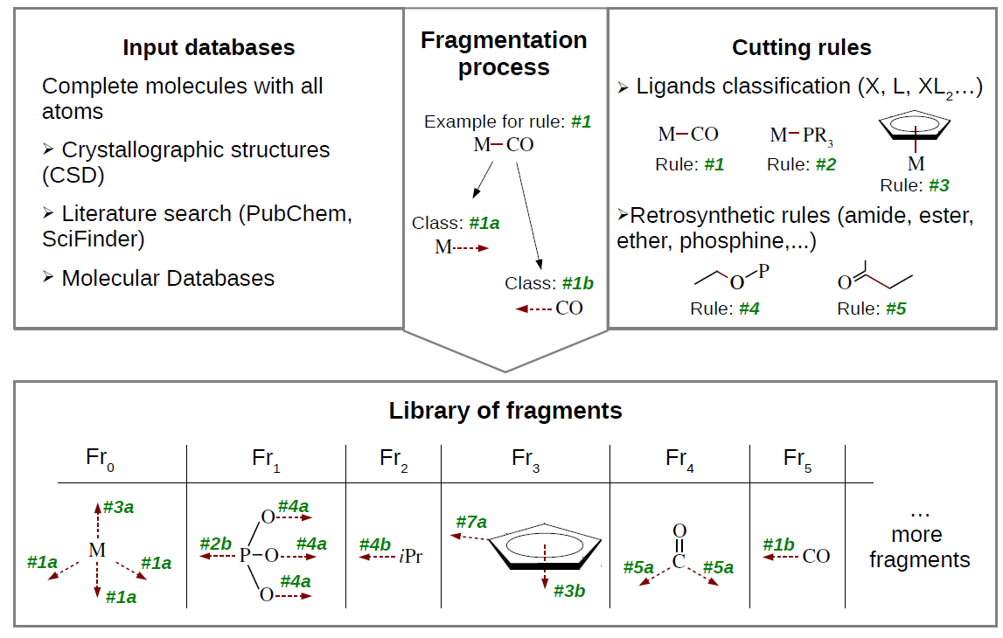Figure 2: Generation of a fragment library according to the class-based approach.

Capping procedure
The capping groups are used to saturate open valences when a standard “hydrogenation” routine (i.e., addition of H to every open valence) is expected to fail. This occurs when the chemical entities under construction are not standard organic molecules for which “hydrogenation” tools have been trained. The capping procedure operates only within the class-based paradigm. The AP classes to be capped and the AP classes of the capping groups are defined by the user in the compatibility matrix file (see Compatibility Matrix file ).

Symmetry
DENOPTIM can repeat any graph operation on sets of APs that are related by high degree of topological similarity or constitutional symmetry. In order to be compatible with the use of both 2D and 3D fragments, the identification of symmetric APs considers only a restricted set of topological features of the APs and the surrounding chemical environment. In practice, APs are considered symmetric when they have i) same attachment point class, ii) same element as the AP’s source atom, iii) same type and number of bonds connected to the source atom, iv) same element and number of atoms connected to the source atom. Users can control the probability of symmetric operations on specific AP classes by setting a numerical value (i.e., 0-100% probability of symmetric operations).

Fitness evaluation
DENOPTIM main programs generate chemicals entities automatically and offers the possibility to submit a subtask for each new entity encountered. This calculation is commonly referred as to the fitness evaluation owing to the fact that a fitness value, or figure of merit, is a typical way to quantify the extent a candidate entity is suitable to a specific function or use.
To ensure general applicability, the calculation of the fitness is performed outside DENOPTIM and is controlled by an external BASH script, i.e., the fitness provider script. This script is prepared by the user according to the needs of the specific case. DENOPTIM programs will then executes the fitness provider, wait for completion, and retrieves the results (i.e., the fitness or an error message). Note that DENOPTIM programs do not interact with the running script.
For each candidate chemical entity that a DENOPTIM program generates, the program produces an SDF file (structure-data file) that is meant to communicate the definition of the entity to the fitness provider script. This SDF file (see Candidate Chemical Entity Files section, page 24) contains the chemical representation of the entity as 2D/3D structure with connectivity table, and its DENOPTIM representation (i.e., DENOPTIMgraph), and is named after the internally unique numerical ID of the entity (e.g., M#_I.sdf where # is the numerical ID and _I identifies the file as the input for the fitness provider script, i.e., a Candidate Chemical Entity Files).
The fitness provider script is expected to do, or manage subtasks that perform the following tasks in a completely independent way for each single entity:
- Read this SDF file (see Candidate Chemical Entity Files section, page 24).
- Perform all molecular modeling tasks, including, for instance, model construction, property calculations, output file parsing, and post processing.
- Calculate or obtaining the fitness value either directly or from third parties software.
- Create an output SDF file for storing the fitness value of the item (or a properly formatted error message) in addition to any useful output data that might be used to post-process the results (see Fitness Files section, page 25).

Main programs

DenoptimGA
The search and optimization method is driven by a genetic algorithm where each molecule (a virtual chromosome) is represented by a graph. The overall schematic of the genetic algorithm (GA) is shown in Figure 3. The algorithm begins with a population of molecules that can be given as input or generated from scratch. Next, a given number of generations are created by producing new offsprings either from application of the genetic operators, or by building new entities from scratch.
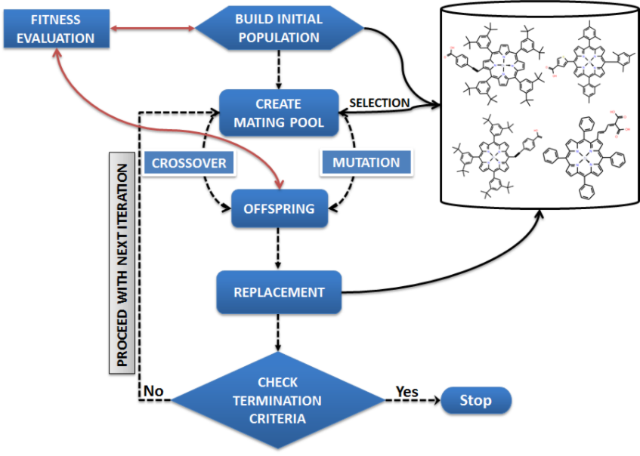Figure 3: Evolutionary optimization scheme.

Genetic Operations
In DENOPTIM, crossover (see Algorithm 1) and mutation are the main genetic operators used. Currently, these schemes are restricted to a single point. In addition, the vertex corresponding to the scaffold is not subject to crossover or mutation, i.e. only vertices attached to the scaffold partake in the genetic exchange. In addition, for symmetric graphs, addition or removal of a vertex can be propagated across all points related by symmetry. Where classes are involved, crossover points are chosen according to the rules defined in the compatibility matrix.

Require: Scaffold and fragment libraries
Require: two molecular graphs G₁ and G₂
Select single crossover vertex V_{i} in G₁
Remove edge with parent vertex PG1 of V_{i}. Update attachment point status.
Extract vertex V_{i} and its children (connected vertices) CVi
Select single crossover vertex V_{j} in G₂
Remove edge with parent vertex PG2 of V_{j}. Update attachment point status.
Extract vertex V_{j} and its children (connected vertices) CVj
Remove vertex V_{i} and CVi from G₁ add to PG2
Remove vertex V_{j} and CVj from G₂ and add to PG1
Algorithm 1: Crossover between two molecular graphs.
Mutation in DENOPTIM can be performed in three ways:
- Deletion involves removing a randomly chosen vertex (fragment) and its children (if any).
- Substitution involves replacing a randomly chosen vertex with another fragment which has the same or lower number of attachment points. If reaction information is included, then the replacing fragment should have a compatible reaction type with that of its parent vertex. Any children associated with the vertex to be substituted are removed.
- Appending involves adding a fragment to a randomly chosen vertex. This can also be viewed as growth operation in which the graph may be further extended by adding additional fragments provided the vertex has available attachment points and/or fragments with compatible reactions.

Substitution Probability
In order to prevent very large molecules, addition of a fragment will depend on the level of the tree (graph) at which the fragment is to be added. The substitution probability progressively decreases with increasing level (see Figures 4). For the level associated with the scaffold (L₀), the fragments are always added with a probability 1. For the levels L_{>0}, the probability is lowered according to any one of the following schemes:
- EXP_DIFF Given a growth multiplier factor λ, the probability of addition is given by where L is the level at which a fragment is to be added.
- TANH Hyperbolic tangent scheme where the probability of addition is determined by
- SIGMA This scheme is based on two factors σ₁ (controlling the steepness of the function where p=50%) and σ₂ (controlling the position, i.e., the level, of the point where p=50%) and calculates the probability as
- UNRESTRICTED This scheme allows for unrestricted growth (provided attachment points on fragments are available). Use with caution.
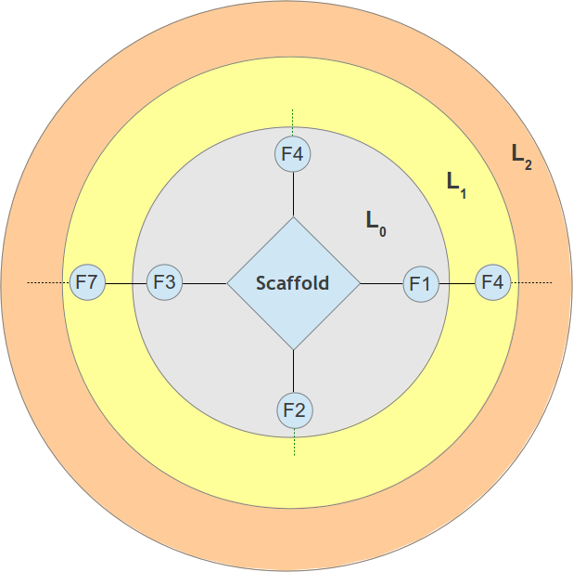Figure 4: Level based probability for attaching fragments.

GA Selection Strategies
An important aspect of any evolutionary system is that of the selection of the best set of individuals (chromosomes) for the next generation. It is also essential to maintain enough diversity in the genetic material so that the solution/chemical space is sufficiently covered. In DENOPTIM, the following selection strategies are available:
- Random In this scheme, chromosomes are randomly selected.
- Tournament (TS) In this scheme, a group of size n (typically 2) is randomly chosen from the current population. The fittest from the group is then added to the mating pool.
- RouletteWheel (RW) In this sampling scheme, each chromosome is assigned a portion/slice of the roulette wheel, the area of the portion being proportional to its fitness. The wheel is then spun a number of times (equal to the size of the population) and the chromosome corresponding to the slice that comes under the wheel marker is added to the pool.
- Stochastic universal sampling (SUS) differs from RW in that it uses N (number of selections required) equally spaced pointers. The population is shuffled randomly and a single random number r in the range [0, 1/N] is generated. The N individuals are then chosen by generating the N pointers, starting with r and spaced by 1/N, and selecting the individuals whose fitness spans the positions of the pointers. Because the individuals are selected entirely based on their positions in the population, SUS has zero bias.
The selection schemes are used to create a mating pool of chromosomes. The size is preset to 50% of the population.

GA Parallelization Schemes
Two parallelization schemes based on the consumer-producer pattern have been implemented. In the following, a batch implies a set of jobs, i.e., fitness function evaluations (generally equal to the number of processors available) submitted for parallel execution. The first such scheme (SCH-1) uses a serial batch processing scheme wherein, the subsequent batches can only be submitted on completion of the previous. This implies that while some jobs may be completed sooner, the program will still wait for the other submitted tasks to complete.
To remove this waiting time, the second scheme (SCH-2) enables continuous submission so that new jobs may be launched whenever free CPUs are available. While this will speed-up the processing, the user runs the risk of carrying out more fitness evaluations than necessary. Although one could potentially kill such tasks, we have decided against it given that some of the evaluations are generally run on the supercomputer and would thus result in unnecessary loss of computer time. Additionally, DenoptimGA can only kill the launched process. There is no guarantee that subprocesses will be killed. In any case, supercomputer jobs are outside its scope. Another aspect of this scheme is that results from a long running calculation, for e.g. started in Gen01, may only be available in Gen20. In such cases, the evaluated molecule will become part of the population only in that generation. The generational behaviour of the GA is subsequently lost.

DenoptimGA Input
Input to DenoptimGA is in the form of a text file containing one input parameter per each line. The # character is used to denote a comment and lines starting with this character are not processed. Each input parameter is specified by means of a keyword, which may or may not require the specification of a value (syntax: keyword=value). The complete list of keywords is available in the appendix (see page 15). Examples of input files can be found in the test folder.

DenoptimGA Output
The program outputs a number of files during its execution. At the beginning of the execution, the program creates a directory RUNDDMMYYYYHHMMSS and a log file RUNDDMMYYYYHHMMSS.log that are named according to the date (DDMMYYYY) and time (HHMMSS). All files generated by DENOPTIN associated with the current run are stored in this folder. Instead, files managed by the fitness provider script are not controlled by DenoptimGA and can thus be placed anywhere. Files pertaining to a specific generation are stored in subfolders RUNDDMMYYYYHHMMSS/Gen# (where # is the generation number), while the final results of an evolutionary experiment are collected in subfolder RUNDDMMYYYYHHMMSS/Final (see Figure 5).
Figure 5: Directory structure from a DenoptimGA run.
Once a generation is completed, the software creates a summary of the current population. For instance, the summary for generation N, where N is an integer number, is available as a TXT file (GenN/GenN.txt) or HTML (GenN/GenN.html).

FragSpaceExplorer
FragSpaceExplorer performs systematic exploration of chemical spaces. The tool can be used to visit all the combination of fragments that can be obtained from a given starting point (i.e., one or more graphs) and a defined fragment space, i.e., an ensemble of fragments, connection rules and constraints. FragSpaceExplorer can be used for combinatorial approaches, where a number of alternative molecules need to be generated and evaluated, and also to enumerate entities or just to appreciate the characteristics of a designed fragment space. For instance, you may want to know how many acceptable chemical entities are encoded in your fragment space, or the amount of redundancy in the fragment space (i.e., number of different graphs that encode the same chemical entity).
A set of initial graphs (from now on referred as to the roots) can be given as input or build from a library of scaffolds. FragSpaceExplorer iterates over all roots and all the combination of fragments (including fragments, capping groups, if any, and the “empty fragment”, which represents the possibility of leaving the AP unused if permitted) that can be appended to the set of free attachment points of each root graph. Only one fragment is appended on each attachment point, thus each root is coated by fragments layer-by-layer. The graphs generated by adding N layers of fragments belong to the level=N-1 and are used as roots to create the graphs of level=N (Figure 6).
Figure 6: Numbering of the levels (L) follows DENOPTIM general rule: the initial root graph belongs to level L=-1.
L = -1
L = 0
L = 1
L = 2
The exploration terminates with the exhaustion of the combinatorial space or with the completion of the maximum allowed level set by the user (see keywords in page 22).
All graphs are stored as serialized DENOPTIMGraphs (i.e., binary file). Graphs that are complete (i.e., no capping needed) and acceptable (i.e., respecting all constraints imposed by the user; for instance max. number of heavy atoms, max. molecular weight, etc.) can be sent to an external subtask using the same fitness-provider mechanism of the external BASH script as described for DenoptimGA. For example, the external subtask may include 3D model construction and property evaluation, or calculation of a fitness.
The construction and evaluation of each graph runs as a parallel asynchronous process that can optionally execute the external subtasks.

FragSpaceExplorer Input
FragSpaceExplorer accept a single argument that must be the pathname of a text parameters file. Possible keyword are listed in the dedicated chapter (see page 22). The only requirement is the definition of the fragment space (see section “Fragment space definition” on page 22).

FragSpaceExplorer Output
The output generated by FragSpaceExplorer is structured as the following folder tree:
    - FSEDDMMYYYYHHMMSS.log (log file)
    - FSEDDMMYYYYHHMMSS.chk (checkpoint file)
- FSEDDMMYYYYHHMMSS
  - FSE-Level_-1
    - FSE-Level_-1.txt list of generated graphs as simplified (human readable) strings.
    - dg_1.ser serialized (binary) DENOPTIMGraph representation of chemical entity with graphID = 1
    - dg_2.ser serialized (binary) DENOPTIMGraph representation of chemical entity with graphID = 2
    - …
  - … other “FSE-Level”-folders
    - … files produced for and by the external subtasks

The binary files can be converted to a human readable format (i.e., SDF) with the utility tool SerConverter (see under src/misc/SerConverter/).

Restart FragSpaceExplorer from Checkpoint file
FragSpaceExplorer can also be restarted from checkpoint file. A checkpoint file is a binary file collecting the information about the latest stored graph corresponding to a point where all previously submitted asynchronous subprocesses were properly terminated. The checkpoint file is recorded with an interval that can be adjusted by the user (by default every N graphs, where N=100; see keywords on page 22). In an event of an abrupt termination, the checkpoint file allows to restart the exploration from the point recorded in the file. FragSpaceExplorer reports proper informations as to where in the combinatorial space (i.e., root, level and fragment combination ID) the exploration is restarted. Calculation that were running when the termination occurred or that were submitted after the generation of the checkpoint file are considered to be lost and will be re-submitted on restart. Therefore, to avoid duplicates the files related to those “lost” calculations should be collected and isolated. The binary checkpoint file can be converted into a readable version with ChechpointReader (see src/misc/CheckpointReader/).

Keywords
When preparing a parameters' file remember that:
- keyword can be accompanied by:
  - no value (e.g., KEYWORD),
  - one value (e.g., KEYWORD=VALUE),
  - more space separated values (e.g., KEYWORD=VALUE1 VALUE2);
- keywords are case insensitive, but values are case sensitive;
- the order of keywords does not matter;
- unless otherwise specified, only the last occurrence of a keyword define the used value of the corresponding parameter.
The following tables list all the keywords grouped according to the main functionality/object affected by the use of a keyword. Unless otherwise specified, the use of the keywords is optional as most parameters have a default value. Since, the settings are reported in the beginning of the log file, the default value of a specific keyword can be found in the log file of a run performed without providing that specific keyword in the input file.

Fragment space definition
Keyword | Description
General
FS-ScaffoldLibFile | Specifies the pathname of the file containing the list of scaffolds. [REQUIRED]
FS-FragmentLibFile | Specifies the pathname of the file containing the list of fragments. [REQUIRED]
FS-CappingFragmentLibFile | Specifies the pathname of the file containing the list of capping groups.
FS-CompMatrixFile | Specifies the pathname of the file containing the compatibility matrix and related information such as the AP-Class to bond order map, the capping map, and the list of forbidden ends.
FS-RCCompMatrixFile | Specifies the pathname of the file containing the compatibility matrix for ring closures.
FS-RotBondsDefFile | Specifies the pathname of the file containing the definition of the rotatable bonds by SMARTS.
Graph filtering criteria
FS-MaxHeavyAtom | Specifies the maximum number of heavy (non-hydrogen) atoms for a candidate.
FS-MaxMW | Specifies the maximum molecular weight accepted for a candidate.
FS-MaxRotatableBond | Specifies the maximum number of rotatable bonds accepted for a candidate.
Symmetry
FS-EnforceSymmetry | Requires to introduce constitutional symmetry whenever possible. Corresponds to setting the symmetric substitution probability to 100%.
FS-ConstrainSymmetry | Introduces a constraint in the symmetric substitution probability. Requires two arguments: the attachment point class to constrain (string), and the imposed value of the symmetric substitution probability (double 0.0-1.0). The constraints defined by this keyword overwrite the symmetric substitution probability defined by DenoptimGA, and the requirement of the FS-EnforceSymmetry keyword.  Multiple constraints can be defined one by one.  Example:  FS-ConstrainSymmetry=apClassA:0 0.25  FS-ConstrainSymmetry=apClassB:1 0.0

Ring closing machinery
Keyword | Description
General
RC-CloseRings | Requires the possibility of closing rings of fragments to be evaluated for all graph containing ring closing vertices. Also requires chemical structures to be generated accordingly. No value needed.
RC-RCPotentialType | Specifies the type of ring closing potential to be used for generation of ring closing conformations with DenoptimCG and Tinker. Accepted values are “BONDOVERLAP” or “BONDCOMPLEMENTARITY”
RC-Verbosity | Specifies the verbosity level of the ring closing machinery.
Ring related graph filtering criteria
RC-MinNumberOfRingClosures | Specifies the minimum number of rings to be closed in order to accept a candidate graph.
RC-MaxNumberRingClosures | Specifies the maximum number of ring closures per graph.
RC-MinRCAPerTypePerGraph | Specifies the minimum number of ring closing attractors of the same type per graph.
RC-MaxRCAPerTypePerGraph | Specifies the maximum number of ring closing attractors of the same type that are accepted for a single graph.
Ring Closability Conditions
RC-EvaluationClosabilityMode | Defined the closability condition's evaluation mode:  - only constitution of candidate ring,  - only closability of 3D chain,  - both 0 and 1.
RC-RequiredElementInRings | Specifies the elemental symbol that has to be contained in all acceptable rings of fragments. The shortest path is used to evaluate this ring closing condition.
RC-ClosableRingSMARTS | Specifies a single constitutional ring closability condition by a single SMARTS string. This keyword may be used multiple times to provide a list of constitutional ring closability conditions.  Example:  RC-ClosableRingSMARTS=C1CCCCC1  RC-ClosableRingSMARTS=C1CCCCCC1
RC-RingSizeBias | Specifies the bias associated to a given ring size when selecting the combination of rings (i.e., RCAs) for a given graph.  The syntax is:  RC-RingSizeBias=<size> <bias>  Multiple occurrence of this keyword can be used.  Example: the following lines give to all 6-member rings a probability of being formed that is twice that given to all 5-member rings. Instead 7-membered rings will never be formed.  RC-RingSizeBias=5 1  RC-RingSizeBias=6 2  RC-RingSizeBias=7 0
RC-MaxSizeNewRings | Specifies the maximum number of ring members for rings created from scratch.
RC-CheckInterdependentChains | Requires evaluation of interdependent closability condition. WARNING: this function require exhaustive conformational search, which is very time consuming.
Search for ring closing conformations in 3D
RC-MaxRotBonds | Specifies the maximum number of rotatable bonds for which 3D chain closability is evaluated. Chains with a number of rotatable bonds higher than this value are assumed closable.
RC-ConfSearchStep | Specifies the torsion angle step (degrees) to be used for the evaluation of 3D chain closability by scanning the torsional space.
RC-LinearityLimit | Specifies the bond angle above which the triplet of atoms is considered linear.
RC-ExhaustiveConfSearch | Requires the search for closable conformations to explore the complete rotational space. WARNING: this is very time consuming, but is currently needed to evaluate closability of interdependent chains.
RC-LinearityLimit | Specifies the bond angle above which the triplet of atoms is considered linear.
RC-RCCIndex | Specifies the pathname of the text file containing the previously encountered candidate closable chains. This file constitutes the index of the archive of ring closing conformations.
RC-RCCFolder | Specifies the pathname of the root folder containing the archive of ring closing conformations.
Evaluation of ring closure in 3D conformations
RC-MaxDotProd | Specifies the maximum value that is considered acceptable for the dot product of the AP-vectors at the two end of a closing chain.
RC-DistanceToleranceFactor | Specifies the absolute normal deviation of the ideal value (a value between 0.0 and 1.0) that is considered acceptable for distances when evaluating the 3D ring closability of a conformation.
RC-ExtraDistanceToleranceFactor | Specifies the factor multiplying the tolerance for interatomic distances when evaluating the closability of a chain by a discrete (vs. continuous) exploration of torsional space.

DenoptimGA
Keyword | Description
General
GA-PrecisionLevel | Specifies the number of figures used to report the fitness.
GA-PrintLevel | Specifies the amount of log produced.
GA-RandomSeed | Specifies the seed number used by the random number generator.
GA-ShowGraphics | Specifies whether to produce the 2D molecular representation for each candidate. Takes strings as true and false.
GA-SortOrder | Specifies whether the candidates should be reported in descending or ascending order of fitness.
Genetic Algorithm
GA-PopulationSize | Specifies the number of individuals in the population.
GA-NumChildren | Specifies the number of children to be generated for each generation.
GA-NumGenerations | Specifies the maximum number of generation.
GA-NumConvGen | Specifies the number of identical generations before convergence is reached.
GA-MaxTriesPerPopulation | Controls the maximum number of attempts to build a new graph, so that the maximum number of attempts to build a new graph is given by the size of the population, times the factor given by the GA-MaxTriesPerPopulation keyword.
GA-GrowthProbScheme | Specifies the growth probability scheme. Acceptable values are: EXP_DIFF, TANH, SIGMA, and UNRESTRICTED.See Genetic Operations.
GA-GrowthMultiplier | Specifies the value of the factor λ used in growth probability schemes EXP_DIFF, and TANH.
GA-GrowthSigmaSteepness | Specifies the value of parameter σ₁ used in growth probability scheme SIGMA.
GA-GrowthSigmaMiddle | Specifies the value of parameter σ₂ used in growth probability scheme SIGMA.
GA-XOverSelectionMode | Specifies the strategy for selecting crossover partners. Acceptable values are: RANDOM, TS, RW, and SUS.See Genetic Operations.
GA-CrossoverProbability | Specifies the probability (0.0-1.0) at which crossover is performed.
GA-MutationProbability | Specifies the probability (0.0-1.0) at which mutation is performed.
GA-SymmetryProbability | Specifies the unspecific symmetric substitution probability. Attachment point-class specific values are defined in the definition of the fragment space.
GA-ReplacementStrategy | Specifies the population members replacement strategy: use 1 for the elitist scheme (survival of the fittest), use 2 for no replacement (all candidates become member of the population, which keeps growing).
Interface
GA-InitPoplnFile | Specifies the pathname of a file (can be an SDF file or a text file where each line containing the pathname to a single-molecule SDF file) containing previously evaluated individuals to be added to the initial population. If the number of individuals is lower than the specified population side, DENOPTIM will create additional individuals.
GA-UIDFileIn | Specifies the pathname of a text file collecting the list of unique individual identification strings (UID; one UID each line) that are to be considered as previously evaluated individuals. DENOPTIM will ignore individuals for which the UID is found in the file. This applies also to the members of the initial population provided by the user (see GA-InitPoplnFile keyword).
GA-UIDFileOut | Specifies the pathname of the file, i.e., the UIDFileOut, collecting the list of unique individual identification strings (UID) encountered during an evolutionary experiment. If no pathname is given, a new UID file is generated under the work space of the experiment. UIDs from individuals found in an initial population file, and those specified via the GA-UIDFileIn keyword are collected in the UIDFileOut.
GA-FitnessEvalScript | Specifies the pathname to the BASH script providing the fitness value for any given candidate system. [REQUIRED]
Parallelization
GA-NumParallelTasks | Specifies the maximum number of parallel tasks to be performed.
GA-Parallelization | Specifies the parallelization scheme: 1 for synchronous (i.e., parallel tasks are submitted in batches, thus no new task is submitted until the last of the previous tasks is completed), 2 for asynchronous (i.e., a new parallel tasks is submitted as soon as any of the previous task is completed).

DenoptimCG
Keyword | Description
General
CG-WorkDir | Specifies the pathname of the directory where files will be created. [REQUIRED]
CG-InpSDF | Specifies the pathname to the input SDF file that must contain DENOPTIMGraph representation of the chemical object. [REQUIRED]
CG-OutSDF | Specifies the pathname of the output SDF file that will contain the generated conformation. [REQUIRED]
CG-KeepDummyAtoms | Dummy atoms are used to handle linearities and multihapto bonds. By default all dummy atoms are removed before returning the final structure. This keyword prevents removal of the dummy atoms. No value needed.
CG-Verbosity | Specifies the verbosity level.
Interface
CG-ToolPSSROT | Specifies the pathname of Tinker’s pssrot executable (see https://dasher.wustl.edu/tinker/). [REQUIRED]
CG-ToolXYZINT | Specifies the pathname of Tinker’s xyzint executable (see https://dasher.wustl.edu/tinker/). [REQUIRED]
CG-ToolINTXYZ | Specifies the pathname of Tinker’s intxyz executable (see https://dasher.wustl.edu/tinker/). [REQUIRED]
CG-ForceFieldFile | Specifies the pathname of the file that defines Tinker’s force field parameters (see https://dasher.wustl.edu/tinker/). An example is available at src/DenoptimCG/data/uff_vdw.prm [REQUIRED]
CG-KeyFile | Specifies the pathname of the file with Tinker’s keywords (see https://dasher.wustl.edu/tinker/). An example is available at src/DenoptimCG/data/build_uff.key [REQUIRED]
CG-RCKeyFile | Specifies the pathname of the Tinker’s keywords used in ring-closing conformational searches (see DOI: 10.1021/acs.jcim.5b00424).
CG-PSSROTParams | Specifies the pathname of a text file with the command line arguments for standard conformational search with Tinker’s pssrot. An example is available at src/DenoptimCG/data/submit_pssrot [REQUIRED]
CG-RCPSSROTParams | Specifies the pathname of a text file with the command line arguments for ring-closing conformational search with Tinker’s pssrot (see DOI: 10.1021/acs.jcim.5b00424).

FragmentSpaceExplorer
Keyword | Description
General
FSE-WorkDir | Specifies the pathname of the directory where files will be created.
FSE-MaxLevel | Specifies the maximum number of layers of fragments to consider. Note that the root (i.e., scaffold or root graph) is considered to belong to level = -1 according to DENOPTIM's practice (see Figure 6). Therefore, when setting FSE-MAXLEVEL=3 at most 4 layers of fragments will be used (namely levels = 0, 1, 2, and 3).
FSE-UIDFile | Specifies the pathname of the file with unique chemical entity IDs.
FSE-DBRootFolder | Specifies the pathname of the directory where to place the folder tree of generate graphs.
FSE-MaxWait | Specifies the wall time limit (in seconds) for waiting for completion of one or more tasks. Accepts only integer numbers.
FSE-WaitStep | Specifies the sleeping time (or time step, in seconds) between checks for completion of one or more tasks. Accepts only integer numbers.
FSE-NumOfProcessors | Specifies the number of asynchronous processes that can be run in parallel. Usually this corresponds to the number of slave cores, if 1 such core corresponds to 1 external task.
FSE-Verbosity | Specifies the verbosity level.
Definition of the root graphs (i.e., starting point of combinatorial exploration)
FSE-RootGraphs | Specifies the pathname of a file containing the list of root graphs.
FSE-RootGraphsFormat | Specifies the format of the root graphs. Acceptable values are 'STRING' for human readable graphs as those reported by DENOPTIM tools in SDF files (default), or 'BYTE' for serialized graphs stored in binary files.
Restart from checkpoint file
FSE-CheckPointStepLength | Specifies the period between two subsequent updates of the checkpoint information as a number of graphs generated.
FSE-RestartFromCheckpoint | Specifies the pathname of the checkpoint file and makes FragSpaceExplorer restart from such file.
External task for acceptable graphs
FSE-ExternalTask | Specifies the pathname of a shell script used to submit external tasks for each acceptable graph generated.

File Formats

Molecular Fragments
SDF file format is used for any type of fragment (i.e., scaffolds, fragments, capping groups). The SDF files must include an <ATTACHMENT_POINT> tag reported with the following format:
...
> <ATTACHMENT_POINT>
n1:v1 n2:v2
...
where n1, n2,… are the integers (1-to-N) identifying which atoms in the atom list of the SDF file hold attachment points, and v1,v2,… define the number of connections available.
In case of class-based approach also the <CLASS> tag must be present in addition to the <ATTACHMENT_POINT> tag. The following syntax is accepted when working with 2D molecular representations.
...
> <CLASS>
n1#c1 n2#c2,c3

> <ATTACHMENT_POINT>
n1:v1 n2:v2
...
Where c1, c2, and c3 are the attachment point classes of the attachment points located respectively on atoms n1, n2, and n2. Note the syntax for the two attachment points on atom n2: while the number of open valences remains a single number (i.e., v2 > 1), multiple AP classes have to be reported in the <CLASS> tag.
Similarly, when working with 3D molecular representations the following syntax is required.
...
> <CLASS>
n1#c1 n2#c2:x2%y2%z2,c3:x3%y3%z3

> <ATTACHMENT_POINT>
n1:v1 n2:v2
...

Compatibility Matrix file
The compatibility matrix file is a text file that includes blocks of information related to the class-based approach:
- the definition of the AP class compatibility matrix (lines starting with RCN keyword),
- the AP class-to-bond order conversion key (RBO keyword),
- the rules to append capping groups (CAP keyword),
- the rules to discharge a graph is an AP os a specific class is still not used (DEL keyword).
Multiple entries for are separated by a comma.
Here is an example of

# Comment line
RCN apclass1:0 apclass1:1,apclass2:0,apclass2:1
RCN apclass1:1 apclass1:0
RCN apclass2:0 apclass2:1
# Note the any class name not found in the library of fragments can be used to impose that no fragment (excluding
# capping groups) is attached on APs of a specific class.
# In this example, no fragment will be attached to APs of class apclass2:1
RCN apclass2:1 none
... ... ...
# CLASS-to-BondOrder conversion
RBO apclass1 1
RBO apclass2 1
RBO apclass3 2
... ... ...
# Capping groups
CAP apclass1:0 cap1:0
CAP apclass1:0 cap2:0
... ... …
# Forbidden ends
DEL apclass1:0

Ring Closures Compatibility Matrix file
The ring closures (RC) compatibility matrix file specifies the pairs of AP classes that are allowed to form ring-closing bonds. Note that, contrarily to the standard compatibility matrix, the RC compatibility matrix is symmetric. The syntax is the same as for a standard compatibility matrix.

# Comment line
RCN apclass1:0 apclass1:1,apclass2:0,
RCN apclass1:1 apclass1:0
… … ...

Initial Population File
SDF format is used to provide an initial set of fully characterized molecules (i.e., initial population). To be properly interpreted by DENOPTIM this SDF file must include the following tags:
- <FITNESS> tag specifying the numerical fitness value.
- <GraphENC> tag specifying the essential part of the graph representation of the chemical entity.

Candidate Chemical Entity Files
SDF format file used to communicate the definition of any candidate chemical entity (e.g., a new candidate molecule in a molecular design run) to the fitness provider script (see Fitness evaluation, page 7).
DenoptimGA outputs the 2D/3D structure of the molecule (in SDF format) together with its DENOPTIMGraph representation (tag <GraphENC>) and additional information (i.e., SMILES, InChiKey). Although the content of these candidate chemical entity files may look weird by visualizing the content within a molecule viewer, it is only intended as a starting point for further calculations within the fitness provider script.

Fitness Files
SDF format file used to return an evaluated chemical entity from the external subtask which has performed the evaluation of the fitness of the candidate entity, back to the main task (i.e., DenoptimGA, or FragSpaceExplorer). Such “fitness file” must contain one of these two tags:
- <MOL_ERROR> tag specifying that the candidate entity cannot be coupled with a fitness value. The content of this field is used to report details on the reasons leading to this result. The following syntax must be used:
…
> <MOL_ERROR>
#Keyword identifying error1: details characterizing the error1
#Keyword identifying error2: details characterizing the error2
…
- <FITNESS> tag specifying the numerical value of the fitness (NB: ensure is not NaN!).
A number of descriptors and properties are typically included in the SDF file using “><DATA>” tags (where DATA is replaced by the name of a specific data tag). The number and kind of descriptors depends on the specific application.

Example of a fitness file with properly terminated calculation of the fitness value:
Mol_000027
CDK 1101131251

126128 0 0 0 0 0 0 0 0999 V2000
0.5414 -0.1399 -0.2777 C 0 0 0 0 0 0 0 0 0 0 0 0
… … ...
4.0589 -3.8870 -13.3457 H 0 0 0 0 0 0 0 0 0 0 0 0
5 8 1 0 0 0 0
… ... …
43 89 1 0 0 0 0
M END
> <cdk:Title>
Mol_000027

> <GraphENC>
...

> <Descriptors>
2.322 153.726 101.605 0.686 -0.583 0.141

> <FITNESS>
-10.096

$$$$

Example of an SDF file with error due to violation of constraints:
Mol_000001
CDK 1101131220

81 85 0 0 0 0 0 0 0 0999 V2000
-0.0647 -0.0004 0.1482 C 0 0 0 0 0 0 0 0 0 0 0 0
… … …
0.1894 1.9223 -2.5200 H 0 0 0 0 0 0 0 0 0 0 0 0
5 8 1 0 0 0 0
… … ...
6 46 1 0 0 0 0
M END
> <cdk:Title>
Mol_000001

> <GraphENC>
...

> <Descriptors>
2.343 166.001 96.680 0.771 -0.601 0.119

> <MOL_ERROR>
#ViolationOfConstraint: Minimum non-bonded distance threshold violated. 2.766890

$$$$

