 *Name*

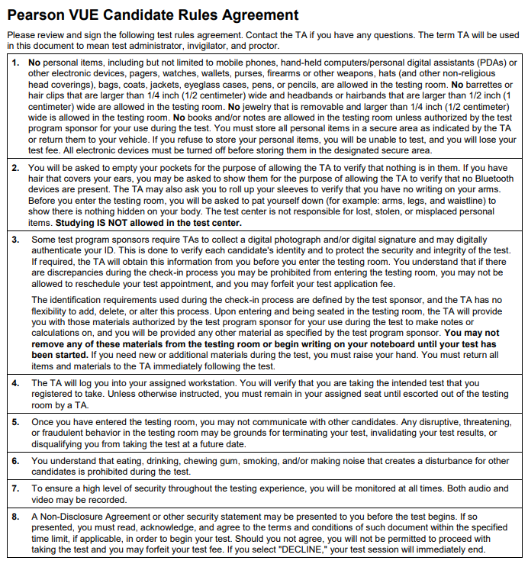

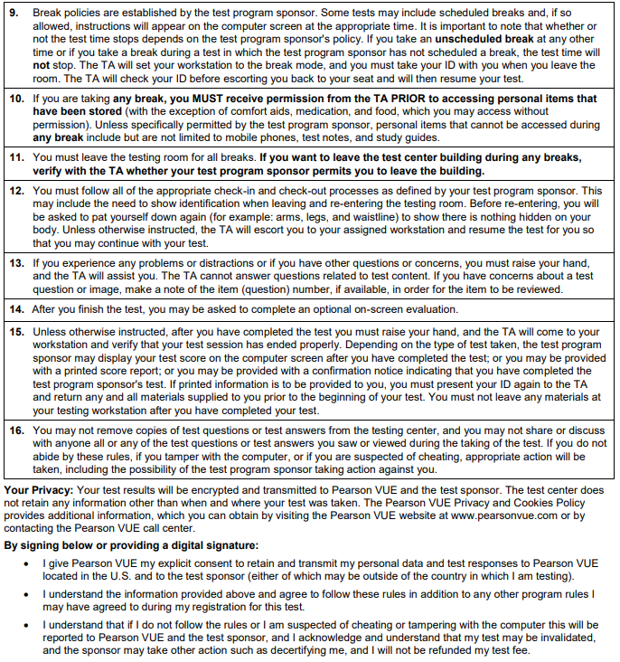

Name (Please print): {{Name}} {{Start}} Date: _____________

Signature Exam: {{Exam}}