Scaling Prosperity: A Hierarchical Bayesian Map of Population Size and Global GDP Through 2100

Short Title: Population–GDP Association: Bayesian Global Forecast

Tomoki Kawahara¹, MD, PhD, Shuhei Terada², MD, PhD

Affiliations: 1: Department of Clinical Information Applied Sciences, Institute of Science Tokyo, Tokyo, Japan, 2: Department of Public Health, Institute of Science Tokyo, Tokyo, Japan

Keywords: Association between population and GDP, Bayesian hierarchical modeling, Cross-variant economic forecasting, Demographic UN variants, Economic projections to 2100

Abbreviations: GDP: Gross Domestic Product, UN: United Nations

Address Correspondence to: Tomoki Kawahara, Department of Clinical Information Applied Sciences, Institute of Science Tokyo, 1-5-45 Yushima, Bunkyo-ku, Tokyo 113-8510, Japan
Tel: +81-3-5803-5377
E-mail: aaagcuugggcu@gmail.com
E-mail2: kawahara.hlth@tmd.ac.jp

Abstract
Background: Population size is an essential but contested driver of macroeconomic output; prior estimates of its association with gross domestic product (GDP) vary widely across regions and study designs. GDP is strongly associated with population health—spanning life expectancy, mortality, and health system capacity—so credible GDP trajectories are directly informative for public health planning. Robust, uncertainty-aware global projections linking demographic pathways to GDP remain limited.
Methods: We assembled panel data for 210 countries and territories (1960–2023) from the World Bank and fit a hierarchical Bayesian model with region- and country-level random effects. Centered log-population entered as a restricted cubic spline (natural spline with linear tails). Model adequacy was assessed with posterior predictive checks and out-of-sample information criteria. For forecasting (2024–2100), posterior draws were combined with eight United Nations World Population Prospects 2024 variants using an anchor-and-delta approach that fixes each country’s base-year GDP level and projects population-driven changes; training knots were reused, and light long-horizon regularization (post-2085 taper and plausibility envelopes) was applied to avoid implausible extrapolation. Variant medians were synthesized on the log scale with random-effects pooling.
Results: The association between centered log-population and log-GDP was positive with mild nonlinearity captured by the spline. Residual fit showed no material lack-of-fit (mean absolute error ≈ 0.12 log units). Relative to a linear specification, the spline model showed comparable predictive performance (e.g., WAIC ΔELPD ≈ 6.4, SE 163.7). Scenario-pooled forecasts indicate world GDP will grow by 38 % (95 % highest-density interval 35–40 %) between 2025 and 2040, with the United States, China, and the United Kingdom remaining the three largest economies in 2040. Between-variant heterogeneity accounted for roughly 38 % of global forecast variance.
Conclusions: Population is positively associated with GDP across countries, with gains that taper and vary by region. A hierarchical Bayesian framework that combines splines, base-year anchoring, and scenario-wise pooling yields transparent, probabilistic GDP projections; estimates beyond 2050 are best interpreted as regularized envelopes rather than unconstrained forecasts.

Introduction
Population size can enlarge labor supply, deepen markets, and foster knowledge spillovers, while also risking capital dilution, congestion, and ecological constraints. These countervailing forces imply a non-constant elasticity of GDP with respect to population that varies by development stage, demographic structure, and institution ^{1,2}. Because GDP is strongly associated with population health—via fiscal space, health-system capacity, and macro-determinants of mortality—these GDP envelopes translate directly into planning bandwidths for ministries of health (e.g., feasible trajectories for public health expenditure or service coverage) [REF Preston; REF fiscal-space].
Cross-sectional and panel studies report positive, null, and negative associations between population indicators and economic output, with estimates sensitive to model specification and endogeneity controls ^{3,4}. Demographic-dividend frameworks stress age structure and institutions ^{1,2}. Machine-learning forecasts can improve predictive accuracy but often sacrifice interpretability and rarely propagate full parameter uncertainty into long-horizon projections ⁵. Existing GDP projections typically model growth rates with convergence and then combine with population scenarios, but few offer probabilistic, globally pooled estimates that allow non-linearity and are tied explicitly to official UN demographic variants [REF SSP/OECD; REF UN WPP 2024].
We still lack a unified, hierarchical, and uncertainty-aware estimate of the population–GDP association that respects cross-country heterogeneity, permits smooth non-linearity without explosive extrapolation, and yields scenario-based GDP forecasts under multiple demographic pathways—forecasts that are interpretable for public-health planning given the tight GDP–health association [REF GDP↔Health overview].
We estimate global and region-specific associations between centered log-population and log-GDP using a hierarchical Bayesian model with restricted cubic splines (RCS) (linear tails) and region/country random effects; quantify uncertainty with full posteriors and out-of-sample criteria; and produce probabilistic GDP projections (2024–2100) under eight UN WPP-2024 variants using an anchor-and-delta design (base-year anchoring, post-2085 taper, plausibility envelopes). By linking demography to GDP transparently, we provide inputs relevant to health-system and development planning [REF UN WPP 2024; REF GDP→Health planning].

Methods
Data Sources
Historical panel (1960–2023): Country–year GDP (current USD) and mid-year population were extracted from the World Bank World Development Indicators (ref.). Income-group and geographic-region codes follow the Bank’s 2024 classification.
Demographic projections (2024–2100): We used eight variants from UN WPP-2024—Medium, Constant-fertility, Instant-replacement zero migration, Momentum, Zero-migration, No change, No fertility below age 18, and Accelerated adolescent-birth-rate decline recuperation—parsed from spreadsheet F01(ref.). After removing records lacking GDP, population, or region identifiers, the analytic sample comprised 180 countries ($≈$97% of world GDP).
Variables
GDP and population were base-10 log-transformed. Centered log-population was defined as $x_{ir}=\log_{10}{({Pop}_{ir})-\overline{x}}$ using the 1960–2023 global mean $\overline{x}$. To allow smooth non-linearity without explosive extrapolation, x entered as a restricted cubic spline (RCS) with knots near the 5th, 35th, 65th, and 95th percentiles; RCS has linear tails by construction.
Hierarchical Bayesian Model
For country $i$ in region $r$:
$$\log_{10}{({GDP}_{ir})=α_{i}+β_{i}x_{ir}+ϑ_{γ}^{T}s(x_{ir})+ε_{ir}, ε_{ir}\sim t_{ν}(0, σ)}$$
with country-level random intercepts/slopes
$$α\sim N(α_{r}, σ_{α, r}^{2}), β_{i}\sim N(β_{r}, σ_{β, r}^{2})$$
and region-level spline weights $θ_{r}\sim N(0, σ_{θ}^{2}I)$. Weakly informative priors were used for $α_{r}, β_{r}$; Half-Student-t($ν=3$) priors for $σ, σ_{α, r}, σ_{β, r}σ_{θ}$; and a Gamma-shifted prior for $ν$ truncated to $[2, 30]$ for numerical stability.
Inference and Diagnostics
Models were fit in PyMC (v5.12) with NUTS (nutpie), four chains, 10,000 post-warmup draws (5,000 warmup), target_accept = 0.99. Convergence required $\hat{R}≤1.01$ and adequate bulk/tail ESS for all monitored parameters. Model adequacy was evaluated with posterior predictive checks and out-of-sample information criteria (LOO/WAIC).
Scenario-Based GDP Forecasting (2024–2100)
To avoid unstable level extrapolation, we used base-year anchoring (2023 or the latest available year): for each country,
$$\log_{10}{({GDP}_{it})=\log_{10}{({GDP}_{i}, base)+β_{i}(x_{it}-x_{i0})+θ_{reg(i)}^{T}}}[s(x_{it})-s(x_{i0})]$$
The same knots were reused at forecast time. To avoid implausible extrapolation, we applied light regularization: a post-2085 taper that reduces population-driven deltas linearly to 60% by 2100, a time-varying soft floor/ceiling relative to the base level ($≈$0.90$→$0.80 pre-peak; 0.80$→$0.50 post-peak; upper bound $≈$4×), and mild clamping of $x$ to a buffered historical envelope ($±$0.25 dex). Posterior predictive trajectories were summarized by medians/95% HDIs per UN variant; variant pooling used random-effects meta-analysis on the log scale.
Software
Analyses were conducted in Python 3.12 (PyMC 5.12, ArviZ 0.21, NumPy 1.27, Pandas 2.2). Reproducible scripts are provided in the project repository.

Result
Descriptive overview
The panel contained 10,390 country–years for 180 countries, with mean (SD) $\log_{10}{Population}$ 7.04 (0.80) and $\log_{10}{GDP}$ 11.61 (1.25). Chains converged ($\hat{R}≤1.01$; median ESS > 1,200). Posterior predictive checks showed no material lack-of-fit (MAE $≈$ 0.12 log units).
Posterior estimates
The association between centered log-population and log-GDP was positive with mild non-linearity captured by the spline. Region-level variance components exceeded country-level components by roughly an order of magnitude, indicating pronounced macro-regional heterogeneity.
Scenario-specific GDP forecasts
Combining posterior draws with eight UN variants yielded country-level paths through 2100. Pooled globally, the median GDP rises from USD 115 trillion in 2025 to USD 168 trillion in 2040, a cumulative increase of 38% (95% HDI 35–40%). The United States, China, and the United Kingdom remain the three largest economies in 2040 across variants. Between-variant heterogeneity contributes ~38% of global forecast variance, larger in low-income regions where fertility and migration diverge.
Sensitivity analyses
Results were robust to normal-likelihood substitution, excluding countries with sparse histories (< 30 observations), and modest changes to the taper and plausibility bounds; global medians shifted by $≤$ 2–3%.

Discussion
Centered log-population showed a positive association with log-GDP, with mild non-linearity captured by the spline and substantial regional heterogeneity. Fit was adequate (MAE ≈ 0.12 log units). Predictive performance was comparable to a linear alternative (WAIC ΔELPD ≈ 6.4; SE 163.7), while the RCS specification yielded stable extrapolations. Scenario-pooled forecasts suggest global GDP rises by ≈38% (95% HDI 35–40%) from 2025 to 2040.
Our pooled, probabilistic estimates align with classic demographic-growth frameworks that find positive but context-dependent effects of population on output ^{1,2} and with meta-analytic evidence that published elasticities vary with model choices and controls ⁴. Unlike earlier cross-sections and linear panels reporting mixed signs ³, we allow smooth curvature while enforcing linear tails, avoiding the late-century inflation seen with polynomials. Compared with recent ML forecasts that emphasize accuracy over interpretability ⁵, the present approach delivers interpretable parameters, full uncertainty, and explicit linkage to UN variants. Finally, because GDP is associated with population health outcomes, our projections complement health-focused scenario efforts (e.g., SSP/GBD) by providing an economic envelope consistent with official demography [REF GDP→Health; REF SSP/GBD GDP modules].
Positive $β$ values are consistent with scale economies (larger markets, specialization, knowledge diffusion) and capital deepening in earlier transitions; attenuation at high x matches congestion/ecological limits and diminishing returns ^{1,2}. Regional variance components indicate the role of institutions, age structure, and human capital in mediating demography–GDP links [REF Demographic dividend]. Policy implications follow: countries approaching population plateaus or declines may need productivity-oriented reforms (human capital, female labor participation, migration management) to sustain output; health-sector planners can use the probabilistic GDP envelope to gauge fiscal space, investment timing, and resilience to demographic shifts [REF Fiscal space & health; REF Health investment macro returns]. Because GDP is associated with mortality and life expectancy, credible economic trajectories can support public-health priority-setting under demographic change [REF GDP→Health].

Limitations
First, macro data carry measurement error, especially in low-income settings, which may attenuate elasticities. Second, we omit explicit age structure, capital stock, and TFP dynamics; future work could embed these to sharpen causal interpretation. Third, UN variants capture demographic but not geopolitical/technological shocks; structural breaks could alter trajectories. Fourth, we pool variant medians with a random-effects step, treating scenarios as exchangeable; dependence across variants may be understated. Finally, late-century projections use light regularization (post-2085 taper, plausibility bounds); these are principled but still priors, so estimates beyond 2050 are best read as regularized envelopes, not point predictions.

Conclusions
Population is positively associated with GDP worldwide, with tapering gains and marked regional heterogeneity. A hierarchical Bayesian RCS model with base-year anchoring delivers transparent, probabilistic GDP projections tied to official demography—useful for development strategy and health-system planning. Incorporating age structure and productivity dynamics, and aligning with health-outcome scenarios, are natural next steps to strengthen policy relevance.

References
1 Bloom, D. E. & Finlay, J. E. Demographic Change and Economic Growth in Asia. Asian Economic Policy Review 4, 45-64 (2009). https://doi.org/10.1111/j.1748-3131.2009.01106.x
2 Lee, R. & Mason, A. Some macroeconomic aspects of global population aging. Demography 47, S151-S172 (2010). https://doi.org/10.1353/dem.2010.0002
3 Kelley, A. C. & Schmidt, R. M. Aggregate Population and Economic Growth Correlations: The Role of the Components of Demographic Change. Demography 32, 543-555 (1995). https://doi.org/10.2307/2061674
4 Headey, D. D. & Hodge, A. The Effect of Population Growth on Economic Growth: A Meta‐Regression Analysis of the Macroeconomic Literature. Population and Development Review 35, 221-248 (2009). https://doi.org/10.1111/j.1728-4457.2009.00274.x
5 Anil Ari, G. P., Liyang Sun. Structural Reforms and Economic Growth: A Machine Learning Approach, <https://www.imf.org/en/Publications/WP/Issues/2022/09/15/Structural-Reforms-and-Economic-Growth-A-Machine-Learning-Approach-523396> (2022).

Table 1. Posterior summary of key parameters from the hierarchical Bayesian model of log-GDP (1960 – 2023)
Region | East Asia & Pacific | Europe & Central Asia | Latin America & Caribbean | Middle East & North Africa | North America | South Asia | Sub-Saharan Africa
alpha_median | 10.27 | 11.01 | 11.89 | 9.90 | 13.24 | 8.93 | 9.76
alpha_hdi_lo | 8.97 | 9.50 | 10.68 | 9.11 | 9.73 | 7.74 | 9.20
alpha_hdi_hi | 11.56 | 12.55 | 13.08 | 10.69 | 16.91 | 10.18 | 10.29
alpha_rhat | 1.00 | 1.00 | 1.00 | 1.00 | 1.00 | 1.00 | 1.00
alpha_ess_bulk | 19929.70 | 4591.23 | 12668.01 | 15027.26 | 9636.08 | 6643.57 | 4104.85
alpha_ess_tail | 21866.74 | 13982.48 | 18576.58 | 19322.64 | 19901.10 | 14465.11 | 11584.81
beta_median | 3.46 | 3.40 | 3.88 | 3.36 | 3.05 | 1.35 | 3.32
beta_hdi_lo | 2.61 | 1.95 | 2.97 | 2.75 | 1.16 | 0.22 | 2.89
beta_hdi_hi | 4.29 | 4.93 | 4.80 | 3.99 | 4.90 | 2.47 | 3.75
beta_rhat | 1.00 | 1.01 | 1.00 | 1.00 | 1.00 | 1.00 | 1.01
beta_ess_bulk | 1322.78 | 534.37 | 4037.91 | 3935.36 | 3950.17 | 3431.97 | 782.86
beta_ess_tail | 4881.23 | 2112.94 | 13419.34 | 10490.27 | 13140.14 | 9200.74 | 2580.55
theta_L2_median | 0.14 | 0.18 | 0.11 | 0.11 | 0.09 | 0.12 | 0.37
theta_L2_hdi_lo | 0.07 | 0.06 | 0.04 | 0.04 | 0.01 | 0.07 | 0.18
theta_L2_hdi_hi | 0.28 | 0.31 | 0.23 | 0.24 | 0.21 | 0.23 | 0.55
theta_L2_rhat | 1.01 | 1.02 | 1.00 | 1.00 | 1.00 | 1.00 | 1.02
theta_L2_ess_bulk | 429.67 | 184.03 | 1194.55 | 1680.87 | 1478.65 | 1056.59 | 345.69
theta_L2_ess_tail | 919.10 | 329.57 | 1648.52 | 2483.47 | 2438.58 | 1176.66 | 725.95

Mean = posterior mean; SD = posterior standard deviation.
p2.5 and p97.5 are the lower and upper bounds of the 95 % highest-density interval (HDI).
r̂ is the Gelman–Rubin convergence diagnostic (values ≈ 1.00 indicate convergence).
ess_bulk and ess_tail are the bulk and tail effective sample sizes, respectively.
Rows labeled alpha_region, beta_region, and gamma_region report region-specific population–GDP coefficients; sigma is the Student-t scale.
The final three rows (alpha_country (all), beta_country (all), gamma_country (all)) give distribution summaries for the 180 country-level effects; sampler diagnostics are not applicable to these aggregated rows.
Table 2.
Figure 1. Global association between population size and economic output, 1960 – 2023
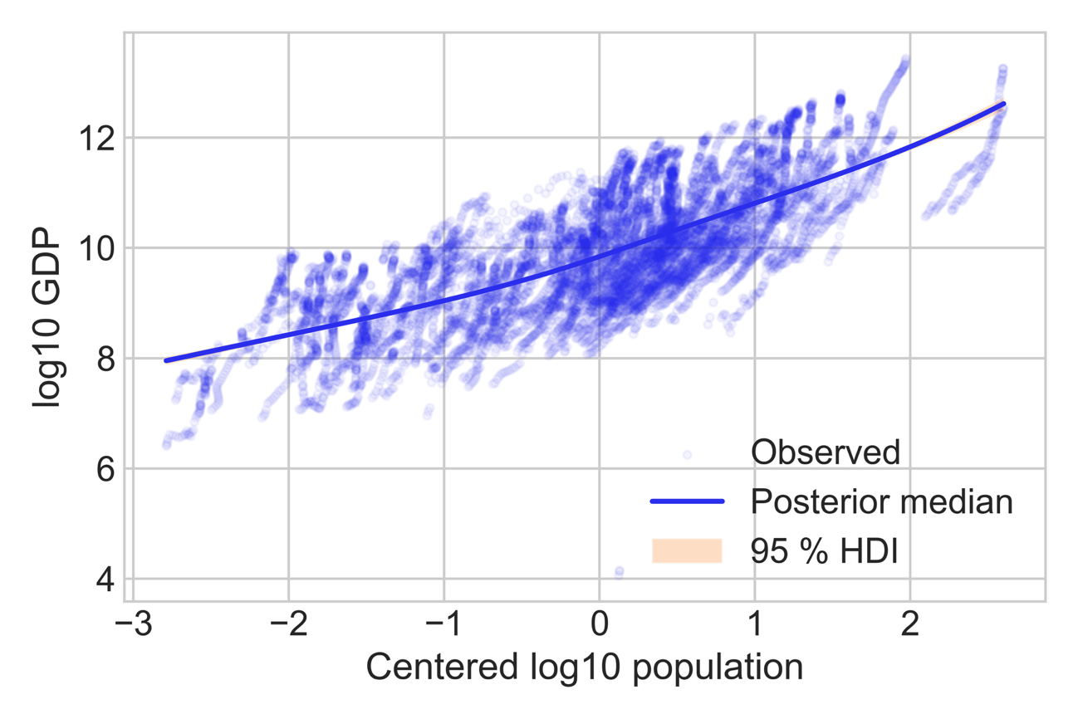
Each gray point is one country–year (n = 10 390; log-transformed units).
The solid black line is the posterior median of the hierarchical Bayesian model; the shaded band is the 95 % highest-density interval.
Population is centered on the 1960 – 2023 global mean (µₚ = 7.04).
The upward-sloping but slightly concave curve indicates a positive, diminishing-returns association between log-population and log-GDP after accounting for region- and country-level random effects.
Figure 2. Global GDP fan chart under eight UN demographic variants, 2025 – 2100
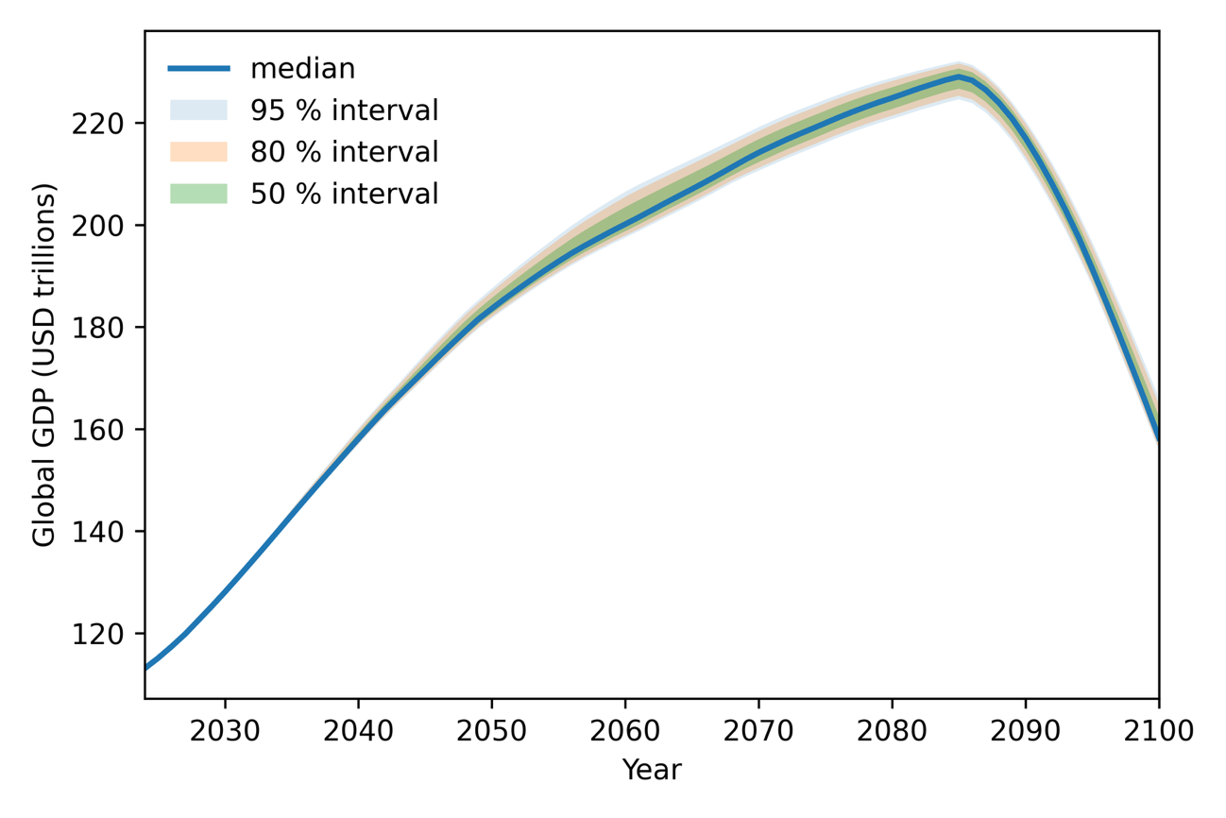
Solid line denotes the pooled median across eight UN WPP-2024 population variants (High and Low excluded). Shaded bands show the 50%, 80%, and 95% highest-density intervals obtained by combining posterior draws with variant-specific population paths under a hierarchical RCS model with base-year anchoring and light long-horizon regularization (post-2085 taper and soft plausibility bounds). Values are reported in current-dollar trillions and summed across all countries. The median rises from USD 115 trillion in 2025 to USD 168 trillion in 2040, with uncertainty widening thereafter as demographic scenarios diverge.

