**Project 3**

This is the environment within a blood vein in an (obviously infected) human or creature. They have bloated red blood cells each infected with an eye monster parasite, in which the monster with teeth is more or less the leader.

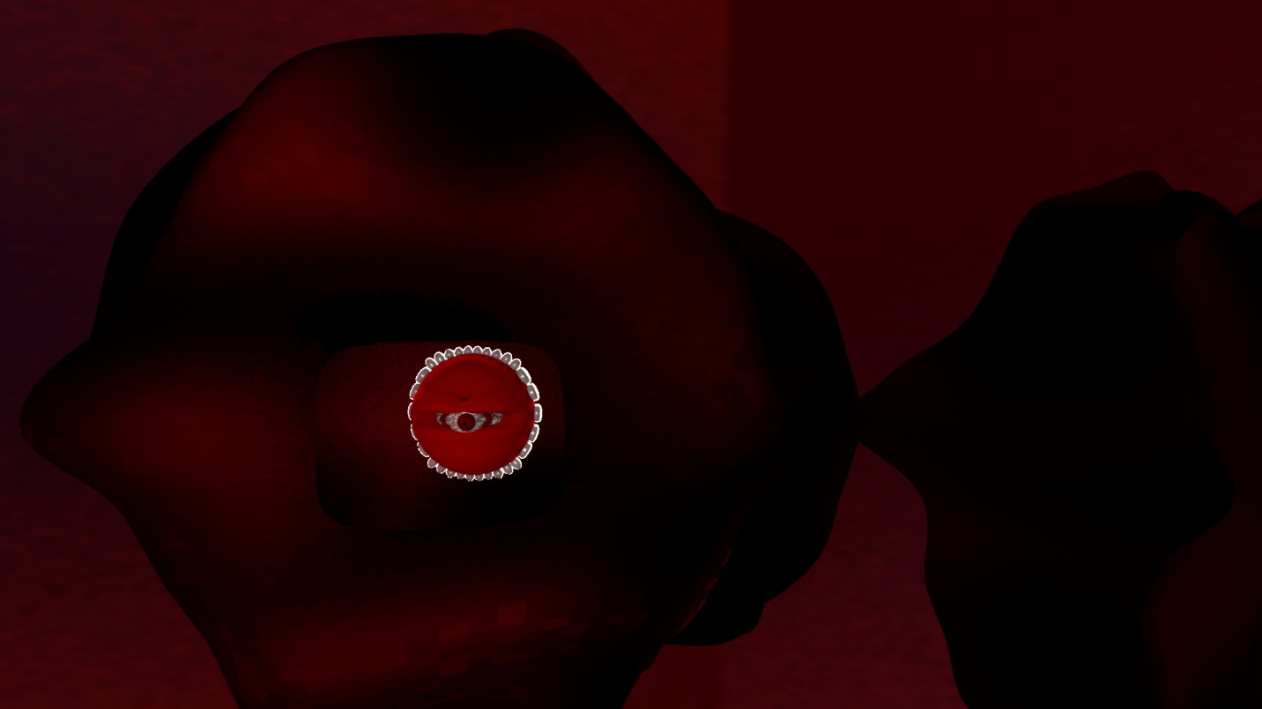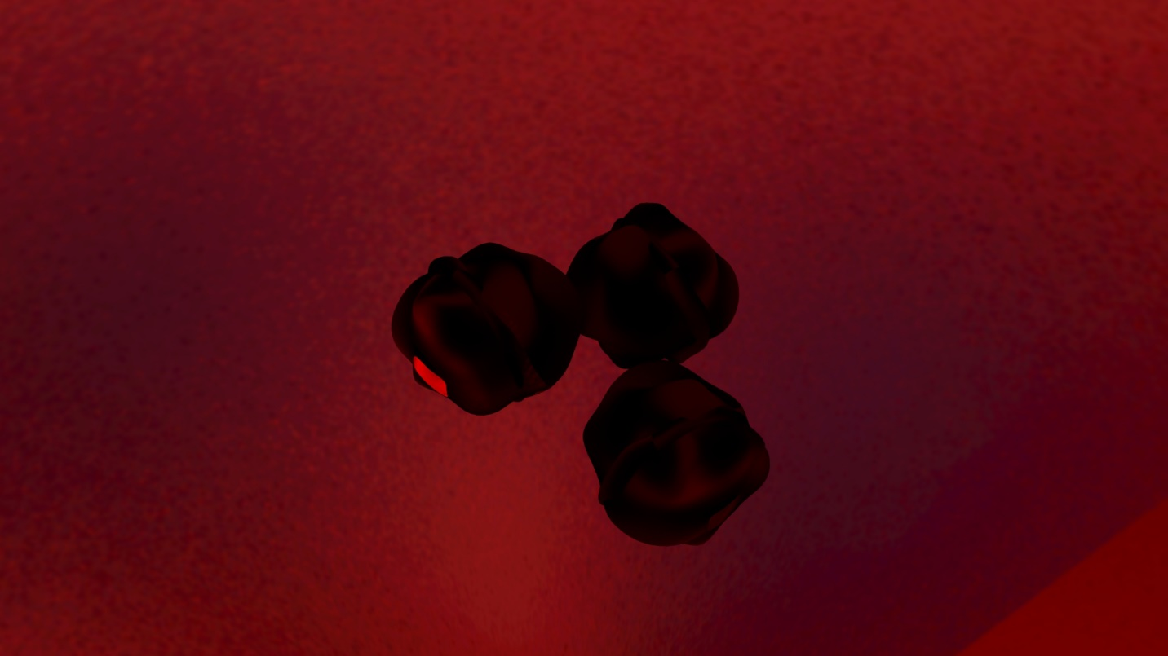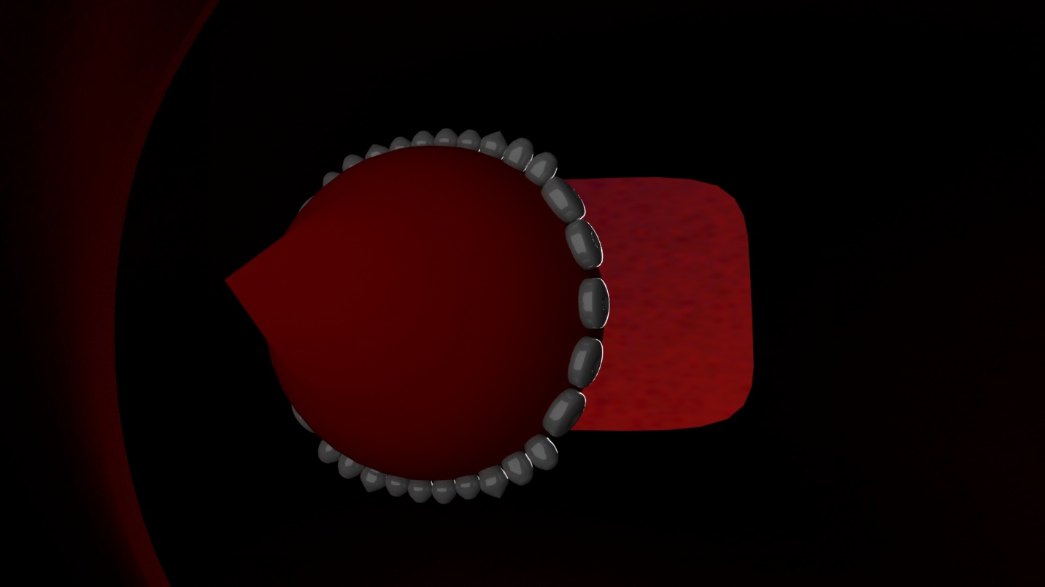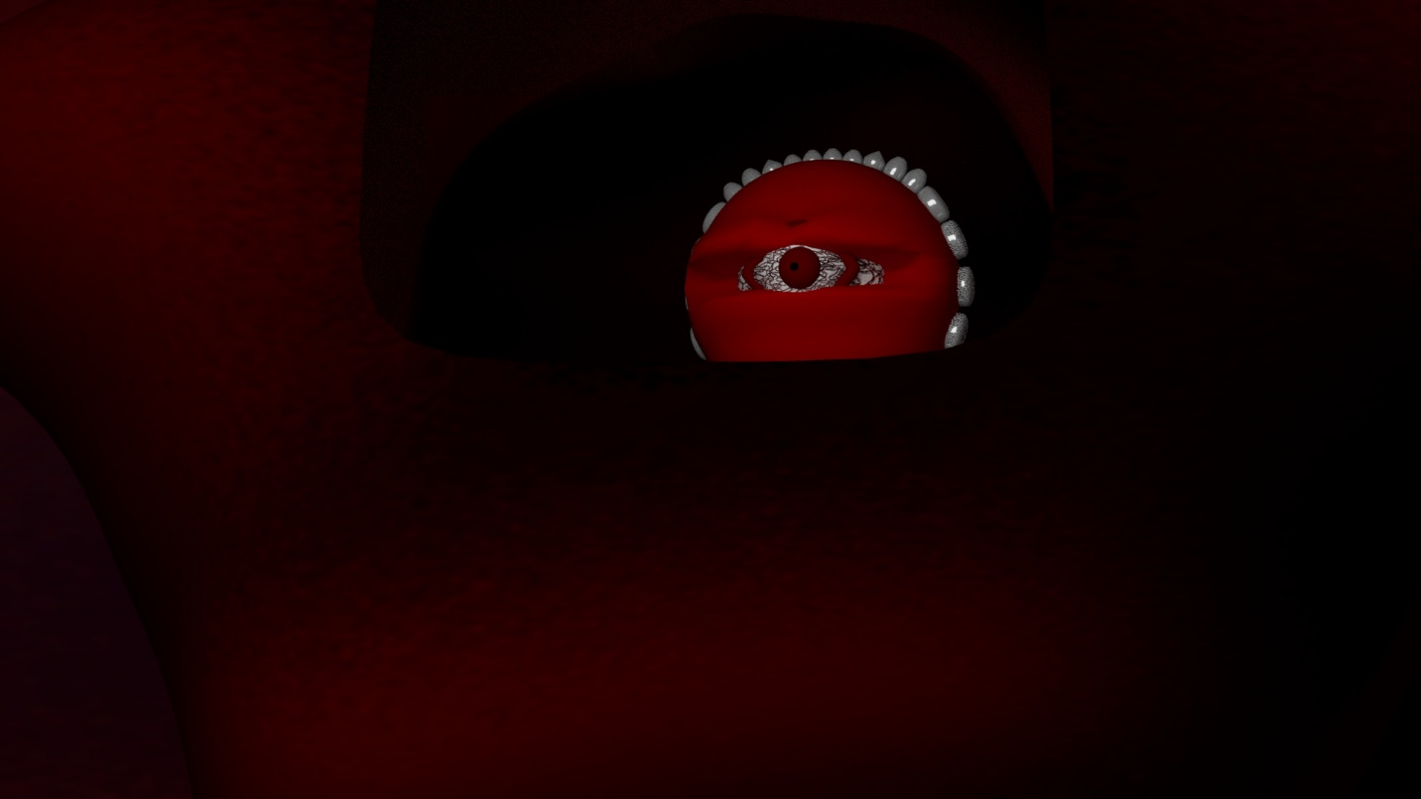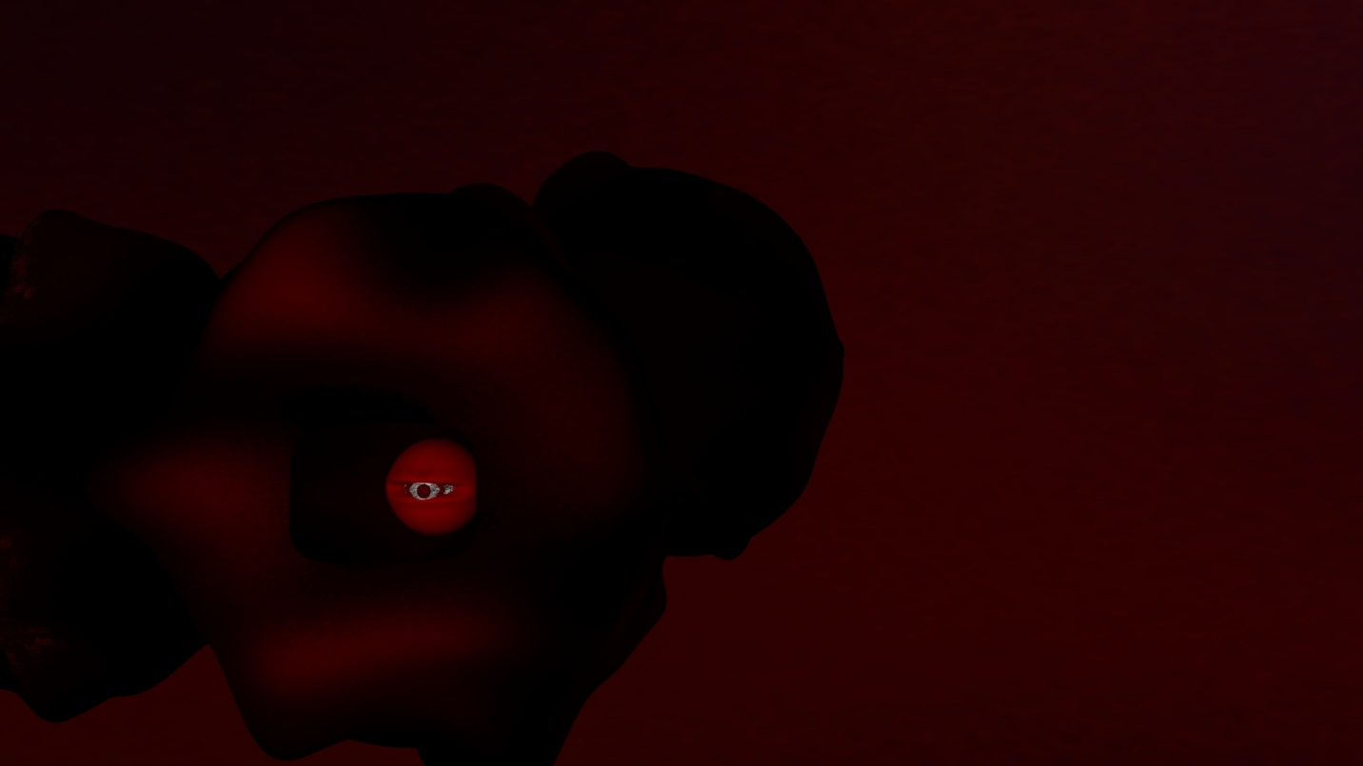

This is the dungeon of Jabu-Jabu’s Belly from Legend of Zelda: Ocarina of Time, where I got the idea to try to create a blood vein environment.

