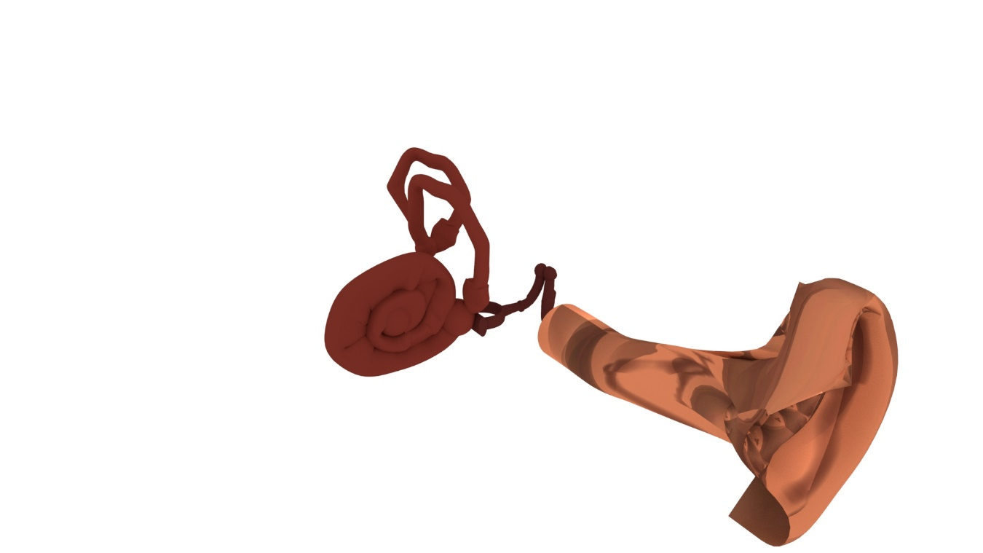**Final Project**

**Dennis Qiu**

**Background**

I decided to create a model of an ear for the final project. I wanted to model an ear because it is tied to my backstory and I have no other ideas to pull from. I was born with hearing loss in both ears and I had two surgeries that returned my hearing to normal, in August 2015 and May 2016. I wanted to try to recreate my ear at the time before I had the surgeries. The doctors determined that one of my ears was severe in hearing loss while the other one was moderate to severe. I forgot which ear was the more severe. The reason why I have a hearing loss in both ears (it is exactly the same problem in both ears) is that one of the bones located in the middle ear is missing. It was never developed properly and thus, created a gap, like when the middle portion of a bridge has collapsed. So I want to try to recreate what an ear with a missing bone in the middle ear looks like.

**Timeline**

• November 19 – Pitch/proposal of ear with reference images

• November 22 – Model outer ear

• November 23-29 – Model middle and inner ear

• November 29-December 3 – Texture and cleanup model. Begin lighting

• December 5 – Final lighting results, renders, and combine into PDF

• December 10 - Presentation

**References**

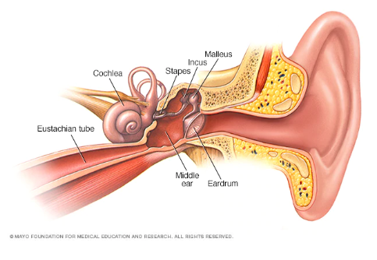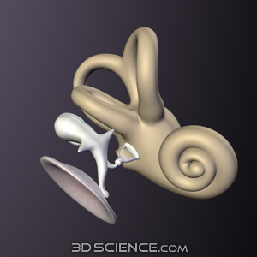

[Outer Ear Tutorial](https://www.youtube.com/watch?v=cStTnFkg6h0" \o "Outer Ear Tutorial)

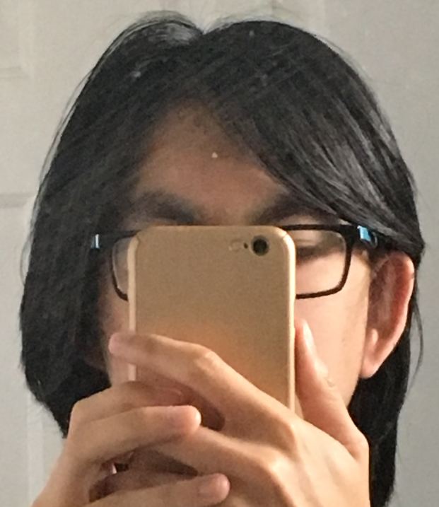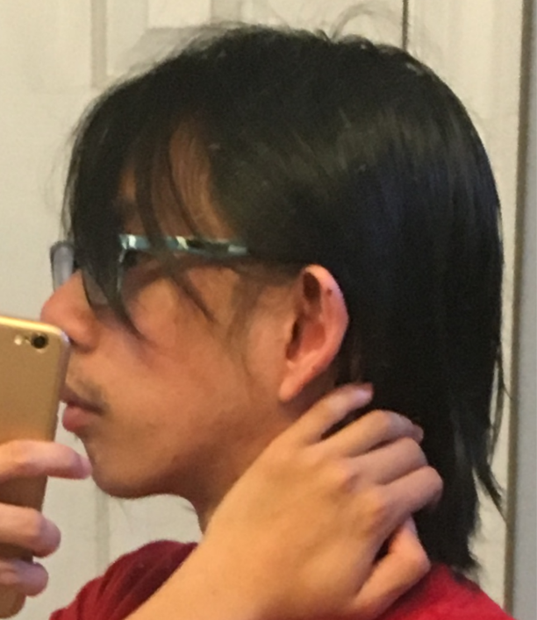

**Ear**

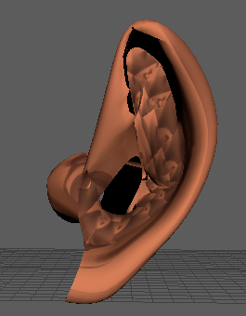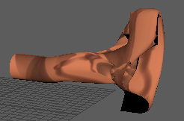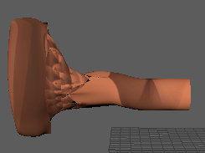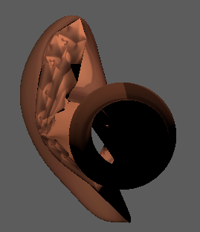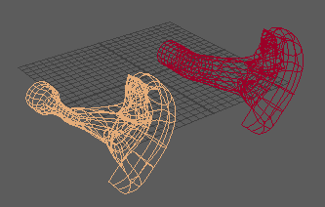

**Eardrum**

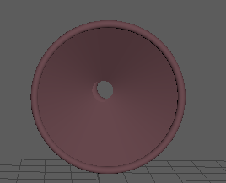

**Stapes, Incus, Malleus**

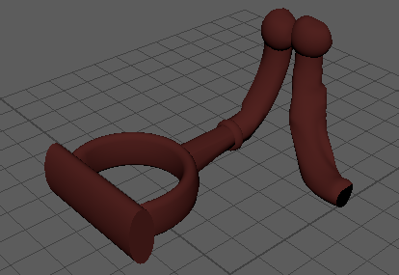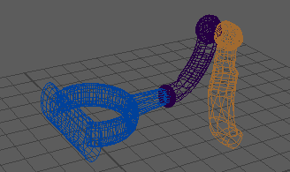

**Cochlea**

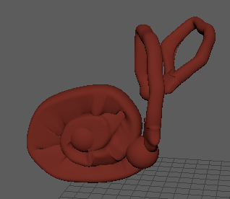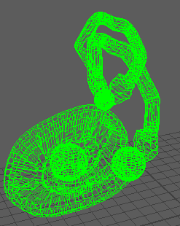

**Renders**

