AcPack:

1. Text for the note we show before user actually applies: 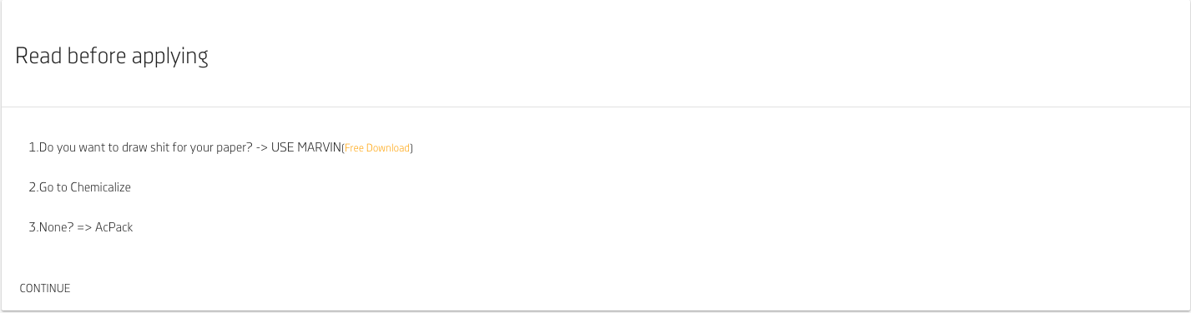
2. Text for the “Accept AcPack conditions” dialog: 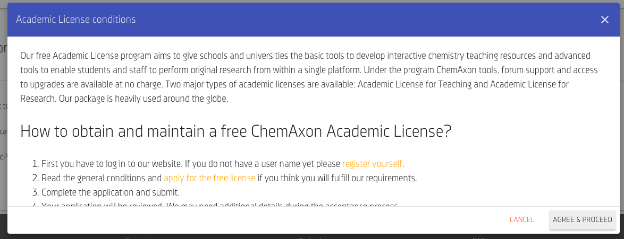
3. Texts for both panes on academic email input view