On April 26, 2023, Joy scheduled a disaster recovery (DR) test to take place on May 13 with team members Ryan Jay and Brad. Joy created change request CHG0114861 to formally notify the Wintel team to prepare for the test. The DR test date was later moved to May 27 due to a patching weekend already scheduled on May 13.

[CHG0114861 | Change Request | ServiceNow (service-now.com)](https://tpicap.service-now.com/now/nav/ui/classic/params/target/change_request.do%3Fsys_id%3Da046e1f31bd62118b0919719b04bcb15%26sysparm_view%3D)

In preparation, Joy asked Jeff Flores from the Wintel team how long it would take to restore a virtual machine (VM) backup to an alternate location. Jeff estimated it would take approximately 3 hours to restore the latest backup copy, configure the VM, and have it ready for testing. He confirmed they could start the recovery process at 6am in order to have the server available by 9am for the application team to begin testing.

On the morning of May 27, Jeff initiated the process of restoring the most recent backup of the VM SG1SHKGMBS01 to an ESX host located at the alternate data center KDH. He provided status updates to the team as he shut down the original VM, brought up the restored copy on the new ESX host, and updated the DNS records to point to the new location.

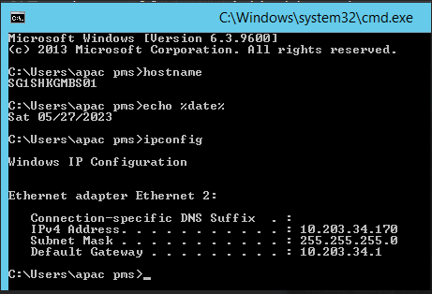

Joy and Wei Chung then attempted to connect to the services and databases from the restored VM backup. Initially they could not connect and received errors that the database and services were unavailable. Jeff investigated and found that the required services had not yet been started on the newly restored VM. He manually started the necessary services which then enabled Joy and Wei Chung to connect.

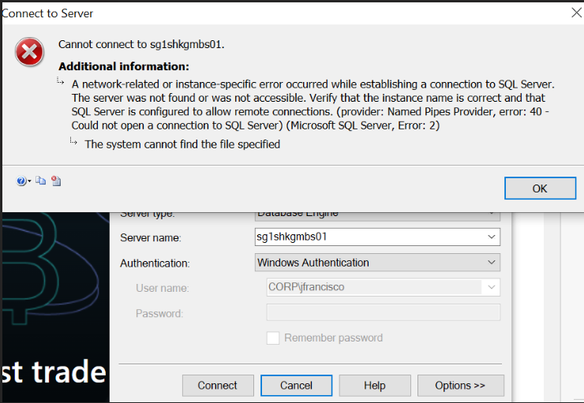

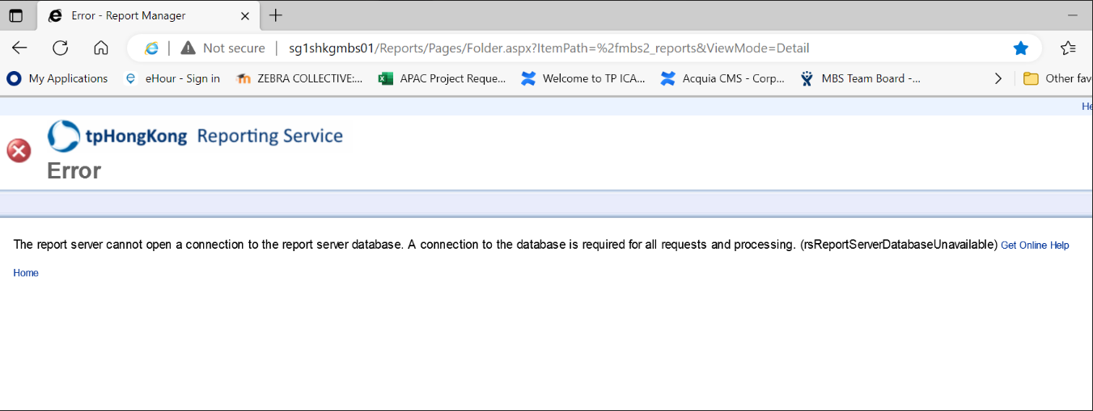

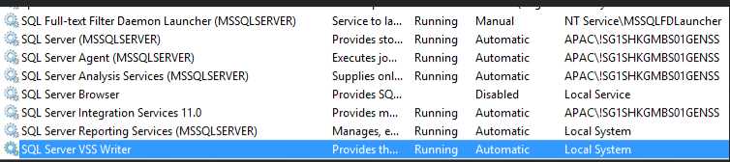

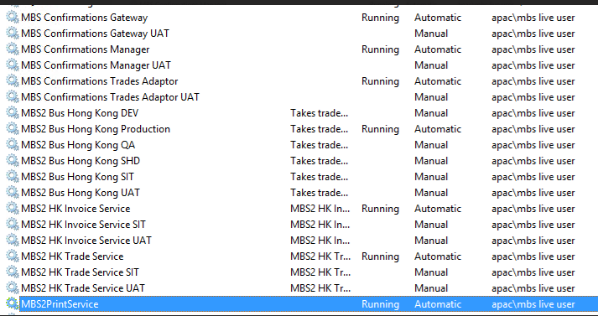

However, upon beginning their application testing they found that the restored VM was a backup from May 25 rather than the expected May 26 backup. Jeff confirmed that this VM backup from the 25th was indeed the latest backup available for that server.



Joy and Wei Chung continued testing and were able to verify that the services were functioning, despite the restored backup being one day older than anticipated. They took screenshots of the version and date information and made notes about the backup date discrepancy. Otherwise, they were able to successfully test the critical MBS services and applications.

After completing the tests, Jeff restored the original VM and services on the SG3 production environment. He requested the change tasks be closed appropriately in order to complete the CHG record for the DR test. Joy attached the full DR test results and notes to the CHG record for documentation.

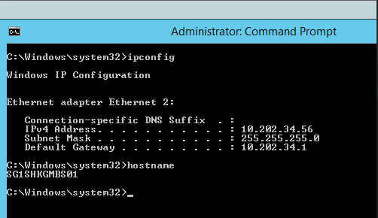

Later Joy followed up with Jeff asking if he had determined why the latest backup available was from two days prior rather than the expected backup from the previous evening. Jeff responded that he had not yet had a chance to investigate the root cause of the older than expected backup.