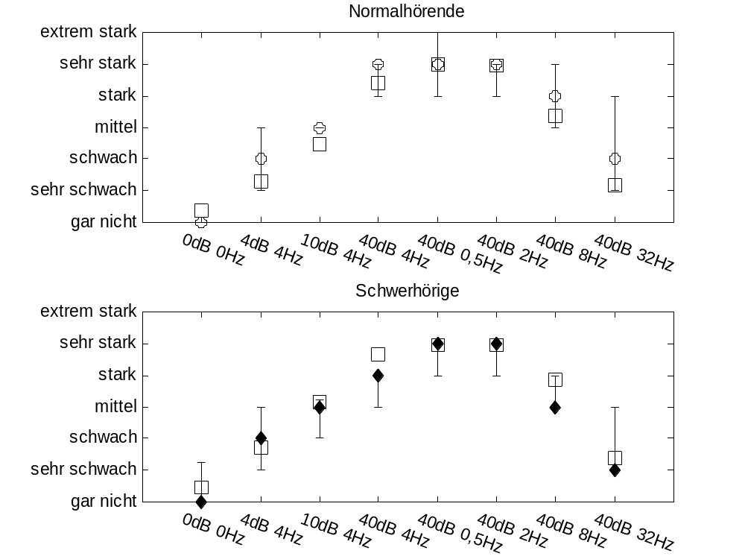

Fig.1: Computed (squares) and subjective loudness fluctuation (diamonds) for normal and hearing-impaired listeners. Modulated broadband noises. Verbal categories relate to the output of fluct.m (0=”gar nicht” = not at all; 6=extremely strong=”extrem stark”. English publication in preparation. The upper chart shows normal,the lower chart hearing-impaired data. Data in fluct.m can be compared to normal hearing data.
From Chalupper, J. (2001) - in german - : Perzeptive Folgen von Innenohrschwerhörigkeit: Modellierung, Simulation und Rehabilitation. Dissertation at the Technical University of Munich, Shaker Verlag.

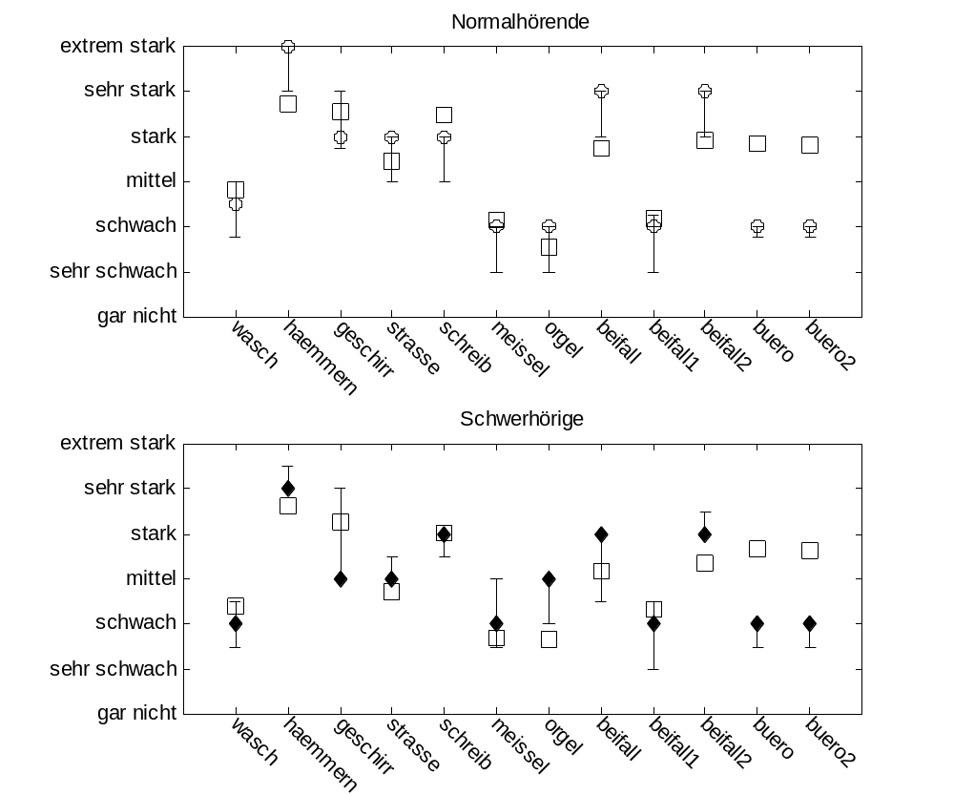

Fig. 2: Computed (squares) and subjective loudness fluctuation (diamonds) for normal and hearing-impaired listeners. Real life sounds, from left to right: washing machine, hammering, dishes clattering, street, typewriter, chisel, church organ, rhythmic applause, steady applause, conversation in the office 1, conversation in office 2,. Verbal categories relate to the output of fluct.m (0=”gar nicht” = not at all; 6=extremely strong=”extrem stark”. English publication in preparation. The upper chart shows normal,the lower chart hearing-impaired data. Data in fluct.m can be compared to normal hearing data.
From Chalupper, J. (2001) - in german - : Perzeptive Folgen von Innenohrschwerhörigkeit: Modellierung, Simulation und Rehabilitation. Dissertation at the Technical University of Munich, Shaker Verlag.

