- Example automations not loading:
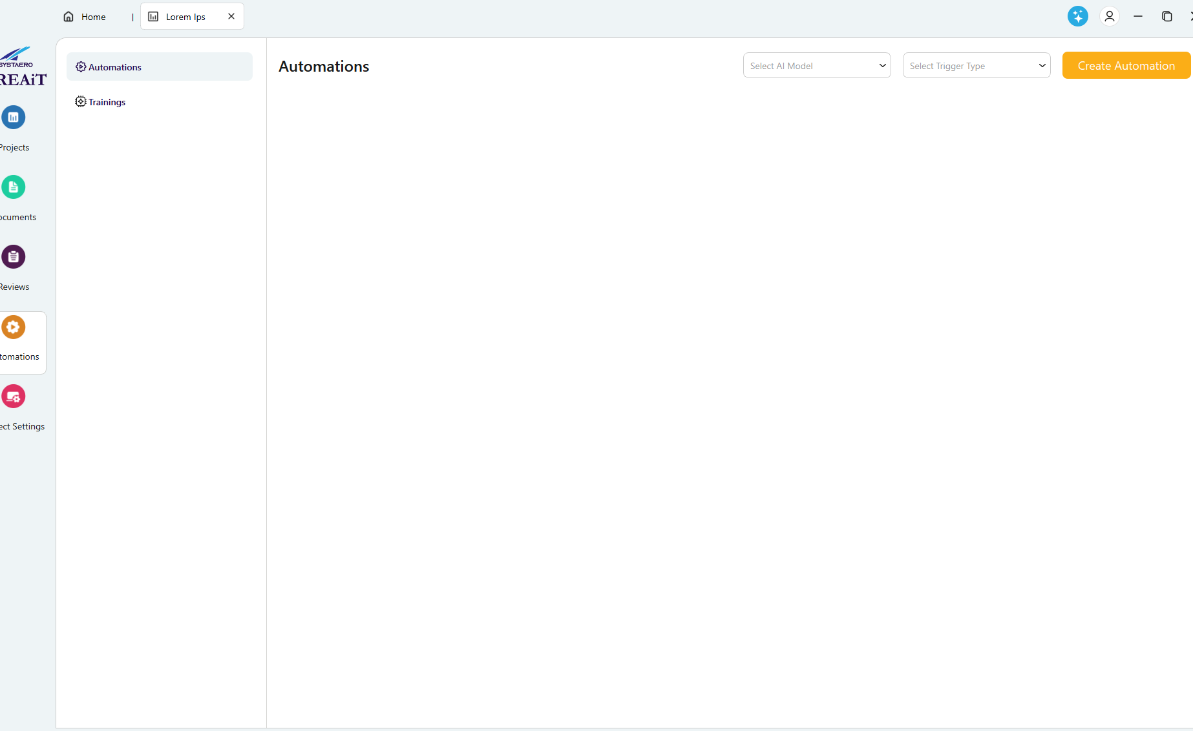
There are automations in the sample project that should be loading with each build.
- Create Automation buttons don’t appear to work. I can’t save a new automation or cancel out of it.
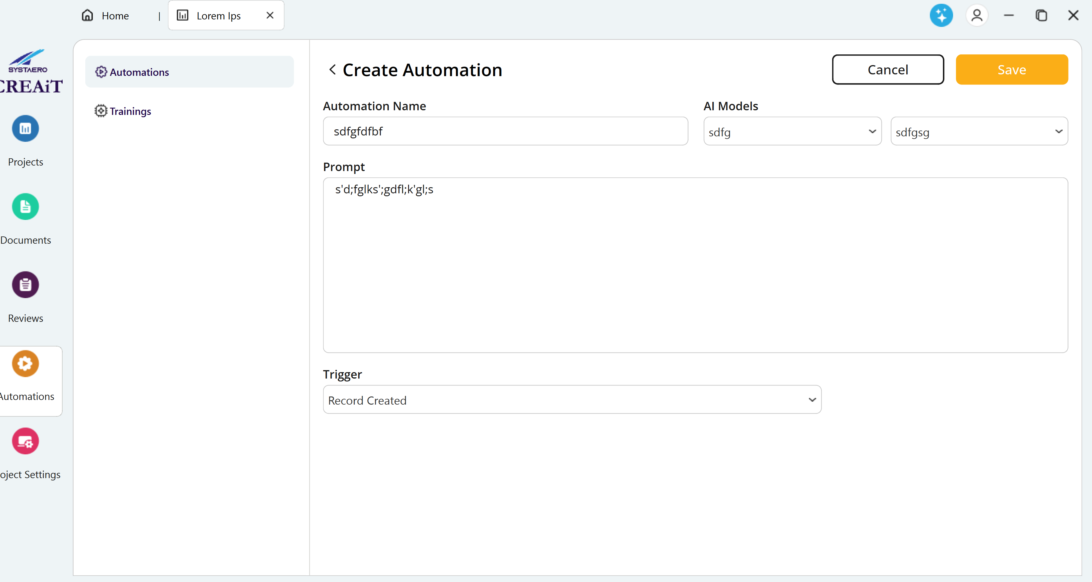
- File uploading does not appear to work when creating a new training
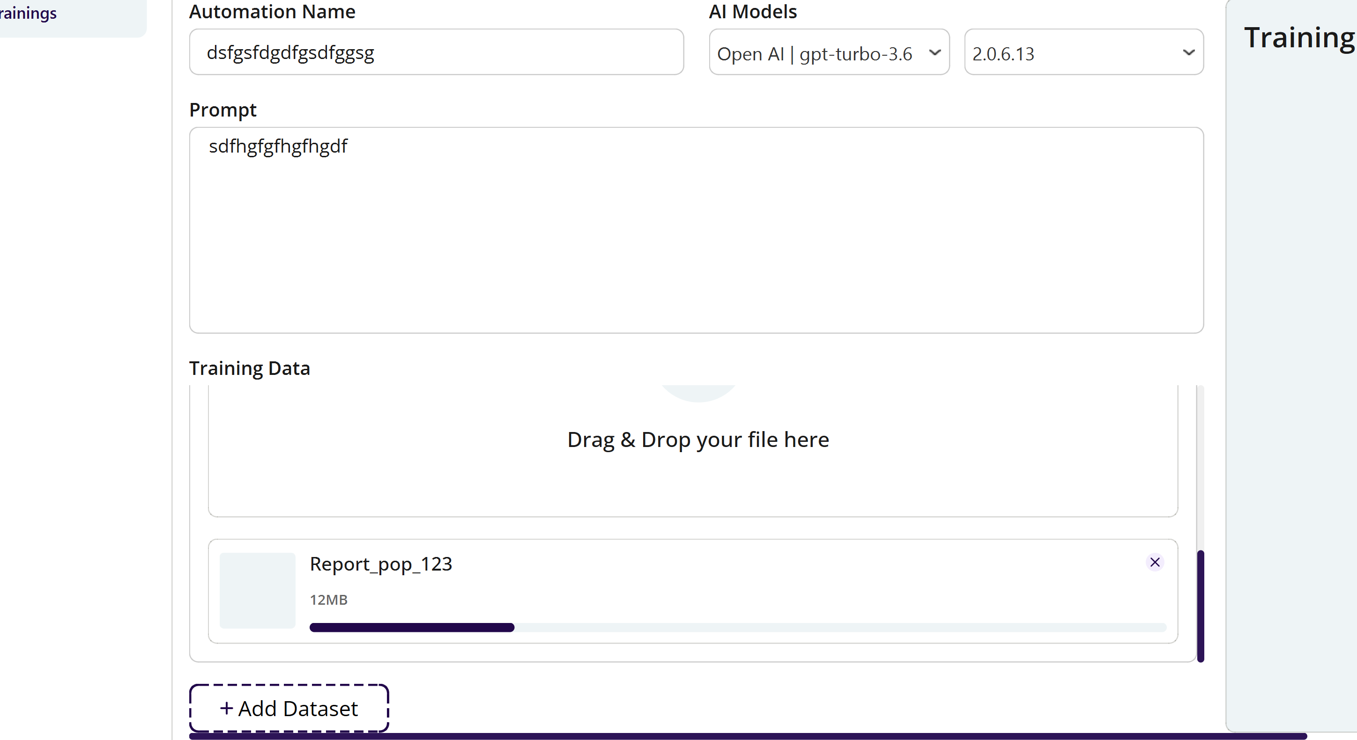
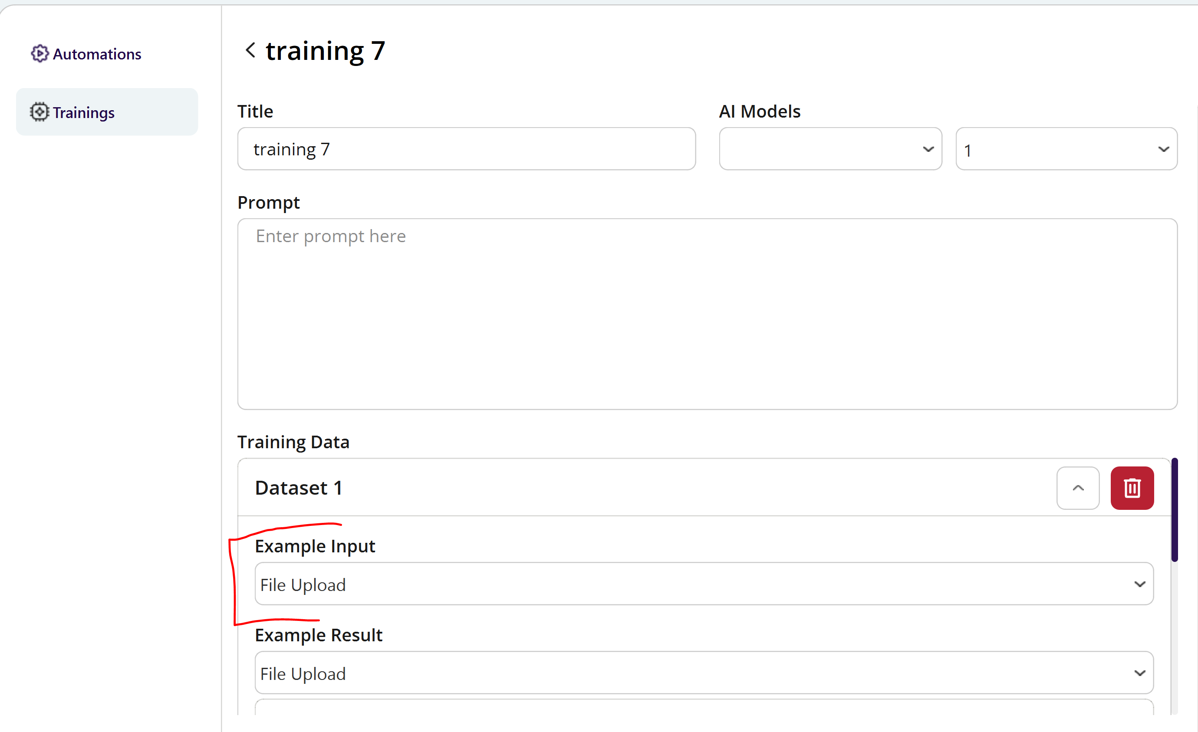
- Cannot edit trainings
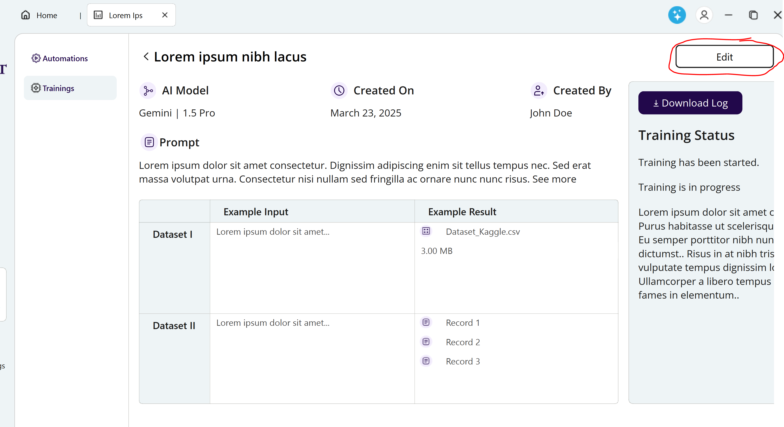

- The Create Automation button now loads the last automation, the fields should all be blank for a new automation.
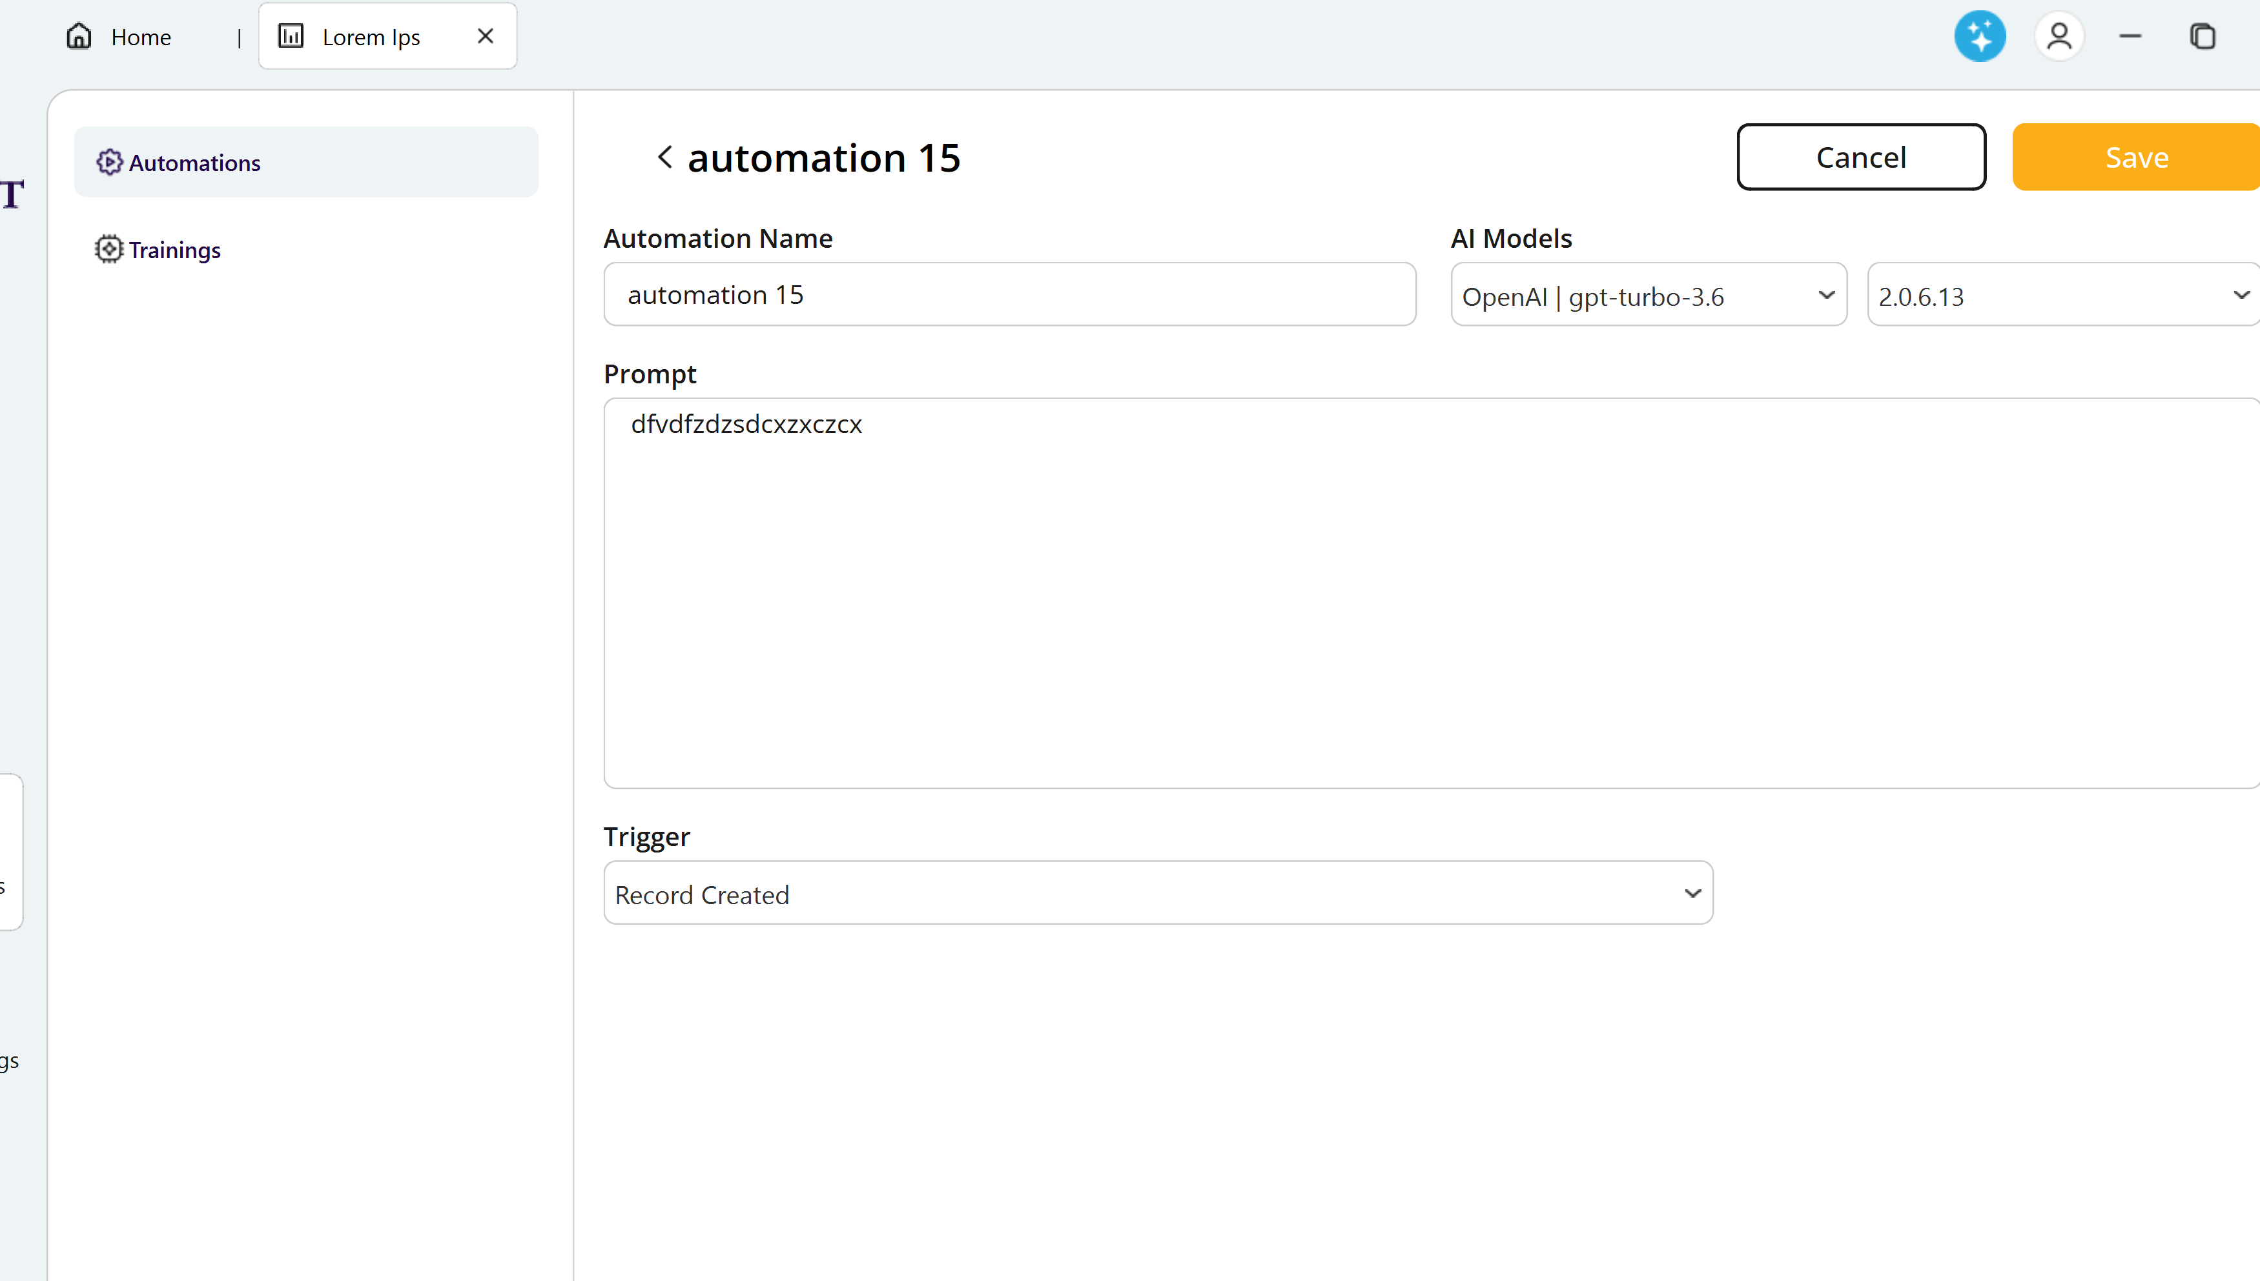
- When Clicking save or cancel on the automation, nothing happens on the GUI. It should go back to the original screen to test the automation. It seems like it saves some items but not the trigger.
- Automation missing the time selection for how often to trigger
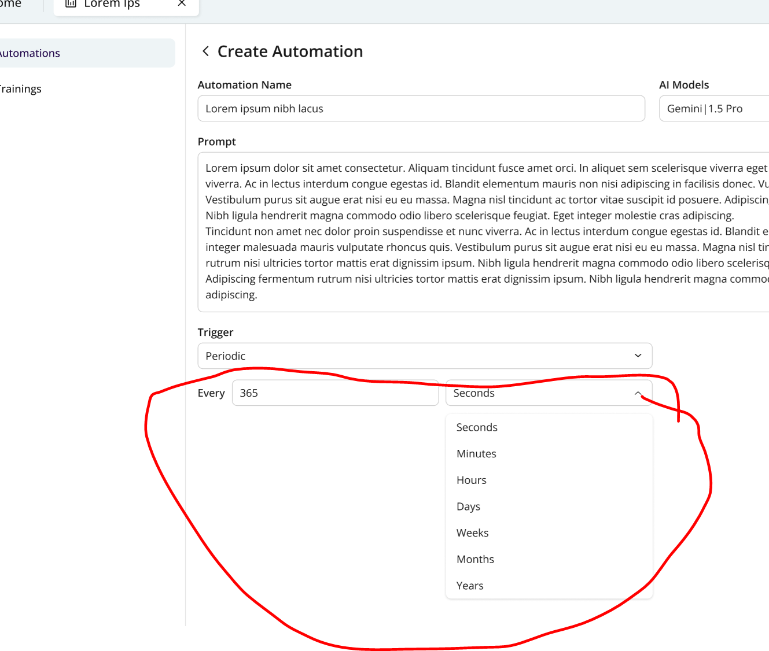
- Deleting an automation takes quite a while. Is there anything that can be done to make it faster?
- After setting up the training, it seems like we should have a SAVE button somewhere. I realize the Figma design does not show this.
- When editing a training, the start training does nothing. Another question I have it how do I test the training start and fail?
- The download log button does not appear to work. We just need a basic text file downloaded that contains the information in the log:
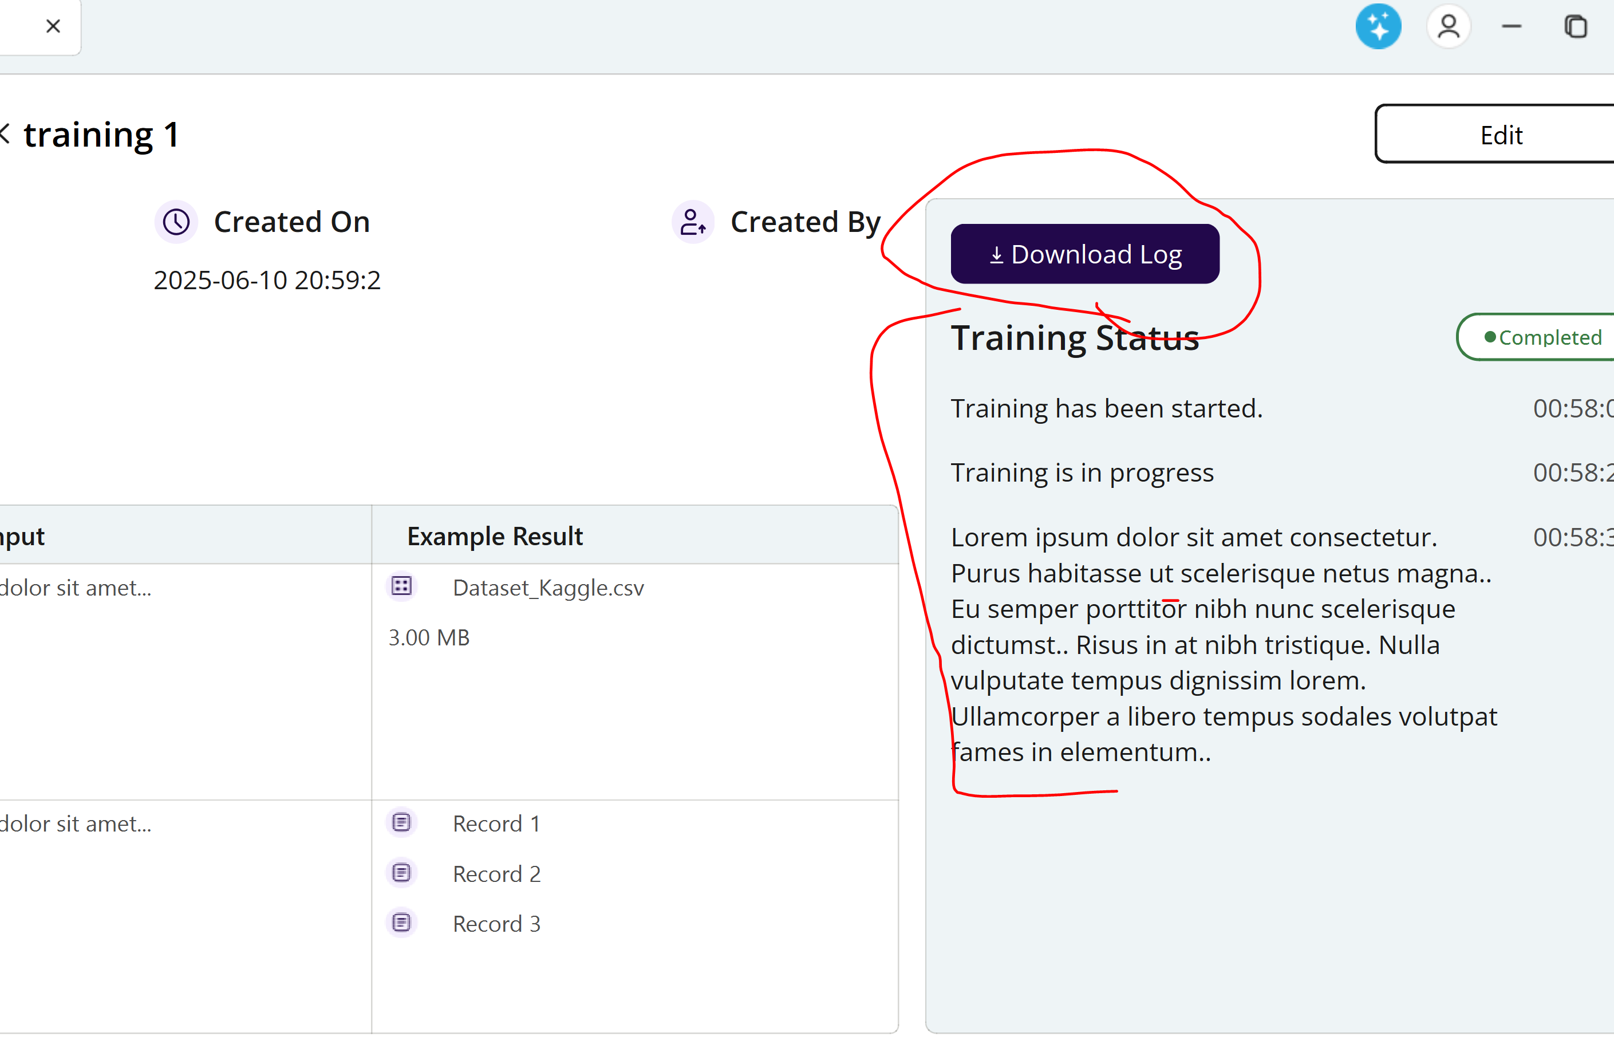

- Training screen does not provide a way to upload a file:
