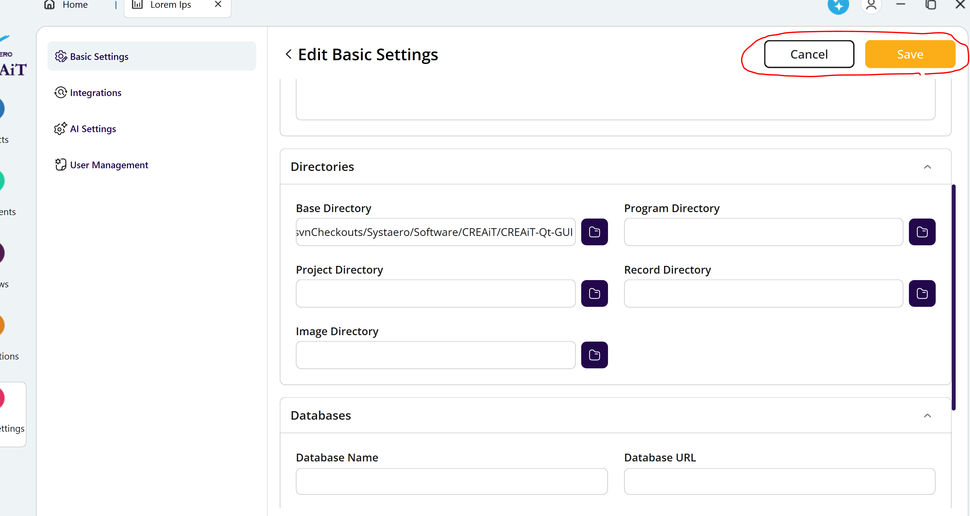
- Save and cancel buttons don’t seem to work
- The additional field buttons do not have a name and value field
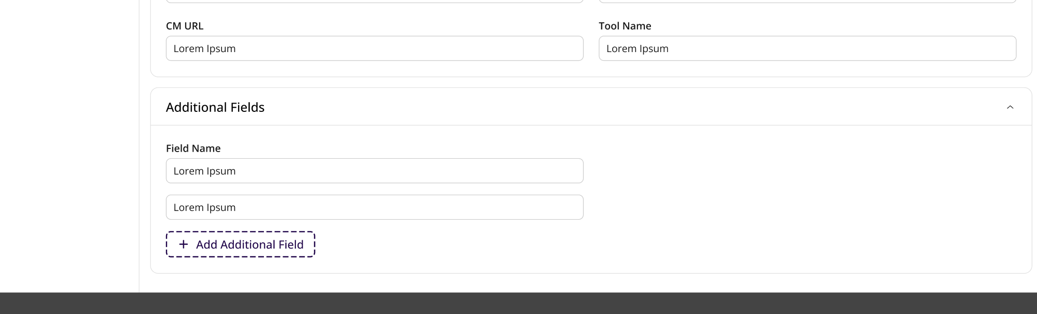
- Adding a new user does not add a new user to the list:
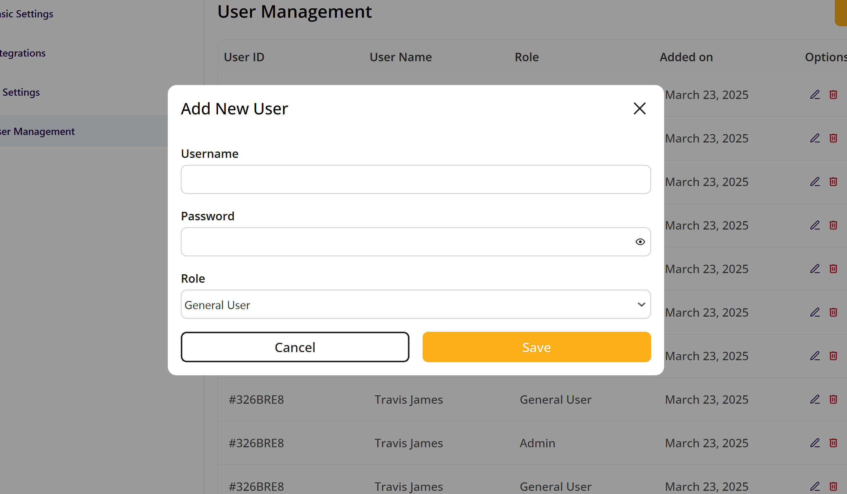
- AI Settings buttons don’t work yet. No change to the GUI. No update to the information
- Same comment for the integrations.

