- When hovering over a record in the treeView, a preview window should display right over the cursor when the cursor is hovering over the top of it over a few seconds
- When hovering over the ID, the popup window needs closed to remove it, however it would be better to be displayed directly over the ID when hovering over it. Mouse movement would still be allowed an when no longer over the ID, it would be removed. Should function like a tooltip and allow the user to move the mouse without closing.
- We also need a time delay before displaying the preview. This keeps the preview from opening when users are simply moving the pointer across the screen.
- I right click on the record, should bring up the same menu as the “…” that is directly over the mouse cursor.
- Description field needs html text display and editable with the following fields:
- Bold
- Italics
- Table Creation
- Bullets
- Numbering
- Alignment
- Image insertion
- Hyperlink insertion
- Font? (Not sure how hard this is. Maybe not needed if it’s too much effort)
- Super and sub scripts
Image is not displayed in doc after it’s saved.
- The AI chat window should be displayed from this icon in all windows and not the connection status.
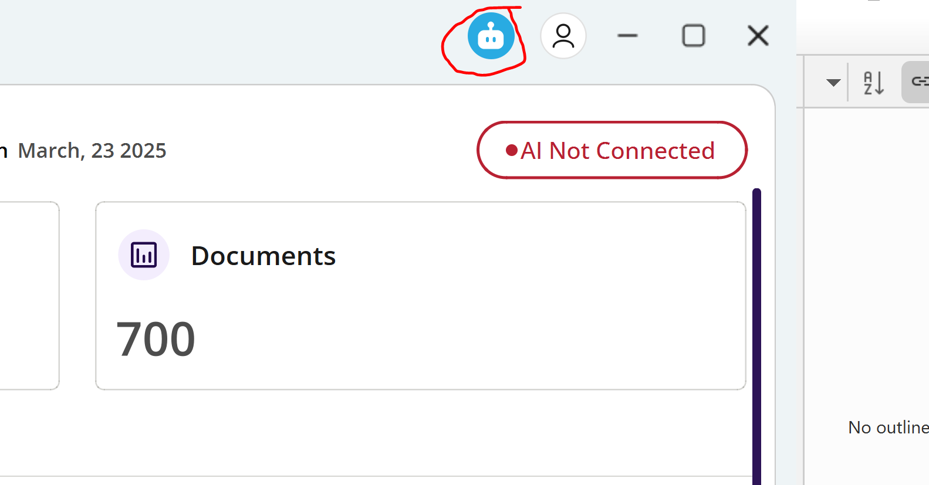
- Extra Icon needed for records created using the AI to the left of the record:
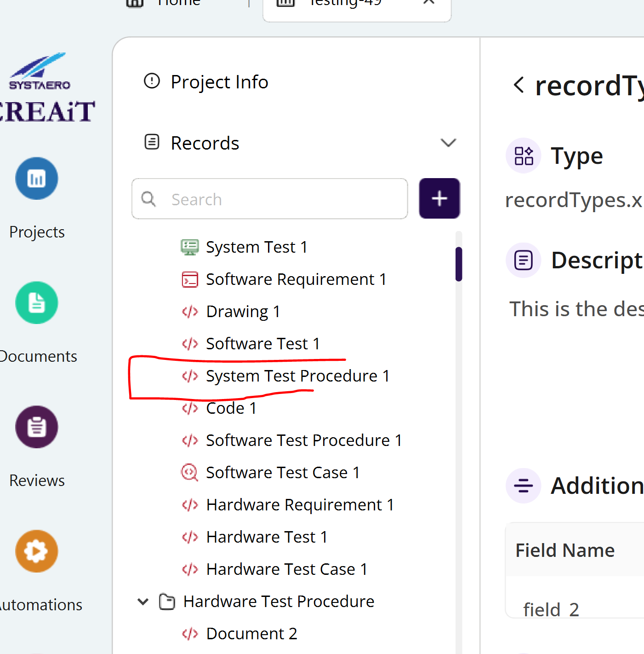
Maybe this? 
- When multiple project tabs are displayed, all projects display the same information as the most recently opened project, they should display existing project info specific to each:
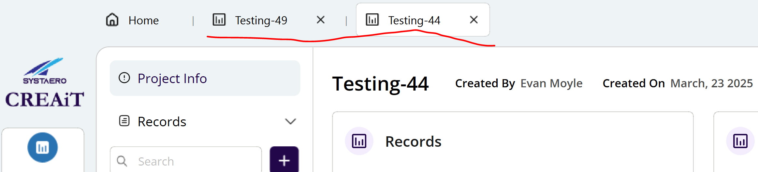
- The icons need to have a more crisp display
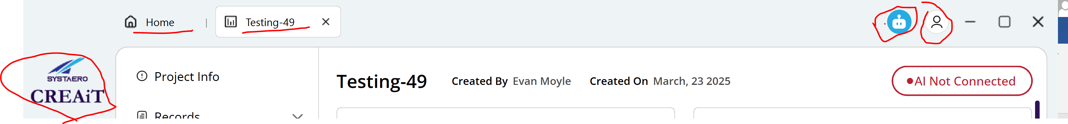
- Arrow does not display anything, lets remove this item.
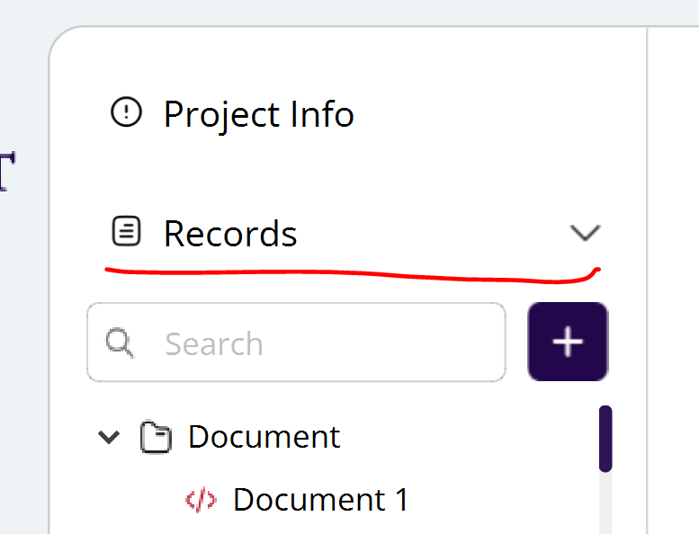
- Need function stubbed in to set this green or red according to backend:
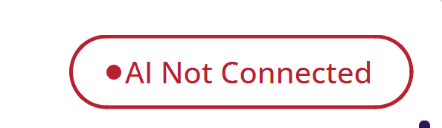
- Application automatically adjusts to display resolution.
- Provide a way to zoom in and out with ctrl key and mouse wheel. Decided prototype design where the application restarts is acceptable.
- Icon does not display the Project Page after a record is selected:
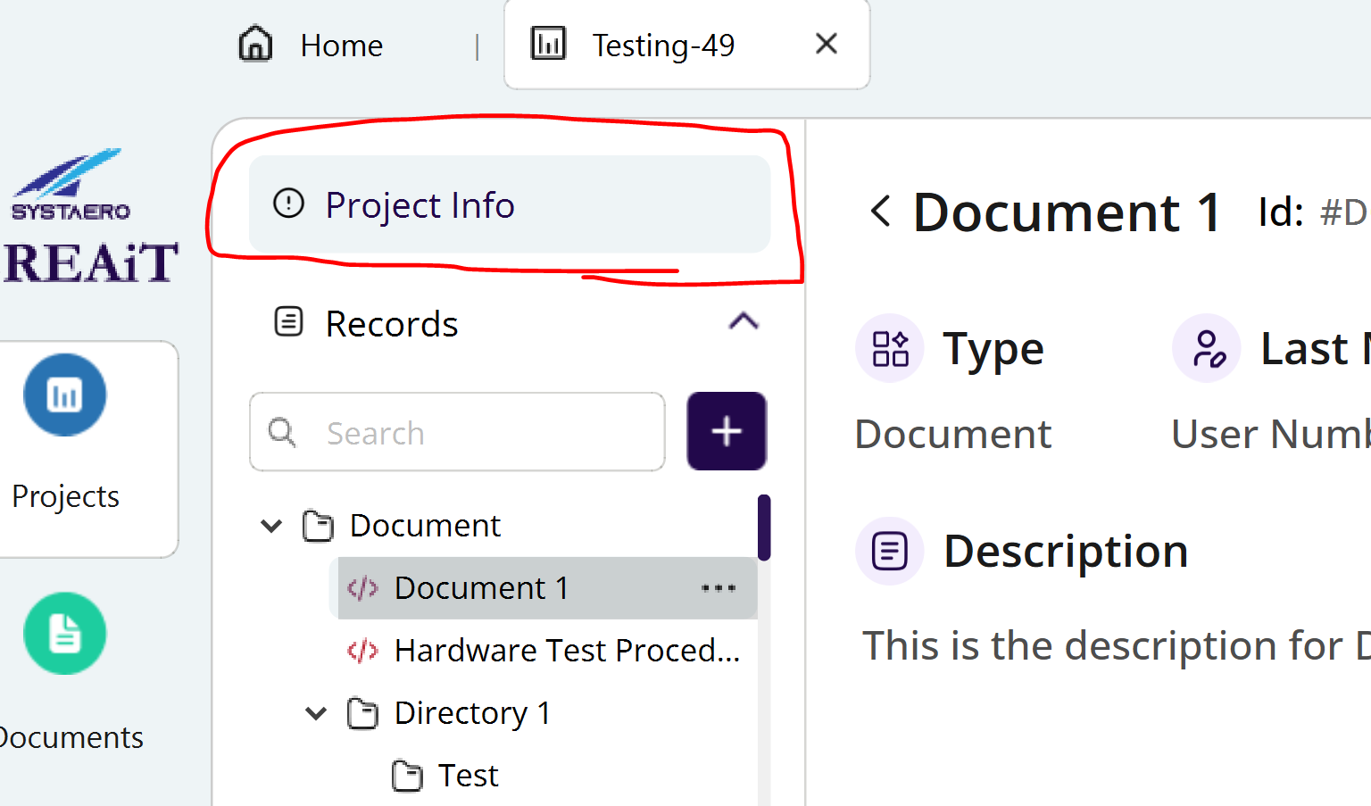
- Graph populated based on recordType dynamically. Also colors should reflect the same state and colors for state (Reviewed, In Review, Draft):
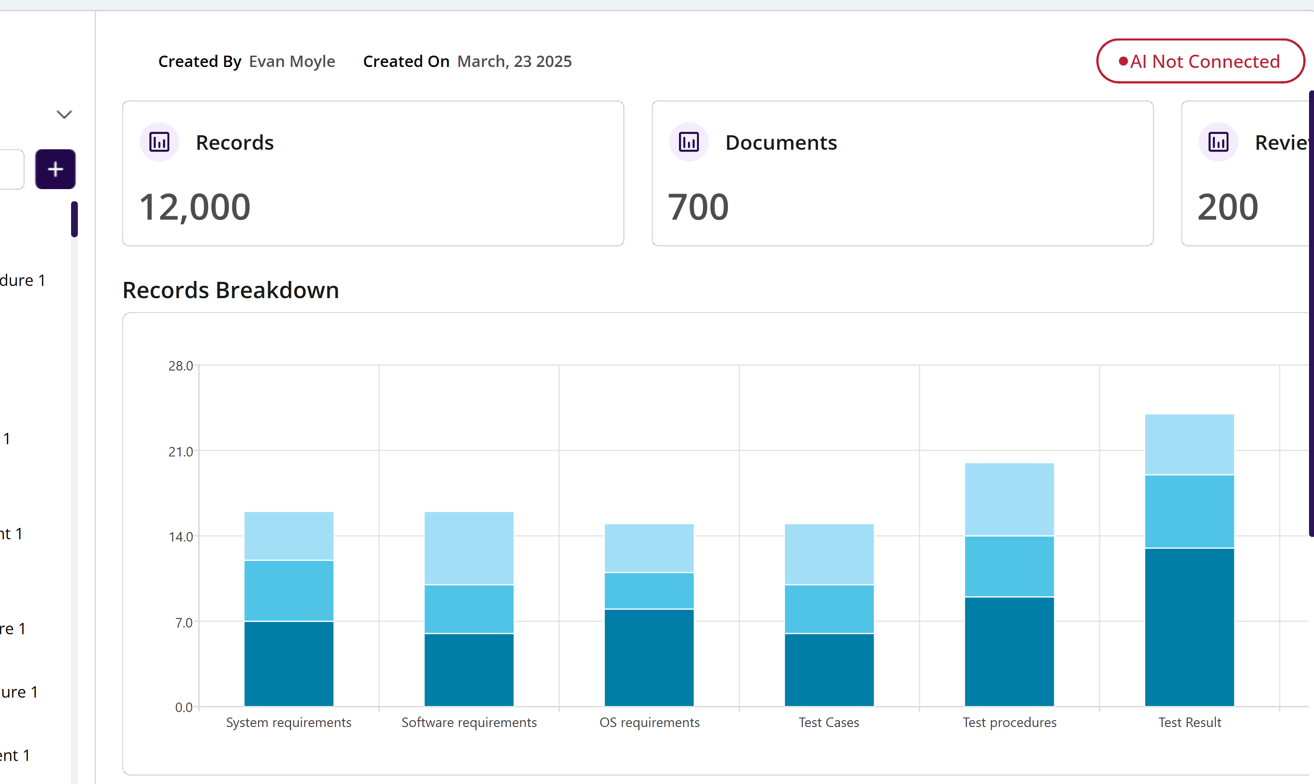
- Connected Ais and Integrations should be the same list displayed in Project Settings:
