- Double Clicking on the side menu does not expand out the display:
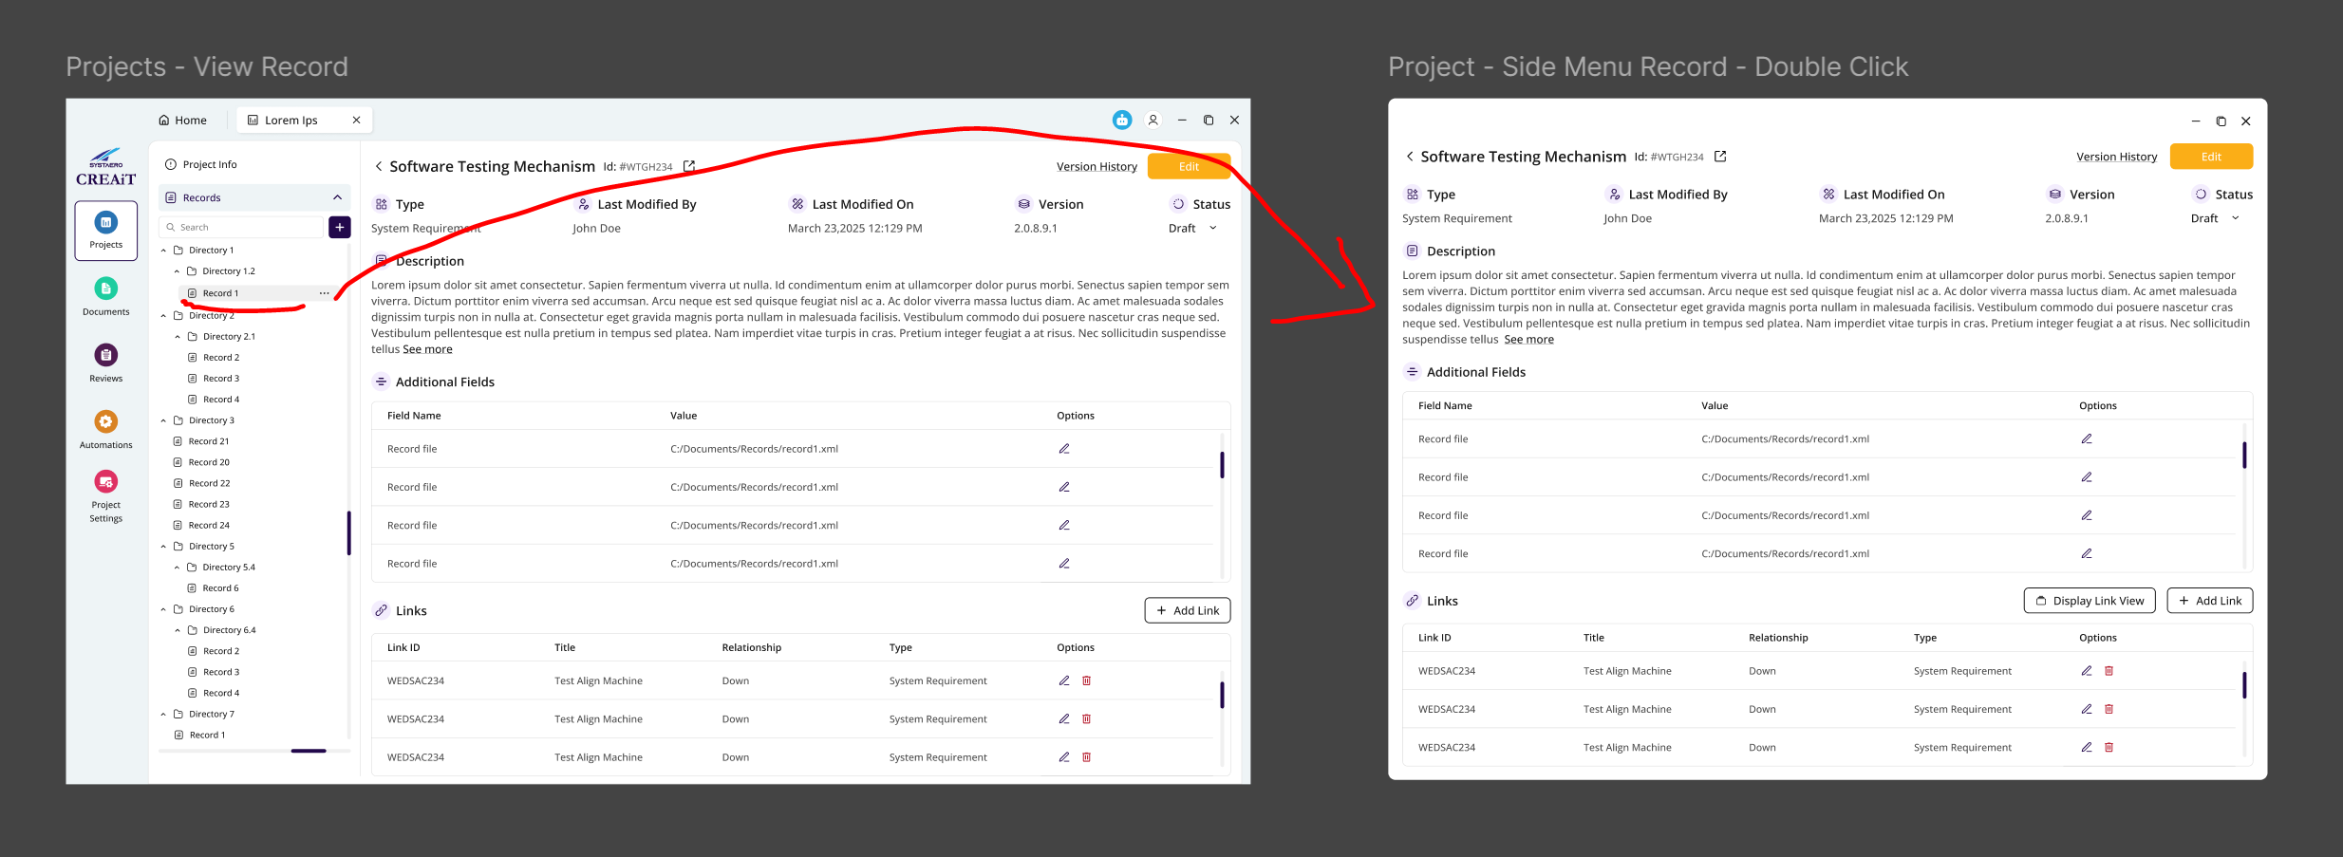
We should be able to do this with up to 6 records.

- Populate Version window with the current version info.
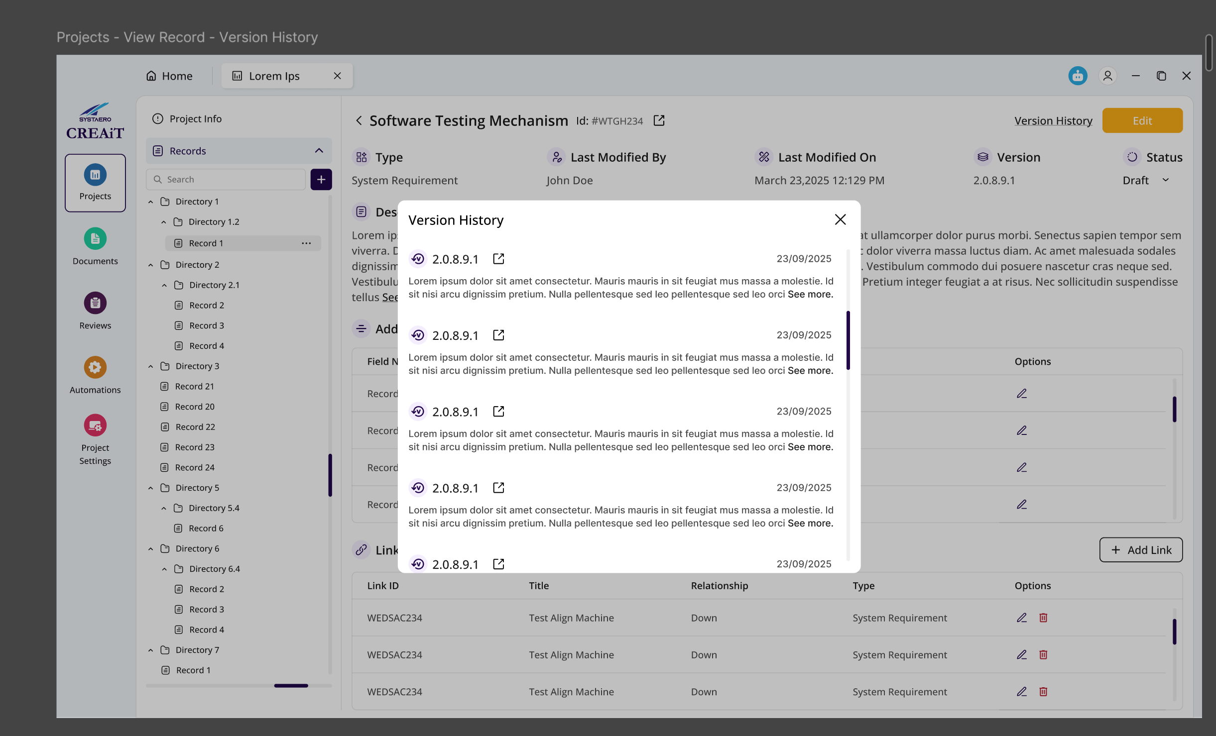
- This is a popup menu that shows up when hovering over IDs in the link area:
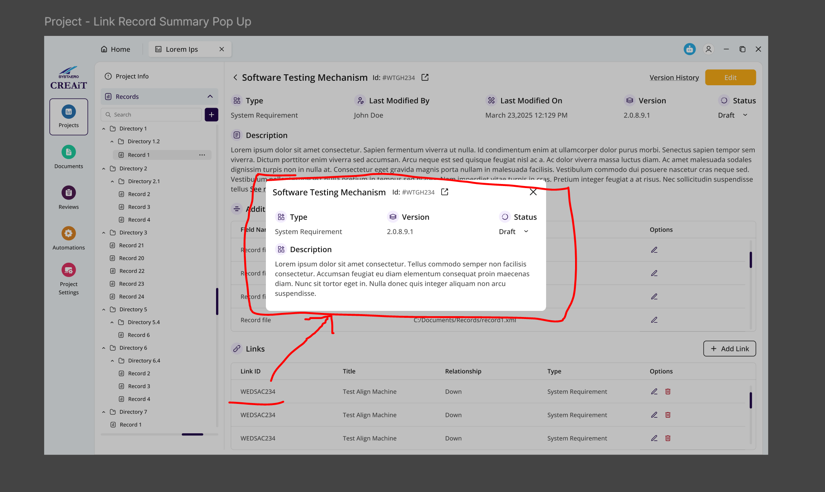
- Add Links window. This brings up a search bar. You type in the name or ID of the item and all relevant search results are populated. I may add a class for you to pull the list from.
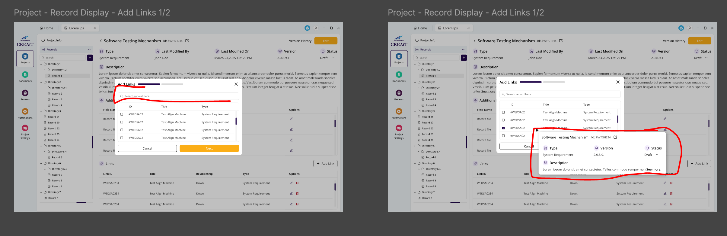
Also the popup when hovering over the object ID is needed.
- The add links window should call the dataRecord class “addLinks”. The selecting on the menu need to be populated with the same popup when hovering over.
- Drag and drop functionality needed to move records around.
- Icons on the treeView need to be specific according to the record type. These icons need to be configurable.
- The icons need to be colored bases on the status. Draft is red, In Review is yellow, Reviewed is Green.
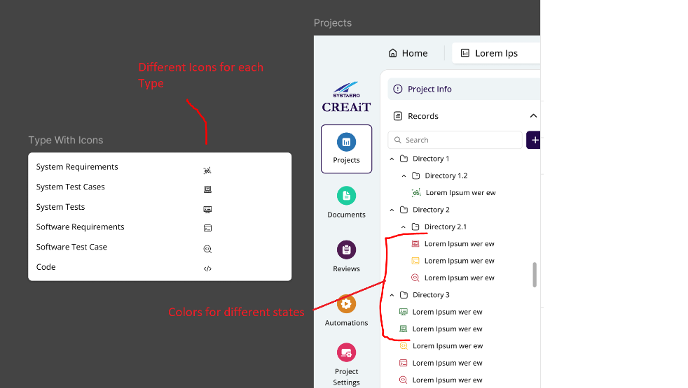
- A cancel button is needed to cancel out of the edit
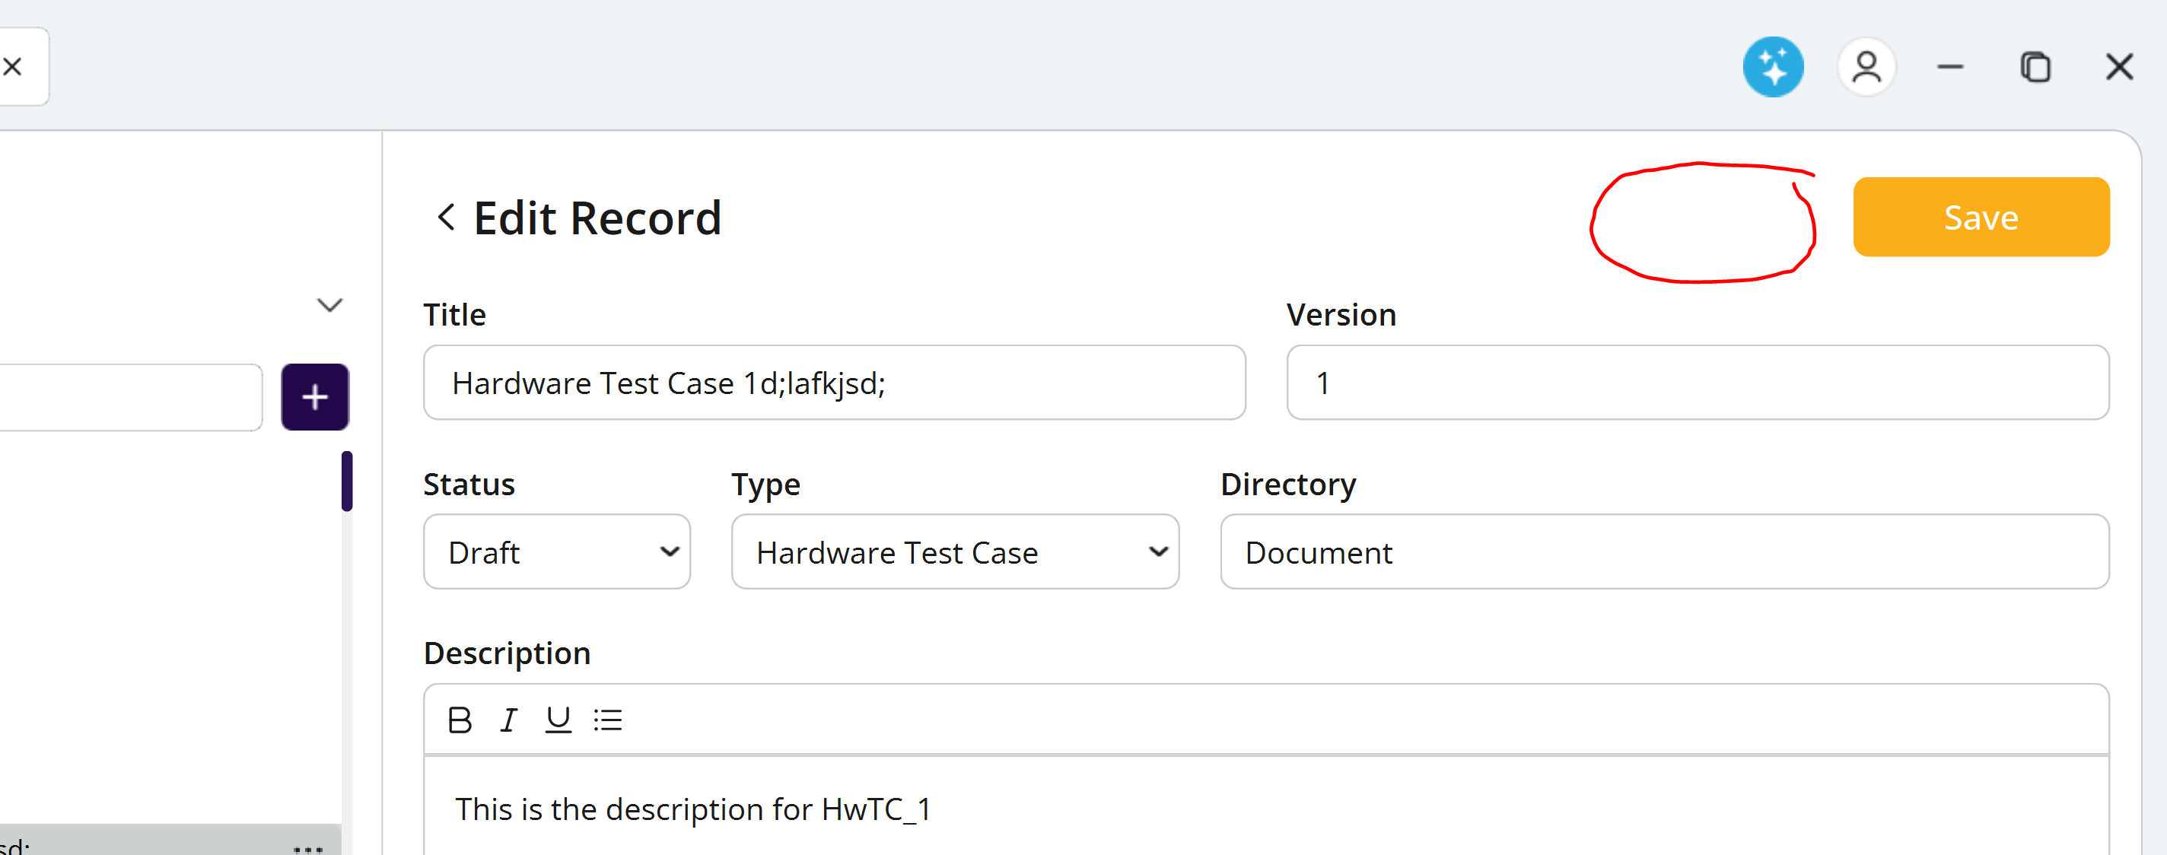
- The create record below button does not work:
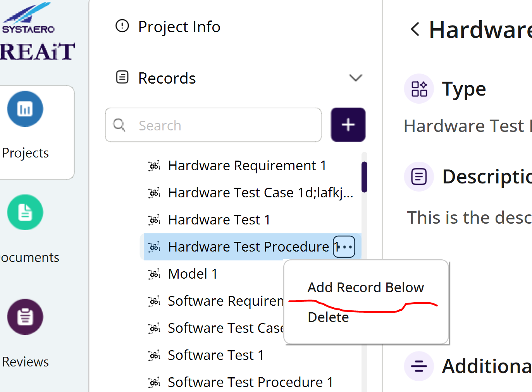
- This button doesn’t really do anything. We should remove it.
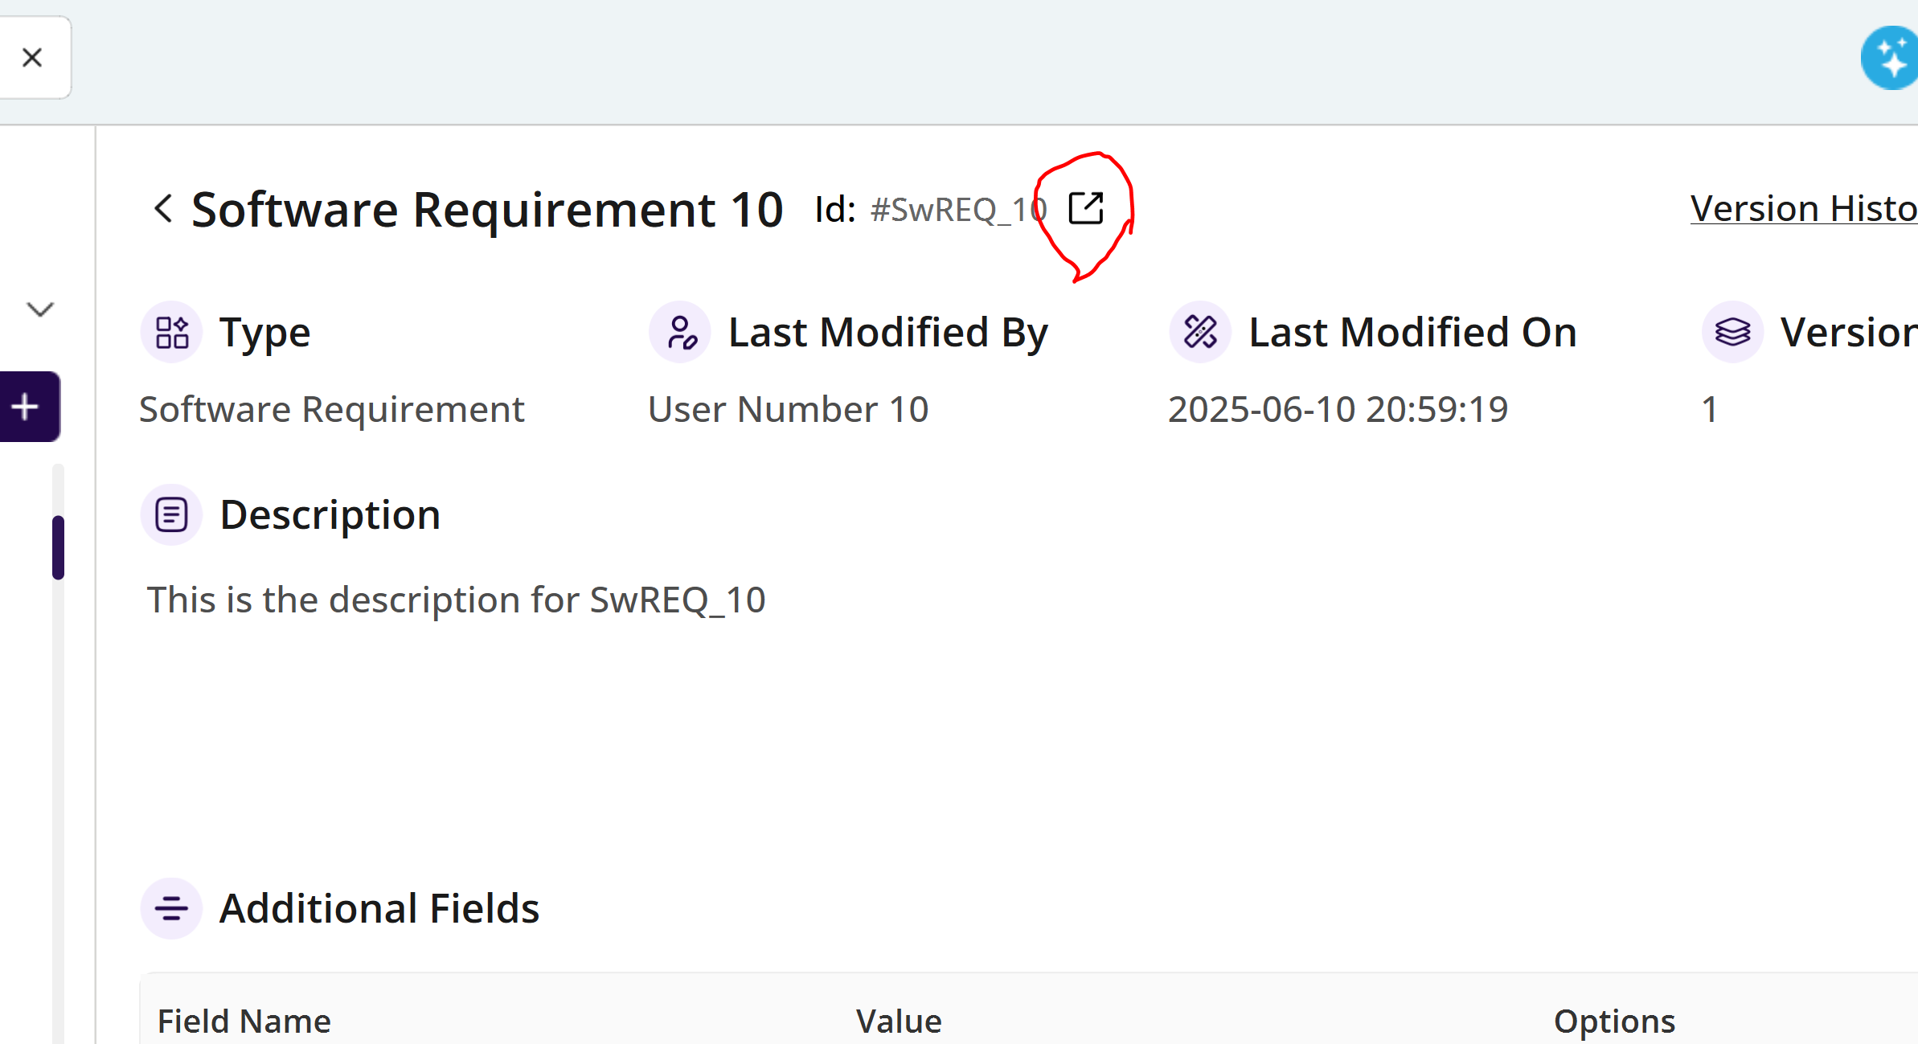
- Can’t create a new record using the + icon
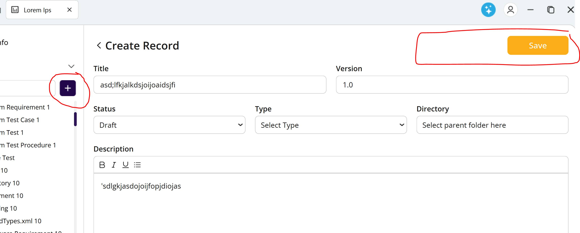
- When hovering over the ID, the popup window needs closed to remove it, however it would be better to be displayed directly over the ID when hovering over it. Mouse movement would still be allowed an when no longer over the ID, it would be removed.
- We also need a time delay before displaying the preview. This keeps the preview from opening when users are simply moving the pointer across the screen.
- I right click on the record, should bring up the same menu as the “…” that is directly over the mouse cursor.
- When hovering over a record in the treeView, a preview window should display right over the cursor when the cursor is hovering over the top of it over a few seconds
- It would be nice to have a window that shows up showing the down stream and upstream links when hovering over the icons.
- Application crashes when saving a new record:
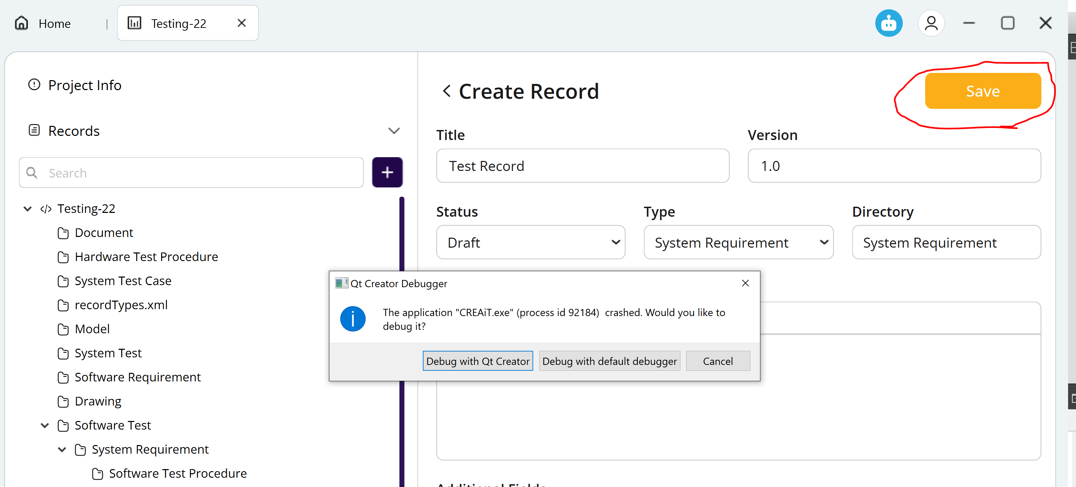
- Description field needs html text display and editable with the following fields:
- Bold
- Italics
- Table Creation
- Bullets
- Numbering
- Alignment
- Image insertion
- Hyperlink insertion
- Font? (Not sure how hard this is. Maybe not needed if it’s too much effort)
- Super and sub scripts
- The AI chat window should be displayed from this icon in all windows and not the connection status.
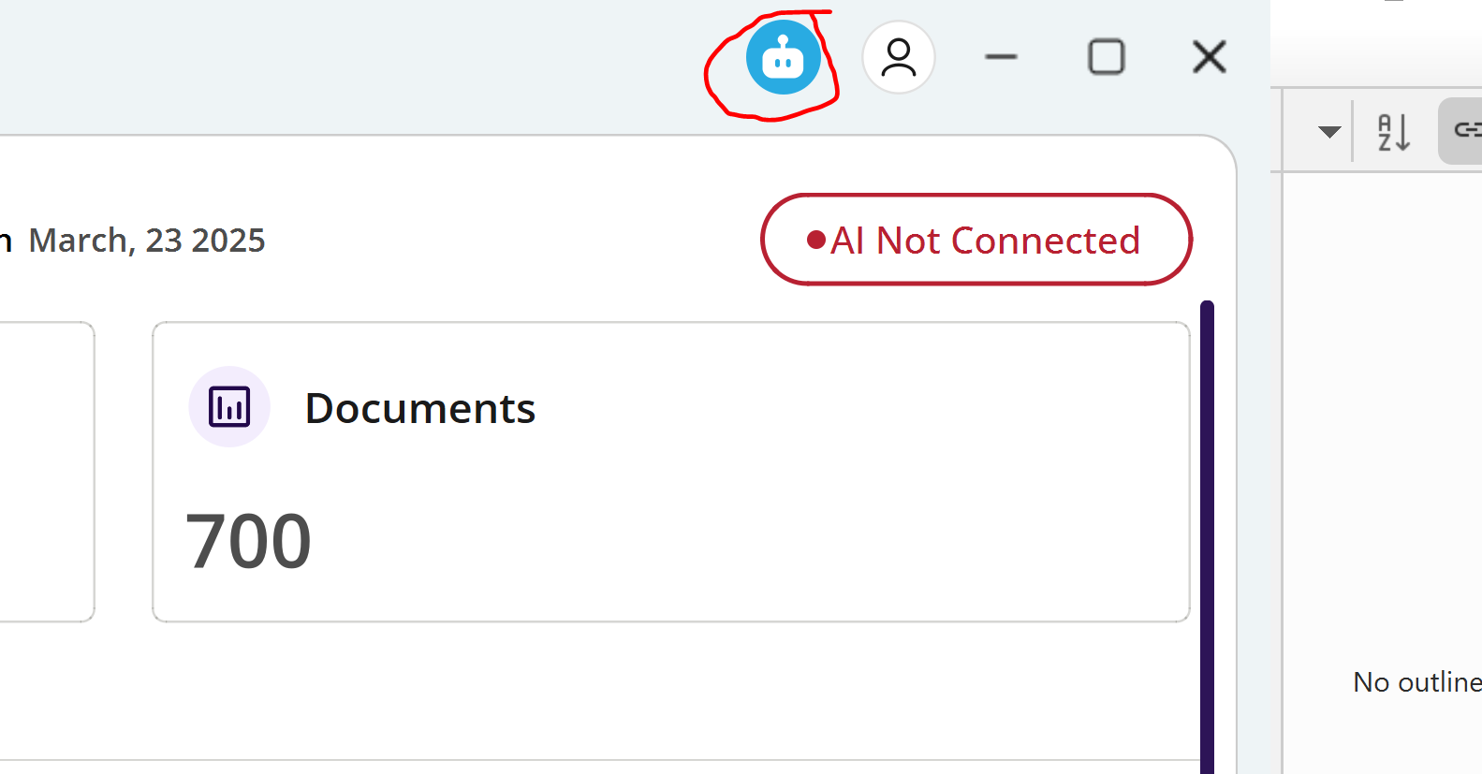
- Extra Icon needed for records created using the AI to the left of the record:
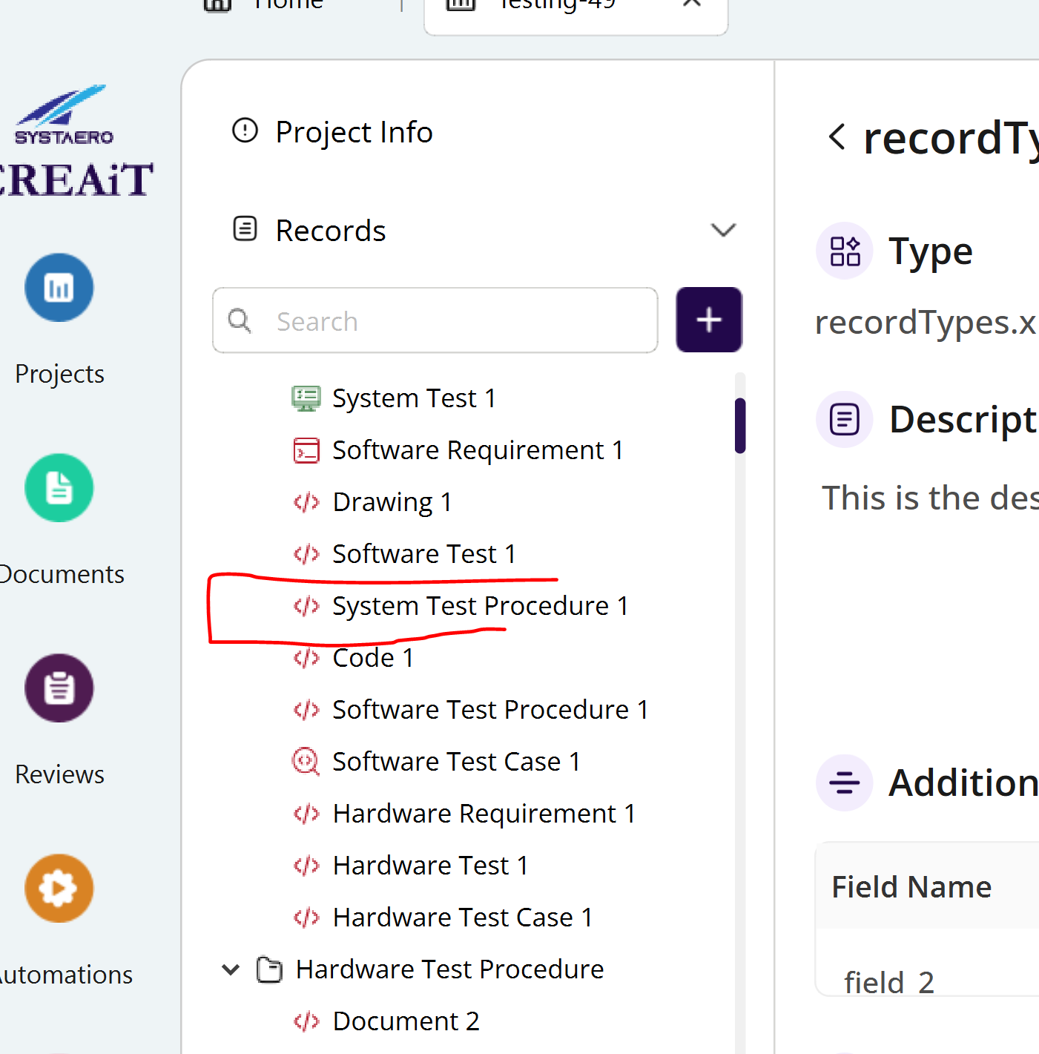
Maybe this? 

