China Intervention Correlation Analysis

Kylie Ainslie

06 April, 2020

# Read in data

1. New daily confirmed cases from China CDC
2. Exante daily intracity movement data
3. Back calculated new infections

# case data  
new_case_dat <- readr::read_csv("china_new_case_data_imported.csv")

## Parsed with column specification:  
## cols(  
## date_confirm = col_datetime(format = ""),  
## province = col_character(),  
## new_cases = col_double(),  
## imported_cases = col_double(),  
## new_cases_wo_imported = col_double()  
## )

# wrangle into incidence data  
incidence_dat <- new_case_dat %>%   
 group_by(province) %>%  
 select(province, date_confirm, new_cases_wo_imported) %>%  
 mutate(date_confirm = as.Date(date_confirm),  
 new_cases_wo_imported = ifelse(is.na(new_cases_wo_imported) | new_cases_wo_imported < 0,   
 0, new_cases_wo_imported)) %>%  
 rename("dates" = "date_confirm", "I" = "new_cases_wo_imported")   
# movement data  
# movement_dat <- readr::read_csv("exante_movement_data.csv")[,-1]  
movement_top6 <- readRDS("movement_province_level_subset.rds")

case_sums <- new_case_dat %>%   
 filter(date_confirm < '2020-02-15') %>%   
 group_by(province) %>%   
 summarise_at(.vars = "new_cases", .funs = sum)  
prop_hubei <- case_sums[case_sums$province == "hubei",2] / sum(case_sums$new_cases)

# Estimate R_t for confirmed case data

#####################################################  
### COVID19 spread with Chinese movement patterns ###  
#####################################################  
# 1. Estimating R_t over time for each province in China using EpiEstim  
# 2. Determining most highly correlated lag time  
# 3. Determine rolling correlation using runCor (at weekly and biweekly resolution)  
  
### 1. Estimating R_t with EpiEstim  
si_mean = 6.48  
si_std = 3.83  
# serial interval estimate used: mean = 6.48, sd = 3.83  
# from Neil's IBM model  
  
r <- incidence_dat %>%  
 tidyr::nest(gg = -"province") %>%  
 mutate_at("gg", purrr::map,function(x) estimate_R(x, method="parametric_si",  
 config = make_config(list(mean_si = si_mean,   
 std_si = si_std)))  
 )

## Default config will estimate R on weekly sliding windows.  
## To change this change the t_start and t_end arguments.   
## Default config will estimate R on weekly sliding windows.  
## To change this change the t_start and t_end arguments.   
## Default config will estimate R on weekly sliding windows.  
## To change this change the t_start and t_end arguments.   
## Default config will estimate R on weekly sliding windows.  
## To change this change the t_start and t_end arguments.

## Warning in estimate_R_func(incid = incid, method = method, si_sample = si_sample, : You're estimating R too early in the epidemic to get the desired  
## posterior CV.

## Default config will estimate R on weekly sliding windows.  
## To change this change the t_start and t_end arguments.

## Warning in estimate_R_func(incid = incid, method = method, si_sample = si_sample, : You're estimating R too early in the epidemic to get the desired  
## posterior CV.

## Default config will estimate R on weekly sliding windows.  
## To change this change the t_start and t_end arguments.   
## Default config will estimate R on weekly sliding windows.  
## To change this change the t_start and t_end arguments.   
## Default config will estimate R on weekly sliding windows.  
## To change this change the t_start and t_end arguments.

## Warning in estimate_R_func(incid = incid, method = method, si_sample = si_sample, : You're estimating R too early in the epidemic to get the desired  
## posterior CV.

## Default config will estimate R on weekly sliding windows.  
## To change this change the t_start and t_end arguments.

## Warning in estimate_R_func(incid = incid, method = method, si_sample = si_sample, : You're estimating R too early in the epidemic to get the desired  
## posterior CV.

## Default config will estimate R on weekly sliding windows.  
## To change this change the t_start and t_end arguments.

## Warning in estimate_R_func(incid = incid, method = method, si_sample = si_sample, : You're estimating R too early in the epidemic to get the desired  
## posterior CV.

## Default config will estimate R on weekly sliding windows.  
## To change this change the t_start and t_end arguments.

## Warning in estimate_R_func(incid = incid, method = method, si_sample = si_sample, : You're estimating R too early in the epidemic to get the desired  
## posterior CV.

## Default config will estimate R on weekly sliding windows.  
## To change this change the t_start and t_end arguments.

## Warning in estimate_R_func(incid = incid, method = method, si_sample = si_sample, : You're estimating R too early in the epidemic to get the desired  
## posterior CV.

## Default config will estimate R on weekly sliding windows.  
## To change this change the t_start and t_end arguments.

## Warning in estimate_R_func(incid = incid, method = method, si_sample = si_sample, : You're estimating R too early in the epidemic to get the desired  
## posterior CV.

## Default config will estimate R on weekly sliding windows.  
## To change this change the t_start and t_end arguments.   
## Default config will estimate R on weekly sliding windows.  
## To change this change the t_start and t_end arguments.

## Warning in estimate_R_func(incid = incid, method = method, si_sample = si_sample, : You're estimating R too early in the epidemic to get the desired  
## posterior CV.

## Default config will estimate R on weekly sliding windows.  
## To change this change the t_start and t_end arguments.

## Warning in estimate_R_func(incid = incid, method = method, si_sample = si_sample, : You're estimating R too early in the epidemic to get the desired  
## posterior CV.

## Default config will estimate R on weekly sliding windows.  
## To change this change the t_start and t_end arguments.

## Warning in estimate_R_func(incid = incid, method = method, si_sample = si_sample, : You're estimating R too early in the epidemic to get the desired  
## posterior CV.

## Default config will estimate R on weekly sliding windows.  
## To change this change the t_start and t_end arguments.

## Warning in estimate_R_func(incid = incid, method = method, si_sample = si_sample, : You're estimating R too early in the epidemic to get the desired  
## posterior CV.

## Default config will estimate R on weekly sliding windows.  
## To change this change the t_start and t_end arguments.

## Warning in estimate_R_func(incid = incid, method = method, si_sample = si_sample, : You're estimating R too early in the epidemic to get the desired  
## posterior CV.

## Default config will estimate R on weekly sliding windows.  
## To change this change the t_start and t_end arguments.

## Warning in estimate_R_func(incid = incid, method = method, si_sample = si_sample, : You're estimating R too early in the epidemic to get the desired  
## posterior CV.

## Default config will estimate R on weekly sliding windows.  
## To change this change the t_start and t_end arguments.

## Warning in estimate_R_func(incid = incid, method = method, si_sample = si_sample, : You're estimating R too early in the epidemic to get the desired  
## posterior CV.

## Default config will estimate R on weekly sliding windows.  
## To change this change the t_start and t_end arguments.

## Warning in estimate_R_func(incid = incid, method = method, si_sample = si_sample, : You're estimating R too early in the epidemic to get the desired  
## posterior CV.

## Default config will estimate R on weekly sliding windows.  
## To change this change the t_start and t_end arguments.

## Warning in estimate_R_func(incid = incid, method = method, si_sample = si_sample, : You're estimating R too early in the epidemic to get the desired  
## posterior CV.

## Default config will estimate R on weekly sliding windows.  
## To change this change the t_start and t_end arguments.

## Warning in estimate_R_func(incid = incid, method = method, si_sample = si_sample, : You're estimating R too early in the epidemic to get the desired  
## posterior CV.

## Default config will estimate R on weekly sliding windows.  
## To change this change the t_start and t_end arguments.

## Warning in estimate_R_func(incid = incid, method = method, si_sample = si_sample, : You're estimating R too early in the epidemic to get the desired  
## posterior CV.

## Default config will estimate R on weekly sliding windows.  
## To change this change the t_start and t_end arguments.   
## Default config will estimate R on weekly sliding windows.  
## To change this change the t_start and t_end arguments.

## Warning in estimate_R_func(incid = incid, method = method, si_sample = si_sample, : You're estimating R too early in the epidemic to get the desired  
## posterior CV.

## Default config will estimate R on weekly sliding windows.  
## To change this change the t_start and t_end arguments.   
## Default config will estimate R on weekly sliding windows.  
## To change this change the t_start and t_end arguments.

## Warning in estimate_R_func(incid = incid, method = method, si_sample = si_sample, : You're estimating R too early in the epidemic to get the desired  
## posterior CV.

## Default config will estimate R on weekly sliding windows.  
## To change this change the t_start and t_end arguments.

## Warning in estimate_R_func(incid = incid, method = method, si_sample = si_sample, : You're estimating R too early in the epidemic to get the desired  
## posterior CV.

## Default config will estimate R on weekly sliding windows.  
## To change this change the t_start and t_end arguments.

## Warning in estimate_R_func(incid = incid, method = method, si_sample = si_sample, : You're estimating R too early in the epidemic to get the desired  
## posterior CV.

## Default config will estimate R on weekly sliding windows.  
## To change this change the t_start and t_end arguments.

## Warning in estimate_R_func(incid = incid, method = method, si_sample = si_sample, : You're estimating R too early in the epidemic to get the desired  
## posterior CV.

## Default config will estimate R on weekly sliding windows.  
## To change this change the t_start and t_end arguments.

# loop through provinces to concatenate   
R_t <- list()  
for(i in 1:length(r$province)){  
 R_t[[i]] <- r$gg[[i]]$R %>%   
 mutate(province = r$province[i],  
 date_start = r$gg[[i]]$dates[t_start],  
 date_end = r$gg[[i]]$dates[t_start][t_end]) %>%  
 rename(r_mean = `Mean(R)`, r_q2.5 = `Quantile.0.025(R)`,  
 r_q97.5 = `Quantile.0.975(R)`,  
 r_median = `Median(R)`) %>%  
 select(date_start, date_end, province, r_mean, r_q2.5,  
 r_q97.5, r_median)  
}  
  
r_dat <- bind_rows(R_t)

# Combine R_t estimates and pop-weighted avg movement data for top 6 provinces

movement_top6 <- movement_top6 %>%   
 filter(year == 2020, province != "anhui") %>%  
 mutate(year = as.numeric(year))   
r_top6 <- r_dat %>% filter(province %in% c("hubei", "guangdong", "henan", "zhejiang",  
 "hunan", "beijing", "hong_kong_sar"))  
dat_all_top6 <- left_join(r_top6, movement_top6, by=c("date_end" = "date", "province")) %>%  
 select(-date_start, -year, -month_day, -id)

# Determine cross correlation between R_t and movement

### cross correlation  
# restrict cross correlation to peak of epidemic  
dat_top6_peak <- dat_all_top6 %>% filter(date_end < '2020-02-15')  
  
hubei <- dat_top6_peak %>% filter(province == "hubei", !is.na(movement))  
hubei_corr <- ccf(hubei$movement, hubei$r_mean, lag = 10)

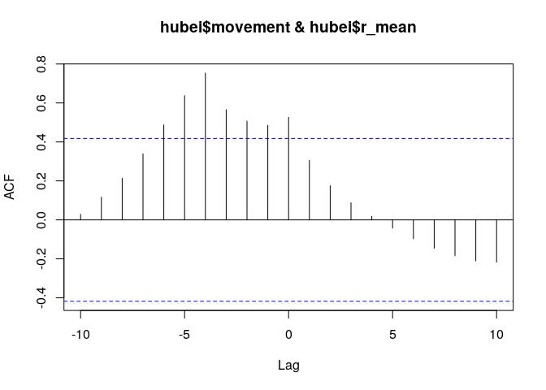

lag_hubei <- hubei_corr$lag[which(hubei_corr$acf == max(hubei_corr$acf))]   
  
# plot hubei corr  
plot(hubei_corr, main = "", cex.lab = 1.25, cex.axis = 1.25)  
axis(1, at=c(seq(-10:10)-11),cex.axis=1.25)

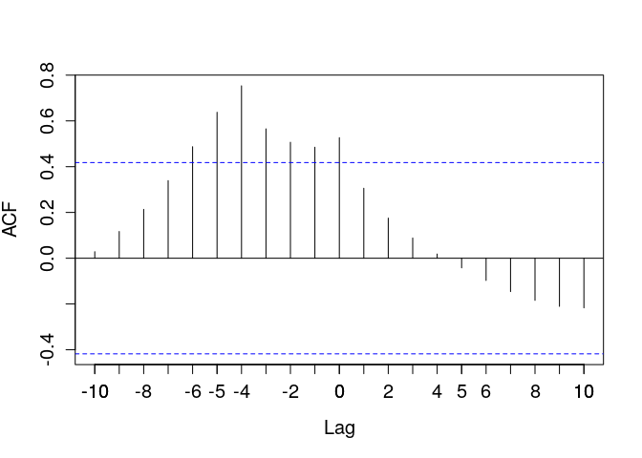

### cross correlation sensitivity analysis  
 # look at distribution of lag time with highest corr for all locations  
movement_2020 <- movement_top6 %>%   
 filter(year == 2020) %>%  
 mutate(year = as.numeric(year))   
  
rhos <- dat_top6_peak %>%  
 filter(!is.na(movement)) %>%  
 tidyr::nest(gg = -"province") %>%  
 mutate_at("gg",purrr::map,  
 function(x) ccf(x$movement, x$r_mean, lag.max = 10))

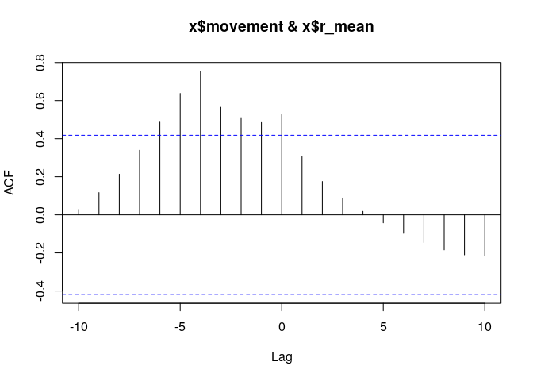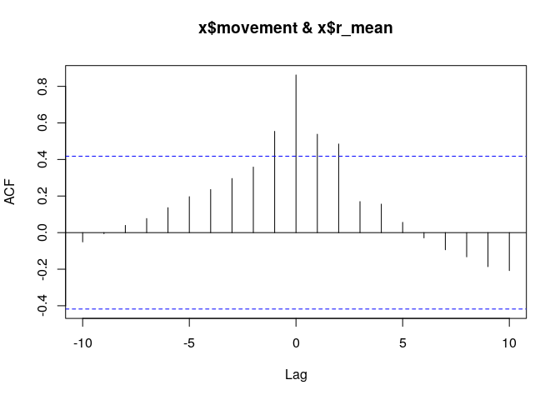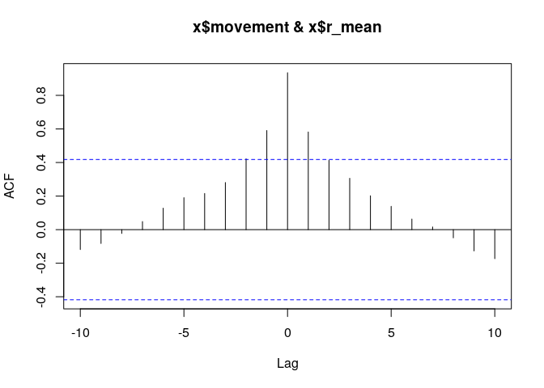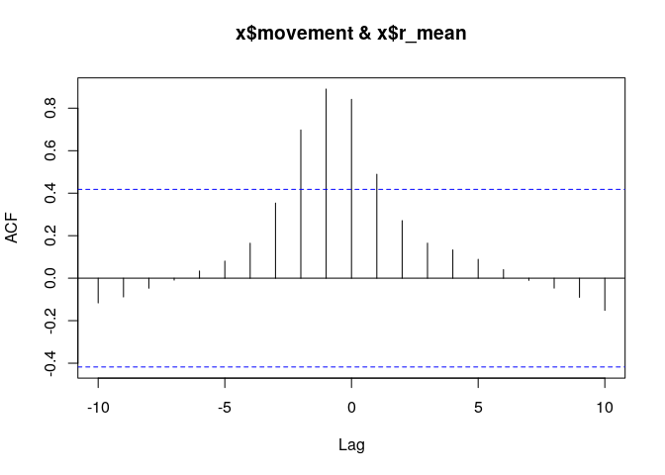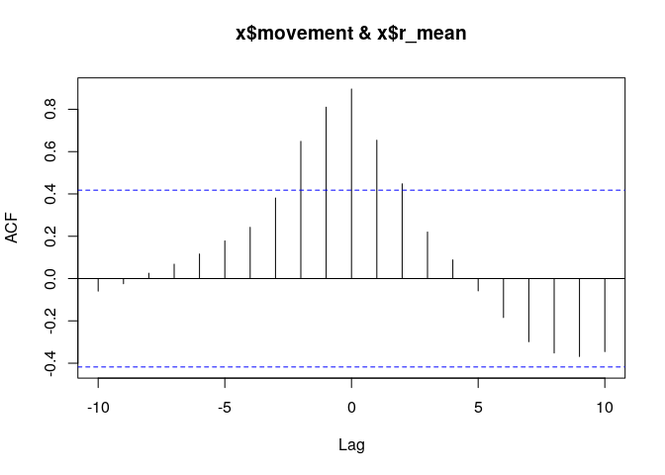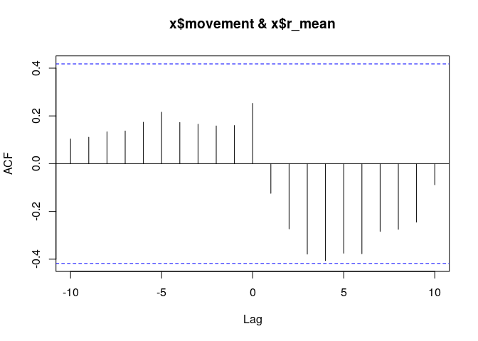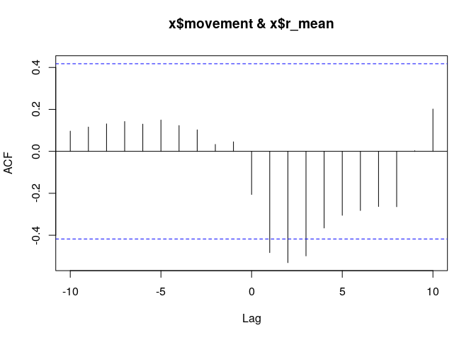

max_lag <- numeric(nrow(rhos))  
for (p in 1:nrow(rhos)){  
 df <- tibble(province = rhos$province[p],lags = rhos$gg[[p]]$lag[,1,1],cc = rhos$gg[[p]]$acf[,1,1]) %>%  
 filter(lags < 1)  
 max_lag[p] <- df$lags[which(df$cc == max(df$cc))]  
}  
lag_df <- tibble(province = rhos$province, lag = max_lag)  
p_lags <- ggplot(lag_df, aes(x=lag)) +   
 geom_histogram(binwidth = 2) +  
 theme(legend.position = "none",  
 panel.grid.major = element_blank(),  
 panel.grid.minor = element_blank(),  
 panel.background = element_blank()  
 )  
ggsave("figure_S2.png", p_lags,  
 width = 4, height = 4,  
 dpi = 500)

# create date_lag variable using hubei only  
dat_all_top6a <- dat_all_top6 %>% mutate(date_lag = date_end + lag_hubei) %>%  
 select(-date_end, -movement)  
dat_all_top6b <- left_join(dat_all_top6a, movement_top6,   
 by = c("date_lag" = "date", "province")) %>%  
 select(-id, -month_day, -year)  
  
# create lag variable using lag for each region  
dat_all_top6c <- left_join(dat_all_top6, lag_df, by = "province") %>%   
 group_by(province) %>%  
 mutate(date_lag = date_end + lag) %>%  
 select(-date_end, -movement) %>%  
 filter(!is.na(date_lag))  
dat_all_top6d <- left_join(dat_all_top6c, movement_top6,   
 by = c("date_lag" = "date", "province")) %>%  
 select(-id, -month_day, -year)

# Determine biweekly rolling correlation between R_t and movement

### determine rolling biweekly correlation  
# rolling correlation - biweekly  
rolling_corr_bi <- dat_all_top6b %>%  
 group_by(province) %>%  
 filter(!is.na(movement)) %>%  
 tq_transmute_xy(x = movement,   
 y = r_mean,  
 mutate_fun = runCor,  
 n = 14,  
 col_rename = "rolling.corr.biweekly")  
  
# rolling correlation - Hubei vs R_t in other provinces  
dat_all_top6b <- dat_all_top6b %>%  
 group_by(province) %>%  
 mutate(movement_hubei = dat_all_top6b[dat_all_top6b$province == 'hubei',]$movement)  
  
rolling_corr_hubei <- dat_all_top6b %>%  
 group_by(province) %>%  
 filter(!is.na(movement_hubei)) %>%  
 tq_transmute_xy(x = movement_hubei,   
 y = r_mean,  
 mutate_fun = runCor,  
 n = 14,  
 col_rename = "rolling.corr.hubei")  
  
rolling_corr <- left_join(rolling_corr_bi, rolling_corr_hubei,   
 by = c("province", "date_lag")) %>%  
 mutate(date_lag = as.Date(date_lag))  
  
dat_corr <- left_join(dat_all_top6b, rolling_corr, by = c("province", "date_lag"))

### determine rolling biweekly correlation  
# rolling correlation - biweekly  
rolling_corr_bi2 <- dat_all_top6d %>%  
 group_by(province) %>%  
 filter(!is.na(movement)) %>%  
 tq_transmute_xy(x = movement,   
 y = r_mean,  
 mutate_fun = runCor,  
 n = 14,  
 col_rename = "rolling.corr.biweekly") %>%  
 mutate(date_lag = as.Date(date_lag))  
  
# rolling correlation - Hubei vs R_t in other provinces  
# dat_all_top6b <- dat_all_top6d %>%  
# group_by(province) %>%  
# mutate(movement_hubei = dat_all_top6d[dat_all_top6b$province == 'hubei',]$movement)  
#   
# rolling_corr_hubei <- dat_all_top6b %>%  
# group_by(province) %>%  
# filter(!is.na(movement_hubei)) %>%  
# tq_transmute_xy(x = movement_hubei,   
# y = r_mean,  
# mutate_fun = runCor,  
# n = 14,  
# col_rename = "rolling.corr.hubei")  
  
# rolling_corr <- left_join(rolling_corr_bi, rolling_corr_hubei,   
# by = c("province", "date_lag")) %>%  
# mutate(date_lag = as.Date(date_lag))  
  
dat_corr2 <- left_join(dat_all_top6d, rolling_corr_bi2, by = c("province", "date_lag"))

readr::write_csv(dat_corr, "dat_all.csv")  
readr::write_csv(dat_corr2, "dat_all_lag_sens_analysis.csv")