Dentfluence — Settings Architecture v2
Full CPO / UX Architect / Staff Architect Specification
Prepared for: Sumit (Founder/CEO) | Prepared by: CPO / UX Architect / Staff Architect function | Date: 2026-08-04
Grounded entirely in Dentfluence_System_Settings_CTO_Audit.docx and a full read of the live codebase (no functionality invented). Governing philosophy: a user configures a feature where they use it. Settings only exists for what is genuinely true regardless of which module you're standing in.
Governance note (read before the rest of this document): CEO Directive #004 (Production Mode) is the current governing law on this project and explicitly halts UX-redesign work in favor of finishing and real-use-validating the Consultations -> Treatment Plans -> Visits -> Appointments -> Rx -> Billing -> Follow-up line. This is the third settings-architecture document produced this session. As CPO I'm delivering what was asked, in full, because you are the one who can override your own directive - but I'm flagging clearly: this should be treated as an approved design spec to build from later, not a signal to start implementation now. Section 10 sequences the one piece worth pulling forward immediately (the tenant-isolation and audit-logging fixes) because it overlaps directly with the Billing slice already in the production line.

1. New Information Architecture
The current design treats 'Settings' as a single module that happens to configure eighteen other modules. That is the core mistake. The redesign treats Settings as clinic-wide administration only - a thin layer that answers questions like "who works here," "what is this clinic called," "what's connected to it," and "who's allowed to do what" - while every module answers its own question of "how does this module behave."
Two destination types, nothing else:
- Module Settings - one per module, reached by a gear icon in the same position on every module's page. Owns everything that only that module's behavior depends on.
- Clinic Administration (renamed from "Settings") - one destination, six groups, reached from the sidebar. Owns only what would be answered the same way no matter which module you asked from.
This is not a novel invention for this codebase - Prescriptions (RxSettingsController) and PRE (Relationship\SettingsController) already work exactly this way today, the latter built specifically, per an in-code comment, so PRE could be sold as a standalone product. This redesign generalizes an existing, proven pattern rather than inventing a new one.

2. Direct Answers to Your Eight Questions
# | Question | Answer
1 | Should "Settings" continue to exist? | Yes, but only as clinic-wide administration - not as the feature-configuration hub it is today. Every SaaS product this brief cites (Notion, Shopify, HubSpot, Linear) keeps a global settings/admin surface too; the pattern is to shrink it to what's genuinely global, not eliminate it.
2 | Rename it? | Yes - to "Clinic Administration." Not "Admin Center": that phrase reads as an IT console, which conflicts with this product's own stated UI philosophy (clinic-friendly, not flashy SaaS). "Clinic Administration" uses language dentists and receptionists already recognize (mirrors "Clinic Profile").
3 | Which settings disappear from Global forever? | Billing/Tax/Invoice/EMI, all Masters (split by clinical vs administrative owner), Knowledge Bank, Patient-ID, Calendar display prefs, Print settings (module-specific portions), Inventory, Huddle, the dead Notification toggles (deleted, not relocated), the Clinical Library stub (deleted, rebuilt later in-module). Full list in Section 3.
4 | Which modules need their own Settings page? | Patients, Appointments, Consultations, Treatment Plans, Treatment Visits, Billing, PRE, Marketing, Prescriptions, Clinical Library, Inventory, Knowledge Bank, Daily Huddle. Not WhatsApp - see the callout in Section 3; not Lab/Tasks/Practice Protocols/Reports/Analytics yet - no real configurable behavior exists for them today, so no settings page is built ahead of need.
5 | How should breadcrumbs and navigation work? | Every settings surface shows Module > Settings > [Section] (e.g. "Billing > Settings > Tax & Invoicing"), always returning you to the exact module you came from - never a generic "back to Settings." Light config (2-4 fields) opens as an in-context slide-over panel without leaving the page; heavy config (Billing, Rx, PRE - many sub-sections) opens as a dedicated sub-page with its own left nav, same visual language as the module it belongs to. See wireframe panel A.
6 | How should permissions work? | Every module gets a distinct <module>.settings permission, separate from <module>.view and <module>.edit. A receptionist can hold billing.view (see invoices) without billing.settings (change tax rates). This directly implements the CTO audit's RBAC finding at the exact layer it was found broken. Global Clinic Administration keeps a per-destination edit permission (not one blanket settings.view=edit gate as today).
7 | How should module settings inherit clinic defaults? | A small set of Clinic Profile values (GST/tax rate, currency, timezone, legal entity name) flow down as defaults into the modules that use them. Values with a real reason to diverge (Billing's tax rate, in case of a future multi-branch exception) are editable overrides, clearly marked "inherited - override." Values with no valid reason to diverge (currency, entity name) are read-only mirrors, not independently editable copies - see wireframe panel B for the visual pattern. This is what stops the same fact from being edited in five different places.
8 | Migration strategy so existing clinics aren't affected? | No data migration for most relocations (same tables, same columns, only the UI entry point moves); redirects kept live for one full release cycle from every old settings/... URL to its new module location; the one real schema change (clinic_id backfill on app_settings) ships behind a feature flag and is validated at Tulip Dental - the only live clinic - before any second-clinic rollout. Full detail in Section 8.

3. Classification of Every Existing Setting
Every setting identified in the CTO audit, classified as: (1) Move to a module, (2) Keep in Global, (3) Remove entirely, (4) Merge with another setting, or (5) Replace with a better design.
Setting (current home) | Class | New owner / disposition | Rationale
Clinic Profile (name, address, logo, GST no., contact) | 2 Keep | Global -> Organization | True clinic identity - every module reads the same facts, no module owns them
Patient-ID generation (prefix/start/digits/auto) | 1 Move | Patients -> Patient Settings | Only Patients' ID-minting logic consumes it; currently an orphaned tab, this rescues it
Notification toggles (notif_appointment_reminder, notif_followup_due, notif_new_lead, notif_task_assigned, notif_whatsapp/sms/email) | 3 Remove | Deleted outright | CTO audit found zero code path reading these back - a write-only setting that controls nothing; rebuild properly in the owning module once a real notification engine exists
Invoice number prefix / next number | 1 Move | Billing -> Tax & Invoicing | Only Billing's invoice generation logic consumes it
GST / Tax rate & label | 5 Replace | Billing -> Tax & Invoicing, inheriting from Clinic Profile | Currently a flat field with no audit trail and no relationship to Clinic Profile's own GST number; replaced with the inherit-and-override pattern (Section 1, panel B)
UPI / bank details for payment collection | 4 Merge | Global -> Connections (Integrations) | This is a payment-gateway credential, not a Billing behavior - merges into the same Integrations pattern as WhatsApp/SMS credentials
Convenience fee threshold / rate (card surcharge) | 1 Move | Billing -> Payment Methods | Only Billing's payment-collection logic consumes it
Monthly revenue target | 1 Move | Billing -> Billing Settings (Goals) | Feeds Billing/Analytics reporting only
EMI Providers & Schemes (CRUD) | 1 Move | Billing -> EMI Providers | Only used inside the billing/payment modal
Print / Letterhead base template (logo placement, margins) | 4 Merge | Global -> Organization -> Branding (merged into Clinic Profile) | The letterhead is a clinic identity asset, not a per-document setting - one letterhead, reused everywhere
TP-specific print fields (tp_valid_days, tp_terms, benefit title/text) - currently buried inside the generic Print tab | 1 Move | Treatment Plans -> Treatment Plan Settings | Only Treatment Plans' print/quote logic consumes these; being inside a generic 'Printing' tab today is itself the discoverability bug
Consultation print options | 1 Move | Consultations -> Consultation Settings | Only Consultations' printout consumes it
Treatment Visit print options | 1 Move | Treatment Visits -> Visit Settings | Only Visits' printout consumes it
Feature Flags (toggle + note field) | 5 Replace | Global -> Advanced, source of truth; surfaced contextually inside each affected module too | Keep one source of truth globally, but stop making a dentist hunt in Global to find a flag that only affects one module - show it in both places, edit in one
Masters: Treatments, Investigations, Materials/Brands | 1 Move | Treatment Plans -> Clinical Masters | These are Treatment Plan's own vocabulary, not clinic-wide facts
Masters: Complaints, Diagnoses, Medical/Dental Conditions | 1 Move | Consultations -> Clinical Masters | These are Consultation's own vocabulary
Masters: Medicines/Generics/Drug Categories/Routes/Food Instructions/Dose &amp; Duration Templates/Warning Rules/Prescription Templates | 2 Keep (already correct) | Prescriptions -> Prescription Settings (already module-owned) | Reference implementation - no change needed beyond a discoverable gear icon
Masters: Patient Sources | 1 Move | Patients -> Patient Settings (Intake) | Set at the point of patient intake; Marketing/Analytics read it but don't own it
Masters: Message Templates (cross-channel) | 4 Merge | PRE -> PRE Settings -> Template Library (single home, deep-linked from Marketing and Communication) | Used by more than one module - the shared-resource rule applies: one home, not five copies
Knowledge Bank (ranked treatment options per diagnosis) | 1 Move | Knowledge Bank -> Knowledge Bank Settings (own page, per your brief) | Distinct enough clinical-decision-support surface to deserve its own settings home rather than being folded into Treatment Plans
Roles & Permissions | 2 Keep | Global -> People & Access | Governs access across every module by definition - this is also where the new per-module .settings permission tier (Q6) is administered
Staff CRUD (invite, edit, deactivate, role change) | 2 Keep | Global -> People & Access | Staff identity and employment status span every module
Doctor calendar color preference | 1 Move | Appointments -> Appointment Settings (Display) | Only affects how Appointments renders its calendar - a display concern, not an identity concern
Operatories / Chairs | 2 Keep | Global -> Organization | Shared physical resource read by Appointments, Treatment Visits, and Lab alike - owning it in any one module forces the others to reach outside their own settings
Tags | 2 Keep | Global -> Data | Cross-module taxonomy used by Patients, Marketing, Tasks
Data Import / Export | 2 Keep | Global -> Data | Genuinely cross-module (touches Patients, Appointments, Billing at once); already correctly the most tightly-gated route in the app - keep that gating exactly as-is
Calendar display prefs (card_style, color_source) | 1 Move | Appointments -> Appointment Settings (Display) | Only Appointments' calendar rendering consumes it
Working Hours (does not exist yet) | 1 Move (new build) | Appointments -> Appointment Settings | Sole consumer would be the scheduling grid - fits "configure where you use it" better than a generic clinic-wide field, with a per-doctor override
Activity / Audit Log viewer | 5 Replace | Global -> Platform -> Audit Logs | Keep the viewer, but replace the underlying pattern: today only Staff and Roles write to it; every relocated module setting must write to it too (the CTO audit's core finding) - this becomes a true aggregate, not a viewer for two of eighteen settings surfaces
Clinical Library settings (static "Phase 6" stub) | 3 Remove | Deleted now | A settings link that opens a non-functional placeholder is worse than no link - remove until Clinical Library has real configurable behavior, then build Library Settings properly in-module
Huddle settings (write endpoint exists; UI parked in the old hub) | 1 Move | Daily Huddle -> Huddle Settings | Backend already branch-scoped correctly; only the UI location is wrong today
Marketing settings (Standalone vs Integrated toggle) | 2 Keep (already correct) | Marketing -> Marketing Settings (already module-owned) | Correct pattern already, needs to grow (GBP/Meta status, SEO, blog, campaign defaults) as Marketing itself matures
PRE settings (recall rules, referral rewards, birthday automation, flags, call outcomes, dismiss reasons) | 2 Keep (already correct, gold standard) | PRE -> PRE Settings (already module-owned) | Reference implementation for the entire redesign - built specifically so PRE could be sold standalone
WhatsApp "settings" | 4 Merge | No standalone WhatsApp module - behavior config folds into PRE Settings -> Channels; credentials go to Global -> Connections | Per the already-decided PRE Communication Simplification plan, WhatsApp/SMS/Email are PRE channels, not modules - giving WhatsApp its own top-level settings page would contradict architecture already agreed at CEO level this same day
Inventory settings (categories, sub-types, locations, vendors, GRN correction window) - duplicated across a web hub tab and a separate mobile API controller | 1 Move + fix duplication | Inventory -> Inventory Settings (single source, web and mobile both read it) | Relocation must also collapse the existing web/mobile duplication - moving it without fixing that would just relocate the bug
Subscription, Security (2FA/session policy), Backup & Restore, System Information | 2 Keep (do not exist yet) | Global -> Platform | Genuinely clinic/account-level once built; not being invented now, just reserving the correct future home so they don't get bolted onto a module by accident later
API Keys | 4 Merge | Global -> Connections (folded into Integrations) | API keys are a subset of "what's connected to this clinic" - a separate top-level item would be one more place to look for the same category of thing
AI Settings / AI Access Policy | 5 Replace | Global -> Advanced (clinic-wide policy) + per-module AI defaults stay in-module (e.g. Clinical Library's auto-tagging) | Splits "what is the AI allowed to touch at all" (global governance) from "how does this module use AI" (module behavior) - same Integrations-style split used elsewhere
Branches | 2 Keep (exists as HQ plumbing only, not owner-facing) | Global -> Organization | Build an owner-facing branch list once a second clinic/branch is actually being onboarded - not ahead of need

4. New Navigation Hierarchy
Maximum depth from anywhere in the app to any setting: two clicks. Open the module, click its gear (or, for global concerns, open Clinic Administration and click the group). One consistent gear position on every module page removes the need to search - the dentist develops one habit, not nineteen tab labels to memorize.
Sidebar (top level) -> Dashboard, Patients [gear], Appointments [gear], Consultations [gear], Treatment Plans [gear], Treatment Visits [gear], Prescriptions [gear], Clinical Library [gear], Knowledge Bank [gear], Billing/Finance [gear], Inventory [gear], PRE/Relationships [gear], Marketing [gear], Daily Huddle [gear], HR, Lab, Tasks, Practice Protocols, Reports, Analytics, Clinic Administration.

5. Wireframes
Wireframe set 1 - module-level settings pattern (Appointments) and the reorganized global hub structure:
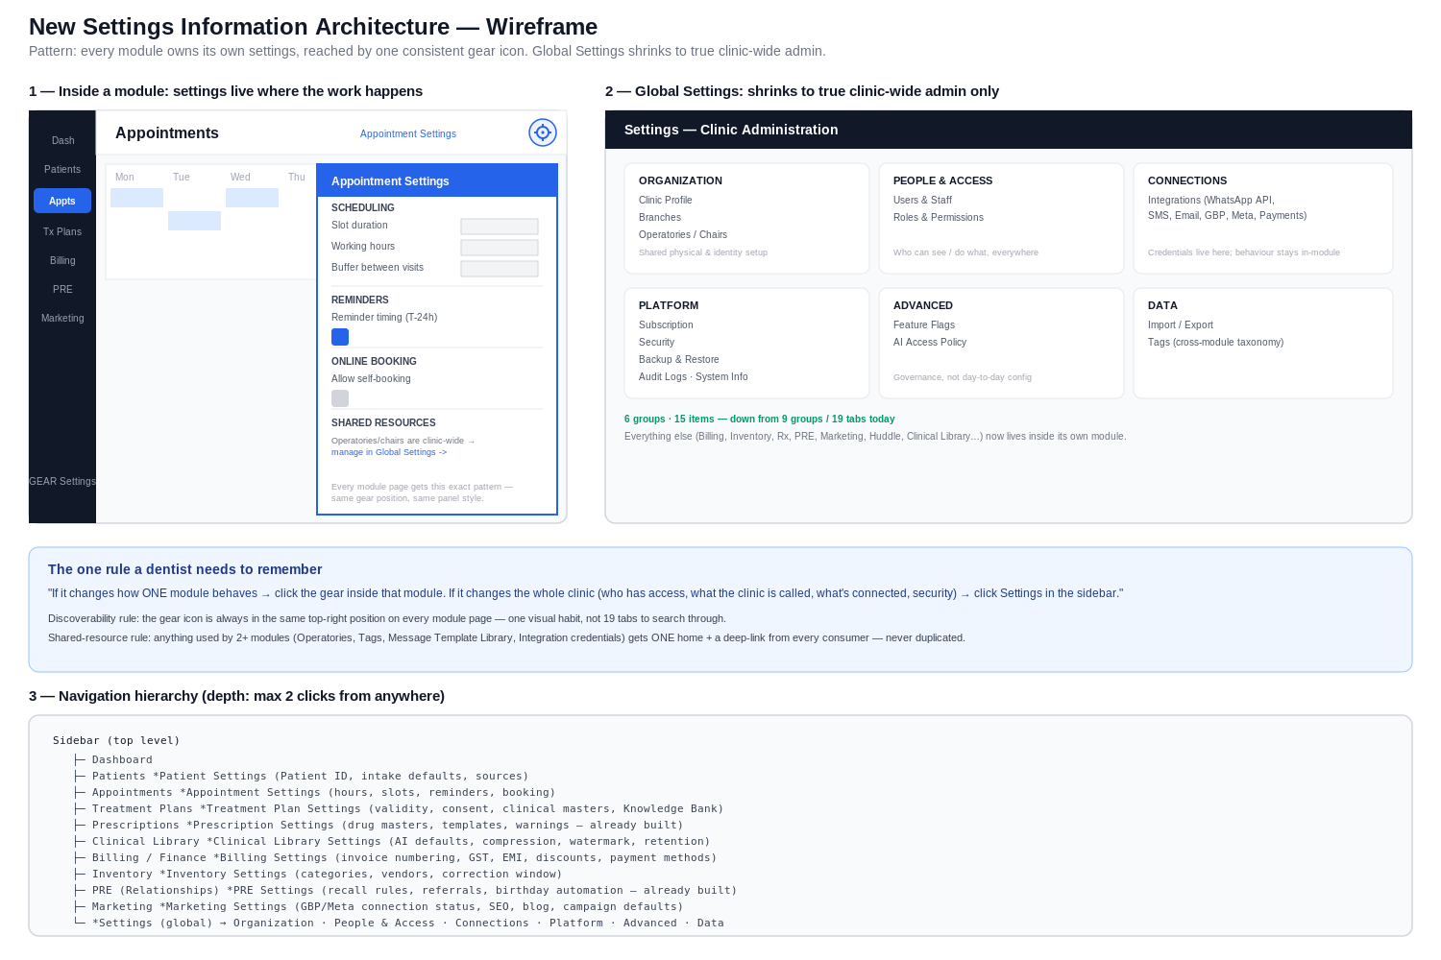
Wireframe set 2 - breadcrumb pattern for heavier module settings (Billing), the inheritance/override pattern, the renamed six-group Clinic Administration hub, and the plain-language rule for where any setting belongs:
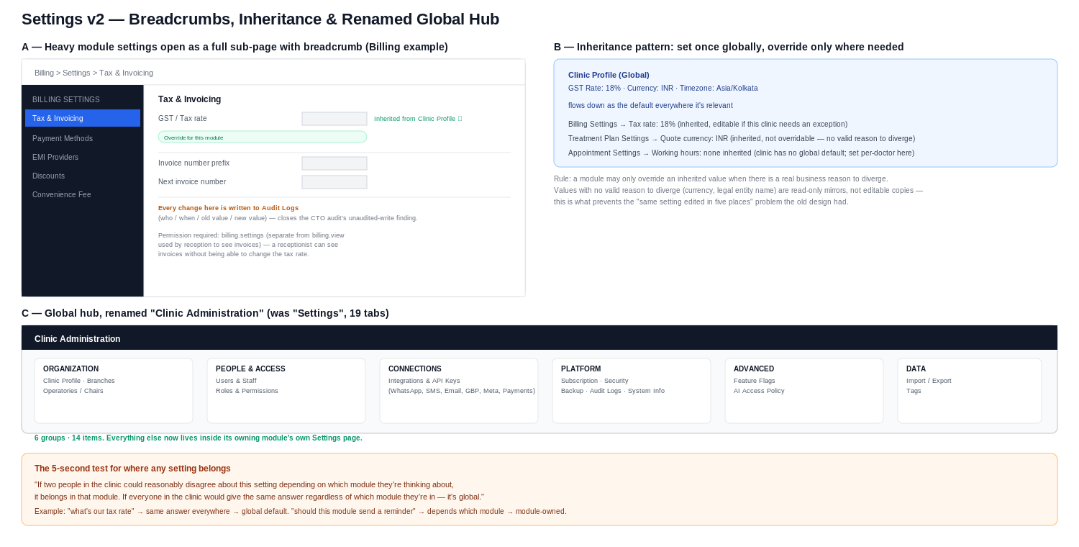

6. UX Rationale
- Contextual configuration over centralized configuration: every SaaS product cited in the brief (Notion, Shopify, HubSpot, Linear) puts feature configuration next to the feature, and reserves the global settings area for account-level concerns. This isn't a stylistic choice - it directly reduces the search space a dentist has to scan from nineteen tabs to whatever's on the module page they're already looking at.
- One consistent affordance beats a well-organized menu: a dentist doesn't need to learn where Billing settings live versus where Appointment settings live if the rule is always "the gear, top-right, on the module I'm using." This is a stronger discoverability guarantee than even a perfectly labeled nineteen-tab menu, because it requires zero memorization of a taxonomy.
- Breadcrumbs that return you to where you came from, not to a generic hub, preserve task continuity - a dentist who opened Billing to check something, then clicked into settings, should land back in Billing, not in a settings homepage they now have to navigate away from again.
- The inherit-and-override pattern exists specifically to prevent the failure mode centralization was hiding: today, changing the clinic's GST number in one place doesn't touch the separately-stored Billing tax rate - two facts that should be the same fact are quietly allowed to drift. Making inheritance explicit and visual (Section 1, panel B) turns a silent data-integrity risk into a UI pattern the dentist can see and reason about.
- No giant settings page, ever again, by construction: because every module owns its own settings, no single page can grow to nineteen tabs the way the old hub did - the ceiling on any one settings page is the complexity of that one module, not the sum of all eighteen.

7. Database Impact
Change | Tables affected | Migration type
Add clinic_id/branch_id tenant scoping (CTO audit finding) | app_settings | Schema change + backfill - the one real data migration in this whole redesign
Split view/edit/settings permission tiers | role_module_permissions (add an action column or equivalent), modules | Schema change, additive only - existing rows default to today's behavior (view implies edit implies settings) so no access is silently narrowed
Extend audit logging to all relocated settings | audit_logs (existing table, no schema change) + add Auditable trait usage to AppSetting and its module-specific successors | Code-only change, no migration - the table and trait already exist
Consolidate duplicate Inventory settings sources | No new table - retire the parallel API-only settings path, both surfaces read the same rows | Code-only change, no data migration
Delete dead Notification toggle fields | app_settings rows under group=notifications | Data cleanup migration - delete the rows, not a schema change (key/value store)
Everything else in Section 3 classified "Move" | No schema change - same tables (app_settings key/value rows, or already-dedicated tables like emi_providers, masters tables) simply get a new UI entry point | Zero migration - this is the majority of the redesign by setting count

8. Backend Impact
- Route reorganization: existing Settings\SettingsController methods split across the new owning module's controller namespace (e.g. saveBilling() moves to a Billing-owned settings controller). Because most of these read/write the same app_settings key/value rows, this is a controller-layer move, not a data-layer rewrite.
- New permission middleware tier: module:<slug>,settings alongside the existing view/edit actions - additive to CheckModulePermission, not a rewrite of it.
- Audit trail wiring: add the existing Auditable trait to AppSetting (and any new module-specific settings models) and call AuditLog::event() from each save method - infrastructure already exists and is proven in Staff/Roles.
- Inheritance resolution service: a small shared service (e.g. ClinicDefaultsResolver) that a module's settings controller can call to pre-fill an inherited value and flag whether it's been locally overridden - one new, small, reusable class, not a framework.
- Redirect layer: every old settings/... route kept alive as a 302 redirect to its new module location for at least one release cycle, so bookmarks and muscle memory don't break on day one.
- Feature-flag-gated rollout: the new IA ships behind a flag so it can be validated at Tulip Dental before being the default for any future second clinic - consistent with how Feature Flags already work in this codebase.

9. Migration Strategy (Existing Clinics Unaffected)
- Dual-run, not big-bang: old settings hub and new module-owned pages coexist behind a feature flag for the full transition; nothing is removed until its replacement has been used in real clinic operation.
- Zero data migration for the majority of settings (Section 7) - relocating a UI entry point to read the same app_settings rows from a new controller doesn't touch a single row.
- The one real data migration (clinic_id backfill) runs against a single-clinic dataset today (Tulip Dental is the only live clinic), which is the safest possible time to do it - there is no second tenant's data to conflict with yet.
- Permission migration defaults every existing role's current access to the equivalent of the new tiers (a role that could edit Billing today gets billing.edit and billing.settings both, automatically) - access is never silently narrowed on deploy day; the owner tightens deliberately afterward if desired.
- Staged per-module rollout, each validated in real use before the next module moves - identical discipline to how the production V1 line (Consultations -> Treatment Plans -> Visits...) is already being run, so this reuses a process the team already trusts rather than introducing a new one.

10. Risks
- Sequencing conflict with CEO Directive #004: this entire body of work is UX redesign, which the current governing directive halts in favor of the production V1 line. Mitigation: treat this document as an approved spec to execute only where a slice overlaps directly with a Directive #004 module already in flight (Billing's tenant-isolation and audit-logging fixes specifically), and defer the rest until the production line reaches its next checkpoint.
- Relearning cost for existing staff who know today's tab layout - mitigated by redirects and by the fact that the new pattern (gear on the module you're already using) requires less memorization than the old one, not more.
- Shared-resource sprawl if the merge/one-home rule (Section 3) isn't enforced going forward - mitigated by making the shared-resource list a reviewed checklist before any future module settings page ships, not a one-time decision.
- Scope creep on "new build" items (Working Hours, Knowledge Bank Settings, Consultation Settings) - these should ship only as thin as the module's actual current feature set justifies, consistent with this project's own build-for-the-90%-not-the-1% principle, not as fully speculative admin panels.
- Consultations does not currently have its own distinct module permission slug in role_module_permissions (it piggybacks on patients/treatments) - giving it a dedicated Settings page surfaces a real gap in the permission model that should be resolved as part of this work, not worked around.

11. Production Implementation Roadmap
Slice | Scope | Directive #004 overlap
R1 - Permission tiers + audit trail foundation | Add module:<slug>,settings permission action; add Auditable trait to AppSetting; extend the Audit Logs viewer to aggregate all modules | Direct overlap - this is the CTO audit's core production-readiness gap on Billing, which is in the active V1 line
R2 - Billing tenant scoping + relocation | Fix app_settings clinic_id backfill; move Billing/Tax/Invoice/EMI into Billing's own Settings page with inheritance from Clinic Profile | Direct overlap - Billing is explicitly next in the Directive #004 sequence (...Rx -> Billing -> Follow-up)
R3 - Quick wins (already-built modules) | Add gear icons for Prescriptions and PRE; relocate Huddle settings UI | No new backend work - safe to do any time, minimal risk to the production line
R4 - Consultations + Treatment Plans + Treatment Visits settings | Split Masters by clinical owner; relocate TP/print fields; formalize Consultations as its own permission module | Sequence after Directive #004's own Consultations/TxPlans/Visits work reaches its checkpoint - do not run concurrently with that active production work
R5 - Patients, Appointments, Inventory, Knowledge Bank, Marketing | Rescue Patient-ID; build Appointment Settings (working hours, display, reminders); consolidate Inventory web/mobile; stand up Knowledge Bank Settings; grow Marketing Settings | No overlap - schedule after the V1 production line, not before
R6 - New Clinic Administration hub + cleanup | Build the renamed six-group hub; delete dead Notification toggles, Clinical Library stub, orphaned legacy controllers; retire redirects | No overlap - final cleanup slice, gated on one full real-use validation cycle at Tulip Dental

12. Final Recommendation
Approve this specification as the target architecture, but do not start broad implementation now. Two things are true at once: this redesign is the right long-term shape for Dentfluence's settings (it directly fixes the CTO audit's findings while also fixing the discoverability problem this brief opened with), and Directive #004 is correct that finishing the production line takes priority over redesign work. The resolution is R1 and R2 above - they are simultaneously the highest-value slices of this redesign and directly required by the Billing module already active in the production line, so they're the only pieces that should move now. Everything else in this document should sit as an approved, ready-to-build spec until the production line clears its next checkpoint.

Every major decision in this document traces to one of three things: a fact verified in the live codebase, a finding already confirmed in the CTO audit, or an architecture decision Dentfluence has already made this same day (the PRE communication simplification). Nothing here is speculative - the redesign generalizes patterns this codebase already proves work.

