Dentfluence — System Settings Redesign
Information Architecture from First Principles
Prepared for: Sumit (Founder/CEO) | Prepared by: Lead Product Designer / UX Architect function | Date: 2026-08-04
Design philosophy: settings should exist where the user expects them. A dentist has under 30 seconds to find any setting - if it changes how one module behaves, it lives inside that module; if it changes the whole clinic, it lives in Global Settings. This document discards the current 19-tab settings hub and replaces it with a distributed, module-owned model, grounded in a full read of the live codebase (not invented) and the CTO production-readiness audit already completed on this module.

1. New Information Architecture
Today, one controller and one 19-tab page (grouped into 9 sections) owns everything from clinic GST number to EMI interest rates to Rx drug categories to feature flags. That single-page model is why a dentist has to hunt: the page mixes clinic-wide identity settings with deep module-specific configuration that only makes sense in the context of the module it affects.
The new model has exactly two kinds of settings destinations, and only two:
- Module Settings — reached by a gear icon inside every module, in the same top-right position every time. Contains only what changes that module's behavior.
- Global Settings — one destination in the sidebar, reorganized into 6 groups (down from 9) and 15 items (down from 19). Contains only what is true clinic-wide administration: identity, people, connections, platform, governance, and cross-module data.
Two codebase facts make this redesign low-risk rather than speculative. First, the app already has a formal Module registry (a modules database table with name/slug/icon/section, plus a role_module_permissions system keyed to it) - the permission model already thinks in terms of modules, the UI just hasn't caught up. Second, three modules already implement this exact pattern today: Prescriptions (RxSettingsController - a full, self-contained settings module with drug masters, templates, and warning rules), PRE/Relationships (Relationship\SettingsController - built specifically, per an in-code comment, so PRE could be sold as a standalone product), and Marketing (a smaller settings controller). This redesign generalizes a pattern the team has already proven works, rather than inventing a new one.

2. Which Settings Move Into Which Modules
Every row below states the module that owns the setting today (mostly the generic Settings hub) and where it moves to. Settings already living correctly in their module (Prescriptions, PRE) are marked accordingly and simply need a discoverable gear icon added inside their module's UI - no data migration required.
Module | Settings it now owns | Source today | Build effort
Patients | Patient-ID auto-numbering (prefix/start/digits), intake defaults, Patient Source list | app_settings group=patients (orphaned tab - not in current nav), Masters | Low - mostly a rescue + relocation
Appointments | Slot duration, working hours (new), reminder timing (new), online booking toggle (new), calendar display prefs (card style, color source) | app_settings group=clinic (calendar prefs only); working hours/slot duration/reminders do not exist yet anywhere | Medium - some fields are new builds, flagged already as Missing in the CTO audit
Treatment Plans | Default validity days, consent/terms text, benefit title/text, Clinical Masters (Treatments, Investigations, Materials/Brands, Complaints, Diagnoses, Conditions), Knowledge Bank rankings | Buried inside generic 'Printing' tab (tp_valid_days, tp_terms) and 'Masters'/'Knowledge Bank' tabs | Low-Medium - relocation, not new logic
Prescriptions | Drug Categories, Generics, Routes of Administration, Food Instructions, Dose/Duration Templates, Warning Rules, Prescription Templates, Drug Master | Already fully module-owned: Prescription\RxSettingsController, routes/prescriptions.php | Very low - already built; just add the in-module gear icon, retire the confusing /settings/prescription/* URL naming
Clinical Library | AI defaults (auto-tag/summarize), compression/quality, watermark, retention policy, storage quota view | Stub only - hub's 'Clinical Library' tab is explicitly a Phase-6 static placeholder | Medium - real settings need to be designed alongside the module's own build-out (do not build settings ahead of the feature)
Billing / Finance | Invoice numbering/prefix, currency symbol, GST/tax rate and label, payment methods, UPI/bank details, convenience-fee threshold/rate, EMI Providers and Schemes, discount policy | app_settings group=billing, emi_providers, emi_schemes | Low-Medium - relocation, plus the audit-logging fix from the CTO report should ship with this move, not after
Inventory | Categories, sub-types, locations, vendors, GRN correction window, low-stock/expiry alert thresholds (future) | Settings hub 'Operations' tab (web) + a parallel Api\V1\InventorySettingsController (mobile) - these should become one source, not two | Low - relocation; consolidate the web/mobile duplication while moving
PRE / Relationships | Feature flags, referral rewards, recall automation (general + per-treatment-type), birthday automation, call outcomes, dismiss reasons | Already fully module-owned: Relationship\SettingsController, routes/relationship.php | Very low - already built; just needs a gear icon inside the Relationships module page instead of a separately-discovered URL
Marketing | Standalone vs Integrated provider mode, GBP/Meta connection status (pointer to Integrations), SEO defaults, blog defaults, campaign defaults, UTM/source taxonomy | Marketing\SettingsController (minimal today - one toggle) plus scattered env/config for GBP/Meta credentials | Medium - existing controller is a good start; needs expansion as Marketing itself matures
Daily Huddle | Branch-scoped huddle settings (already has a working write endpoint) | Huddle\HuddleSettingsController write endpoint exists, but its UI is oddly parked inside the Settings hub's 'Huddle' tab | Very low - move the existing view into the Huddle module; no new backend work
Communication (PRM/inbox) | Business-hours auto-response window, shared Message Template Library (single home, deep-linked from PRE/Marketing rather than duplicated) | Not currently settings-owned; templates are scattered in Masters | Medium - mainly an organizational move plus building the shared-template pattern once
HR | Staff-specific policy once built (leave rules, shift templates) - deliberately kept separate from 'Users & Staff' account management, which stays global | Not built yet | Future - do not build ahead of need
Lab, Tasks, Practice Protocols, Reports, Analytics | No dedicated settings today, and none are being invented in this redesign. Each gets a settings gear only when it has a real, working configurable behavior to put behind it. | N/A | None now - explicitly deferred, see Section 10

3. What Remains Inside Global Settings
Global Settings keeps only what is genuinely true clinic-wide - the things a dentist would look for under 'Settings' precisely because they are not about any one module. Reorganized into 6 groups (from today's 9) and 15 destinations (from today's 19):
Group | Items | Why global, not module-owned
Organization | Clinic Profile, Branches, Operatories / Chairs | Clinic identity and shared physical resources used by Appointments, Treatment Visits, and Lab alike - owning this in any one module would force the others to reach outside their own settings.
People & Access | Users & Staff, Roles & Permissions | Access spans every module by definition. This is also where the RBAC improvements from the CTO audit belong: today's single view-tier gate on Settings needs to become granular view/edit permissions per settings destination, and that permission model lives here regardless of where each setting itself moved to.
Connections | Integrations (WhatsApp Business API, SMS gateway, Email/SMTP, Google Business Profile, Meta, Payment Gateway, ABDM) | New concept this redesign introduces: credentials and connection status live in one place; the behavior built on top of a connection (which WhatsApp templates fire for recall, how GBP posts are scheduled) stays in the owning module (PRE, Marketing). This mirrors how Slack and HubSpot separate 'Apps & Integrations' from each feature's own configuration.
Platform | Subscription, Security, Backup & Restore, Audit Logs, System Information | Account-level and infrastructure-level concerns that exist above any single module. This is also where the CTO audit's audit-logging and tenant-isolation fixes are surfaced to the owner - Audit Logs becomes the single place to see every settings change across every module, not just the ones the old hub happened to log.
Advanced | Feature Flags, AI Access Policy | Governance, not day-to-day configuration - deliberately separated from Connections and Platform so it isn't confused with routine admin work. AI Access Policy is the clinic-wide question of what the AI Copilot is allowed to touch at all; a module's own AI defaults (like Clinical Library's auto-tagging behavior) stay in that module, similar to the Integrations/behavior split above.
Data | Import / Export, Tags | Cross-module by nature - bulk patient import touches Patients, Appointments, and Billing at once; Tags are used across Patients, Marketing, and Tasks. Keeps the existing (correctly strict) admin-only gating on Import/Export exactly as-is.

4. Navigation Hierarchy
One rule, applied consistently everywhere: if it changes how one module behaves, click the gear inside that module; if it changes the whole clinic, click Settings in the sidebar. Every module page gets a gear icon in the same top-right position - one visual habit to learn, not 19 tabs to search.
Maximum depth from anywhere in the app to any setting: 2 clicks (open the module -> click its gear; or open Settings -> click the group). See the wireframe below for the full tree.
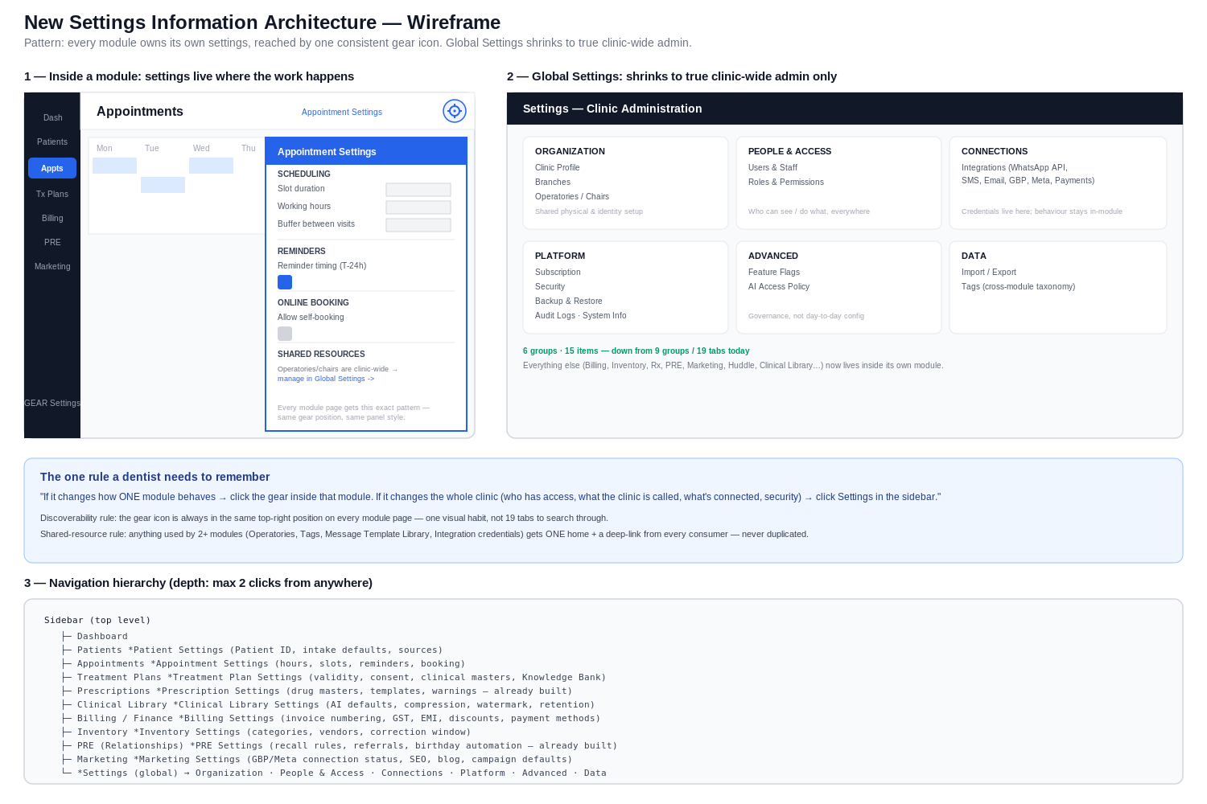
Shared-resource rule: anything genuinely used by two or more modules (Operatories, Tags, the Message Template Library, Integration credentials) gets exactly one home plus a deep-link from every consumer module's own settings panel. This is the rule that prevents the redesign from quietly re-creating duplicate settings inside five different modules - the single most common failure mode when teams decentralize a settings page without a shared-resource discipline.

5. Wireframe of the New Admin/Settings Area
The wireframe above shows three things: (1) a module page (Appointments) with its settings reached via the same gear affordance every module will use, opening a slide-over panel rather than navigating away from the work; (2) the redesigned Global Settings hub, now 6 grouped cards instead of a 19-tab sidebar-within-a-sidebar; (3) the full navigation tree showing every module's new settings destination and what it contains. The slide-over pattern (rather than a full page navigation) keeps the dentist in context - they opened Appointments to check something about scheduling, and the settings panel appears without losing that context, matching the interaction pattern used by Notion and Linear for lightweight per-object configuration.

6. Migration Plan From Current Design
Sequenced to ship value incrementally and to avoid a big-bang rewrite of a page every staff member already relies on daily.

Phase 0 - Foundation (no visible UI change yet)
- Add the granular view/edit permission split to the module permission system (closes the CTO audit's RBAC finding) before any settings move, so every relocated setting inherits correct permissions from day one instead of carrying the old all-or-nothing gate forward.
- Add the Auditable trait / audit logging to AppSetting saves (closes the CTO audit's audit-trail finding) - do this before the Billing/Finance move specifically, since tax and invoice-numbering changes are the highest-risk unaudited writes today.

Phase 1 - Move what's already built (lowest risk, immediate UX win)
- Add a gear icon inside Prescriptions pointing to the existing RxSettingsController pages - zero backend change.
- Add a gear icon inside Relationships/PRE pointing to the existing Relationship\SettingsController page - zero backend change.
- Move the Huddle settings view out of the Settings hub into the Daily Huddle module page - the write endpoint already exists and is branch-scoped correctly.

Phase 2 - Relocate hub tabs that map 1:1 to a module
- Billing & Invoice, Printing (TP-relevant fields only), Masters (Treatments/Investigations/Materials/Complaints/Diagnoses/Conditions), Knowledge Bank -> Treatment Plans / Billing modules, together with the clinic_id tenant-scoping fix from the CTO audit, since this is the natural point to fix app_settings' missing tenant column before code depends on the new location.
- Inventory tab -> Inventory module; consolidate with the parallel mobile API settings controller so there is one settings surface, not two.
- Rescue the orphaned Patient-ID tab into the new Patients module settings (it has a live consumer - the Patient model's ID minting logic - so this is a repair, not a new build).

Phase 3 - Build the new Global Settings hub
- Reorganize Clinic Profile, Operatories, Users & Staff, Roles & Permissions, Feature Flags, Activity Log, Import/Export, Tags into the 6-group layout in Section 3.
- Stand up the new Connections/Integrations page - initially just a directory of what's already configured via env/config (WhatsApp, GBP, Meta), giving the owner visibility even before credential management moves fully into the UI.

Phase 4 - Retire the old hub
- Once every tab has a confirmed new home and has been live for one full billing/reporting cycle (so any missed dependency surfaces), delete the old 19-tab settings/index.blade.php and the now-empty tabs from Settings\SettingsController, and remove the dead root-namespace SettingsController.php stub and the legacy Communication\RecallSettingsController redirect shim.
Each phase should ship with real-use validation at Tulip Dental before the next phase starts, consistent with this project's existing governing principle of finishing and validating each production slice before moving on.

7. Benefits
- Cognitive load: a dentist never has to remember which of 19 unlabeled tabs holds a given field - they're already looking at the module when they need to change it.
- Zero duplicated settings: the shared-resource rule (Section 4) forces one home per cross-module concept instead of the current pattern where, for example, Inventory settings already exist in two different controllers.
- Sellable modules stay sellable: PRE and Prescriptions already prove that a module with its own settings can be lifted out and sold standalone - this redesign makes that the rule for every module, directly supporting this project's stated goal of independent, saleable modules.
- Smaller, safer Global Settings: shrinking from 19 items to 15 genuinely global ones makes it realistic to apply strong protections (granular RBAC, full audit logging) to all of them, instead of the current all-or-nothing gate across a huge, mixed-sensitivity surface.
- Fixes and redesign land together: the CTO audit's tenant-isolation and audit-logging fixes are natural to ship at the exact moment each setting is relocated, rather than as a separate, easy-to-defer hardening project.

8. Risks
- Discoverability regression during transition: staff who have memorized 'Settings -> Printing tab' for treatment plan validity days will need to relearn the new location. Mitigate with in-app redirects from old tab URLs to the new module location for at least one full release cycle, not a hard cutover.
- Shared-resource sprawl if the rule in Section 4 isn't enforced: without discipline, a fast-moving team can easily let Operatories or Tags quietly grow a second, module-local copy. Mitigate by making the shared-resource list an explicit, reviewed checklist before any new module settings page ships.
- Under-building vs over-building: Section 2 already flags several modules (Appointments' working hours, Clinical Library's AI defaults) as new builds, not relocations. There is a risk of scope creep - building a fuller settings page than the module's actual current feature set justifies. Mitigate by keeping the MVP-before-perfection layering from this project's own principles: ship the setting only once the behavior it configures actually exists.
- Permission migration risk: splitting the current single view-tier gate into granular view/edit permissions touches every existing role assignment. This needs its own careful migration (default every existing role's 'view' grant to also carry 'edit', preserving current behavior, then let the owner tighten deliberately) rather than silently narrowing access on deploy day.
- Two Inventory settings surfaces (web hub tab + mobile API controller) need consolidation as part of the move - doing the UX relocation without the backend consolidation would just relocate the duplication instead of fixing it.

9. Production-Ready Implementation Roadmap
Slice | Scope | Depends on
S1 - Permission model foundation | Add view/edit granularity to role_module_permissions; migrate existing roles to preserve current access exactly | None - can start immediately
S2 - Audit logging foundation | Add Auditable trait + AuditLog::event() to AppSetting; build the new global Audit Logs view that aggregates across modules | None - can run in parallel with S1
S3 - Quick wins | Add gear icons for Prescriptions and PRE inside their modules; move Huddle settings view into Huddle module | S1 (so the gear can carry correct permissions from day one)
S4 - Treatment Plans + Billing relocation | Move Masters, Knowledge Bank, TP print fields, Billing/Tax/EMI into their modules; fix app_settings tenant scoping (clinic_id) as part of this move | S1, S2
S5 - Patients + Inventory relocation | Rescue Patient-ID tab into Patients module; consolidate and relocate Inventory settings (web + mobile) | S1, S2
S6 - New Global Settings hub | Build the 6-group reorganized hub (Organization, People & Access, Connections, Platform, Advanced, Data); stand up the new Integrations directory page | S1-S5 (needs the relocated tabs gone before the hub can be finalized)
S7 - Cleanup and freeze | Retire old settings/index.blade.php tabs, delete dead SettingsController.php stub and legacy redirect shim, remove old routes with redirects kept live one more cycle | S6, plus one full real-use validation cycle at Tulip Dental
This roadmap follows the project's own stated process: one slice, stop, report, get approval before the next slice - each slice above should be treated as its own approval checkpoint, not a single big-bang release.

10. Settings That Should Be Deleted Entirely
Not every setting deserves a new home - some exist only because the old page made it easy to bolt something on. These should be removed, not relocated:
- Notification preference toggles (notif_appointment_reminder, notif_followup_due, notif_new_lead, notif_task_assigned, notif_whatsapp/sms/email) - the CTO audit found no code path anywhere that reads these flags back. A settings UI that controls nothing actively misleads the owner into thinking they've configured something they haven't. Recommendation: delete the fields and the UI now; rebuild properly, in the owning module (likely Communication or PRE), only when a real notification-preference engine exists to read them.
- The Clinical Library 'Settings' external-link stub - it is explicitly a Phase-6 static placeholder with no real settings behind it. A settings entry that leads to a non-functional page is worse than no entry at all. Recommendation: remove the link until the Clinical Library module has real configurable behavior to expose; do not migrate a placeholder into the new architecture.
- The dead root-namespace app/Http/Controllers/SettingsController.php stub - has zero route references, confirmed orphaned legacy code. Delete outright; it is not part of any user-facing flow to preserve.
- The legacy Communication\RecallSettingsController - its routes are pure redirects to Relationship\SettingsController, already superseded. Delete the controller class; keep only a thin route-level redirect if there is reason to believe old bookmarks or external links still point at it, otherwise remove entirely.
Two items are explicitly NOT deletions despite looking similar to the above - flagged here to avoid an over-aggressive cleanup: the orphaned Patient-ID settings tab (Section 6, Phase 2) has a live consumer in the Patient model's ID-minting logic, so the setting itself is real - only its UI wiring is broken, which is a rescue, not a deletion. And the Marketing module's single current toggle, while minimal, is genuinely read by live code and should simply grow inside its module rather than be discarded.

Bottom line: this redesign does not add a single new screen for the sake of it. Every relocation either fixes a discoverability problem a dentist already experiences today, or ships alongside a CTO-audit fix (tenant isolation, audit logging, granular RBAC) that the module needed anyway. The two are sequenced together deliberately - hardening and re-architecture happen in the same motion, not as two separate projects.

