SWEETFUSION

**Components group:**

Barrientos, Denise Giselle.

Navas Briceño, Adriainnee Madeley Lee.

Contenido

Introduction 3

Home 3

About us 4

Contact us 5

Courses 7

Shop 8

Code css: 9

Folder and file structure: 10

Conclusion 11

Bibliografia 12

Introduction:

Como diseñadoras de este proyecto para SweetFusion, nos embarcamos en una emocionante travesía para transformar la presencia en línea de esta encantadora pastelería. Desde el inicio, nuestro objetivo fue capturar la esencia y el encanto de SweetFusion, llevando su dulzura y elegancia a cada aspecto de su presencia digital. Desde el diseño de la página principal hasta la creación de secciones como 'Acerca de nosotros', 'Cursos de pastelería', 'Tienda y Catering', y más, cada paso fue cuidadosamente planeado y ejecutado para brindar una experiencia excepcional a los visitantes del sitio

Home:

The design of SweetFusion's website homepage was carefully crafted to reflect the bakery's aesthetic and provide a visually appealing experience. The navigation is intuitive, seamlessly guiding users to key sections such as the menu and online ordering. Clear calls to action encourage engagement, and if relevant, customer testimonials are included for credibility.

About us:

In the 'About Us' section of SweetFusion's website, we present the story behind the bakery. We highlight how the idea to create SweetFusion came about, based on the shared passion for baking of the founders. We explain how the business started, focusing on core values of quality, creativity, and customer satisfaction. We also include information about SweetFusion's commitment to the community and our focus on providing moments of joy and sweetness through our products. In summary, the 'About Us' section offers visitors an authentic and heartfelt insight into what makes SweetFusion unique and special

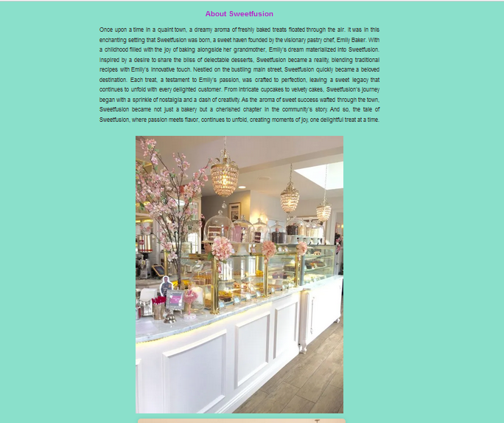

Contact us:

For the 'Contact Us' section of SweetFusion's website, we designed a welcoming and user-friendly space to facilitate communication with visitors. We provide detailed information about our location, opening hours, and options for customers to reach us directly via phone or email. Additionally, we've integrated an interactive map to make it easy for users to find our bakery. Our goal in creating this section was to offer a seamless experience and ensure that customers feel welcome to reach out to SweetFusion.

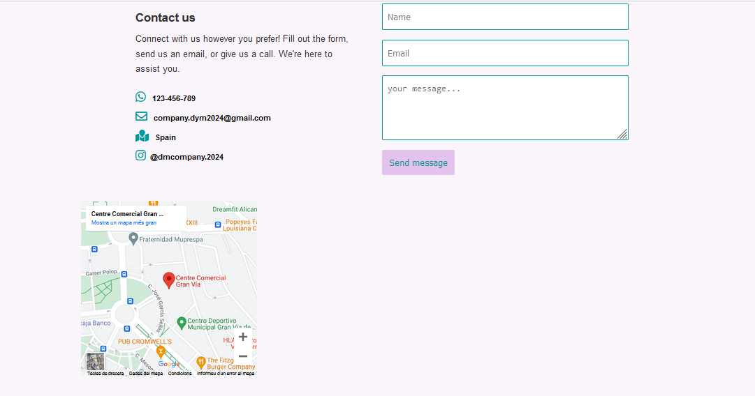

Courses:

In this section we've created a space to provide learning opportunities for customers. We showcase a variety of courses taught by SweetFusion's expert pastry chefs, designed for all skill levels, from beginners to experienced enthusiasts. Each course offers a hands-on and interactive experience, where participants can learn decorating techniques, recipe secrets, and expert tips. We also provide details on dates, schedules, and how to enroll in each course. Our aim with this section is to invite pastry lovers to develop their skills and create sweet delights with SweetFusion.

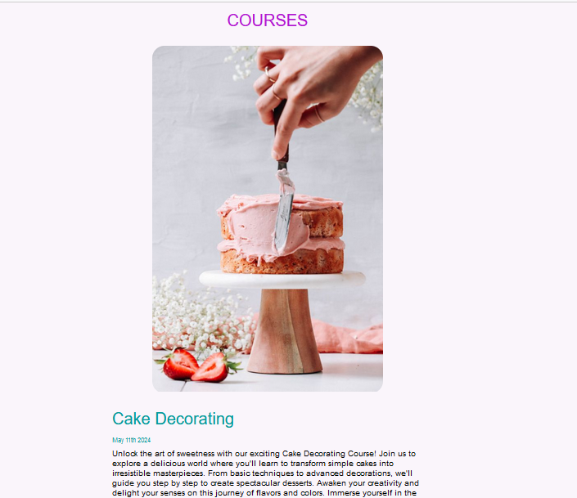

Shop:

For the 'Shop & Catering' section at SweetFusion, we provide a convenient and personalized shopping experience for our customers. Here, visitors can explore and purchase a wide variety of products crafted by SweetFusion. Our goal with this section is to offer a comprehensive solution for our customers' needs, whether it's satisfying their daily cravings or providing high-quality catering services for events.

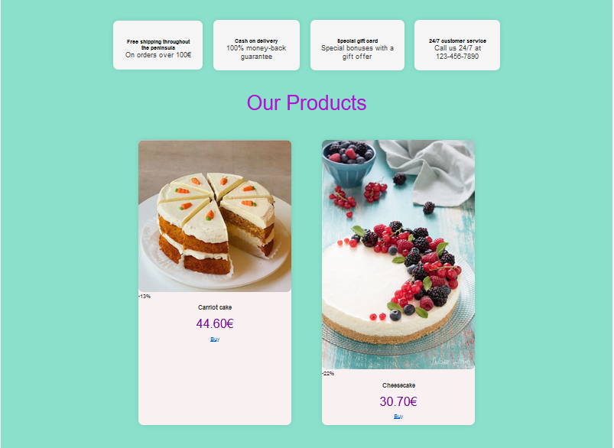

Code css:

Folder and file structure:

Conclusion:

"In conclusion, our journey as designers for SweetFusion has been driven by the strategic implementation of HTML elements complemented by CSS styling to create a visually appealing and engaging website. Through the use of CSS properties such as colors, fonts, layouts, and animations, we've enhanced the aesthetics and user experience of the site. By applying responsive design principles, we've ensured that the website is accessible and functional across various devices and screen sizes. Furthermore, CSS has allowed us to maintain consistency in branding and design elements throughout the site, reinforcing SweetFusion's identity and message. Overall, our integration of HTML and CSS has resulted in a seamless and impactful online platform that effectively showcases SweetFusion's products and services while captivating and delighting visitors.

Bibliografia: