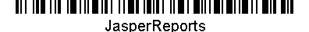
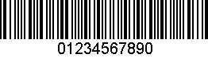
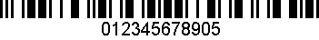
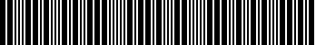
Barcode Sample
This sample uses Barbecue Version 1.5beta1
http://barbecue.sourceforge.net/

