Advertising

Online advertising is a type of advertising for attracting people to buy something or play something or simply look at your media product. Mostly advertising is comercial. The main purpose of advertising is to show your product and in the best ways to force the user to click on your ad and view in more detail, in the future it is possible to buy your product.

Unlike analog advertisements, online ads allow you to target a specific demographic,

such as a certain generation, gender, geographic region, or base targeting on historical

data like past activity. Online ads are also interactive, meaning that the user can respond

to an ad through actions such as clicking and visiting your site.

Ads in YouTube non-premium where you can see different advertisements like banners, video inserts, advertisements from video authors like grammarly, IT courses, ads when you search something in google.

it depends on your advertising profile, for example Google, it analyzes your needs and, depending on them, shows the necessary advertising in its opinion.

Advertising types:

* Pay-per-click(or CPA - Cost per action) Advertising - meaning you can earn money after simple work, for example clicking on ads, viewing another add, playing something etc

Example: 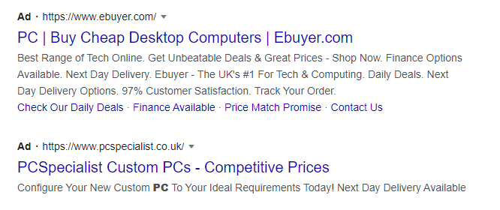

* Product listing ads - Product listings ads (PLA) or shopping ads are ads that appear on a search engine when you look up a physical product. These are PPC (pay-per-click) ads, which means you only have to pay for the number of clicks you received on the ad, and not for the number of times it’s viewed. Below is an example that showed up on Google when I tried searching “pc.”

Example:

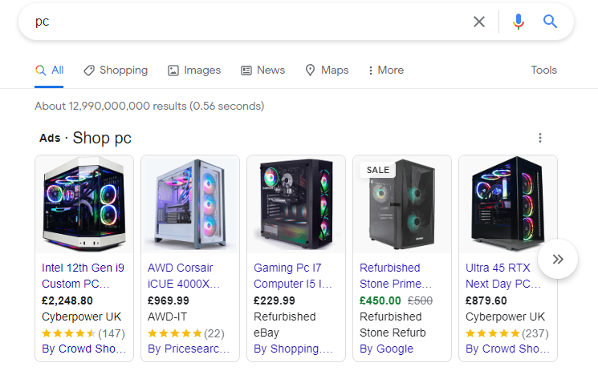

* Display ads - meaning banner, header, image advertisement, retargeting

Example:

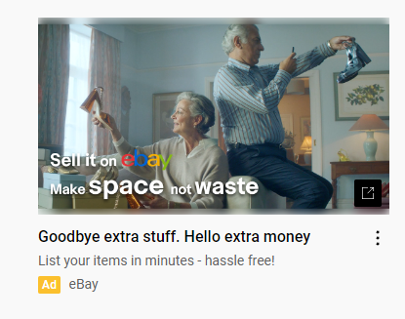

* Demand-side platform ads - A demand-side platform (DSP) is a tool used by businesses to bid on ad space in real-time, and purchase mobile, search, and video ads from a single marketplace. So rather than going to individual vendors like Google Ads to buy ad inventory, you can instead buy ads from multiple channels all in one place.

Example: Facebook Ads Manager. Rocket Fuel. MediaMath. Amazon (AAP) DoubleClick. LiveRamp. Choozle. TubeMogul

* Affiliate ads - Affiliate ads, or more broadly speaking - affiliate marketing - refers to when a website promotes another business’s ads in exchange for commission on every acquired lead that turned into an actual sale.

Example:

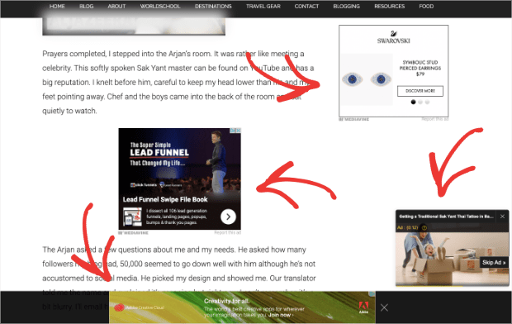

* Native ads - Native ads match the look and feel of the websites they’re placed in, thereby not standing out as typical ads would, and instead flow cohesively with the rest of the web page’s design. Examples include sponsored search results on Google, that line up with the rest of the results, and social media ads like on the Instagram story, which you might watch a few seconds in since they appear like normal stories at first. It should be noted, though, that there still has to be a clear label informing the user that this is an ad, like we can see in this example of the Google ads that show up when I search “web design services.”

Example:

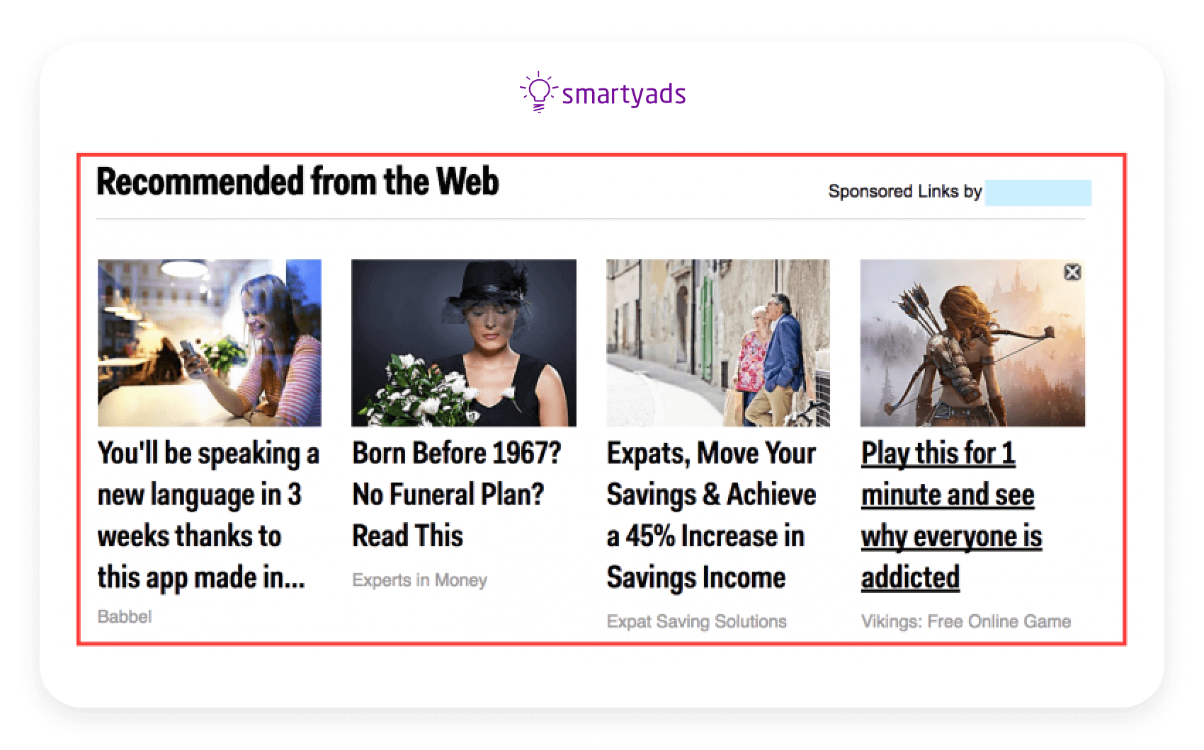

* Social media ads - From Tiktok to Reddit, social media platforms offer perfect conditions for advertising. For example, with Facebook ads, you can choose your audience by age, gender, education, job title, location, interests, and even past purchases, enabling you to reach your ideal customers with a message tailored to them.

Example:

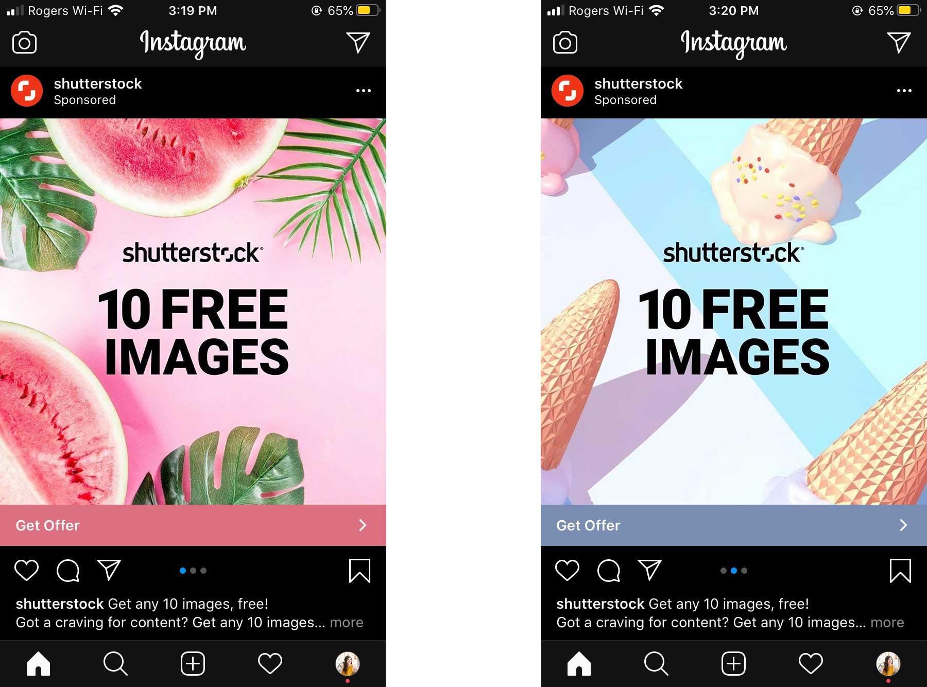

* Video ads - Typically when we refer to video ads, we mean video content that plays on video-sharing sites like YouTube. YouTube ads are generally paid for on a cost-per-view basis. Each view costs somewhere between $0.10 ~ $0.30

depending on your target industry and keywords. Also, if you set a maximum budget, then you’ll only be charged that much, and you can never go over.

The most common type of YouTube ads are called “TrueView In-Stream Ads.” These are the skippable commercials that play before the main video starts. Advertisers only have to pay for these ads when the user has watched for 30+ seconds or clicked on the ad and opened a URL. There’s also another type of In-Stream ads that are unskippable and play before, in the middle of, or after a video that is 10 minutes or longer. These ads are paid for on a PPC basis, so you’ll want to offer an enticing CTA to get as many conversions as possible.

Example:

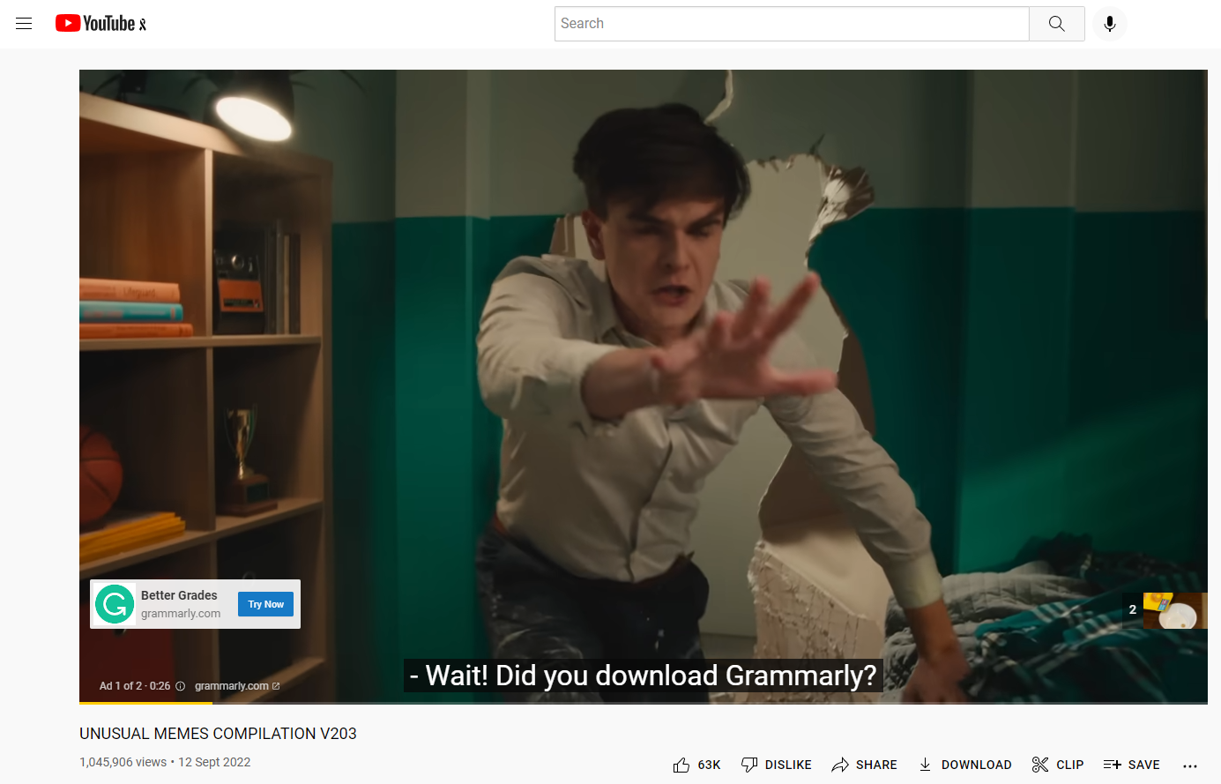

* Email ads. - There are two common methods for advertising with email. One is to insert banner ads and links in the header or footer of email newsletters, and the other is to have users register their preferences, and then send advertising emails that match those preferences.

Example:

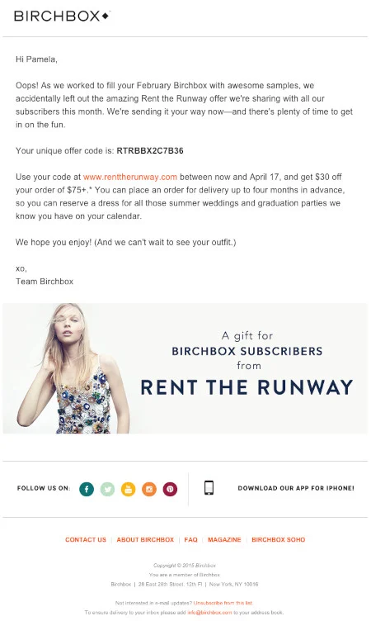

* Banner/PopUp Ads - Banner ads, also known as display ads, have been around for a very long time. This is a type of advertising in which a predetermined space on a website is purchased, as “online real estate” for placing one’s ad. The goal of display ads is to get more brand exposure, and is ideal for attracting new customers that have not yet heard of the product.

Banner ads can also be used for retargeting campaigns, in which you set your ads to show up on the screens of users who have already visited your site, in order to bring them back and further encourage a purchase. You can also set banner ads to be shown to specific demographics, segmenting by gender, age, or region, and choose the time of day for these ads to appear.

Example:

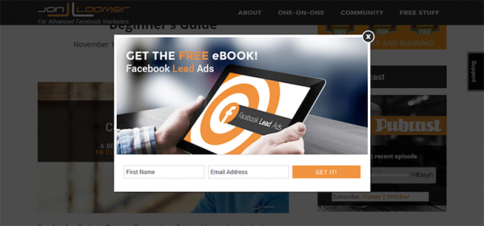

Online ads benefits - Online advertising allows you to show your ads to the people who are likely to be interested in your products and services, while filtering out folks who aren't. And you can track whether those people clicked your ads.

While the benefits of advertising online include the potential to reach a large market and the ability to measure results, online advertising also presents some disadvantages.

* Customers Ignore Ads.
* Technical Viewing Problems.
* Expensive Ad Prices.
* Consumers Get Distracted.
* Too Many Options.

Information Source:

<https://bow-now.com/media/column/types-of-ads#:~:text=The%208%20main%20types%20of%20online%20ads%20include%20>

<https://www.knowonlineadvertising.com/facts-about-online-advertising/advantages-and-disadvantages-of-online-advertising/>  
<https://www.webnode.com/blog/pros-and-cons-of-online-advertising/>

https://www.tidalmarketing.co.uk/our-services/online-advertising