Cloud Computing

CD - it is a working model by which a company accesses shared computing resources such as servers, storage, network, applications and other cloud services. All resources can be used and managed by the user without additional help from a cloud service provider.

There are several types of cloud computing, namely software as a service, platform as a service, infrastructure as a service.

Examples of such technologies are Microsoft 365, Microsoft Azure, Google, Amazon, CI CD of GitHub/Gitlab etc.

Ubiquitous computing

UC - a concept, paradigma that describes computers and computing equipment embedded in everyday life, where different devices have the ability to exchange information with each other. Computers disappear from view, but they do not disappear from everyday life. A person does not concentrate on communicating with the computer, but rather on performing the task itself. This is not virtual reality, where the whole world is displayed on the computer. Ubiquitous computing brings computers into the world around people, information processing is associated with each activity or object encountered.

Networking

Network - connecting computers and other devices with communication lines so that computers (or their users) can exchange resources with each other. Resources in this case can be processor time, memory, information data, etc.

Several types of networks:

LAN(Local Area Network) - by combining a certain number of computers in a relatively small area. Compared to a wide area network (WAN), a local area network usually has a higher speed of data exchange, and the absence of the need to use a telecommunications communication line. For example network between computers in class in your school/college.

WAN(World Area Network) - a computer network covering vast territories. that is, any network whose communications connect whole megacities, regions or even states and contain tens, hundreds or even millions of computers.

What is the difference between them?

Of course, you could have guessed that in terms of size, it is true, there is a much larger number of devices in the global network, then there can be refrigerators, and computers, microwaves, phones, cars, servers and many other devices known to you. Also, WAN combines a much larger number of connection methods, addressing methods, protocols, and restrictions.

The Internet is a global international network in which most modern devices are connected. also has the alternative name WWW World Wide Web. This is a network in which there are many servers for naming, addressing clients, services that you use every day, even now reading this text you are using this network. This is a very large and complex system, which consists of a hybrid topology, contains a lot of people who are responsible for Internet support, and people who give you the opportunity to use the Internet - they are called providers. Many connection and connection models are used, you have probably heard of fibre optic connection, twisted pair, Wi-Fi, optical connection. It does not have centralised management, because all devices are interconnected by a network and address each other without a central server. However, now the old IPv4 model is often used, which is not always enough for full use, that is why IPv6 was born, each device has its own unique address, and it can use it to communicate with other devices. In the 4th version, you need to use various devices such as routers, switches, hubs, switches, DNS servers to contact the client on the other side of the world, because the number of addresses in the 4th version is very limited, and we need to use devices to expand this range. Very soon there will be a transition to the 6th version only, without mentioning the 4th, but it is still quite difficult, since the technology is quite new, and requires detailed study by specialists, but it is much better.

DNS

DNS(Domain Name System) - this system is designed so that computers working in the World Wide Web can determine the IP address of the server by the letter name - the domain - and contact it for content. In turn, the domain is the name of your website on the Internet. Domain names are of the first, second, third and many, many more levels

It so happens that people are not robots and not some precise mechanisms, so it is difficult for most to work and memorise numbers. Especially now in the era of digital technologies, where almost everyone has the opportunity to access the Internet and use it for their own purposes. The main one is the collection of information, for this we usually use various websites, for example Google. One of its IP addresses is 172.253.122.94, but remembering that many digits can be difficult, and it will be much more difficult than remembering google.co.uk. Many people thought so, and in 1983 Paul Mockapetris expanded the possibilities of the Internet by inventing the domain name system.

For example, we can use the https://who.is/dns/ service to view DNS records for this site.

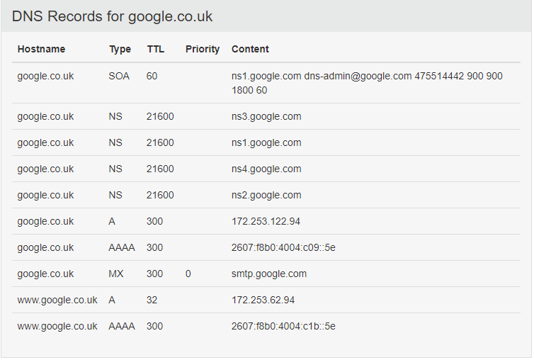

Example of dns editor in cloudflare:

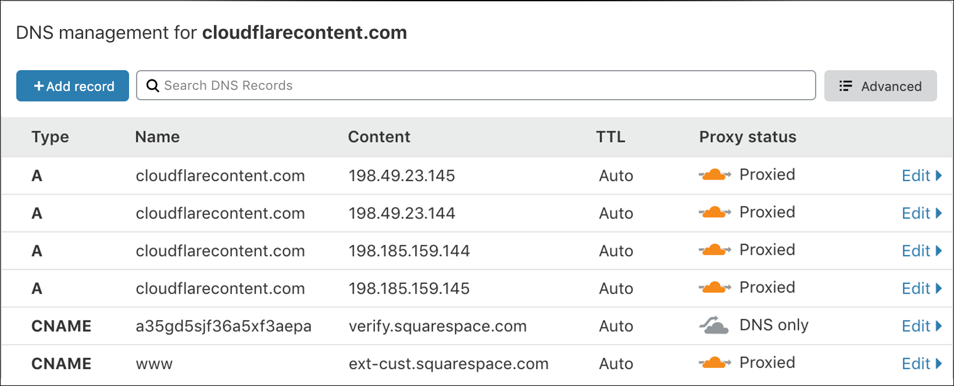

Here we can see 10 dns records(who.is first screenshot), they have different types.

NS - name server - indicate where the entire DNS zone of the domain is stored, there should be more than one such record for fault tolerance.

A - is used to specify a domain name that will be redirected to the IP address you specified. This process is hidden by your browser, but when you specify a domain in the search bar, you are actually working with many IP addresses. That is, the A record defines the IP address of the domain name in the IPv4 network.

AAAA is the same system as A records only for IPv6.

MX - indicate the addresses of the mail servers of the domain, there may be several of them and they have priority; the lower the priority value, the higher it is.

CNAME - Canonical Name - is a record that makes a copy of another domain, in some sense binds the subdomain for which the record was created to a valid (canonical) domain name. A CNAME completely copies all records of another domain, thereby creating a complete copy of another address. For example www CNAME record to A record.

The TTL (Time To Live) parameter determines the storage time of DNS records in the DNS system cache. It is used to reduce the load on the DNS server by reducing the number of requests to them, however, with large values, it increases the time for changes to the domain settings to take effect (DNS servers can return old data from the cache until it is updated). Simply put, the longer the TTL, the less the load on the DNS server, but the longer it takes for changes to the domain settings to take effect. The default for most DNS servers is 15 minutes.

Since DNS works on a hierarchical basis, it resembles a tree. The tree has a vertex - the root zone - for which the null name is reserved, and the root servers are responsible for it. This zone is inconspicuously present in all domain names - it is the dot that is usually omitted when writing, for example, "facebook.com." Root servers, there are only 13 of them, contain information about first-level domains (uk, net, info, etc.).

What the DNS server sees when it is accessed:

1) The browser is checking its cache - maybe you recently visited Facebook and this information was saved. If not, the next step.

2) The browser asks for help from the operating system on your computer. It checks in its own DNS cache and in the hosts file. If nothing is found, the request is sent to the server that is registered as a DNS server in the computer settings.

3) Your provider's DNS server first checks its cache (perhaps one of your neighbors just logged into Facebook). And checks his local database (maybe he keeps the facebook.com zone). If nothing is found, this server makes several queries and compiles a response for you.

4) First, the request is sent to the closest root server. The addresses of the root servers are usually recorded in the settings of all DNS servers, since they change very rarely. The root server responds that it does not know the address of “facebook.com” and returns a list of servers that host all .com domain records.

5) Thus, the provider's server records the received information in the cache, and when searching for all domains ending in .com, it will refer to this small number of servers. Therefore, he asks the first server from the list: what is the address of facebook.com? The received address is sent to your computer and the browser shows you the Facebook feed.

This is the case for any website.

You can use the traceroute Windows terminal utility to trace the entire path to your website.

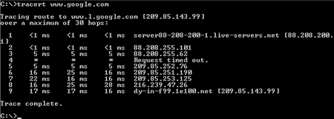

Usually, many large companies allocate many servers to offload the load on those servers, and several types of servers are used. Everything is also built according to the principle of a tree, where immediately upon request you get to the DNS server, and depending on the URL address you choose, it will redirect your request to the main or secondary server, which will process it and return an answer.

To configure servers on Linux, you can use any server, for example nginx or apache. There are also companies that allow you to configure DNS along with a free SSL certificate to increase your security, such as CloudFlare.

To set up a domain name on your server, you need - to have a server and a white ip address, to have a domain and its settings, if you do not have an SSL certificate, you can use cloudflare.

So we now have all the components, in the settings panel of your domain (dns editor) we redirect all traffic to the cloudflare server by adding NC records. In Cloudflare's dns editor, we already do redirection with the help of AAAA or A or CNAME records. So, if the Cloudflare servers notice a familiar URL, the DNS servers check their cache, otherwise they find the desired IP address in the database and redirect you to your website, where the web server is on port 80 or 443. You should also know that you need to separately configure the web server and add ssl on your web server. Usually, changing DNS records can be buffered for several hours, but if you are lucky, everything will change immediately.

Network topology

A network topology(layout, configuration, structure) of a computer network usually refers to the physical location of network computers relative to each other and the way they are connected by communication lines.

There are several basic network topologies: star, bus, and mesh and several secondary ones that are built in combination.

Bus topology: In this case, the computers are connected to each other by a coaxial cable.

Information transmitted from one network computer to another is distributed, as a rule, in both directions. The main advantages of such a scheme are the cheapness and simplicity of cable routing in rooms, and the possibility of almost instant broadcasting to all stations of the network. The main disadvantage of the common bus is its low reliability: any defect in the cable or any of the numerous connectors completely paralyses the entire network. Another disadvantage of the common bus is its low performance, since with this connection method, only one computer can transmit data to the network at any time.

Star topology: In a star topology, each peripheral node (a computer workstation or any other peripheral device) is connected to a central node called a hub or switch. This topology is mostly used, because you can connect to the node you like, while the candles and hubs or routers have a large and convenient functionality for configuring the network

Mesh topology: This type of topology is obtained from the fully connected topology by removing some possible connections. This is a network topology in which there are at least two computers with two or more paths between them.

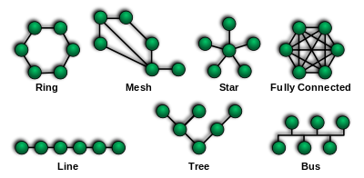

The advantages and disadvantages of a network

Advantages: The ability to easily exchange information, even over intercontinental distances, will be much cheaper than ordinary correspondence or delivery of an information product. A large number of software, sites for communication, data exchange, working with files. The ability to create your own networks, even private ones, to organise communication between devices.

Disadvantages: But if you are engaged in the installation of servers, network connection technologies, then it can be a bit expensive. Because usually good internet equipment and cables are not cheap. Network management is quite complex and requires experience and knowledge in networks, for this there is a profession of system administrator, network installation specialist, providers, etc. Your network can be compromised and infected with viruses that can steal or destroy your data from servers and other devices, or a hacker can do it directly.

Sources of information:

<https://www.techopedia.com/definition/22702/ubiquitous-computing>

<https://www.geeksforgeeks.org/basics-computer-networking/>

<https://en.wikipedia.org/wiki/Network_topology>

<https://www.bbc.co.uk/bitesize/guides/z36nb9q/revision/2>

<https://en.wikipedia.org/wiki/Domain_Name_System>

https://who.is/dns/google.co.uk