Task 2

User requirements:

1. Primary focus: The website should promote and sell mobile phones offered by MobileWorldStation.
2. Target audience: The website should target anyone who is interested in buying mobile phones, regardless of their age, gender, or occupation.
3. User interface: The website should be quick and easy to navigate. The use of menus should be considered to enhance the user experience.
4. Consistency: There should be a consistent use of text, colour schemes, and page styles in all web pages to maintain brand identity.
5. Multimedia content: The website should be visually interesting and engaging, with at least four different original or ready-made multimedia/digital assets embedded, such as digital animation, graphics, audio, or video.
6. Interactive features: The website should contain some interactive features, such as a feedback form, to collect customer enquiries and feedback.
7. External hyperlinks: The website should have at least two external hyperlinks to other interesting web pages related to mobile phones.
8. Internal linking: Each web page should be internally linked, making it easy to navigate menus to access relevant information.

Target Audience:

The target audience for the MobileWorldStation website includes individuals of all ages who are interested in purchasing mobile phones. This could include tech-savvy consumers who are looking for the latest smartphone models, business professionals in need of mobile devices for work, students or young adults seeking affordable options, or even elderly individuals looking for user-friendly phones with basic features. The website should cater to a wide range of potential customers who have varying levels of technical knowledge and diverse preferences in mobile phones.

Intended Purpose:

The main purpose of the MobileWorldStation website is to promote and sell mobile phones, accessories, and services offered by the local mobile phone shop. The website serves as an online platform for potential customers to learn about the products and services available, view product specifications and pricing, and make purchases. The website should provide an informative and user-friendly experience, showcasing the various offerings of MobileWorldStation and encouraging visitors to make purchases or inquire about products through interactive features like feedback forms. Additionally, the website should also aim to engage visitors with interesting multimedia content and external hyperlinks to other relevant web pages, enhancing their overall experience and promoting the brand image of MobileWorldStation as a trusted source for mobile phone products and services.

Sitemap:

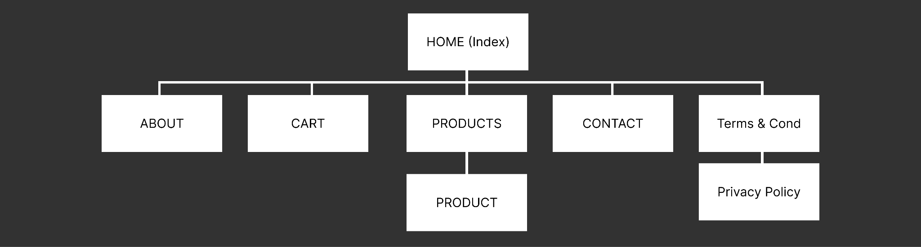

Storyboards with description:

Main Layout of all pages.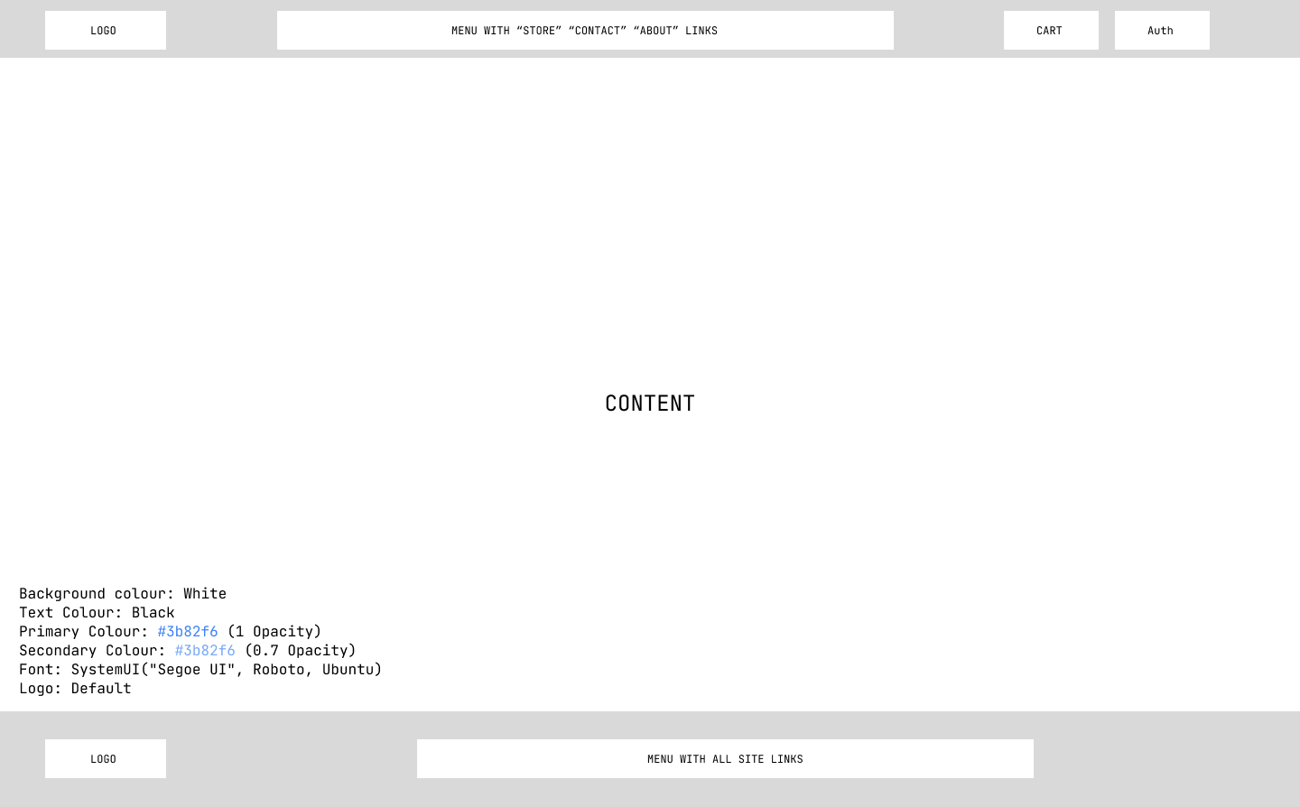

Home page.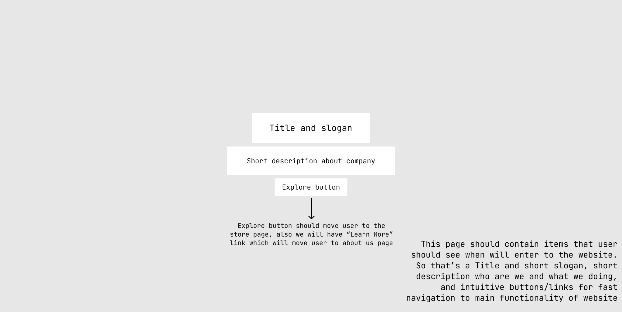

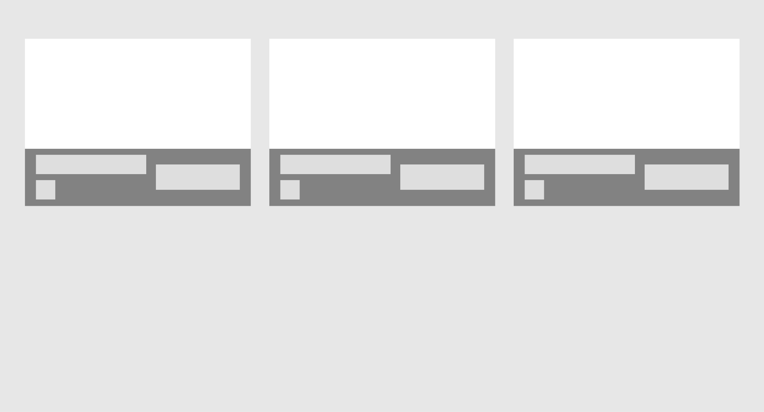

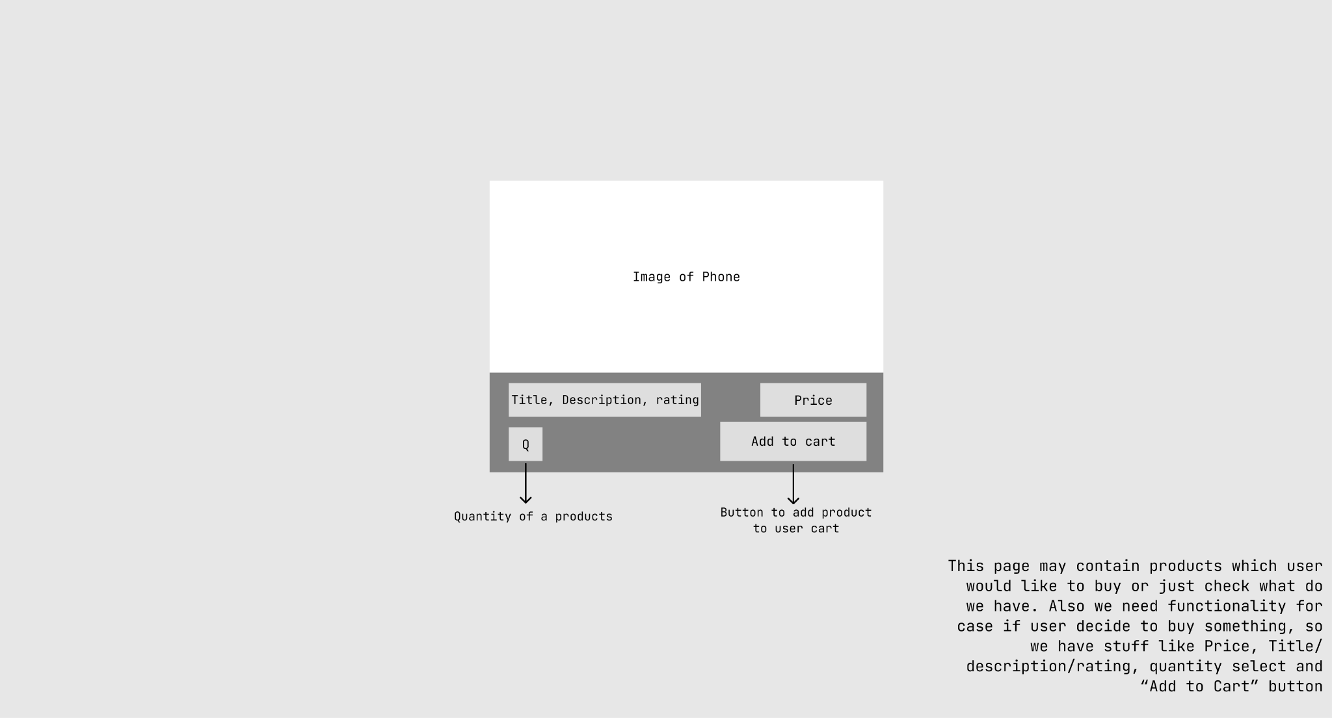

Products page.

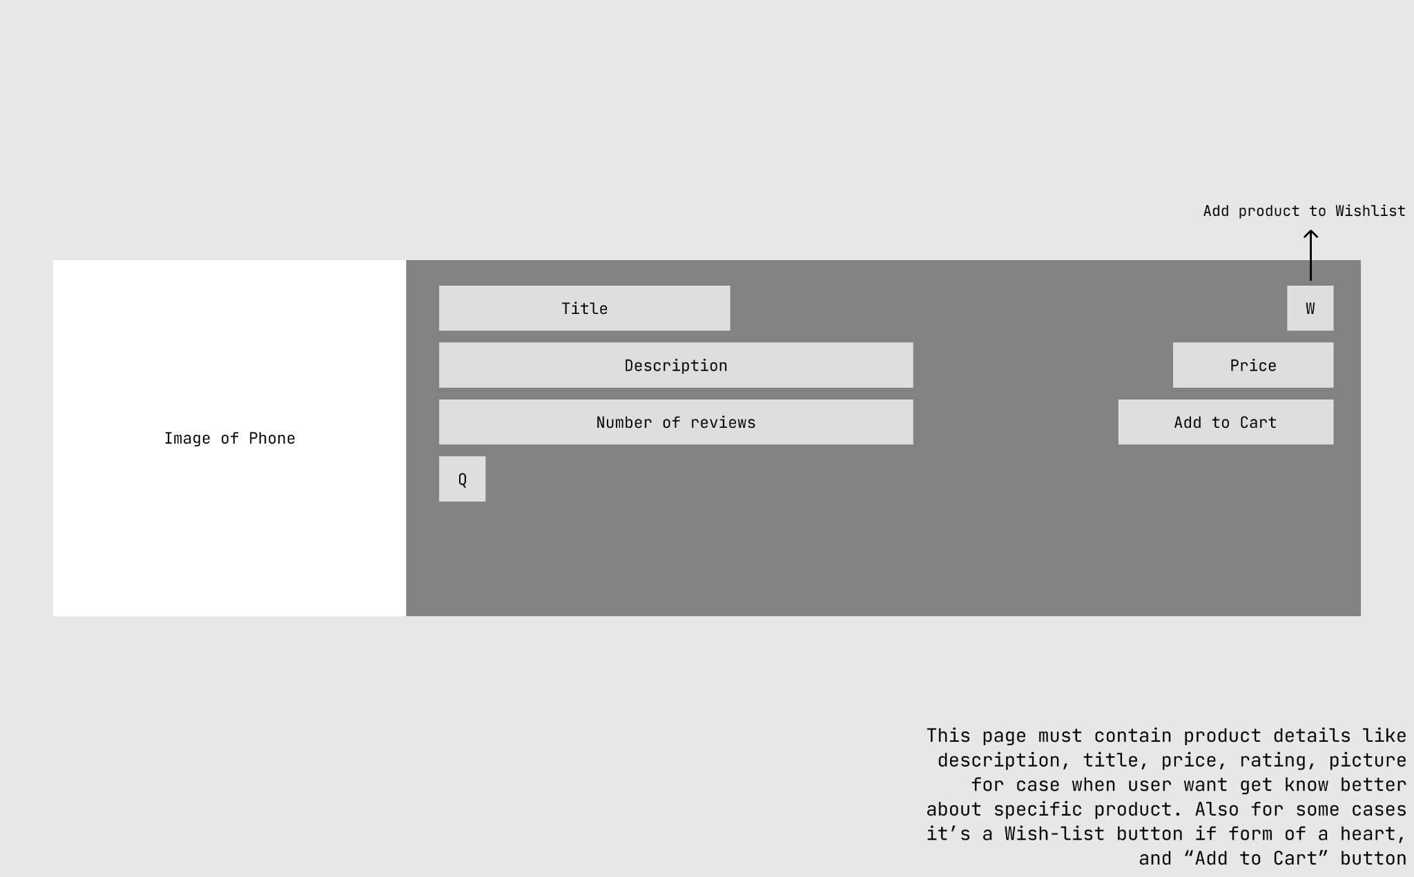

Product page.



Cart page.

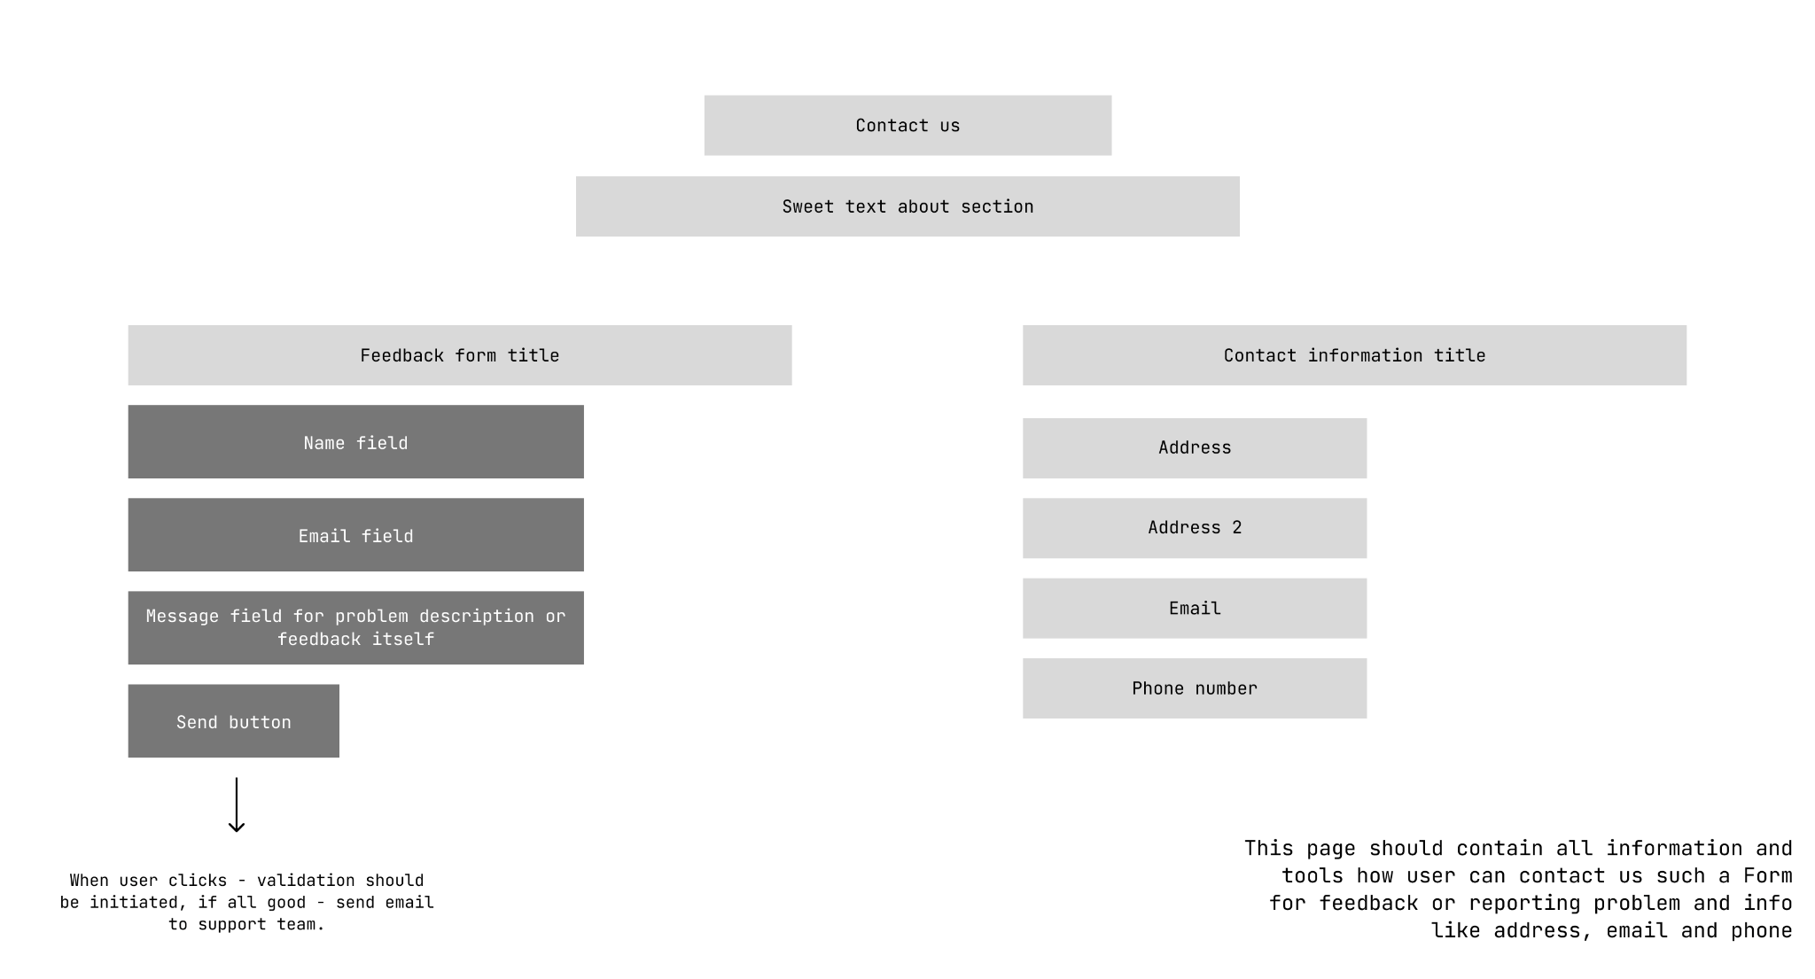

Feedback/Contact us page

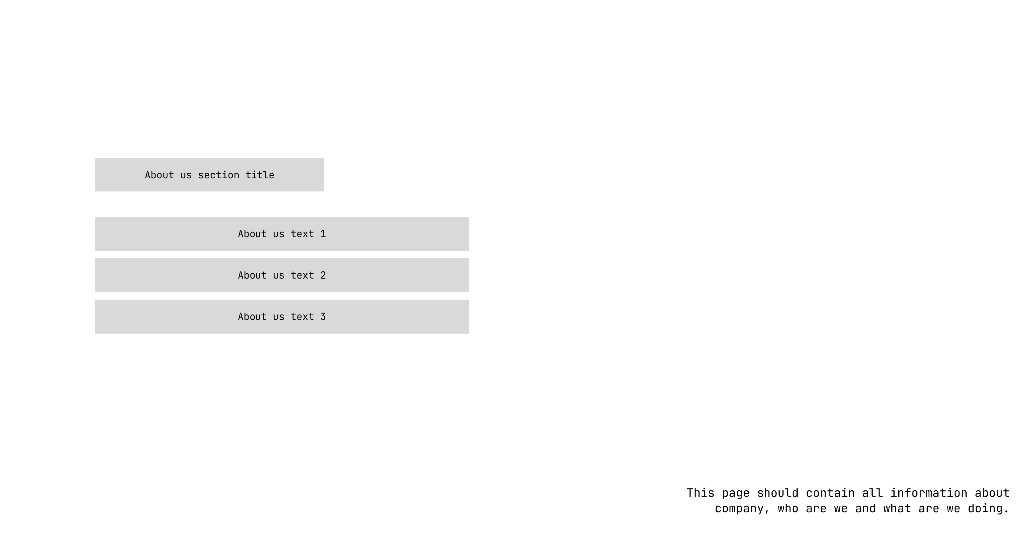

About us page.

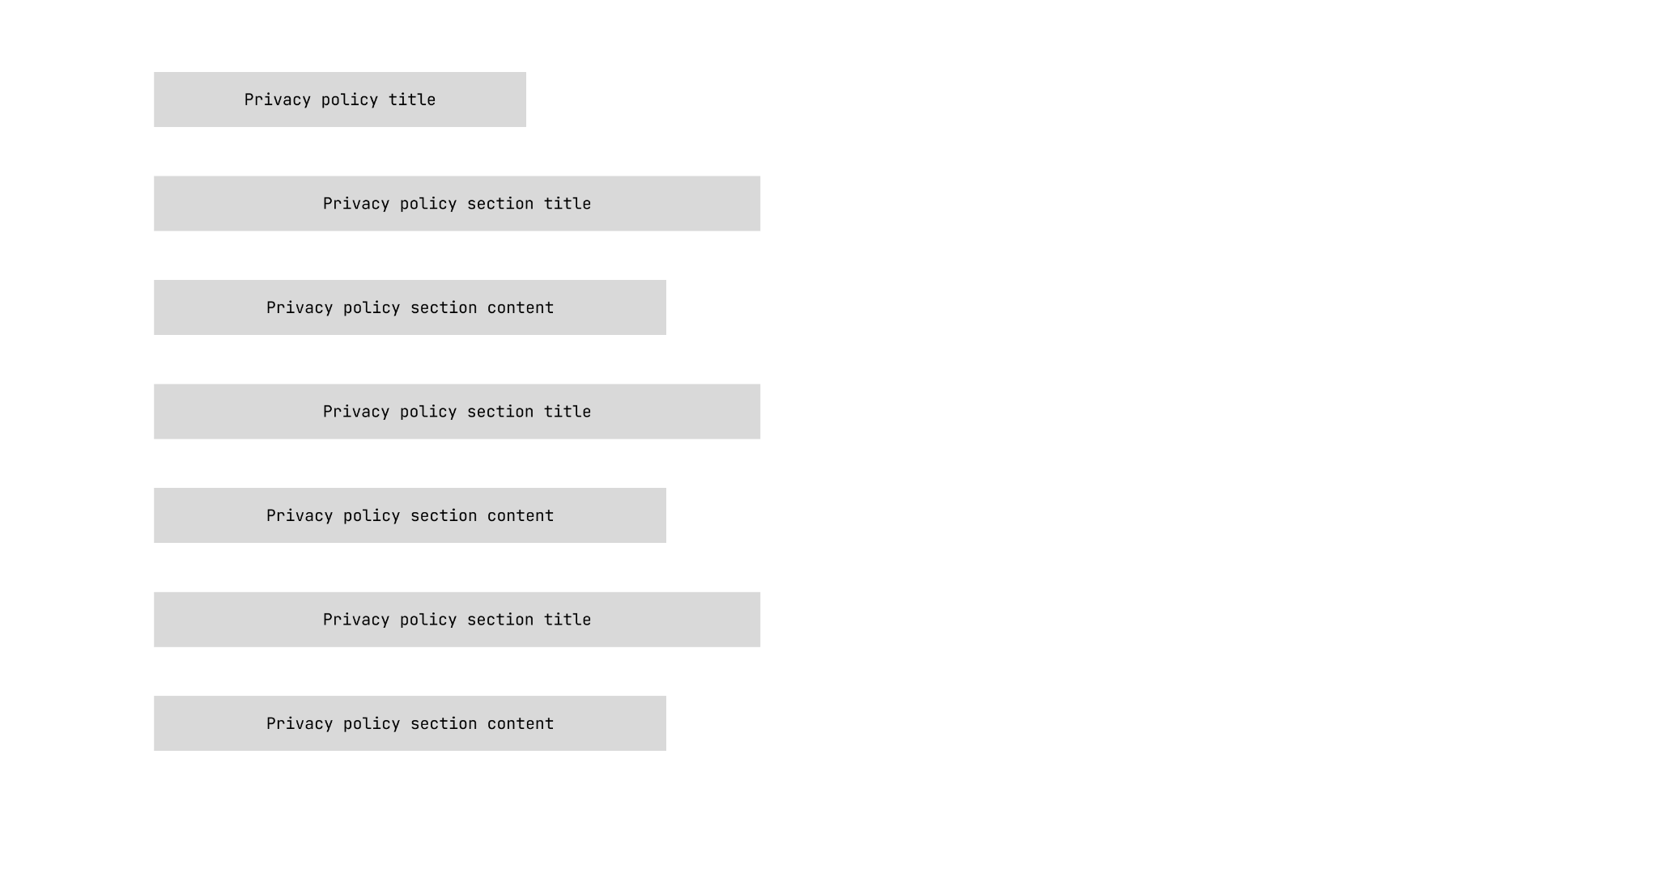

Privacy policy page

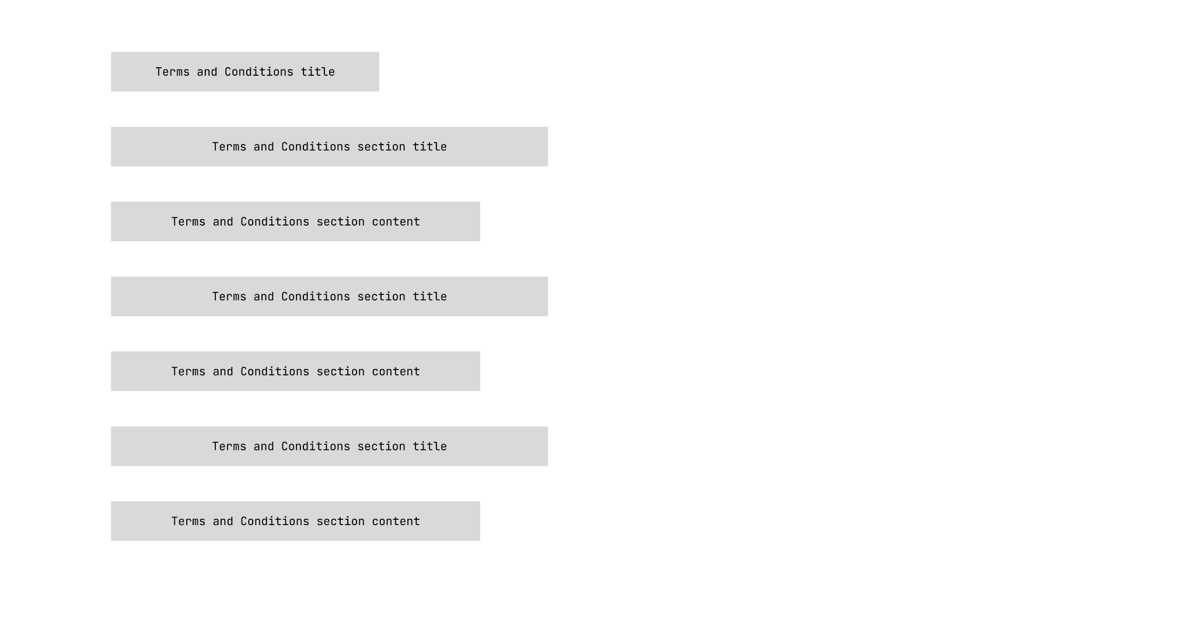

Terms and conditions page.

Assets List:

| N | Name | Source | Description |
| --- | --- | --- | --- |
| 1 | logo.png | Selfmade | Logo of MWS company |
| 2 | galaxy-s23-ultra-highlights-design-end-s.jpg | <https://images.samsung.com/uk/smartphones/galaxy-s23-ultra/images/galaxy-s23-ultra-highlights-design-end-s.jpg> | Galaxy S23 Ultra Picture |
| 3 | Apple-iPhone-14-Pro-iPhone-14-Pro-Max-hero-220907_Full-Bleed-Image.jpg | <https://www.apple.com/newsroom/images/product/iphone/standard/Apple-iPhone-14-Pro-iPhone-14-Pro-Max-hero-220907_Full-Bleed-Image.jpg.xlarge_2x.jpg> | iPhone 14 Pro Max Picture |
| 4 | Xiaomi-Redmi-Note-12-Pro-5G-Plain_featured-image-packshot-review-1024x691.jpg | <https://cdn.dxomark.com/wp-content/uploads/medias/post-145957/Xiaomi-Redmi-Note-12-Pro-5G-Plain_featured-image-packshot-review-1024x691.jpg> | Redmi Note 12 Pro 5G Picture |

Project File Structure:  
​​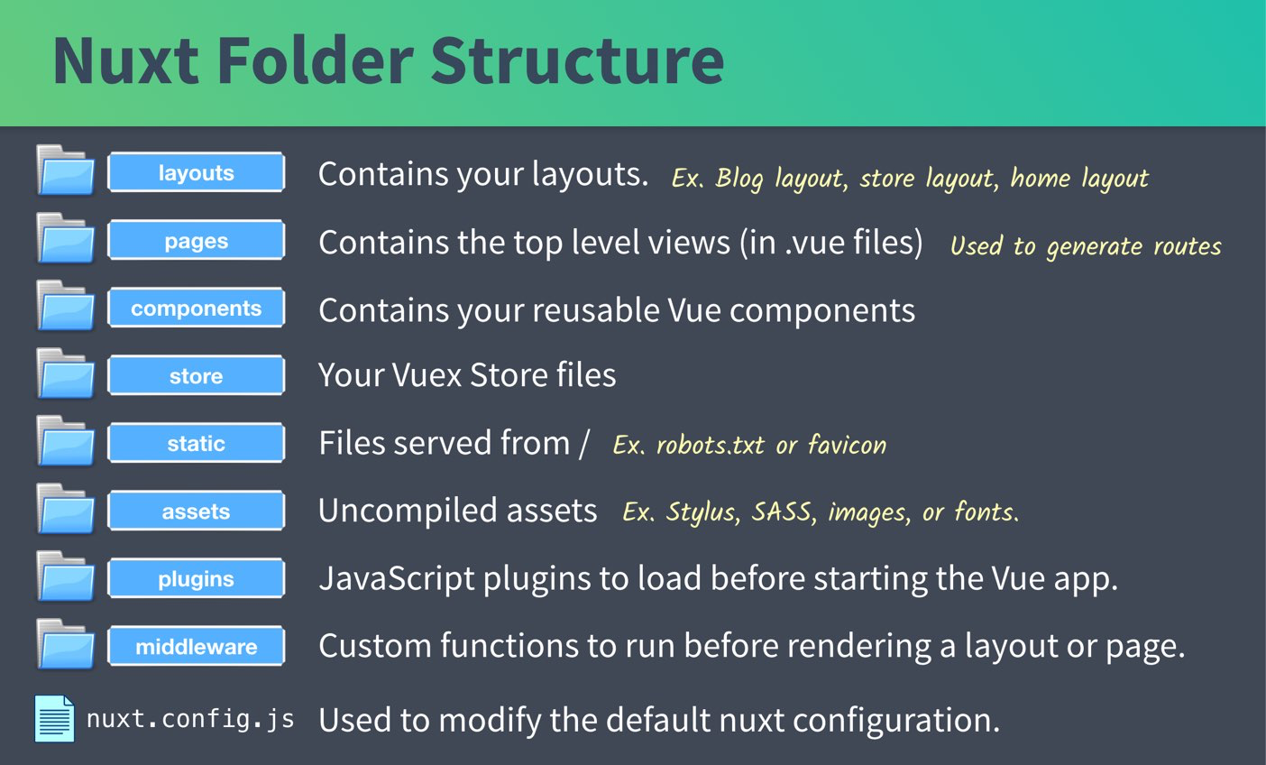

*Pic url:* [*https://coursehunters.online/t/vuemastery-scaling-vue-with-nuxt-js/797*](https://coursehunters.online/t/vuemastery-scaling-vue-with-nuxt-js/797)

Test Plan and Data

| N | Action | Description | Expected result | Actual result | Fix |
| --- | --- | --- | --- | --- | --- |
| 1 | Click on Logo | Every page contain logo in navbar, so user can click to this logo | User should be redirected to the home page. | User redirected to home page. | - |
| 2 | Sign up button pressed | To process with cart you should have account | User account will be created and stored in local DB | User account has been created successfully. | - |
| 3 | Click on Get Started button | On the main page we have a “Get Started” button which should redirect users. | User should be redirected to the store page | User wasn’t redirected to store page | User was redirected to store page |
| 4 | Query entered to the search product field | Users may want to look up their own key-codes or phones with specific words in model name. | Only products related to the query will be displayed | Only products related to the query has been displayed | - |
| 5 | Add to cart button click | While users looking for phone - they may choose one and decided to buy this phone, but before they should add it to the cart | Product will be added to the cart | Product added to the cart | - |

Description of styles applied

Using **Vue** with **Nuxt** good option - is using **CSS frameworks** like **TailwindCSS**, because:

1. It’s much faster and easier to style your website
2. You have option to use **SCSS** to make a dynamic calculation
3. Reducing file size and amount of files at all
4. All styles with same theme will be applied for every page

General snap of page: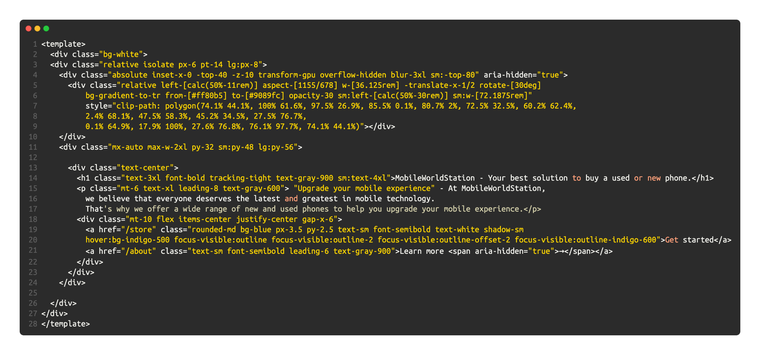

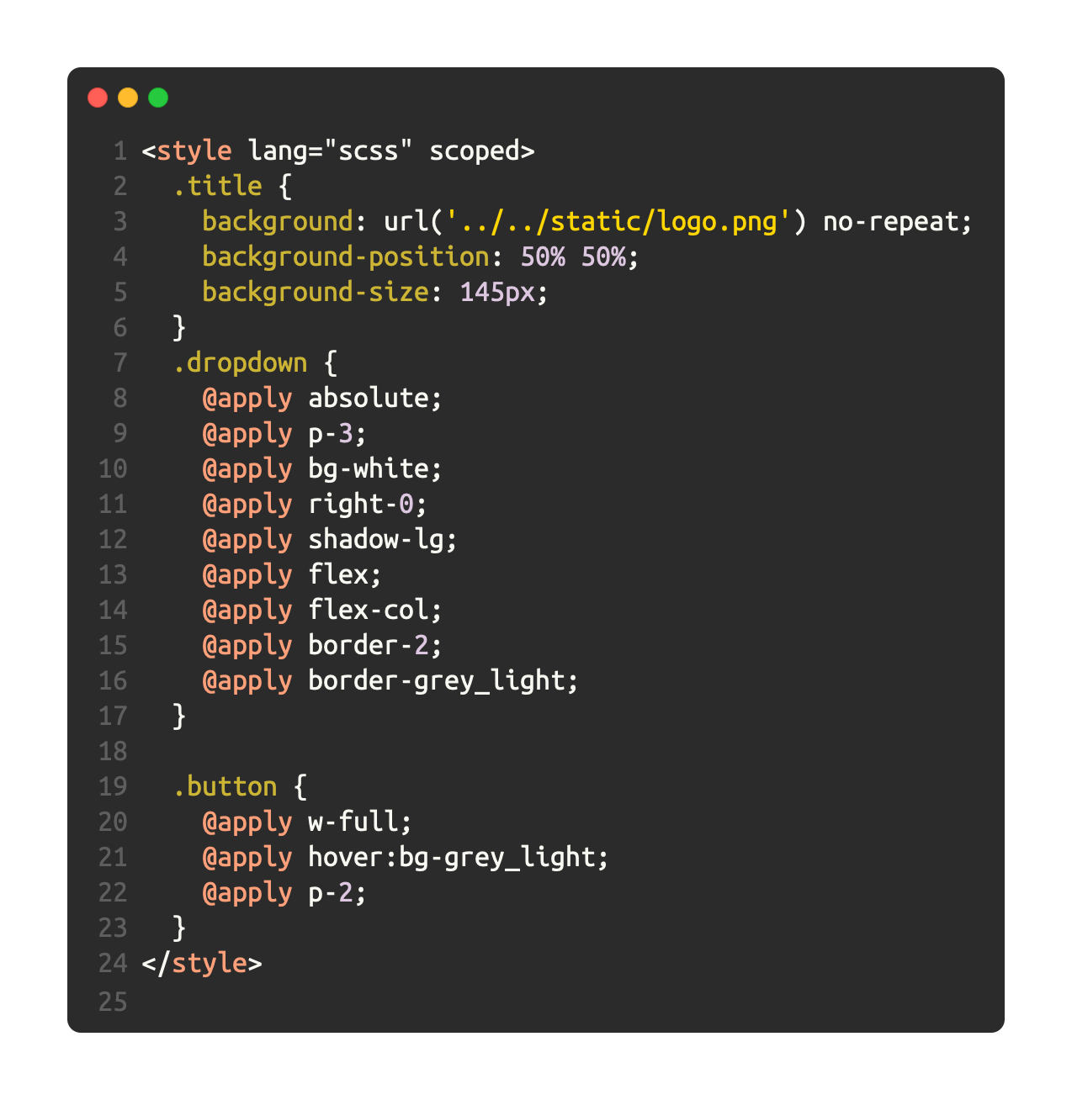

**SCSS Snap:**

The provided code includes both CSS and HTML code snippets, which are used to style and structure a webpage using Vue with Nuxt and Tailwind CSS.

The CSS code snippet uses SCSS (Sass) syntax and defines the styling for the body element of the webpage. The **@apply** directive is used to apply multiple CSS properties to the element, which includes setting it to display as a flex container with a column direction, and taking up the full height of the viewport while having no margin.

The HTML code snippet defines a div element with the classes **"absolute", "inset-x-0", "-top-40", "-z-10",** and "**transform-gpu**". These classes are provided by Tailwind CSS and are used to position and transform the div element in relation to its parent element. The div element is also given an aria-hidden attribute to indicate that it is not visible to screen readers.

Inside this div element, another div element is defined with a variety of Tailwind classes used to position, transform, and style it. The element has a relative position and is offset from the centre of the parent element using the **"left-[calc(50%-11rem)]"** and **"sm:left-[calc(50%-30rem)]"** classes. It also has a gradient background that goes from pink **(#ff80b5)** to purple **(#9089fc)** and a 30% opacity.

The element is further styled using inline CSS, which includes a clip-path property that uses a complex polygon shape to define the shape of the element. This shape is created by specifying a series of x-y coordinates that define the vertices of the polygon.

Alternative solutions:

Logo variants:

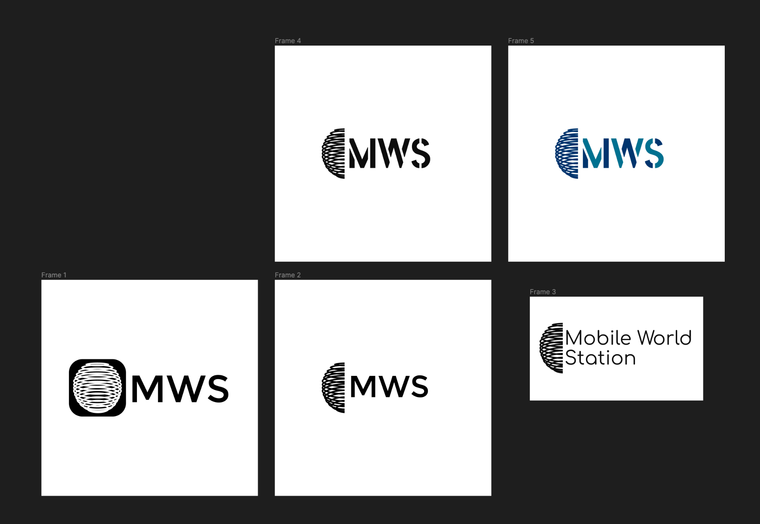

We decided to choose this variant:

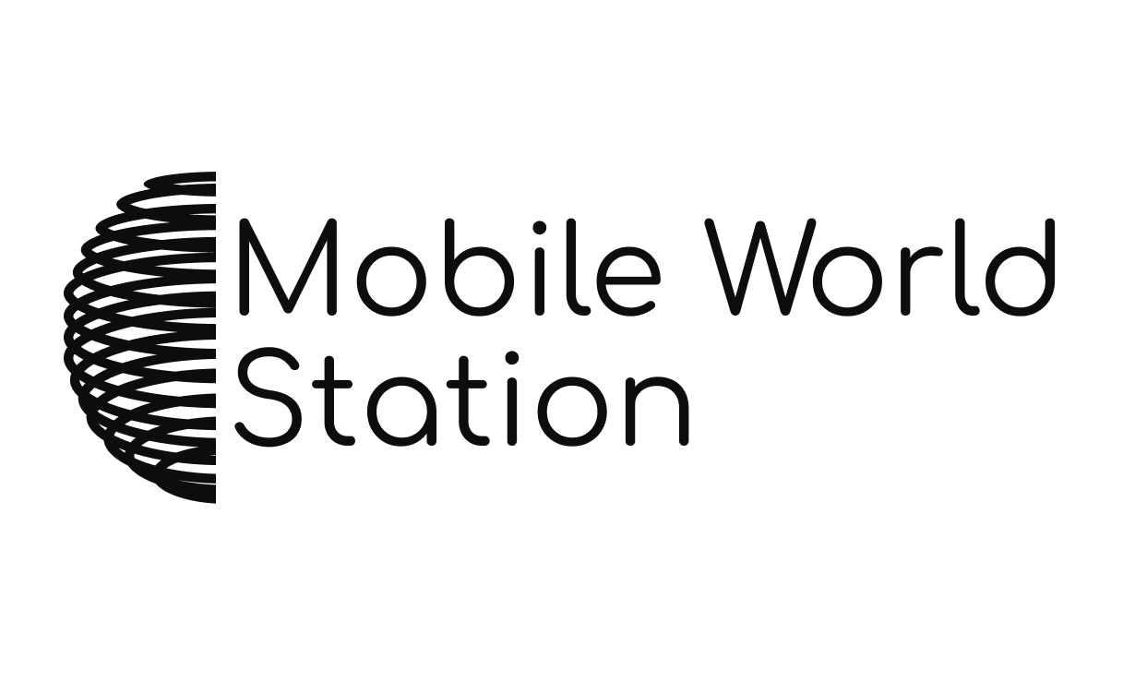

Because it still looks confident, professional and memorable for customers.

This variant also provides capital letters in each word to make abbreviation MWS which also can be used to identify service or company.

Alt design for general layout:

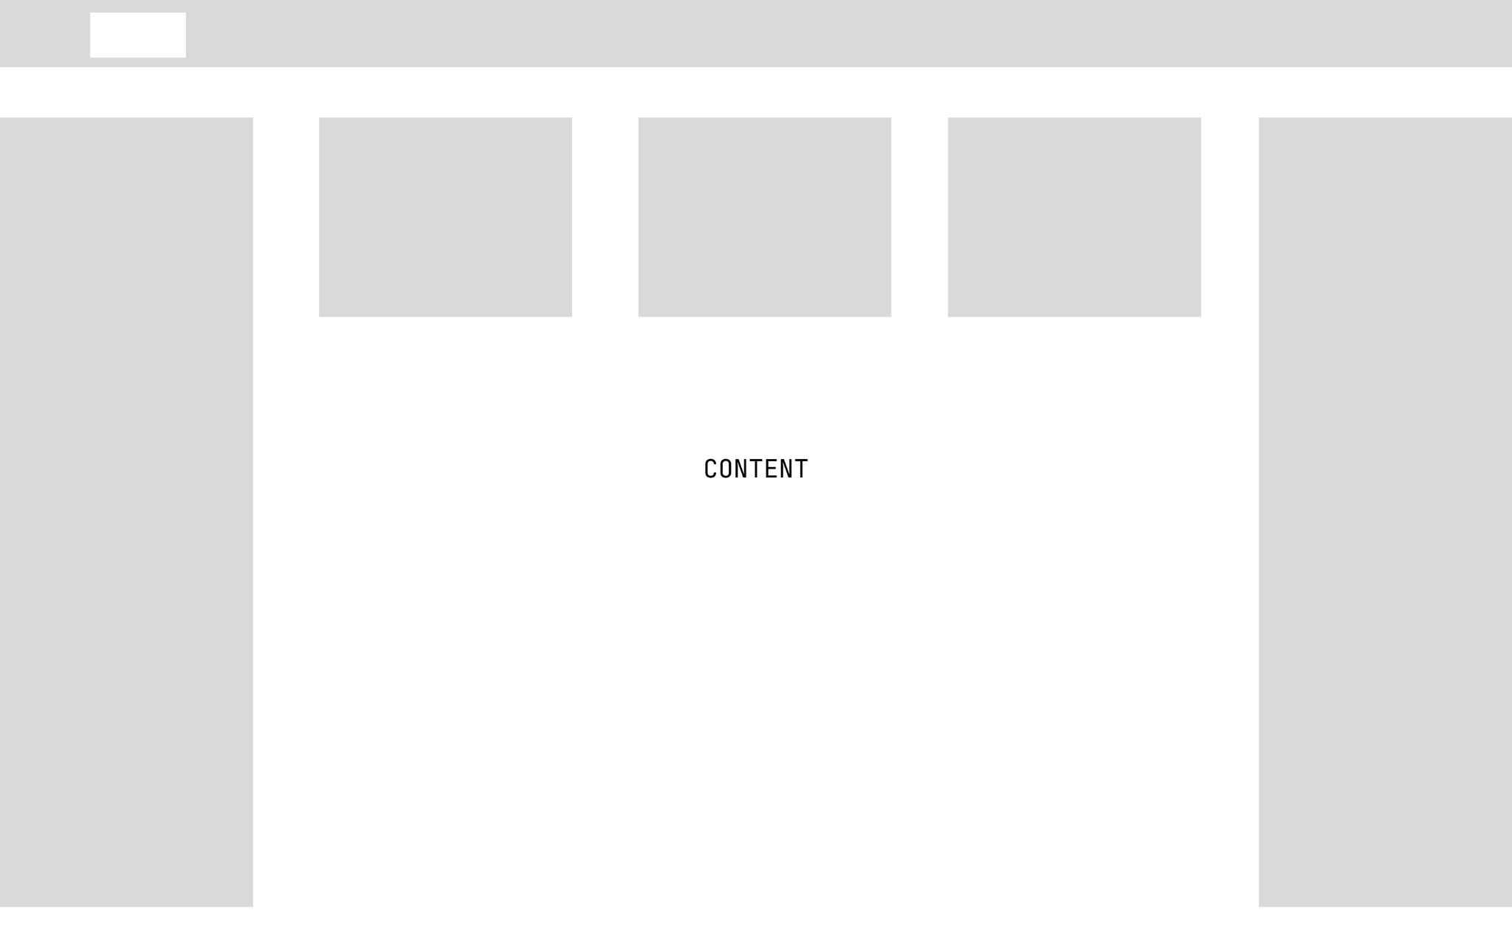

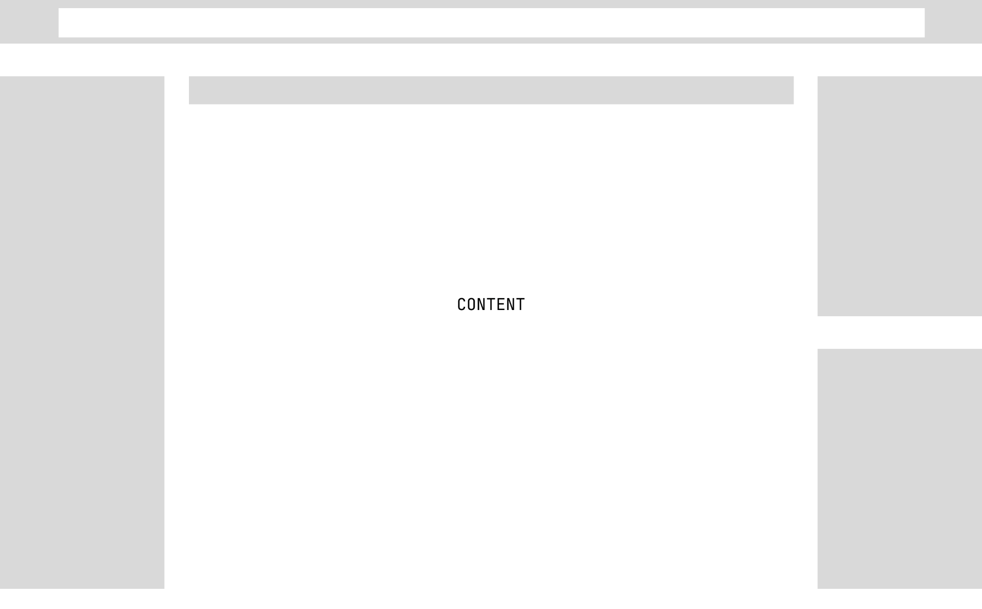

This design was rejected because there are too many items which can be interacted with by users. On the home page should be only the main information about the website, no more stuff, because users will need more time to process when the page is overloaded.

Also there is a lot of empty space which can’t be used as there's not a lot of information to fit on the start screen. And we’ve got a hard way to navigate through a website, users will need a bigger amount of time to process the page that they may need.

Plus we don’t have a logo or any other items which can identify our website as a Company.

Design justification.

After our “bad” layout

We decided to change layout to much easier and faster to process, by:

1. Adding a logo to the navbar, which is interactive and will move users to the home page.
2. Menu in a navbar are now smaller to fit more information, and now contain only necessary links.
3. Added cart button and Authorisation dropdown for fast functionality access as this is one of the main functions of the website at all.
4. Added Footer, which will have all other non-primary links and contact information/links
5. Removed all additional navbars to keep screen clear and easy2use and navigate.

Result after justification and currently our main layout:



So the summary of justification:

1. Simplified and Clear Layout: The decision to simplify the layout of the website was made to improve user experience and reduce cognitive load. The initial design was cluttered with too many items, which could overwhelm users and make it difficult for them to focus on the main content. By removing unnecessary elements and keeping the design clean and clear, we aim to provide a seamless and efficient browsing experience for users, allowing them to easily find the information they are looking for.
2. User-friendly Navigation: The inclusion of a logo in the navbar, along with a simplified menu, was done to enhance the website's branding and make it easy for users to navigate through different pages. The smaller and more concise menu items will allow users to quickly access the main sections of the website, such as products, services, and shopping cart, without getting lost in a complex navigation structure.
3. Focus on Key Functions: The addition of a cart button and authorization dropdown in the navbar is justified by the fact that the main purpose of the website is to promote and sell mobile phones and accessories. These key functions are made easily accessible to users from any page on the website, allowing them to quickly add items to their cart and proceed to checkout, or login/register for a personalised experience. This ensures that the website fulfils its intended purpose of promoting and facilitating the purchase of mobile phones and related products.
4. Footer for Additional Links: The inclusion of a footer section with additional links and contact information is justified by the need to provide users with a convenient way to access secondary information, such as customer support, FAQs, and other non-primary links. This helps in improving the overall user experience and makes it easier for users to find relevant information without cluttering the main content area.
5. Constraints and Software Availability: The design decisions also take into consideration constraints such as software availability. The chosen layout and design can be easily implemented using commonly available web development tools and technologies, ensuring that the website can be developed efficiently and without major technical limitations.

Overall, the updated design focuses on providing a simple, clear, and user-friendly experience for visitors to the MobileWorldStation website, ensuring that it meets the user requirements and fulfils its intended purpose of promoting and selling mobile phones and related products. The design decisions are based on the need to improve usability, simplify navigation, and enhance branding, while considering constraints such as software availability for smooth development.