Task 4

The MobileWorldStation website has been designed with the primary focus of promoting and selling mobile phones. The target audience for the website includes individuals of all ages who are interested in purchasing mobile phones, with the website catering to a wide range of potential customers who have varying levels of technical knowledge and diverse preferences in mobile phones.

To ensure the website meets its purpose and user requirements, the design has been structured around the user interface, consistency, multimedia content, interactive features, external hyperlinks, and internal linking.

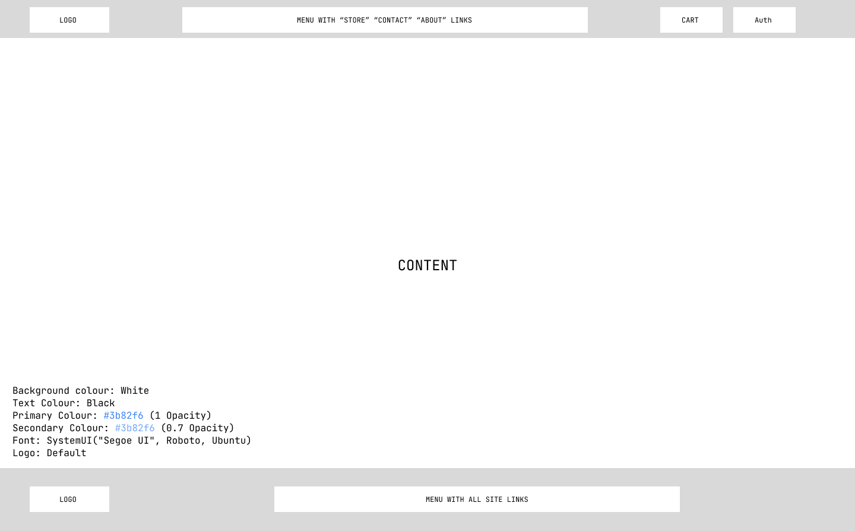

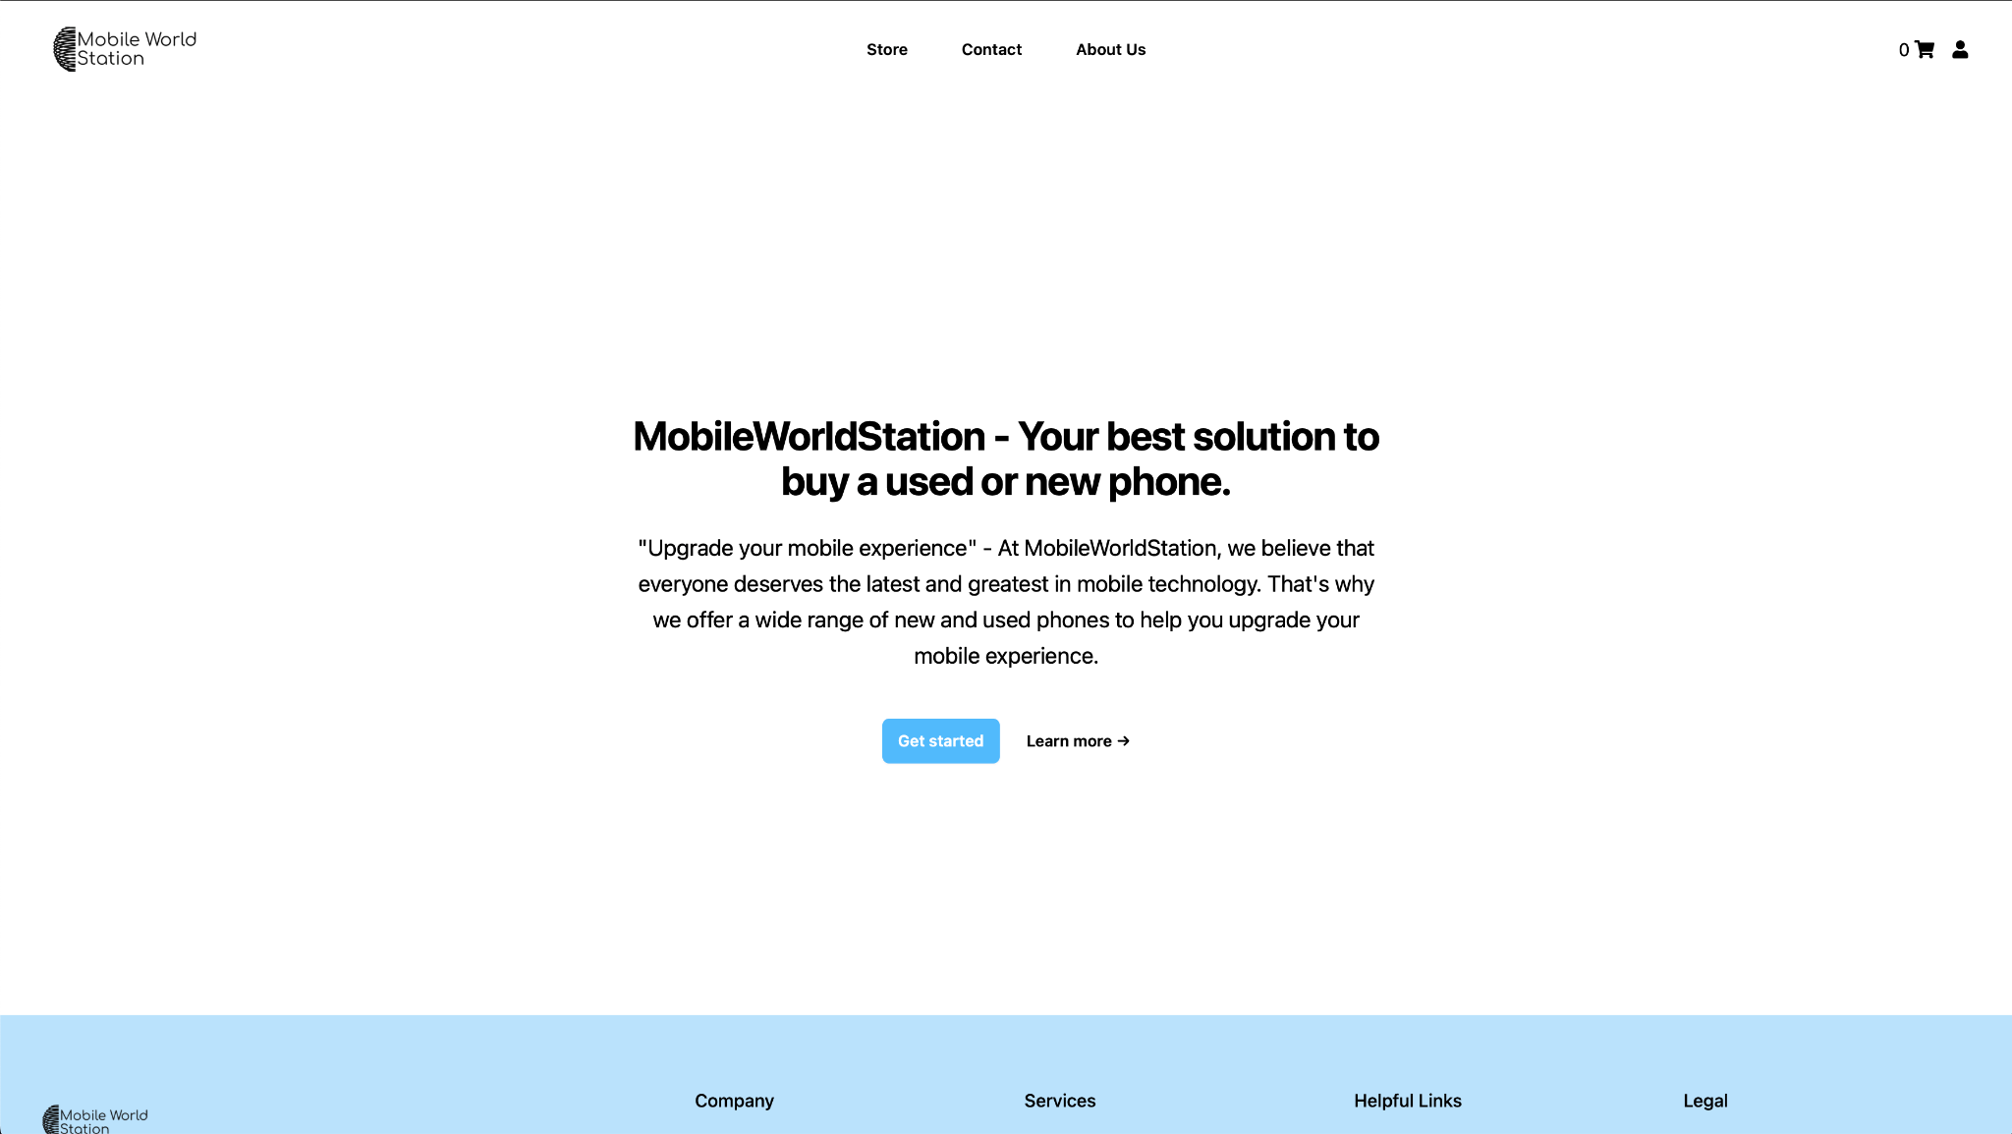

The website has been designed to be quick and easy to navigate with the use of menus, such as a menu in the navigation bar(at the top of the page) where you can easily navigate to all essential pages like store(with all our products), contact/feedback page and about company, then we have one more menu in a bottom of page(also known as footer) with all rest of the website routes which user might need, then we have authorisation dropdown where we fit functions like SignIn, SignUp, Logout, Wishlist and cart. All that was made to enhance the user experience in navigation on our website. There is a consistent use of text, colour schemes, and page styles in all web pages to maintain brand identity. Additionally, the website includes multimedia content such as pictures, which make it visually interesting and engaging. The website also has some interactive features, such as a feedback form, to collect customer enquiries and feedback.

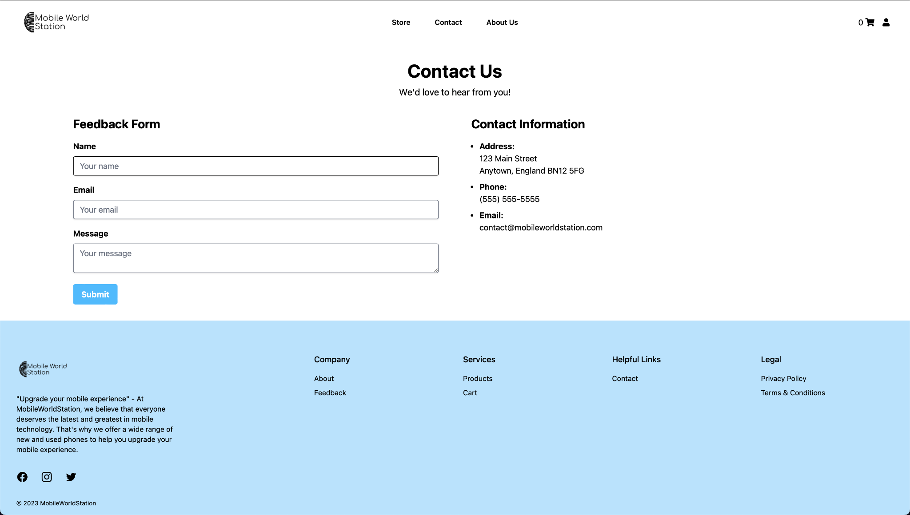

Bad layouts: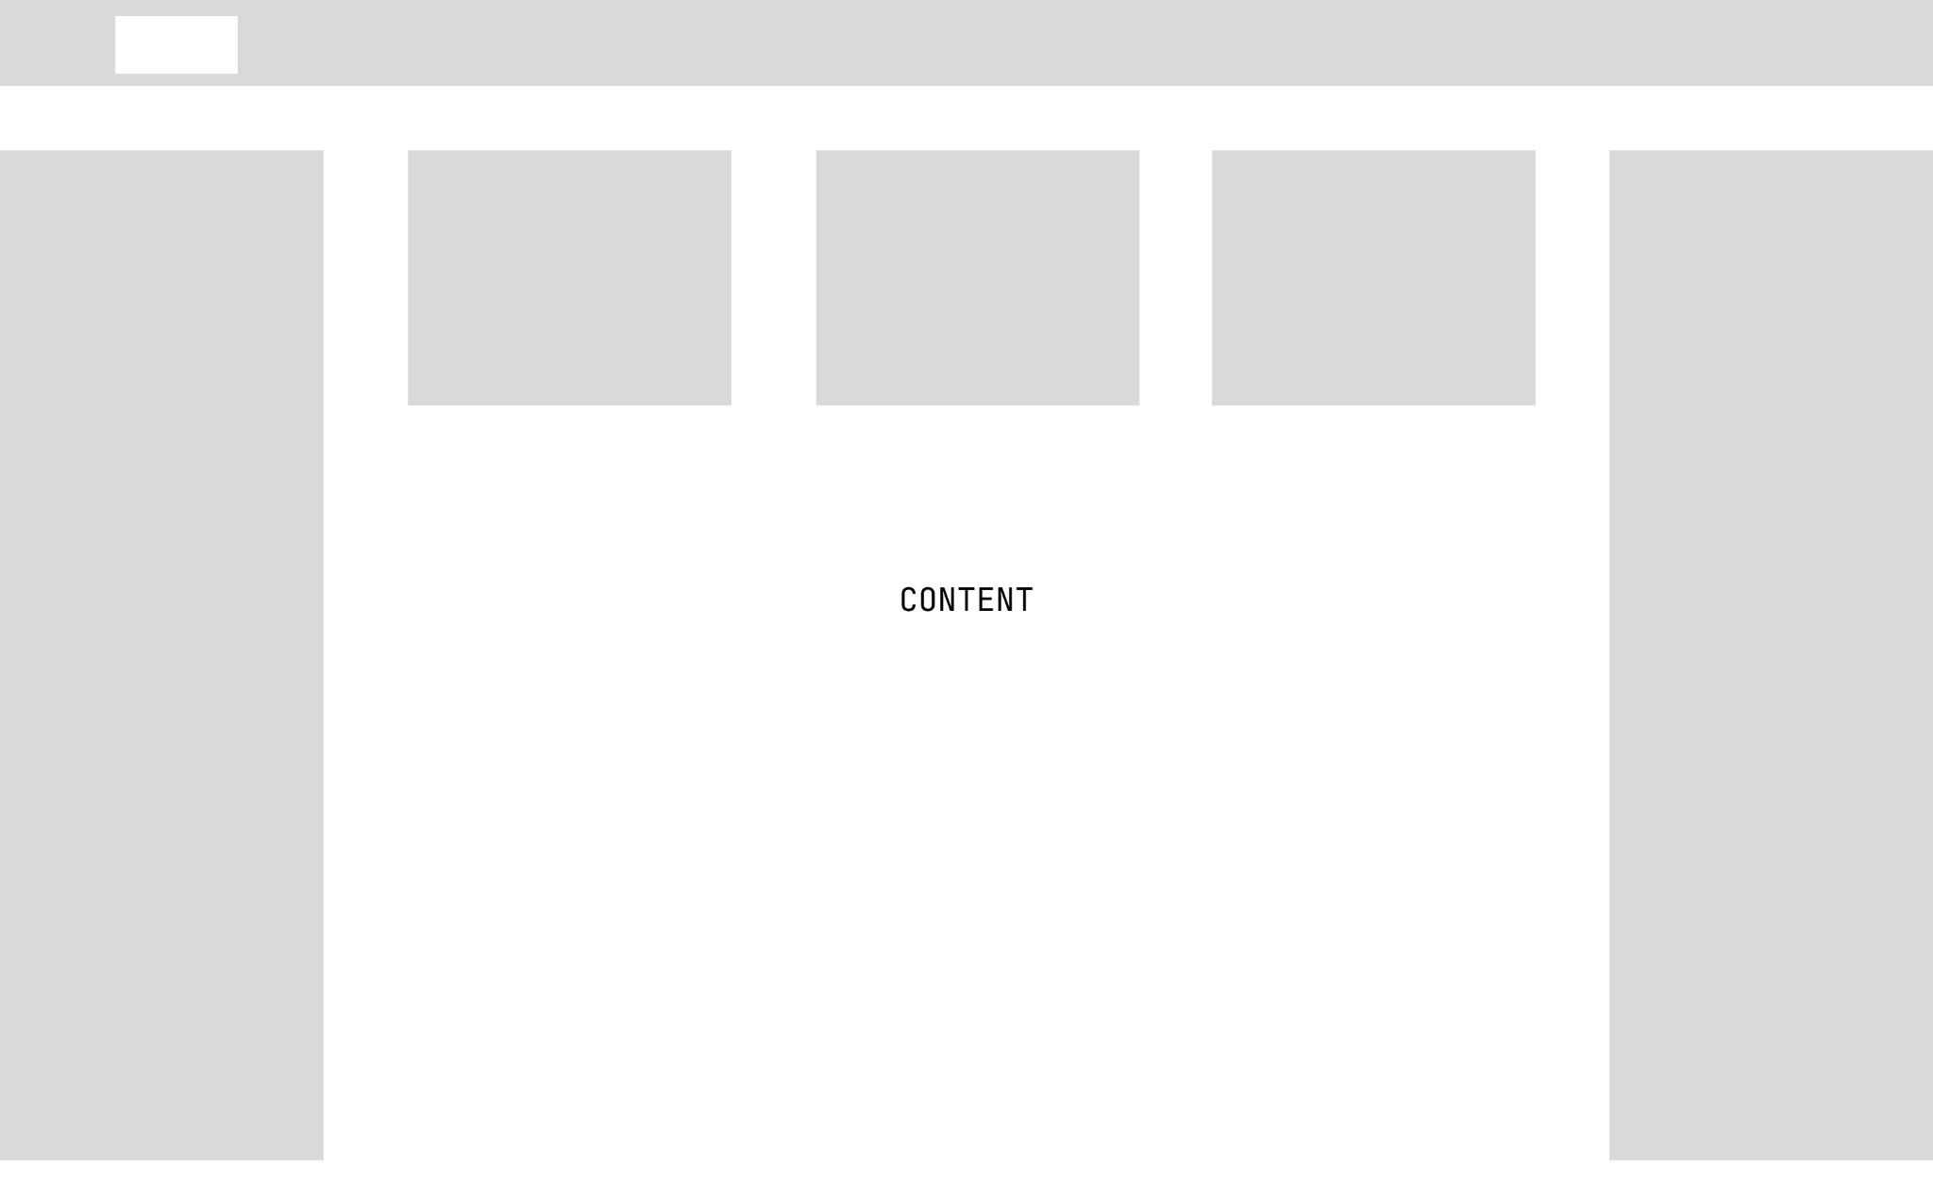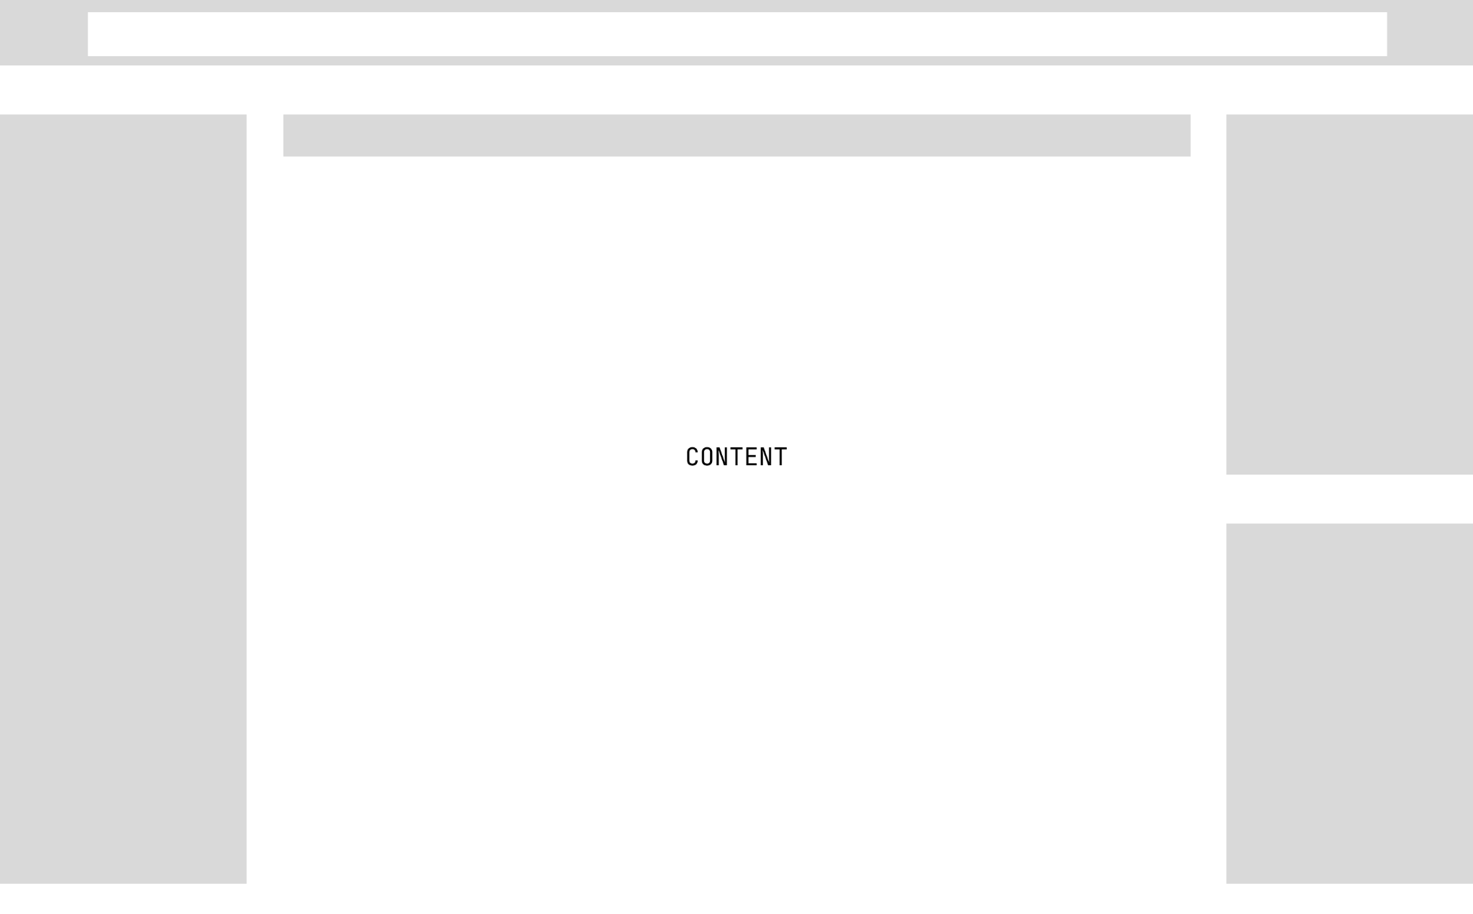

Regarding the evaluation of the initial design ideas/prototypes against the final website in terms of overall user experience and ‘client’ requirements in the original brief, some changes were made to the website. For instance, the main page was optimised by reducing the number of assets and changing the layout to address feedback from testers that it took too long to load. Additionally, the checkout process was re-designed to make it more straightforward and intuitive after feedback from testers that it was confusing and unclear.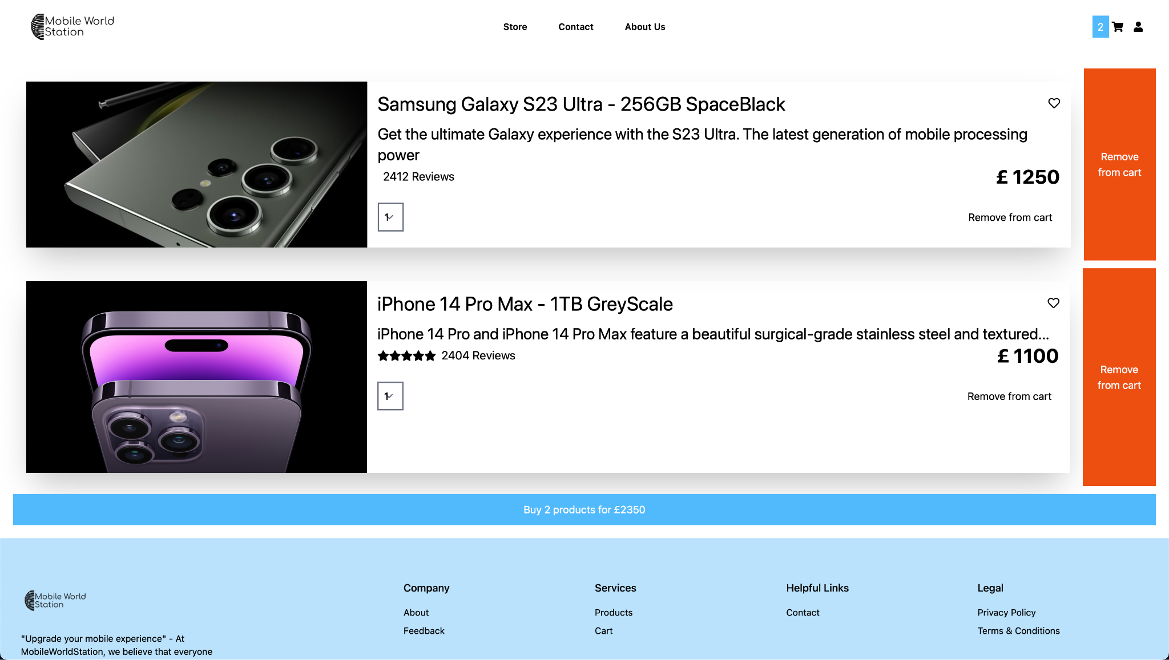

Feedback was also gathered from at least one other person, and it was used to consider how suitable the product is and any constraints. For example, testers reported that some links on the website(especially on the home page) took too long to load and some didn't work, causing frustration and a poor user experience.. This feedback was accepted, and the issue was fixed by correcting some route names for links.

You can see more details below:

Before:

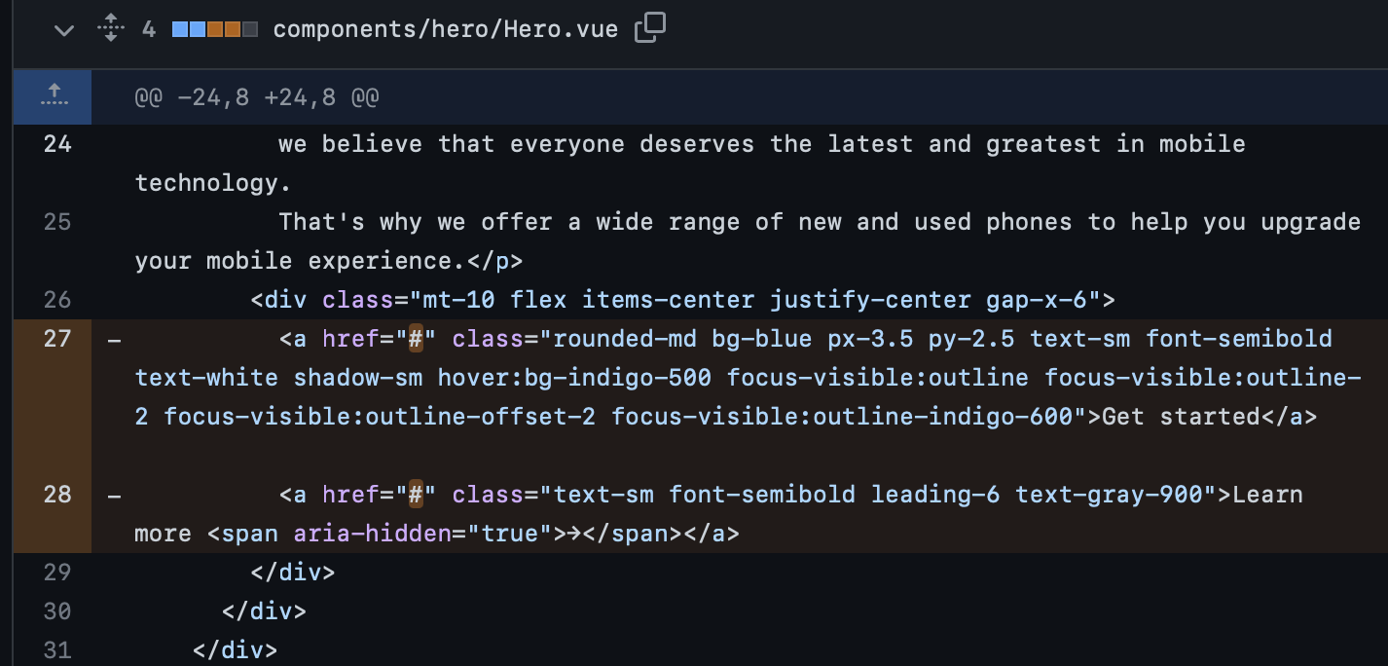

As you can see here - links didn’t worked as their href(route link) was a hashtag(#), that's the reason why our front-end wasn’t able to load the page.

After:

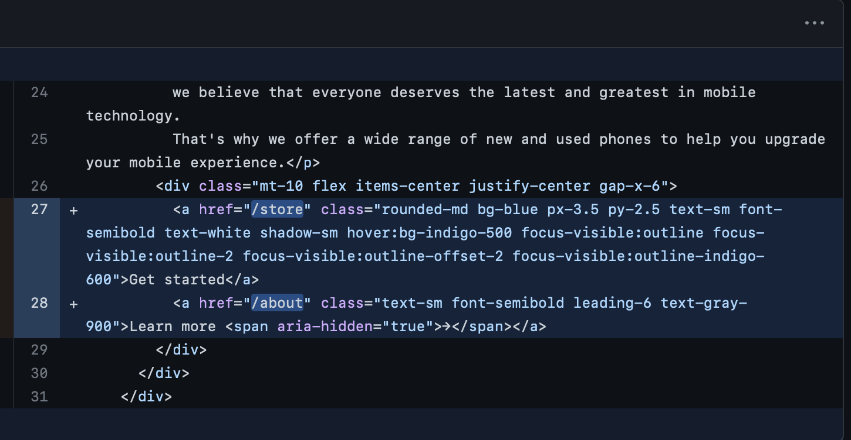

The fix itself was pretty simple - we changed an hashtag to actual page route which stored in folder with other pages, and so like this we have successful access to route store and about from our NavBar menu.

Commit with fix - <https://github.com/denver-code/mobileworldstation_website/commit/408d2d61dcba684c531c15faa886206c889f2083>

To meet the user requirements and purpose of promoting and selling mobile phones offered by MobileWorldStation, I propose a website design with the following features:

1. User Interface: The website will have a clean and modern interface with quick and easy navigation using a menu that will be available on every page of the website. The menu will be designed to guide users through the different categories of mobile phones and help them easily find what they are looking for.
2. Consistency: To maintain the brand identity of MobileWorldStation, the website will have a consistent use of text, colour schemes, and page styles across all pages. The brand colours will be used in the website design to create a cohesive look and feel.
3. Multimedia Content: To make the website visually engaging, I will use high-quality images and videos of the mobile phones on offer. Additionally, I will include at least four different multimedia/digital assets, such as digital animations, graphics, audio, or video, to make the website even more visually appealing.
4. Interactive Features: To make the website interactive, I will include a feedback form that will allow customers to ask questions and provide feedback. Additionally, I will include a search bar that will make it easy for users to find what they are looking for.
5. External Hyperlinks: The website will have at least two external hyperlinks to other interesting web pages related to mobile phones. These links will be selected to provide valuable information to users while keeping them on the website for as long as possible.
6. Internal Linking: Each web page will be internally linked, making it easy to navigate menus to access relevant information. The website will have a clear hierarchy and structure, with each page designed to provide users with all the information they need.

By implementing these features, the website will meet the user requirements and purpose of promoting and selling mobile phones offered by MobileWorldStation. The user interface will be quick and easy to navigate, and the website will be visually engaging with multimedia content and interactive features. The consistency of the website will maintain brand identity, and external and internal links will provide users with valuable information.

In addition to developing our website, we conducted comprehensive testing procedures to verify its optimal performance and functionality. These tests were crucial in ensuring that our website operates precisely as intended, providing a seamless user experience and meeting all required specifications.

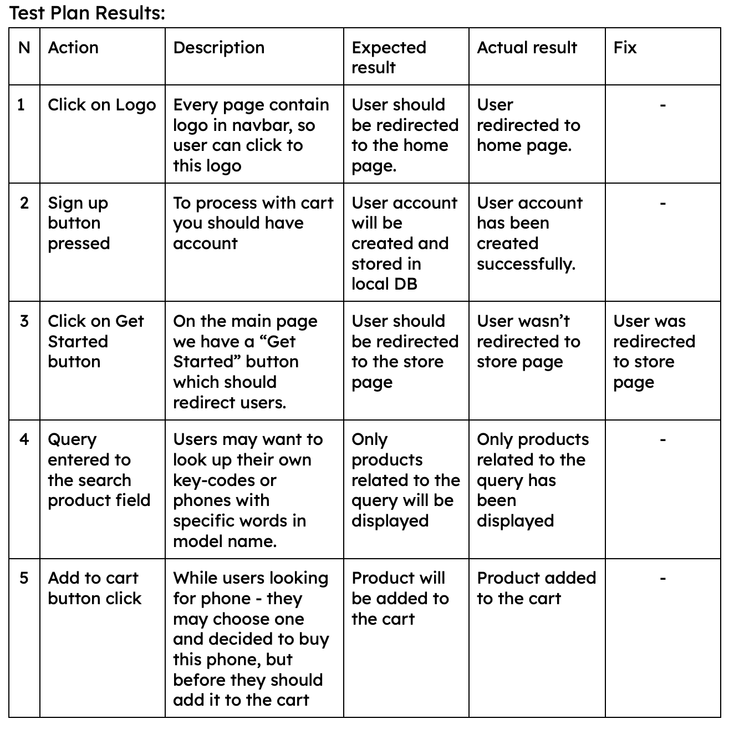

Based on the feedback received, it seems that the product has both strengths and weaknesses. The testing process showed us the strength of websites like fast loading time on most pages, as it has helped to identify critical issues such as broken links on the website and potential solutions with suggestions how we can fix and improve it. However, the test plan needs to be more detailed to ensure that all aspects of the website are tested thoroughly. The user requirements are comprehensive, but there is a need for prioritisation to ensure that the most critical requirements are met within the given timeline and budget. Conducting user research would also be helpful to better understand the target audience's preferences.

In terms of constraints, the budget and development resources are clearly a limitation for the product. This constraint affected the ability to implement all of the desired features, such as the chatbot feature requested by the users. Additionally, there may be time constraints, as some feedback suggests that some aspects of the website need improvement before deployment.

Three improvements, which we are going to implement in the feature:

1. Personalisation: Personalising the website experience based on user preferences and behaviours could enhance the user experience. For example, by recommending products based on a user's previous purchase history or search history.
2. Chatbot feature: While it was not possible to implement a chatbot due to budget constraints and limited development resources, it could be considered in the future as it could provide efficient customer support.
3. Mobile app or PWA: Developing a mobile app or PWA for MobileWorldStation could enhance the user experience for customers who prefer to use mobile devices for online shopping. A mobile app could also provide additional features such as push notifications for new products or discounts.

To summarise everything we can go through original brief as a Junior Website Developer in a small company and we been asked to create a website for company which sell mobile phones, with requirements:

* The main focus of the website is to promote and sell mobile phones, accessories and services.

We achieved this by having the store page where users can browse all products that company have in stocks, cart page and additional details for brand identification with related to mobile phones industry

* The website should target anyone who is interested in buying mobile phones.

We achieved this by creating a simple colour scheme on every page, to make the website easy and fast to use, as you don’t need to load animations, and a lot of graphic content which might increase load on users' devices.

So everyone with every device can access our website and use every functionality like everyone else.

* The website should load easily and be quick and easy to navigate (consider using menus).

We have few menus options:

* NavBar menu with all essential links such a store, about us, feedback.
* Footer menu with all rest of routes
* Dropdown menu with user authentication functions
* The website should contain at least eight linked pages.

Website contain 8 pages:

1. Home Page
2. About
3. Contact us/feedback
4. Store Page
5. Product Details
6. Cart
7. Terms and conditions
8. Privacy Policy

The website should contain at least one table.

* There should be a consistent use of text, colour schemes and page styles in all of the web pages.

Our main theme and layout been described for every page as a same:

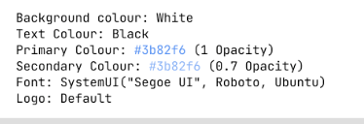

* The website should be interesting and have at least four suitable, different original and/or ready-made, embedded multimedia/digital assets, e.g. digital animation, digital graphics, digital audio, digital video.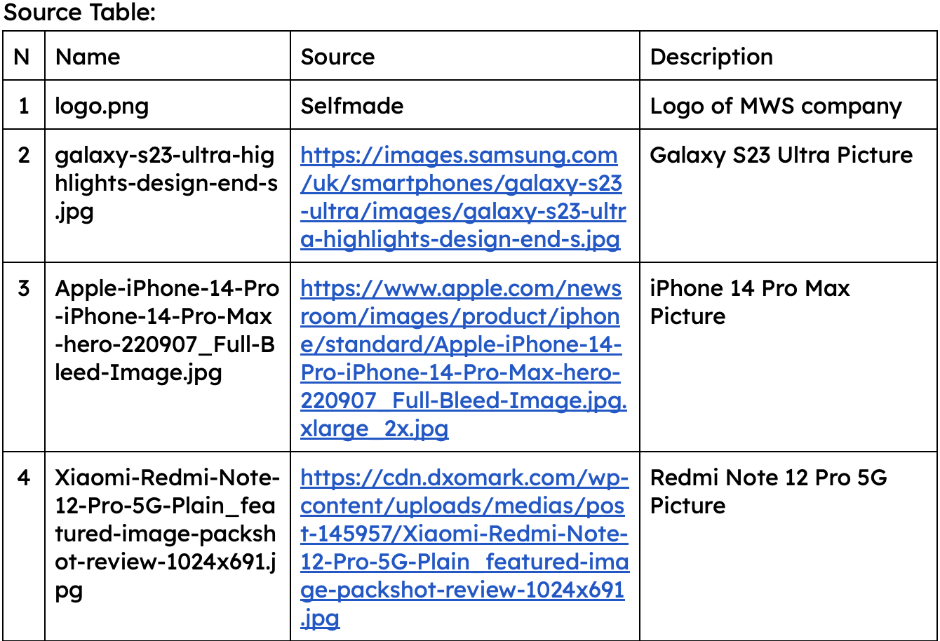
* The website should contain some interactive features, e.g. a feedback form to collect customer enquiries.
* The website should have at least two external hyperlinks to other interesting web pages.
* Each web page should be internally linked, with easy-to-navigate menus.
* The website should contain a link to an online forum.

There are some of website interactive features, menus, hyperlinks: