Example Report

2022

# 1X Analog Gain, 10bit

Example Table 0: My Summary Metrics

|  |  |  |
| --- | --- | --- |
| Metric | Default | Improved |
| System Gain [DN/e] | 0.440496 | 0.440717 |
| Conversion Factor [e/DN] | 2.27017 | 2.269028 |
| Dark Noise [e] | 6.19455 | 6.14032 |
| Dark Noise [DN] | 2.728672 | 2.706145 |
| total_dsnu [e] | 8.118619 | 2.955084 |
| row_dsnu [e] | 0.612022 | 0.548535 |
| col_dsnu [e] | 0.733596 | 0.42093 |
| pix_dsnu [e] | 8.068992 | 2.875472 |
| Linearity Error Max [%] | 0.848748 | 0.398638 |
| Linearity Error Max [DN] | 6.38441 | 3.363942 |
| Linearity Error Min [%] | -0.495795 | -0.51929 |
| Linearity Error Min [DN] | -13.418104 | -19.264517 |
| Total PRNU1288 [%] | 0.796604 | 0.654421 |
| Row PRNU1288 [%] | 0.013885 | 0.012264 |
| Col PRNU1288 [%] | 0.142747 | 0.134295 |
| Pix PRNU1288 [%] | 0.784246 | 0.640915 |
| Saturation Capacity [e] | 8557.097563 | 8517.184572 |
| Saturation Capacity [DN] | 3769.364039 | 3753.670507 |
| Sensitivity Threshold [e] | 6.714696 | 6.660644 |
| Sensitivity Threshold [DN] | 2.957794 | 2.935461 |
| Dynamic Range [ratio] | 1274.383401 | 1278.732913 |
| Dynamic Range [dB] | 62.106002 | 62.135597 |
| Total Temp Noise [e] | 6.228652 | 6.177802 |
| Col Temp Noise [e] | 1.292472 | 0.744471 |
| Row Temp Noise [e] | 2.996594 | 2.798474 |
| Pixel Temp Noise [e] | 5.315256 | 5.467321 |

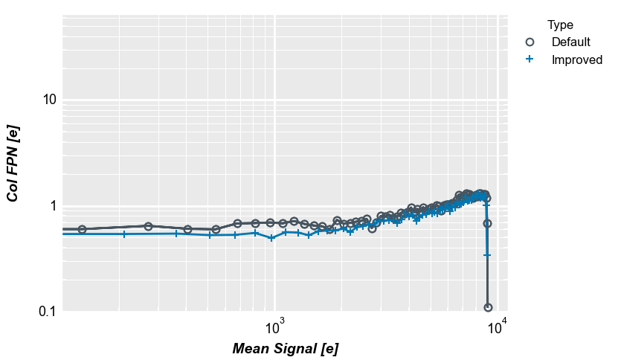

Example Plot 0: My Summary Metrics