**ELLIPSIS TECH SERIES 2025**

**Proposal Submission Template**

**General Brief**

1. Fill in the Team Details table with your team’s information and use this document as a template to write your team’s proposal.
2. By submitting this proposal, all participants have acknowledged the terms stated in the Terms and Conditions document and the Code of Conduct document.
3. Rename the proposal submission document as “***ProposalSubmission_<TeamName>***”.
4. Submissions that do not follow the format of this document will be disqualified.
5. The text of this document should be font “**Arial**”, font size **11**, and line spacing of **1.5**.
6. Ensure you have filled up your team name and team member’s details.
7. Keep this proposal to a maximum of 10 pages only excluding the cover page, content outline, appendix, and references.
8. Submit your team’s proposal [**here**](https://forms.gle/LkhMnByWNZNC8mR58) by **Saturday, 30th August 2025, 6pm**.
   1. Only one submission is necessary per team.

**Team Details**

| **Team Name** | Nemo | | |
| --- | --- | --- | --- |
| **Team Members Details** | **Full Name** | **Email Address** | **Student ID** |
| **Member 1 ~~(Team Leader)~~** | Chan Yun Wen | yunwen.chan.2023@scis.smi.edu.sg | 01486562 |
| **Member 2** | Denxi | denxif.sa.2023@scis.smu.edu.sg | 01489542 |
| **Member 3** | Bjorn Tin Kar G | bjorn.tin.2023.@scis.smu.edu.sg | 01349954 |
| **Member 4** | Namyra Farouk | namyra.f.2023@scis.smu.edu.sg | 01492257 |

**Content Outline**

|  | **Page Number(s)** |
| --- | --- |
| **1. Solution Overview** | 3 |
| **2. Solution Features and Implementation Strategy** | 3 |
| **3. Solution Impact** | 4 |
| **4. Solution Architecture** | 6 |
| **5. Future Development & Scalability** | 6 |
| **6. Appendix** | 8 |
| **7. References** | 10 |

# 1. Solution Overview

There are 1,576,500 foreign workers as of Dec 2024, making up 26.1% of total population in SG and 40% of the total workforce (Ministry of Manpower Singapore, 2025)

Migrant workers face a key challenge of navigating multiple, disjointed communication channels to learn about community events. Different organisations, such as the Ministry of Manpower (MOM) and various non-governmental organisations (NGOs), individually promote events through their own specific channels, like SMS or roadshows. As a result of this fragmented approach, migrant workers may miss out on community events that they might be interested in. With limited access to community initiatives, this perpetuates social isolation and loneliness within the migrant worker community.

While there are existing government apps that provide migrant workers with access to essential services, our solution is designed to complement these existing platforms by centralising events and facilitating team formation to create a space where migrant workers have greater access to community activities and strengthen social bonds to improve their overall well-being.

# 2. Solution Features and Implementation Strategy

The solution aims to provide a simple, accessible interface to browse and book recreational facilities and community-driven workshops. Some core features include:

| **Core Feature** | **Description** | **Problem Solved / Value Added** |
| --- | --- | --- |
| **Facility & Workshop Browsing** | * View a collated list of community activities and events * Filter based on user’s preferences   [Scrollable list view with activity “cards” (title, photo, summary) in multiple languages.] | Simplifies discovery of community events from various organisations. |
| **Activity Sign-up & Team Formation** | * Sign up for available activities either individually or as a team * Invite friends to sign up together for an event   [Detailed activity page showing description, photos, location, capacity, and participant list, with a clear “Join” button. Team formation allows users to sign up together.] | Tackles social isolation by encouraging group participation and fostering peer connections. |

For our backend, we will use Flask. Its lightweight and minimal nature makes it an excellent choice for a rapid development cycle. While Flask itself is minimal, it has a rich ecosystem of extensions that can be leveraged for tasks such as database integration and API development. For the frontend, we will be using Vue.js, which is known for its ease of use and flexibility.

**Frontend**: Vue.js  
**Backend**: Flask will be used for the backend. The frontend will communicate with the backend via a RESTful API. The Flask application will expose JSON endpoints for the Vue.js client to consume.   
**Architecture**: This project will follow a monolithic architecture, where both the Flask application and the static Vue.js frontend files are contained within a single project for streamlined deployment. This approach is highly feasible and convenient for the short timeline of this hackathon, providing a solid foundation for future scalability.

# 3. Solution Impact

Migrant workers need social support to combat loneliness and isolation through community programs, counselling, and recreational activities. Our solution will improve their access to social events, promoting social cohesion among migrant workers. This is essential for improving their mental health and work-life balance. By creating opportunities for new friendships and inculcating a strong sense of community, our app will contribute to a happier, healthier, and more productive workforce in the long run.

#### Unique Selling Point:

**Community-Centric:** While apps like FWMOMCare provide essential, one-way services, our platform is built around **social interaction and community building**. It’s not just about what you can do, but who you can do it with.

**Empowerment Through Organisation:** The app empowers users to be proactive, instead of just consuming services.

**Integrated Wellness Platform:** It uniquely combines physical health (facility booking), mental health (social connection), and personal growth (workshops) into a single, easy-to-use experience tailored for them.

#### Key performance indicators (KPIs):

User Adoption & Reach:

* Number of App Downloads: Total downloads from the app stores.
* Number of Registered Users: Users who have successfully authenticated via FWMOMCare.

Engagement & Activity:

* Daily Active Users (DAU) / Monthly Active Users (MAU): Measures how many users are returning to the app.
* Bookings per User: Average number of facilities booked by an active user per month.
* Workshop Sign-ups: Total number of enrollments in workshops.
* Session Duration: Average time a user spends in the app per session.

Community & Social Impact:

* Team Formation Rate: Percentage of bookings that have more than one person (i.e., are a team).

User Satisfaction:

* App Store Ratings & Reviews: Qualitative and quantitative feedback.
* User Retention Rate: Percentage of users who return to the app a week or a month after their first use.

# 4. Solution Architecture

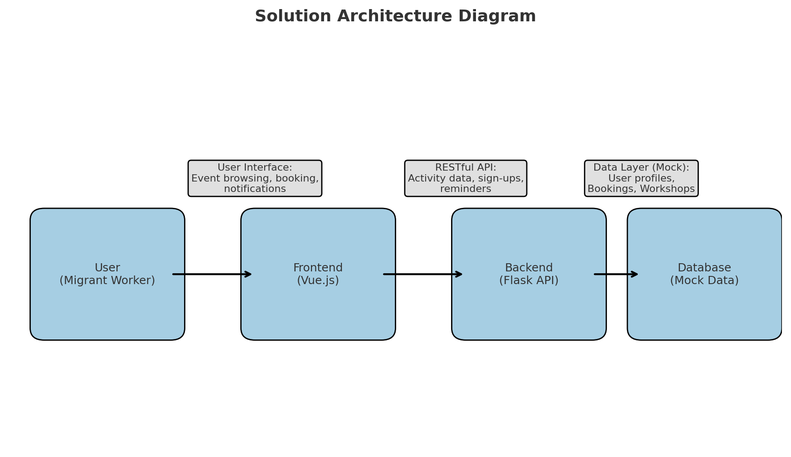

# 5. Future Development & Scalability

#### Future Partnership Consideration

**User Authentication**

Integration with the existing **FWMOMCare login system** to authenticate users securely. The user will be redirected to the FWMOMCare login portal. Upon successful login, the FWMOMCare system will redirect the user back to our application with a secure token. Our backend will use this token to verify the user's identity and create a session.

**External Partnerships**

Manual process for a representative from MWC or NTUC to add new facilities and workshops to our database. There will be no live API integration with their systems yet. We will focus on building a robust data model for facilities and workshops that is flexible enough to accommodate data from multiple partners in the future. This also ensures real-time updates on event availability and reduces manual overhead.

**Targeting New Communities**

While the immediate focus of the app is on migrant workers, the platform's architecture can be easily repurposed to serve other communities in Singapore facing similar challenges of social cohesion or resource discovery, such as:

**- Senior citizens** (social activities, health workshops)

- **Residents of new housing estates** (interest groups, neighbourhood events)

**- University students** (CCA recruitment, peer workshops)

Each new community requires different content and a partnership strategy, but the underlying technology remains the same.

#### Future Enhancements: Social, Engagement, and Maintenance

**Waitlist and Dynamic Queueing** - if a facility or event is fully booked, a user can join a digital waitlist. When a slot becomes available due to a cancellation or no-show, the system can automatically notify the next person in the queue.

**Gamification** - Points/Badges for organising games, booking facilities, or playing/signing up for workshops regularly. Leaderboards for active players/learners or teams for friendly competitions. Highly active members who are consistent in organising group activity (e.g. organised more than 5 events consistently over 3 months) get a “Community Leader” title, providing recognition and encouraging users to take initiative.

**Social Networking** - Ability to add friends, request to view what workshops/games they sign up for and receive suggestions to join certain activities together, fostering stronger community bonds.

**Logistics and Maintenance** - users can submit feedback or upload photos of facilities post-use, ensuring spaces remain well-managed and user experiences continuously improve.

**Multilingual ability** - overcomes language barriers among migrant workers, facilitating activity sign-ups and supports inclusivity

**Offline Mode** - Store upcoming event info on the phone so workers without consistent data plans can still view bookings.

#### Future scalability

The codebase will be organised into distinct modules (e.g., a "workshops" module) to ensure clarity and maintainability. This modular structure provides a clean separation of concerns and will make it straightforward to scale or refactor the application in the future.

For long-term scalability, the database can use PostgreSQLto store data, to provide a better foundation that can be scaled as the application grows.

Transition to a cloud infrastructure by leveraging a cloud provider like AWS, Google Cloud, or Azure to host our application. By using containerization technologies like **Docker** and orchestration platforms like **Kubernetes**, we can achieve automatic scaling. This means the system can dynamically allocate more resources during peak periods and scale down during off-peak hours to manage costs efficiently.

# 6. Appendix

### We created a user persona following a 24-year-old construction worker, living in a dorm at Changi. Hence, we can analyse the possible pain points and motivations he has when it comes to planning an eventful weekend with his friends.

We created this Customer Journey Map to better understand our users' experiences and identify their key pain points. Based on these pain points, we have developed a set of additional features to enhance their journey, which we will consider for future development.

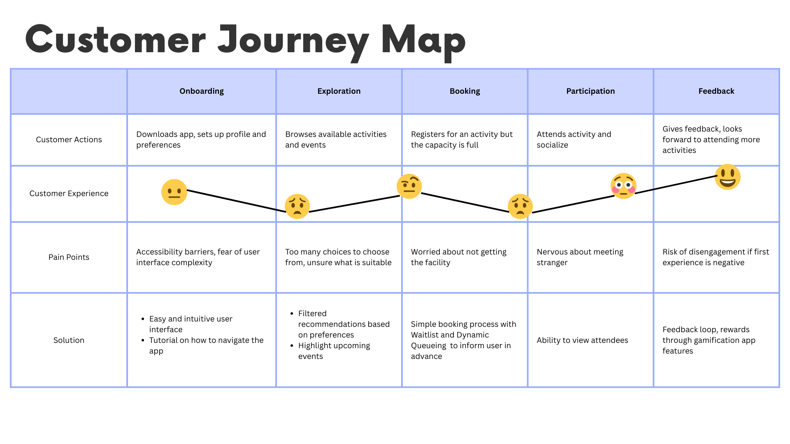

This is an AI-generated mockup of the app's layout, showing our vision for the demo.

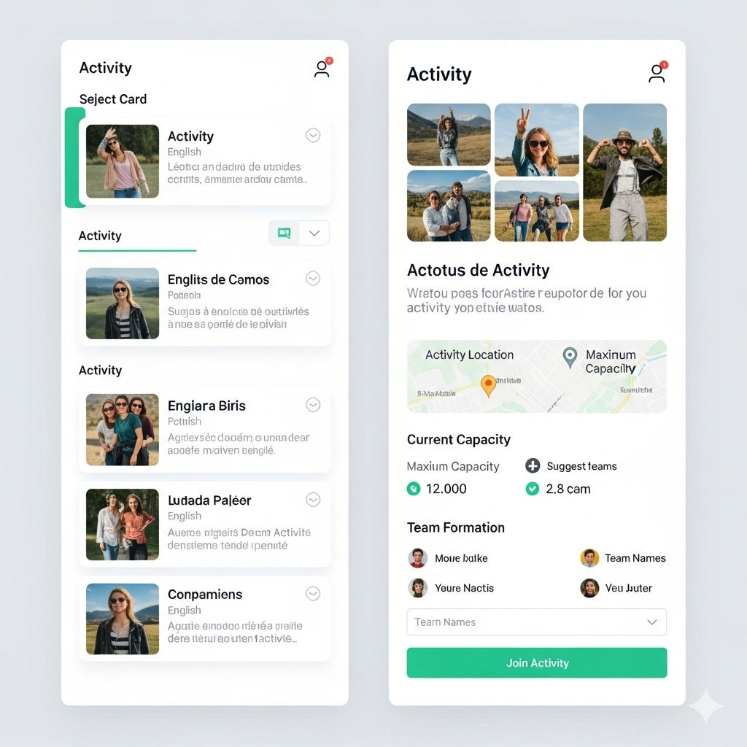

# 7. References

*Foreign workforce numbers. (2025, March 12). Ministry of Manpower Singapore.* [*https://www.mom.gov.sg/foreign-workforce-numbers*](https://www.mom.gov.sg/foreign-workforce-numbers)

*Ministry of Manpower. (2025, March 4). FWMOMCare.* [*https://www.mom.gov.sg/eservices/fwmomcare*](https://www.mom.gov.sg/eservices/fwmomcare)