MLPerf Training new benchmark proposal: Vision-Language Model (Qwen3-VL)

Motivation
Vision-language models (VLMs) have become the default form of frontier LLMs: current flagship models are natively multimodal, and the open-weight ecosystem has followed (Qwen-VL, InternVL, Llama 3.2 Vision, Gemma 3, Pixtral, Molmo). Multimodal pretraining — training a vision encoder, a projector and a language model jointly on interleaved image-text documents — is now a substantial share of large-scale training compute, yet the MLPerf Training suite contains no vision-language training workload: the LLM benchmarks (Llama 3.1 8B/405B pretraining, Llama 2 70B LoRA) are text-only, and the vision benchmarks (Stable Diffusion, FLUX, RetinaNet) do not exercise a language model.
Core concept. A VLM couples three components: a vision transformer (ViT) that turns each image into a variable number of visual tokens (native / dynamic resolution), a small projector ("merger") that maps them into the LLM embedding space, and a decoder-only LLM that consumes the interleaved sequence of text and visual tokens with multimodal positional encoding (M-RoPE). Training on interleaved web documents has system characteristics that no current benchmark covers: two heterogeneous networks with very different shapes per step, sequences whose composition (text vs. image tokens) varies sample to sample, a data pipeline dominated by image decoding and resizing, and modality-dependent execution paths whose collectives must stay aligned across data-parallel ranks.

Literature study
Possible model candidates (open weights, dense unless noted):
- Qwen3-VL (2025/10; technical report arXiv:2511.21631)
- Size: dense 2B / 4B / 8B / 32B and MoE 30B-A3B / 235B-A22B.
- Architecture: 27-layer ViT with 16-px patches and 2×2 spatial merge (one token per 32×32 px, native dynamic resolution), MLP merger, Qwen3 decoder LLM; interleaved-MRoPE; DeepStack injects multi-level ViT features into early LLM layers; 256K context.
- Availability: weights public (Apache-2.0); training recipe described in detail (4 pretraining stages with data mixture, token budgets and sequence lengths); an official fine-tuning framework (HF Trainer + DeepSpeed) is public, full pretraining code is not.
- InternVL3 (2025/04)
- Size: 1B – 78B (InternViT-300M/6B encoder + Qwen2.5 / InternLM3 LLMs).
- Architecture: ViT + MLP projector + LLM, "native multimodal pretraining".
- Availability: weights and the InternVL training code are public.
- Llama 3.2 Vision (2024/09)
- Size: 11B and 90B.
- Architecture: frozen-LLM-friendly cross-attention vision adapter rather than early fusion — a less representative architecture for today's natively multimodal models.
- Availability: weights under the Llama license; no training code.
- Gemma 3 (2025/03)
- Size: 4B / 12B / 27B with a 400M SigLIP encoder.
- Availability: weights public; no training code or recipe details.

Why should we add a VLM to MLPerf Training?
- Relevance to modern LLM training. Frontier models are trained multimodally from pretraining onward; the benchmark suite currently measures text-only LLM training and image generation, but not the joint vision-language training that dominates real workloads.
- Architectural and system coverage. VLM training stresses components dense LLM benchmarks do not: a second (vision) network with its own parallelism and memory profile, variable-length packed sequences of mixed modality, image preprocessing throughput in the input pipeline, and cross-rank alignment of modality-dependent computation. It also exercises long-sequence attention (8K here, up to 256K in the model's later pretraining stages) on realistic interleaved data.

Preferred VLM model characteristics
- Model size. Tens of billions of dense parameters — large enough to require multi-node training and represent production-scale VLM pretraining, small enough for a reasonable compute budget per run.
- Availability. Public weights and a detailed description of the training methodology (stages, data mixture, sequence lengths).
- Training code / recipe. A public training framework or a recipe reproducible in open-source frameworks.
- Data. An openly licensed interleaved image-text corpus matching the model's own pretraining data type.

Proposal: Qwen3-VL-32B on MINT-1T
Given the above, we propose continued multimodal pretraining of Qwen3-VL-32B on the MINT-1T interleaved corpus, mimicking Stage 1 ("Multimodal Pre-Training") of the Qwen3-VL recipe:
- Model: Qwen3-VL-32B-Instruct public checkpoint (33.4B parameters: 32.8B in the LLM — 64 layers, hidden 5120, 64 heads / 8 KV heads, vocab 151,936 — plus a 27-layer ViT and merger). All parameters trained.
- Codebase: the official Qwen3-VL fine-tuning framework (HF Trainer + DeepSpeed ZeRO-3), extended on our branch with full-sequence next-token loss (continued pretraining rather than SFT), interleaved-data preprocessing, image-guaranteed batch construction, held-out evaluation and transformers-v5 compatibility. This codebase is the proposed reference implementation; before submission it will be trimmed to the code paths the benchmark uses (e.g. removing the SFT/LoRA and video paths).
- Dataset: MINT-1T (HTML subset) — the largest open interleaved image-text corpus (~1T tokens, CC-BY-4.0), i.e. the public proxy for the interleaved data that dominates Qwen3-VL's Stage 1. Documents are chunked to fit the 8,192-token context; images are stored at native resolution and capped at training time; text-only chunks are retained (as in the paper's data mixture) and made safe for ZeRO-3 by anchoring every micro-batch with an image sample.
- Quality metric: per-token cross-entropy (eval loss) on a held-out set of MINT-1T samples, evaluated periodically during training; the benchmark target is a fixed eval loss.

Qwen3-VL-32B details

Goals
- Reasonable compute budget: 64–96 GB200 GPU-hours per run (BF16); the target loss is chosen so that a run lands inside this budget (see table).
- Low variance: measured CV of samples-to-target of 2–4% over 10 seeds at the candidate targets.
- Evaluation cost below 5% of the training budget (currently ~14%; see open items).
- Scalability: reference convergence points for GBS 1k / 2k / 4k to be produced.

Training
Scenario: continued pretraining from the publicly available checkpoint (weights only; no optimizer state). The checkpoint is already available to everyone, so no additional artifact needs distributing. The public checkpoint is post-trained (Instruct), but on interleaved web data the loss is far from saturated: eval loss falls from 2.98 to 2.42 over ~125k samples. Training from scratch is not viable at this scale, and Qwen3-VL base checkpoints are not released.
All experiments (10 seeds) were run with the following setup:
- 64 GB200 GPUs (16 nodes × 4), DeepSpeed ZeRO-3, BF16
- Global batch size 1,024 samples (micro batch 2 × grad accumulation 8 × 64)
- Sequence length 8,192 (documents packed per micro-batch with per-document attention boundaries); image budget 200,704 px per image (≤196 visual tokens)
- All parameters trainable (vision encoder, merger, LLM)
- Optimizer: AdamW (β₁ 0.9, β₂ 0.999, weight decay 0.01), gradient clipping 1.0
- LR schedule: cosine with linear warmup — peak LR 5e-6, warmup 10 steps, 150 planned steps
- Evaluation: every 5 iterations on 4,096 held-out samples (seed-specific held-out split, disjoint from training)
Performance:
- Train step (1,024 samples): ~40 s median (≈25 samples/s at 64 GPUs)
- One evaluation (4,096 samples): ~30 s
- Runs reached 120–130 steps (~125k samples) before the 1.5 h wall clock; by then the cosine schedule was essentially complete (LR ≈ 3e-7).
- 9 of 10 seeds completed; seed 10 stopped at step 44 with an NCCL collective timeout (see open items).

Learning curves (10 seeds)
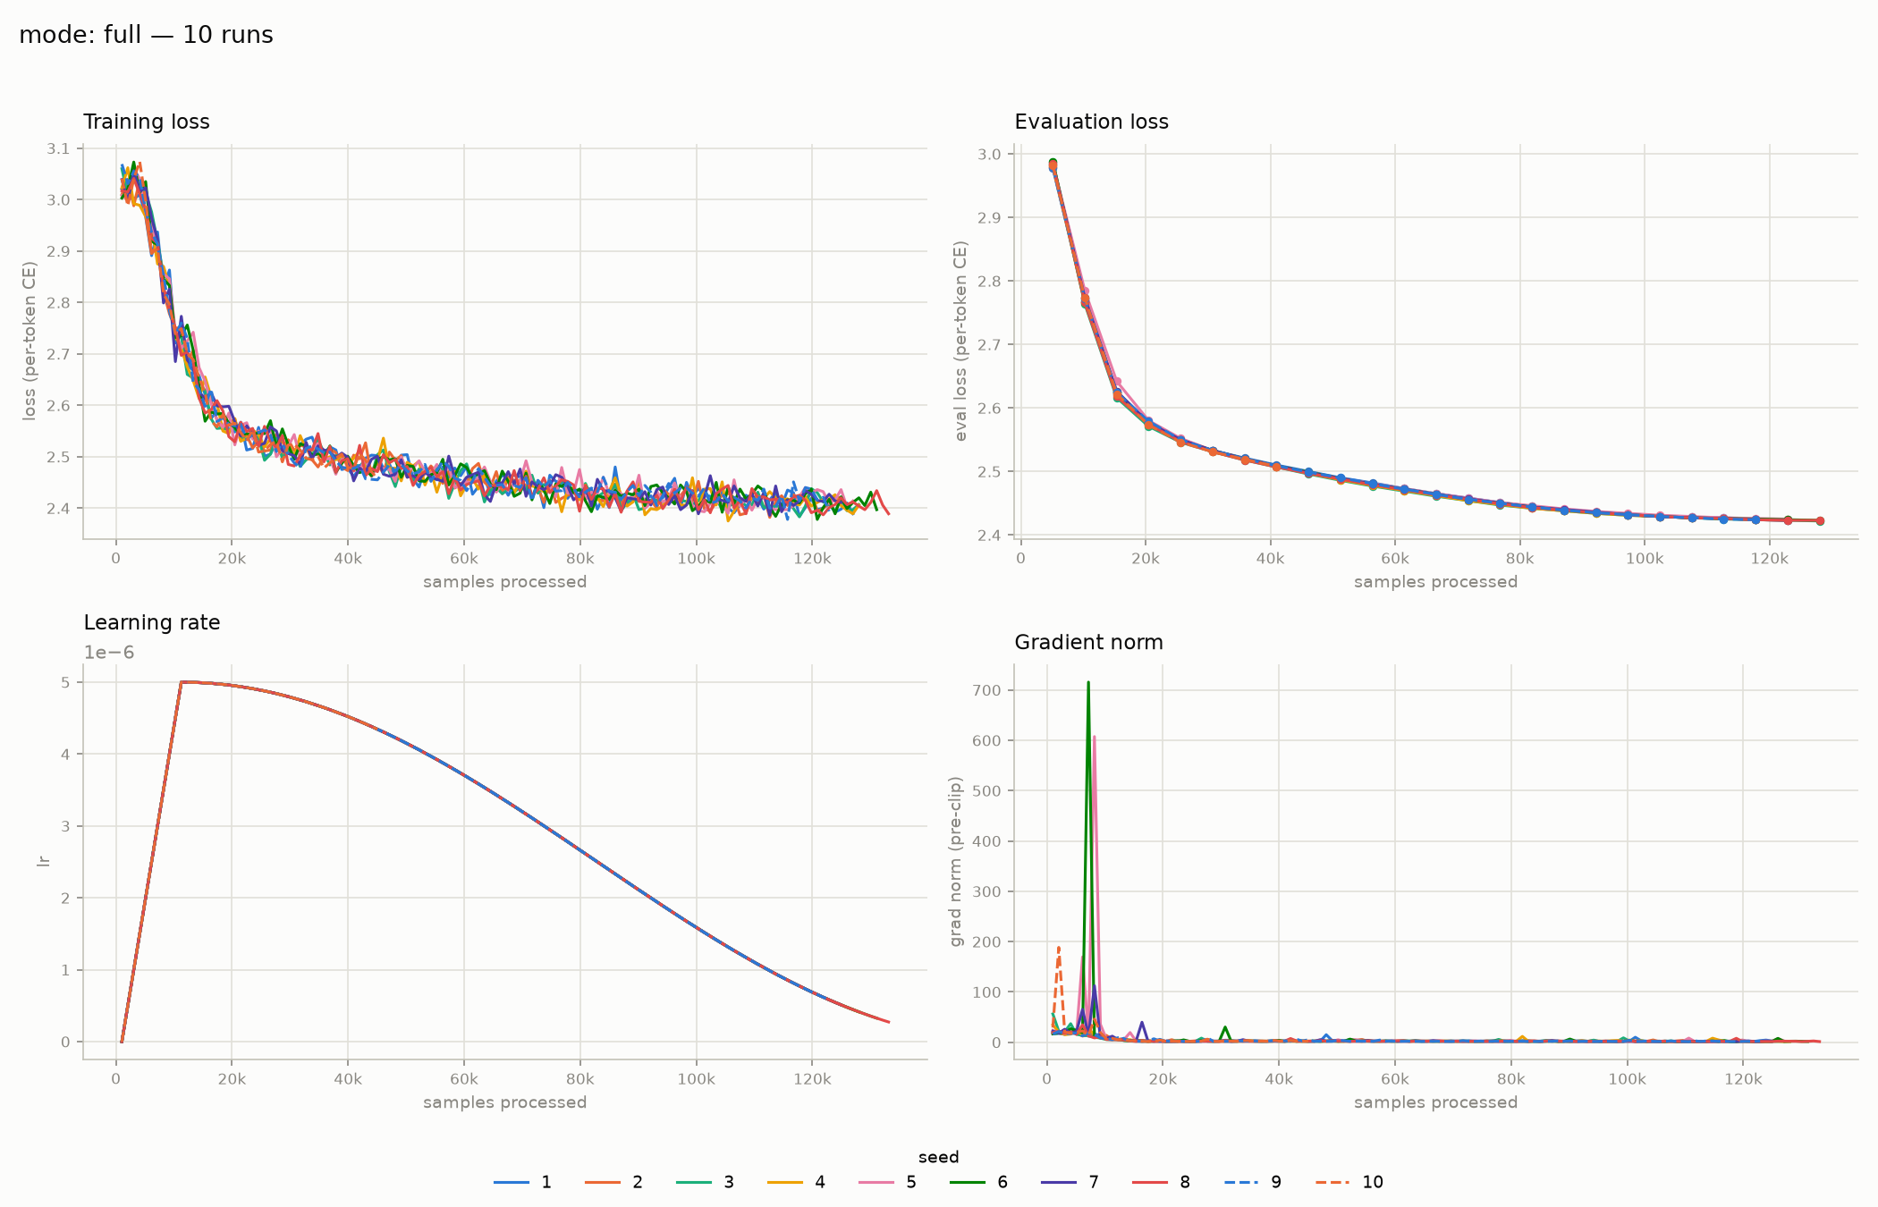
Training loss drops from ~3.0 to ~2.4 and the ten seeds are statistically indistinguishable after the first ~20k samples. Gradient norm shows isolated spikes (up to ~700, clipped to 1.0) during the first ~8k samples of warmup and stays below ~10 afterwards.

Convergence variance
Samples to first reach a target eval loss, over 10 seeds (eval every 5,120 samples; targets ≥ 2.60 are reached within the first few evaluations and are therefore quantized to 0% CV):
Target eval loss | Seeds reached | Mean samples | Std | CV | Min – max
2.43 | 9/10 | 103,538 | 2,258 | 2.2% | 102,400 – 107,520
2.44 | 9/10 | 88,747 | 2,560 | 2.9% | 87,040 – 92,160
2.45 | 9/10 | 79,644 | 2,698 | 3.4% | 76,800 – 81,920
2.50 | 9/10 | 46,649 | 1,707 | 3.7% | 46,080 – 51,200
2.55 | 10/10 | 27,648 | 2,644 | 9.6% | 25,600 – 30,720
2.60 | 10/10 | 20,480 | 0 | 0.0% | 20,480

(9/10 at the lower targets reflects the seed-10 hang, not divergence.)
Candidate targets: eval loss 2.43 (~104k samples, ~80 GB200 GPU-hours including evaluation, CV 2.2%) sits inside the 64–96 GPU-hour goal; 2.45 (~80k samples, ~60 GPU-hours, CV 3.4%) falls just below it. The CV values are upper bounds set by the 5,120-sample evaluation granularity; denser evaluation near the target would tighten them further.

Summary
 | Continued pretraining from the public Qwen3-VL-32B checkpoint
Compute budget | 64–96 GB200 GPU-hours per run (goal); ~80 GPU-hours at target loss 2.43 (~105k samples at GBS 1,024)
Variance | CV = 3.4% at loss 2.45; 2.2% at loss 2.43 (10 seeds)
Evaluation cost | ~30 s per 4,096-sample eval (~14% of run time at the current cadence); moving to 1,024 samples → ~7 s, ~3.5%; CV to be re-measured with the smaller set
Scalability | To be checked (RCPs for GBS 1k / 2k / 4k)

Open items / next steps
- Evaluation set size: reduce the held-out evaluation set from 4,096 to 1,024 samples (~7 s per evaluation instead of ~30 s, i.e. ~3.5% of run time at the current every-5-steps cadence, meeting the 5% goal; currently 24 evals × 30 s ≈ 12 min of an ~88 min run). A smaller evaluation set has a noisier loss estimate, so the coefficient of variation will be re-measured with the 1,024-sample set before fixing the target.
- Data robustness: ~3–4% of samples per run still exceed the 8,192 context after heuristic chunking (non-Latin scripts) and are skipped at load time; the skip substitution can break the image-per-batch guarantee and caused the seed-10 NCCL hang. Fix: exact tokenizer-based chunking in preprocessing and image-aware substitution in the loader.
- Reference implementation: clean up the current codebase (remove unused code paths, pin dependencies, document the run procedure) and define the reference convergence points for GBS 1k / 2k / 4k.
- Target selection: choose the target eval loss (2.45 vs. 2.43) and fix the held-out evaluation set (currently seed-specific) as a shared benchmark artifact.
- Scale sensitivity: repeat the variance study at 2× and 4× GBS with LR scaling to establish RCPs.

