NAME: MUGWANEZA Denyse

DEPT: BIT

CAMPUS: GIKONDO CAMPUS

SUBJ: ADVANCED JAVA PROGRAMMING

ASSIGNMENT

Control statement(if_else)

Question:1

**class denyse {**

**public static void main(String[] args) {**

**int number=12;**

**if(number%2==0){**

**System.out.println("EVEN NUMBER");**

**}else{**

**System.out.println("ODD NUMBER");**

**}**

**}**

**}**

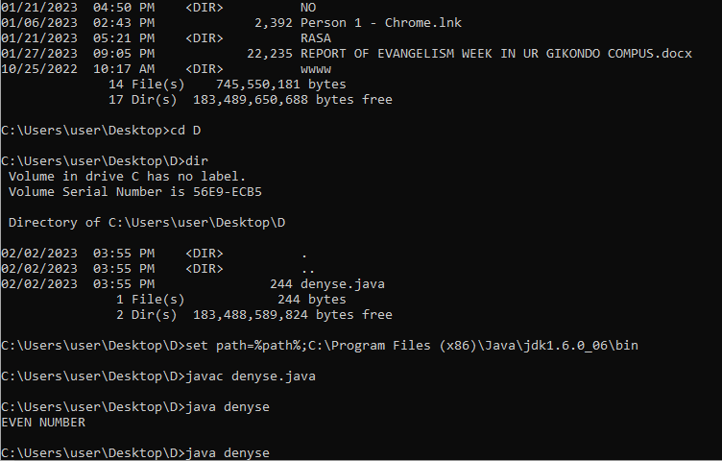

**Question:2**

**class numbers {**

**public static void main(String[] args) {**

**int number=-13;**

**if(number>0){**

**System.out.println("POSITIVE");**

**}else if(number<0){**

**System.out.println("NEGATIVE");**

**}else{**

**System.out.println("ZERO");**

**}**

**}**

**}**

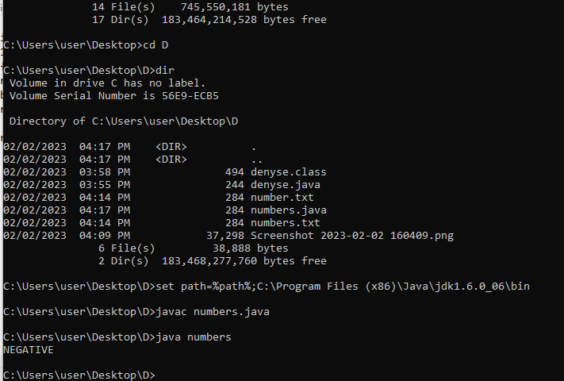

**Question:3**

**class deny {**

**public static void main(String[] args) {**

**int no=5555;**

**if(no>0){**

**System.out.println("GOOD");**

**}else if(no<0){**

**System.out.println("NOT");**

**}else{**

**System.out.println("NEGATIVE");**

**}**

**}**

**}**

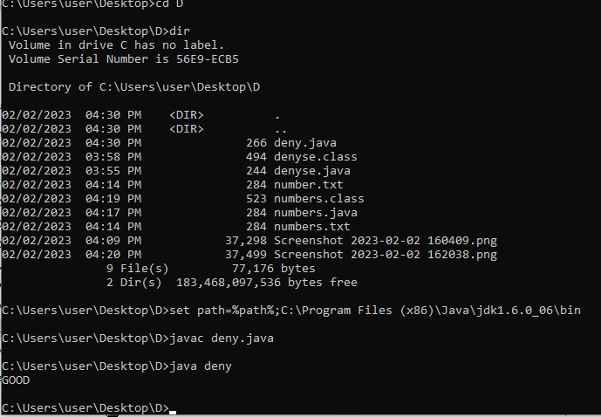

**Java object and class:**

Question:4

class Lecturer{

int id;

String name;

public static void main(String args[]){

Lecturer s1=new Lecturer();

System.out.println(s1.id);

System.out.println(s1.name);

}

}

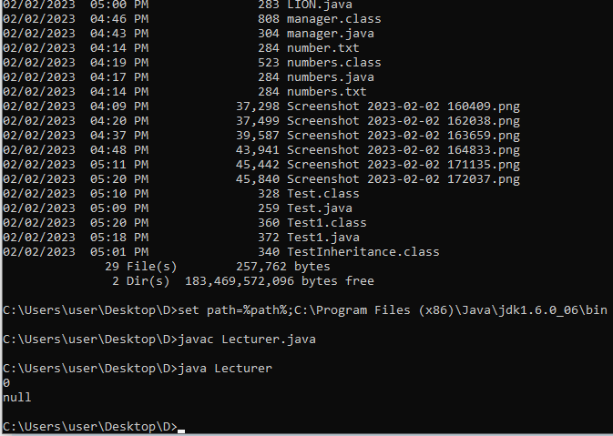

Question:5

class doctor{

int id;

String name;

}

class Testdoctor1{

public static void main(String args[]){

doctor s1=new doctor();

s1.id=10;

s1.name="MUGWANEZA Denyse";

System.out.println(s1.id+" "+s1.name);

} 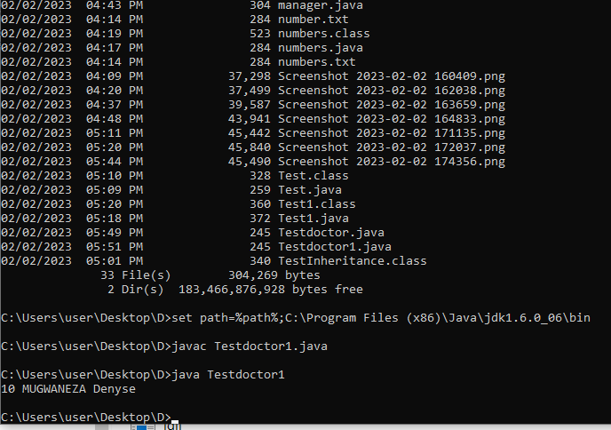

}

Question:6

class driver{

int id;

String name;

}

class Testdriver{

public static void main(String args[]){

driver d1=new driver();

driver d2=new driver();

d1.id=22103467;

d1.name="MUGWANEZA";

d2.id=22100344;

d2.name="DENYSE";

System.out.println(d1.id+" "+d1.name);

System.out.println(d2.id+" "+d2.name);

}

}

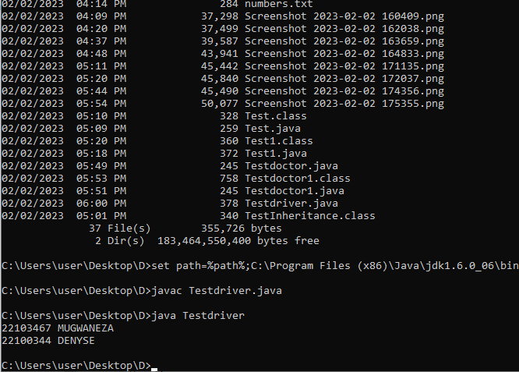

Java inheritance

Question:7

class Employee{

float salary=400000;

}

class manager extends Employee{

int bonus=100000;

public static void main(String args[]){

manager p=new manager();

System.out.println("manager salary is:"+p.salary);

System.out.println("Bonus of manager is:"+p.bonus);

}

}

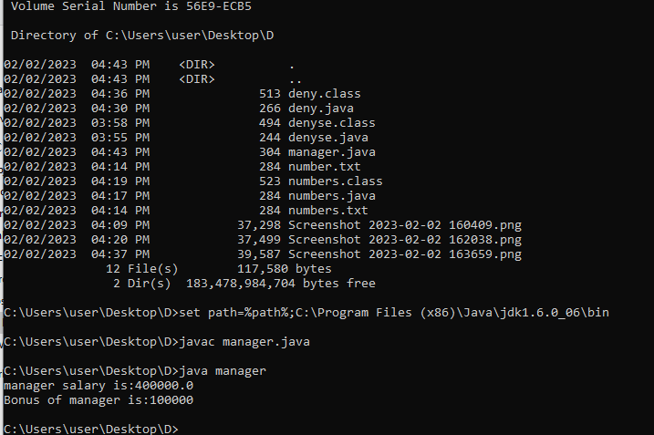

Question:8

class Animal{

void eat(){System.out.println("EATS MEAT...");}

}

class Dog extends Animal{

void bark(){System.out.println("BARK...");}

}

class Test{

public static void main(String args[]){

Dog d=new Dog();

d.bark();

d.eat();

}}

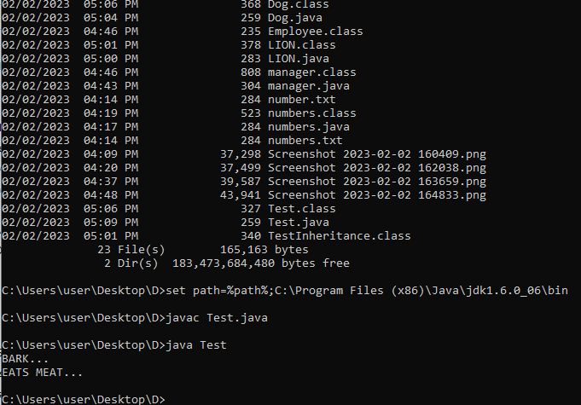

Question:9

class Animal{

void eat(){System.out.println("EATING...");}

}

class Lion extends Animal{

void bark(){System.out.println("BARKING...");}

}

class BabyLion extends Lion{

void weep(){System.out.println("WEEPING...");}

}

class Test1{

public static void main(String args[]){

BabyLion d=new BabyLion();

d.weep();

d.bark();

d.eat();

}}

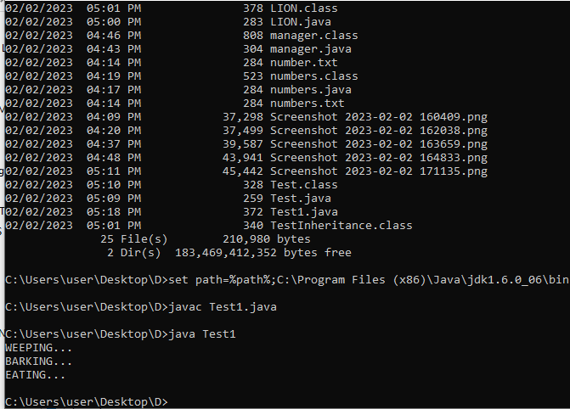

Java polymorphism:

Question:10

class Adder{

static int add(int a,int b){return a+b;}

static int add(int a,int b,int c){return a+b+c;}

}

class adding{

public static void main(String[] args){

System.out.println(Adder.add(110,171));

System.out.println(Adder.add(181,191,141));

}}

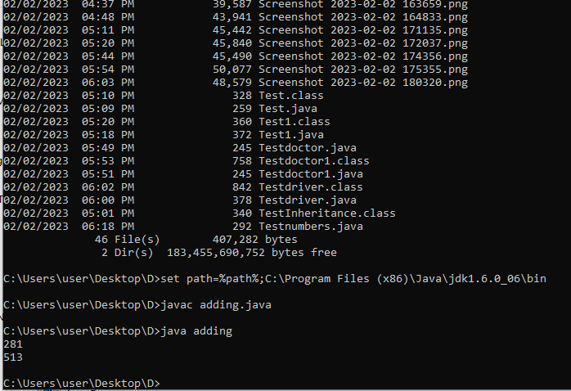

Question:11

class Numbers{

static int add(int a, int b){return a+b;}

}

class Numbers2{

public static void main(String[] args){

System.out.println(Adder.add(156,11000));

}}

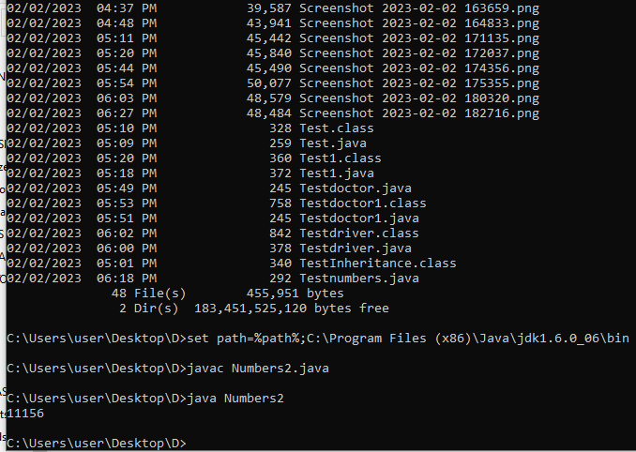

Question:12

class MUGWANEZA{

void sum(int a,long b){System.out.println(a+b);}

void sum(int a,int b,int c){System.out.println(a+b+c);}

public static void main(String args[]){

MUGWANEZA obj=new MUGWANEZA();

obj.sum(200,720);

obj.sum(820,120,220);

}

}

