**Document for Installation Process:**

**Step: 1**

Download the installer from below link:

<http://vlabsapitest.magicard.com/releases/MagiCard.Bundle.zip>

**Step: 2**

Extract the file from zip folder then “Magicard_Driver_v2.0.40” file is extracted.

**Step: 3**

Double click on the installer then installation of horizon is started.

**Note**: If installer is already installed in the system it will ask for “Uninstall” or “repair” the software.

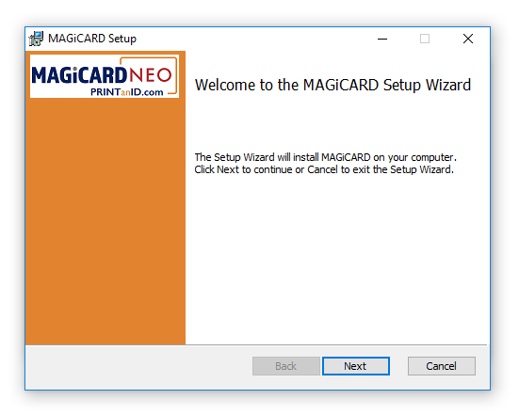

**Step: 4**

“Magicard will be installed in your system” is displayed, click on “install” option.

**Step: 5**

Alert is displayed as "do you need to install this in your computer" click on Yes option.

**Step: 6**

Click on next option.

Check the check box beside "I accept the terms in the License Agreement".

Click on next option.

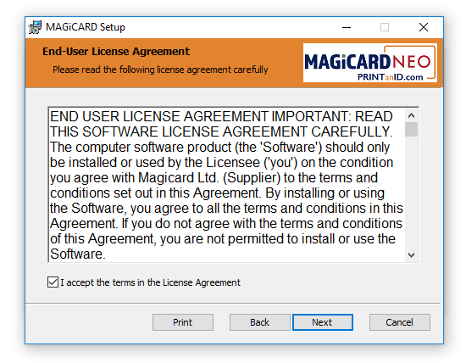

**Step: 7**

"Website Name" is displayed and click on next option.

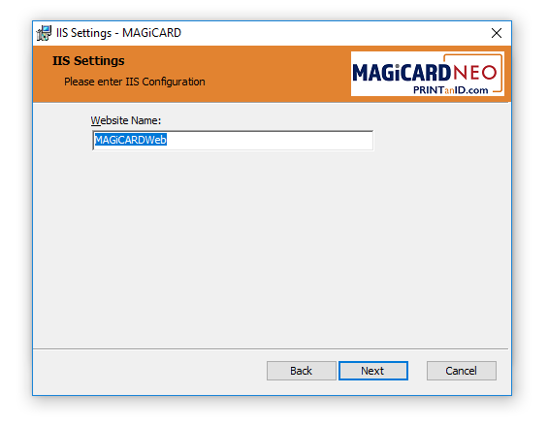

**Step : 8**

"Application pool name" is displayed and click on next option.

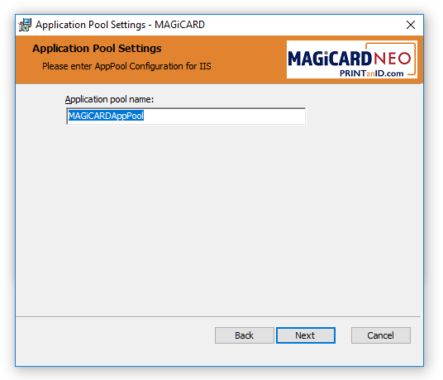

**Step: 9**

In "Custom Setup" click on next option.

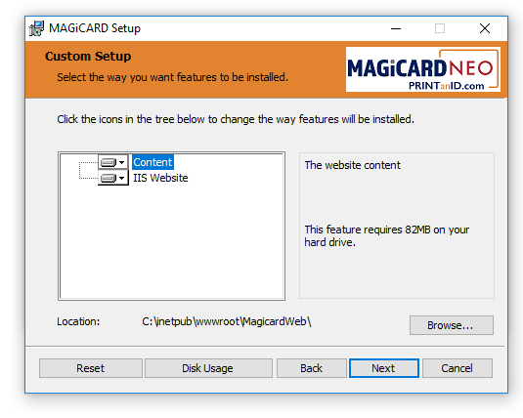

**Step: 10**

In "Ready To install MAGiCARD" click on Install option.

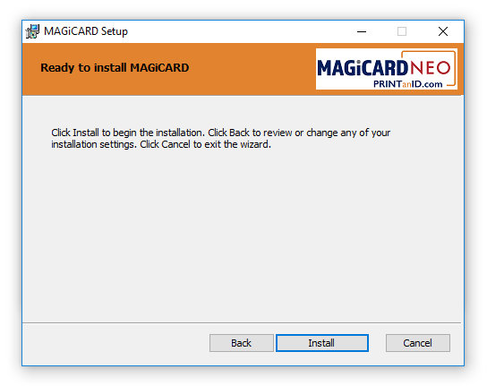

**Step: 11**

"Completed the "MAGiCARD Setup Wizard" click on Finish option.  
"Setup Successful" is displayed click on close option.

**Step: 12**

In Browser enter <http://localhost:85>   
Log page of MAGiCARD is displayed.