EquiDoc — Core User Workflow
A step-by-step map of how a user moves through EquiDoc, from photographing a document to hearing it explained in their own language. This expands Section 5 of the PRD.

At a glance
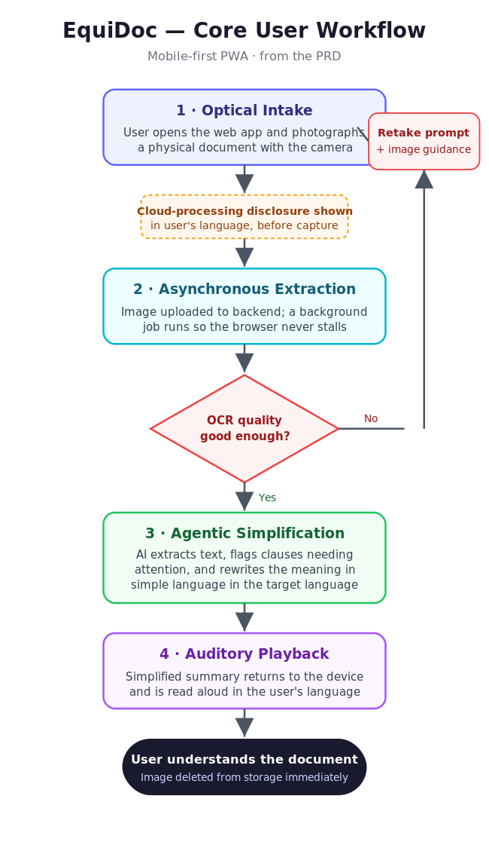

The four steps
1 · Optical Intake
User does | Opens the web app (mobile PWA) and uses the device camera to photograph a physical document.
System does | Presents the camera capture screen. Before capture, clearly discloses — in the user’s language — that the image will be sent to a cloud model for processing.
Outcome | A captured image, ready to upload.

2 · Asynchronous Extraction
User does | Waits briefly; can keep the app open without the browser freezing.
System does | Uploads the image to the backend and triggers a background job so heavy OCR does not stall the browser or time out.
Branch | If image quality is too low for reliable OCR, the app shows a retake prompt with image-quality guidance and returns the user to Step 1.
Outcome | Clean, machine-readable text extracted from the photo.

3 · Agentic Simplification
User does | Nothing — this runs automatically.
System does | The AI extracts the text, flags clauses that warrant attention or critical instructions, and rewrites the core meaning in simple, conversational language in the user’s target language.
Outcome | A short, plain-language summary in the user’s language, with important clauses highlighted.

4 · Auditory Playback
User does | Listens to the summary read aloud; can replay as needed.
System does | Returns the simplified summary to the device and reads it aloud in the user’s localized language via text-to-speech.
Outcome | The user understands the document without needing to read dense text.

After playback
Once processing completes, the uploaded image is deleted from Supabase Storage immediately to minimize privacy risk. EquiDoc is positioned as comprehension support, not legal advice, and shows an explicit disclaimer.

Key decision points
Two branches keep the workflow honest: (1) the cloud-processing disclosure gate before capture, which the user must see in their own language; and (2) the OCR-quality check after extraction, which loops back to a retake prompt when the photo is too poor to process reliably. OCR accuracy on real phone photos is the core product risk, so this loop matters more than any other fallback.

